Week 4: Machine Learning Model Development & Evaluation

Executive Summary
This project evaluated two supervised learning models for predicting Titanic survival using a compact, interpretable feature set. The workflow included feature engineering, imputation, preprocessing, stratified train/test splitting, model training, classification evaluation, and visual analysis. Logistic regression provides a strong baseline with transparent coefficients, while the random forest model offers non-linear structure capture and improved flexibility. In practical terms, the goal was to assess not only overall predictive performance but also which model balances accuracy, recall, and calibration trade-offs for a binary classification problem with meaningful operational implications.

Methodological Description
The Titanic dataset was downloaded and preprocessed using a structured feature engineering workflow. Family size was derived as SibSp + Parch + 1 to capture household structure. A ColumnTransformer was then built with separate pipelines for numerical and categorical data: median imputation and StandardScaler for Age, Fare, SibSp, Parch, and FamilySize, and mode imputation plus OneHotEncoder(drop='first') for Pclass, Sex, and Embarked. The target variable was survival status, and an 80/20 stratified train-test split with random_state=42 was used to preserve the class balance across training and evaluation sets.

Quantitative Performance Data
Model | Accuracy | Precision | Recall | F1-Score | ROC-AUC
Logistic Regression | 0.8045 | 0.7931 | 0.6667 | 0.7244 | 0.8432
Random Forest | 0.8101 | 0.8431 | 0.6232 | 0.7167 | 0.8433
The best-performing model by F1-score was Logistic Regression. The highest ROC-AUC observed was 0.843, indicating the strongest discriminatory power across the two models tested.

Figure 1: Confusion Matrices
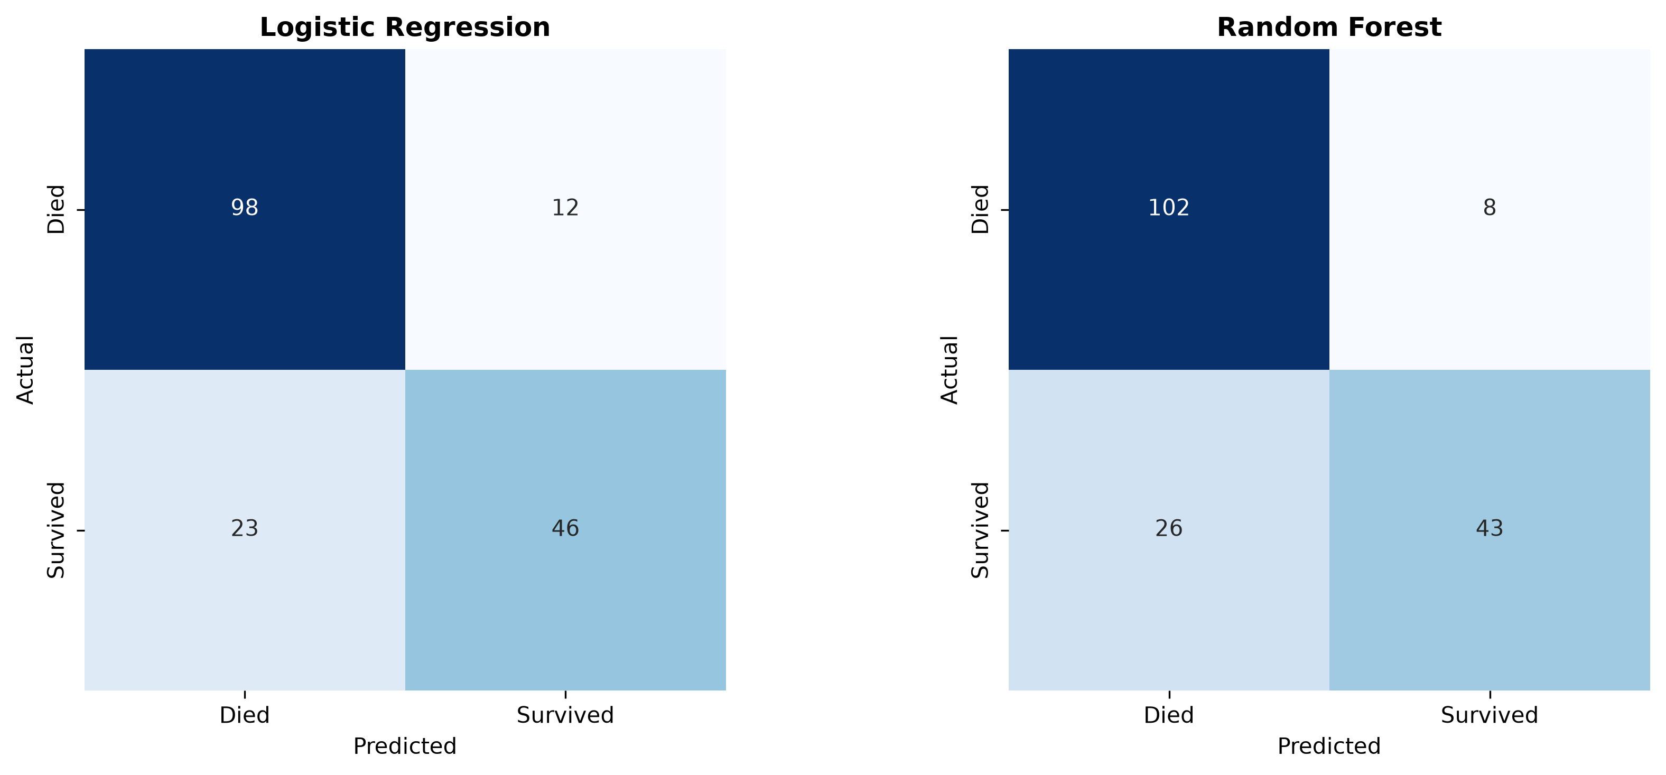
Figure 1 compares the classification error patterns of the logistic regression and random forest models. A confusion matrix highlights how often each model correctly identifies survivors and non-survivors and where it makes false positive or false negative mistakes. This comparison is useful because a model with strong overall accuracy can still perform poorly on one class if the error distribution is imbalanced.

Figure 2: ROC Curves
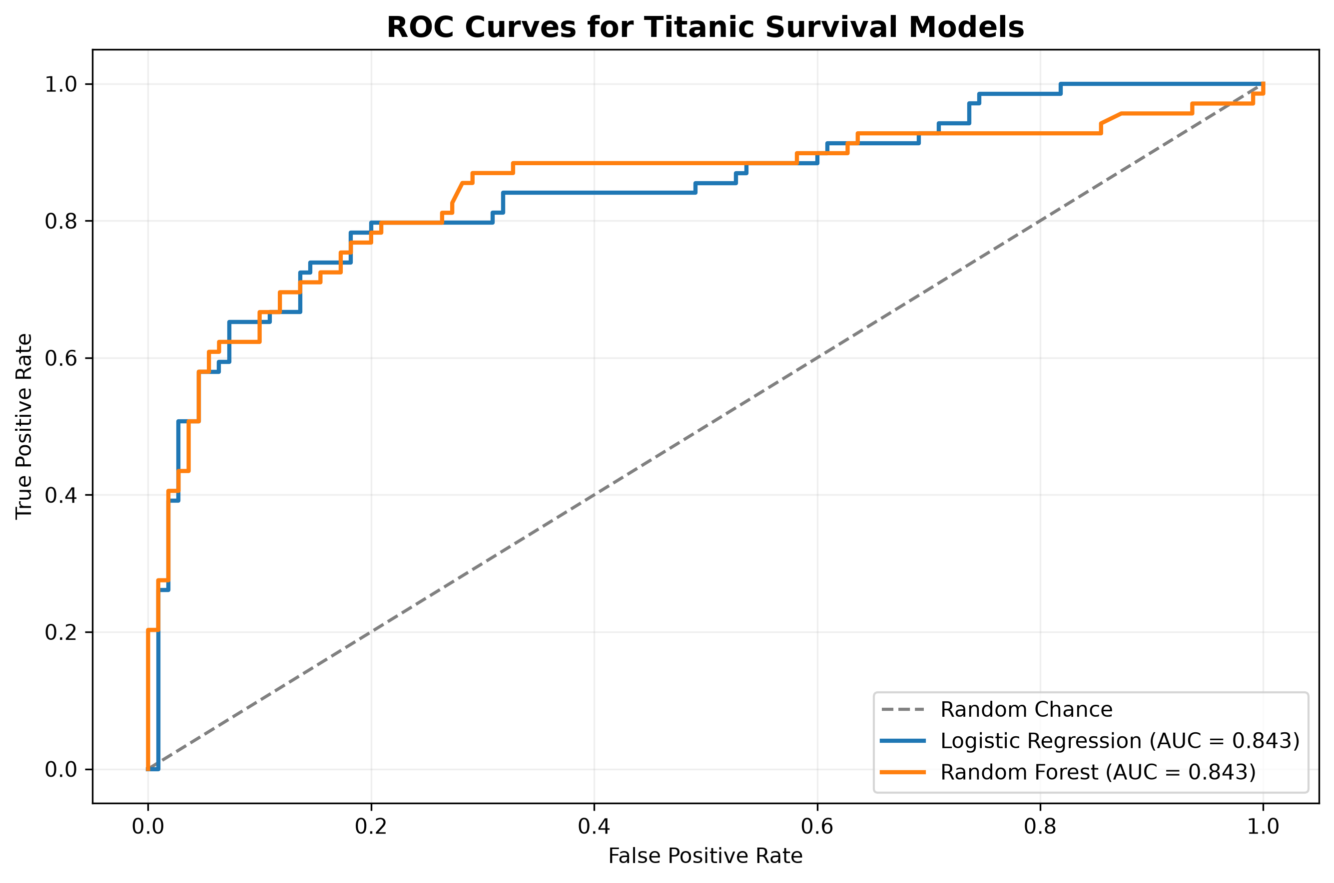
Figure 2 overlays the ROC curves for both models and includes a random-chance benchmark. The ROC curve summarises the trade-off between sensitivity and specificity over a range of decision thresholds, while the area under the curve provides a threshold-independent measure of discriminative power. This is particularly relevant when the operational cost of false negatives differs from false positives.

Critical Discussion
Potential sources of error include the omission of variables not present in the dataset, the possibility that historical data reflect social biases, and the fact that the train/test split may not capture all temporal or population-level variation. The logistic regression model is interpretable but may underfit if the relationship between predictors and survival is non-linear. Conversely, the random forest model can capture non-linear interactions but may overfit if the tree depth or minimum split criteria are not tuned carefully.
Future improvements should include a more systematic hyperparameter search using GridSearchCV, model comparison against stronger baselines such as XGBoost, and validation using cross-validation to better estimate robustness. Additional diagnostics such as calibration curves, precision-recall curves, and feature importance analysis would support more nuanced model selection and operational deployment decisions.

