Comprehensive Data Analysis Report: Titanic Survival Dataset
Prepared from 891 source rows. Generated automatically with pandas, NumPy, Seaborn, Matplotlib, and python-docx.

Section 1: Methodology & Data Acquisition
The pipeline retrieves the public Titanic CSV directly from GitHub, preserves the raw DataFrame for auditability, applies deterministic preprocessing, calculates descriptive statistics, creates reusable visualizations, and packages the results into this report.

Acquisition and analysis code
1 def acquire_data(url: str = DATA_URL) -> pd.DataFrame:
2 """Download the Titanic CSV into a DataFrame."""
3 LOGGER.info("Downloading dataset from %s", url)
4 return pd.read_csv(url)
5
6
7 def summarize_data(data: pd.DataFrame) -> tuple[pd.DataFrame, pd.DataFrame]:
8 """Return numerical and categorical summary statistics."""
9 numerical = data.select_dtypes(include=np.number).describe().round(2).T
10 categorical_columns = data.select_dtypes(include=["str", "category"]).columns
11 categorical = data[categorical_columns].describe().T if len(categorical_columns) else pd.DataFrame()
12 return numerical, categorical

Section 2: Data Cleaning & Preprocessing
Age is imputed with its median because it is numeric and the median is robust to skew and outliers. Cabin is removed because more than 70% of its values are missing, making reliable single-value imputation inappropriate. Missing Embarked values are filled with the mode, the most frequent observed embarkation port. Duplicate rows are removed, and key discrete variables are converted to categorical dtype for correct analysis semantics.

Cleaning code
1 def clean_data(data: pd.DataFrame) -> tuple[pd.DataFrame, dict[str, Any]]:
2 """Apply documented missing-value, duplicate, and dtype transformations."""
3 cleaned = data.copy()
4 missing_before = cleaned.isna().sum()
5 duplicate_rows = int(cleaned.duplicated().sum())
6 cabin_missing_rate = float(cleaned["Cabin"].isna().mean()) if "Cabin" in cleaned else 0.0
7
8 if "Age" in cleaned:
9 cleaned["Age"] = cleaned["Age"].fillna(cleaned["Age"].median())
10 if "Cabin" in cleaned and cabin_missing_rate > 0.70:
11 cleaned = cleaned.drop(columns="Cabin")
12 if "Embarked" in cleaned:
13 cleaned["Embarked"] = cleaned["Embarked"].fillna(cleaned["Embarked"].mode().iloc[0])
14 cleaned = cleaned.drop_duplicates().reset_index(drop=True)
15
16 for column in ("Survived", "Pclass"):
17 if column in cleaned:
18 cleaned[column] = cleaned[column].astype("category")
19 for column in ("Sex", "Embarked"):
20 if column in cleaned:
21 cleaned[column] = cleaned[column].astype("category")
22
23 verification = {
24 "rows_before": len(data),
25 "rows_after": len(cleaned),
26 "columns_before": len(data.columns),
27 "columns_after": len(cleaned.columns),
28 "duplicates_removed": duplicate_rows,
29 "cabin_missing_rate": cabin_missing_rate,
30 "missing_before": missing_before[missing_before > 0].to_dict(),
31 "missing_after": cleaned.isna().sum()[cleaned.isna().sum() > 0].to_dict(),
32 "dtypes": {column: str(dtype) for column, dtype in cleaned.dtypes.items()},
33 }
34 return cleaned, verification

Verification output
Rows: 891 -> 891
Columns: 12 -> 11
Duplicate rows removed: 0
Cabin missing rate before cleaning: 77.1%
Missing values before: {'Age': 177, 'Cabin': 687, 'Embarked': 2}
Missing values after: none
Dtypes after cleaning: {'PassengerId': 'int64', 'Survived': 'category', 'Pclass': 'category', 'Name': 'str', 'Sex': 'category', 'Age': 'float64', 'SibSp': 'int64', 'Parch': 'int64', 'Ticket': 'str', 'Fare': 'float64', 'Embarked': 'category'}
Final dataset dimensions: 891 rows x 11 columns.

Section 3: Exploratory Data Analysis & Visualizations

Numerical summary statistics
index | count | mean | std | min | 25% | 50% | 75% | max
PassengerId | 891.0 | 446.0 | 257.35 | 1.0 | 223.5 | 446.0 | 668.5 | 891.0
Age | 891.0 | 29.36 | 13.02 | 0.42 | 22.0 | 28.0 | 35.0 | 80.0
SibSp | 891.0 | 0.52 | 1.1 | 0.0 | 0.0 | 0.0 | 1.0 | 8.0
Parch | 891.0 | 0.38 | 0.81 | 0.0 | 0.0 | 0.0 | 0.0 | 6.0
Fare | 891.0 | 32.2 | 49.69 | 0.0 | 7.91 | 14.45 | 31.0 | 512.33

Categorical summary statistics
index | count | unique | top | freq
Survived | 891 | 2 | 0 | 549
Pclass | 891 | 3 | 3 | 491
Name | 891 | 891 | Braund, Mr. Owen Harris | 1
Sex | 891 | 2 | male | 577
Ticket | 891 | 681 | 347082 | 7
Embarked | 891 | 3 | S | 646
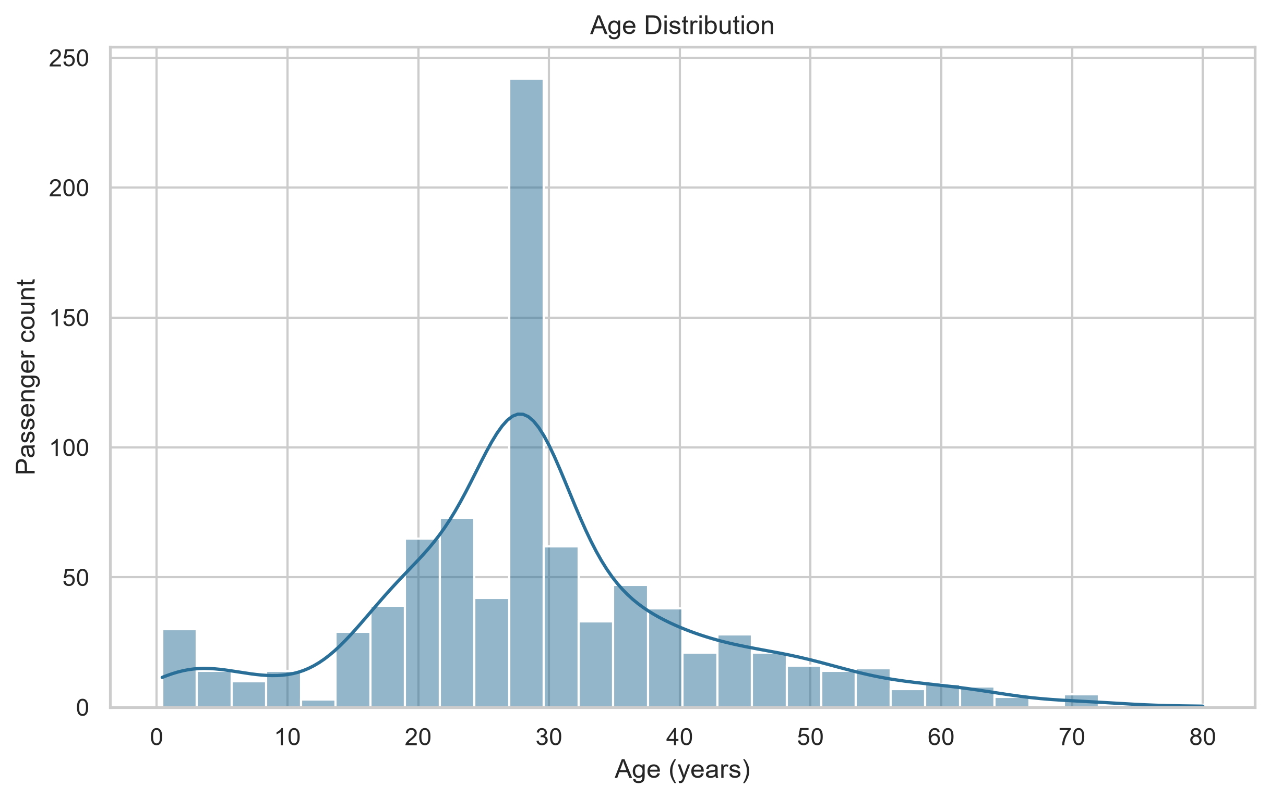
Figure: Age Distribution
Analytical insight: The distribution is concentrated among young and middle-aged adults, with the KDE showing the overall shape after median imputation.
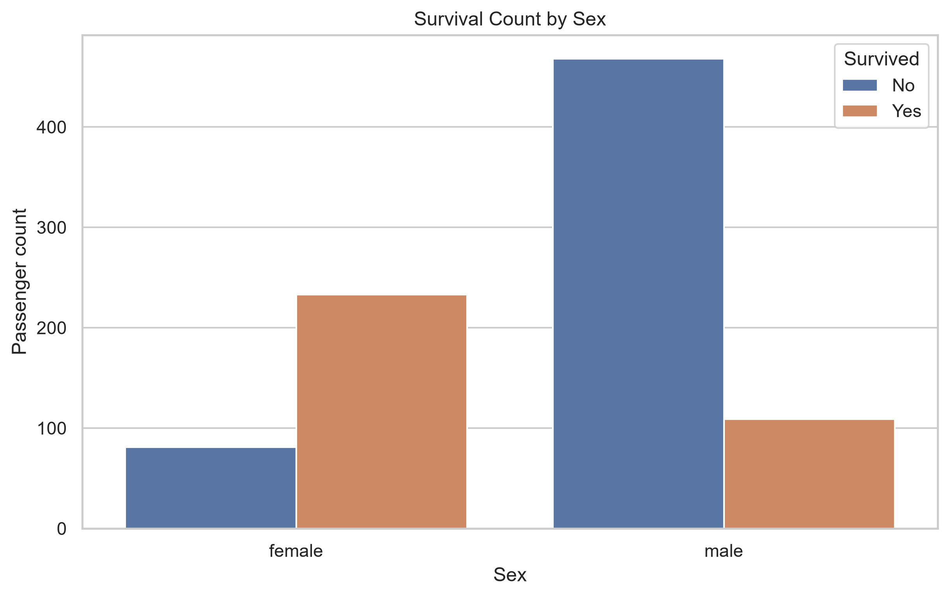
Figure: Survival Count by Sex
Analytical insight: Female passengers have substantially more survivors and fewer deaths than male passengers, revealing a strong association between sex and survival outcome.
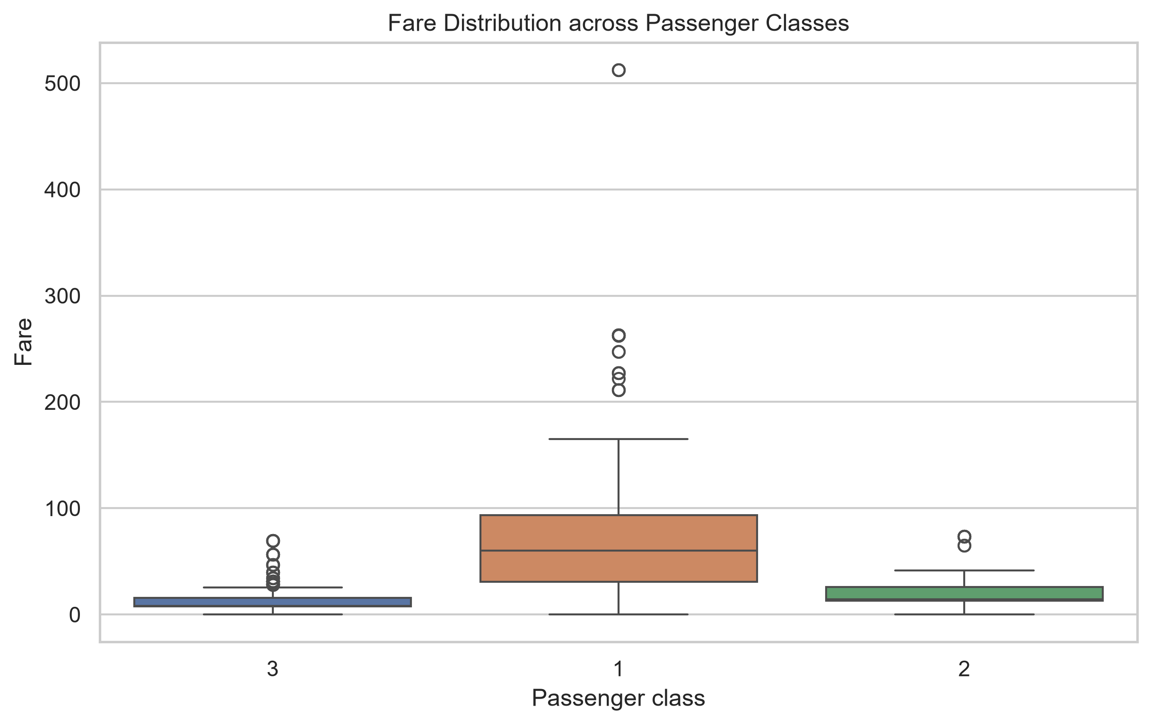
Figure: Fare Distribution across Passenger Classes
Analytical insight: Fare generally increases with passenger class, while the spread and high-value outliers show that price varied considerably within classes.

Section 4: Summary of Key Insights & Future Scope
The analysis indicates that passenger sex and class are important descriptive correlates of Titanic survival, while passenger ages are broadly distributed across the adult population. Future work could add survival-rate confidence intervals, investigate interactions among sex, class, age, and family size, and evaluate predictive models with cross-validation. Any model should use a documented train/test split and avoid leakage from imputation or feature engineering.
Artifacts are stored alongside this report in the output directory.

