## Fold and Sum

Read an array of **4*k** integers, fold it like shown below, and print the sum of the upper and lower two rows (each holding 2 * k integers):

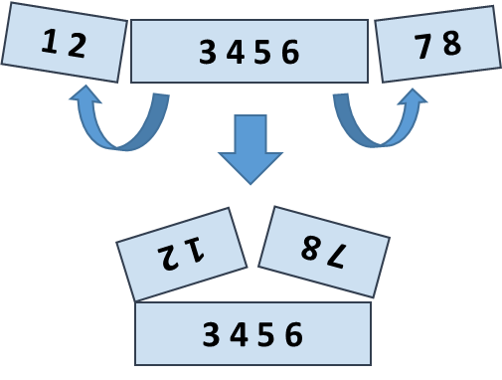

### Examples

|  |  |  |
| --- | --- | --- |
| **Input** | **Output** | **Comments** |
| 5 **2 3** 6 | 7 9 | 5 6 +  2 3 =  7 9 |
| 1 2 **3 4 5 6** 7 8 | 5 5 13 13 | 2 1 8 7 +  3 4 5 6 =  5 5 13 13 |
| 4 3 -1 **2 5 0 1 9 8**  6 7 -2 | 1 8 4 -1 16 14 | -1 3 4 -2 7 6 +  2 5 0 1 9 8 =  1 8 4 -1 16 14 |