**Diagonal Difference**

Write a program that finds the **difference between the sums of the square matrix diagonals** (absolute value).

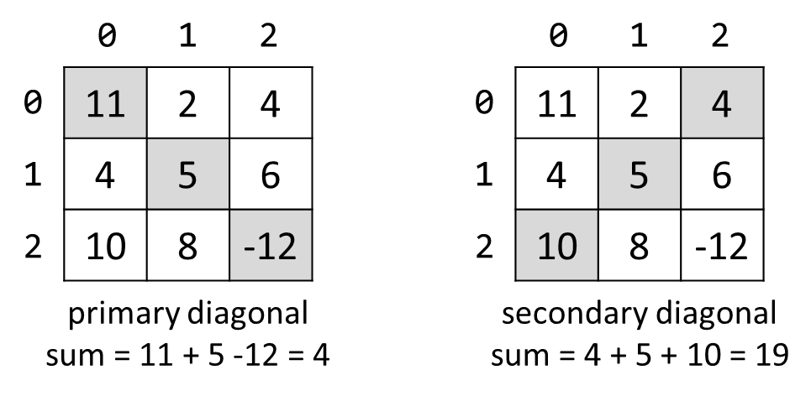

**Input**

* On the **first line**, you are given the integer **N** – the size of the square matrix
* The next **N lines** holds the values for **every row** – **N** numbers separated by a space

**Output**

* Print **the absolute** difference between **the sums** of the primary and the secondary diagonal

**Examples**

|  |  |  |
| --- | --- | --- |
| **Input** | **Output** | **Comments** |
| 3  11 2 4  4 5 6  10 8 -12 | 15 | **Primary diagonal:** sum = 11 + 5 + (-12) = 4  **Secondary diagonal:** sum = 4 + 5 + 10 = 19  **Difference:** |4 - 19| = 15 |