Steps

1. Install RStudio from this link according to your system.

<https://rstudio.com/products/rstudio/download/>

1. Open screener.R
2. Select All (Ctrl+A) and then press Ctrl+Enter. It will take about a minute to download the data.
3. The data is available in the Environment in the right hand side of the Rstudio screen like in this screenshot.

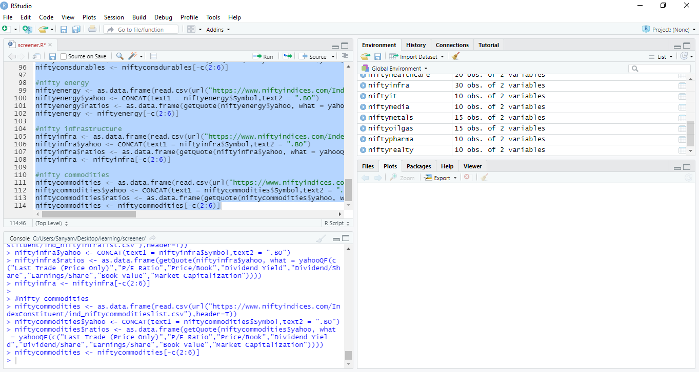

1. Click on the index for which you want the data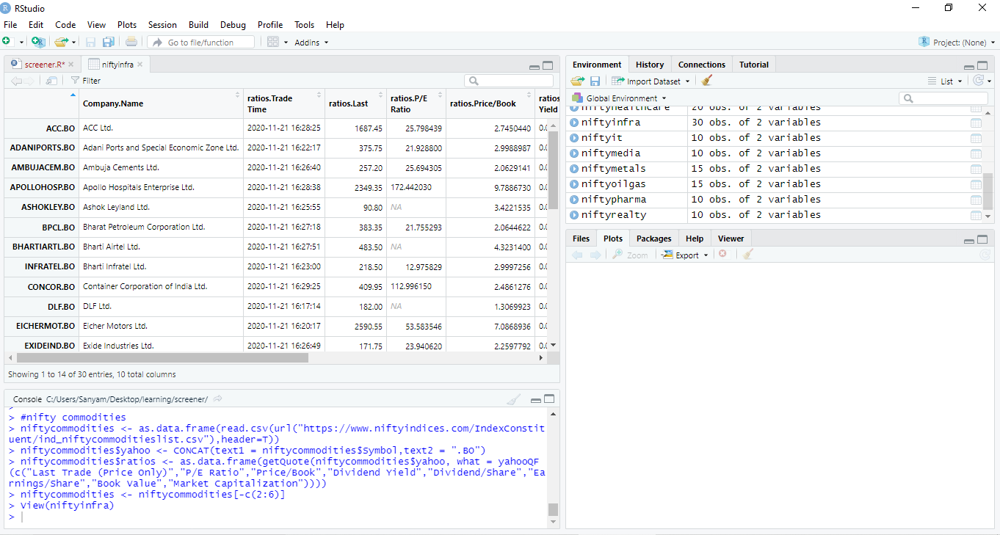

It will look something like this once click on the index.

1. When running the code for the subsequent times, delete the first three lines of the code. The install.packages one’s.

Remember:

1. There will be some fields with N/A. This is because of the unavailability of data.
2. This code gives live data as on run time. It will give the live data for the companies in the index present at that time. Basically, changes in index constituents will be accounted for.