CHAPTER 3: RESULTS AND DISCUSSION

Two types of graphs were plotted -

1. The AQI value of a single pollutant for all locations in one graph.

2. The AQI value of all the pollutants in one location.

3. The pollutants were coloured as follows

* PM10-Red
* SO2-Blue
* NOx-Black

Comparison has also been done between actual and predicted values.

Variation of the AQI parameters

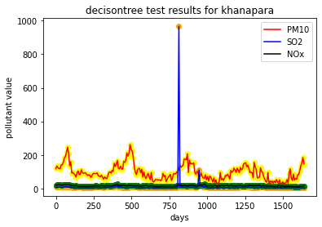The matplotlib library of python was used to plot the pollutants against the days the pollutants was measured.Matplotlib is a plotting library for the Python programming language and its numerical mathematics extension NumPy. It provides an object-oriented API for embedding plots into applications using general-purpose GUI toolkits like Tkinter, wxPython, Qt, or GTK+.Matplotlib was originally written by John D. Hunter. Python 3 support started with Matplotlib 1.2. Matplotlib 1.4 is the last version to support Python 2.6[8]

Figure 1

In the above graph we can see that all the pollutants have been plotted for the station Khanapara. The pollutants have been plotted in the y-axis against the days the pollutants have been measured , plotted in the x-axis. The pollutants have been labelled as follows: PM10 has been represented with orange colour, SO2 has been represented by blue and Nox has been represented with black colour.

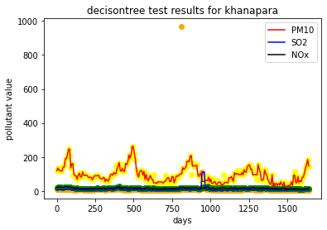Dealing with Anomalies

Figure 2

In the above graph ,we can also see an abnormal spike in the SO2 value for a day. It has occurred due to an error in the sensor at that location. We chose to take that anomaly because we wanted to keep the collected data as much unaltered as possible. In the prediction from our model , the value was seen to be balanced. The results for predicted values for the khanapara are given below

COMPARISON OF VALUES ACTUAL VS PREDICTED IN ALL THE STATIONS OF GUWAHATI

* Total six number of graphs were plotted. The graphs were plotted for the three pollutants separately and included all the stations’ data.
* The graphs were generated using the matplotlib library of Python.
* Each graph contains the data of a single pollutant for a period of about 300 day.
* The pollutant measuring stations were labelled as following colors:
  + Borgaon-Red
  + Pragjyotish-Blue
  + Bamunimaidan-Green
  + Guwahati University-Yellow
  + Khanapara-Black
  + Gopinathnagar-Violet

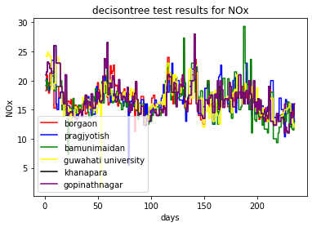1.For pollutant Nox

Figure 3

Decision tree graph results for Actual measured values of pollutant NOx

In this graph, the pollutant NOx has been plotted. The x-axis represents the days on which the data was obtained from the sensors from each location i.e. Borgaon, Pragjyotish,Bamunimaidan,Guwahati University,Khanapara, Gopinathnagar. The y-axis contains the NOx value obtained from the sensors at each location.

Decision tree graph results for predicted values of pollutant NOx

In this graph, the pollutant NOx has been plotted. The x-axis represents the days on which the data

was obtained from the sensors from each location i.e. Borgaon, Pragjyotish,Bamunimaidan,Guwahati University,Khanapara, Gopinathnagar. The y-axis contains the NOx value obtained from the predicted values of the decision tree.

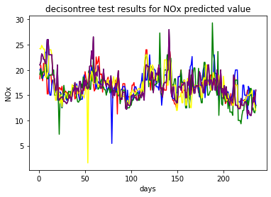

Figure 4

2.For Pollutant PM10

Decision tree graph results for Actual measured values of pollutant PM10

In this graph, the pollutant PM10 has been plotted. The x-axis represents the days on which the data was obtained from the sensors from each location i.e. Borgaon, Pragjyotish,Bamunimaidan,Guwahati University,Khanapara, Gopinathnagar. The y-axis contains the PM10 value obtained from the sensors at each location. 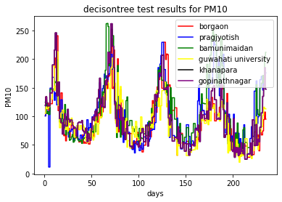

Figure 5

Decision tree graph results for predicted values of pollutant PM10

In this graph, the pollutant PM10 has been plotted. The x-axis represents the days on which the data

was obtained from the sensors from each location i.e. Borgaon, Pragjyotish,Bamunimaidan,Guwahati University,Khanapara, Gopinathnagar. The y-axis contains the PM10 value obtained from the predicted values of the decision tree.

Figure 6

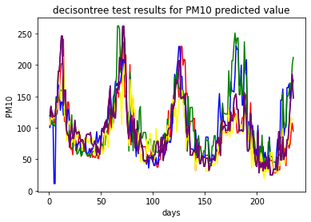

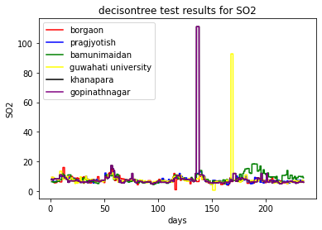3.For pollutant SO2

Figure 7

Decision tree graph results for Actual measured values of pollutant SO2

In this graph, the pollutant SO2 has been plotted. The x-axis represents the days on which the data

was obtained from the sensors from each location i.e. Borgaon, Pragjyotish,Bamunimaidan,Guwahati University,Khanapara, Gopinathnagar. The y-axis contains the SO2 value obtained from the sensors at each location.

Decision tree graph results for predicted values of pollutant SO2

In this graph, the pollutant SO2 has been plotted. The x-axis represents the days on which the data

was obtained from the sensors from each location i.e. Borgaon, Pragjyotish,Bamunimaidan,Guwahati University,Khanapara, Gopinathnagar. The y-axis contains the SO2 value obtained from the predicted values of the decision tree.

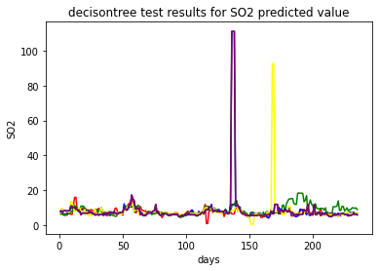

Figure 8

ACCURACY ANALYSIS

The following mean absolute error and root mean square errors were found

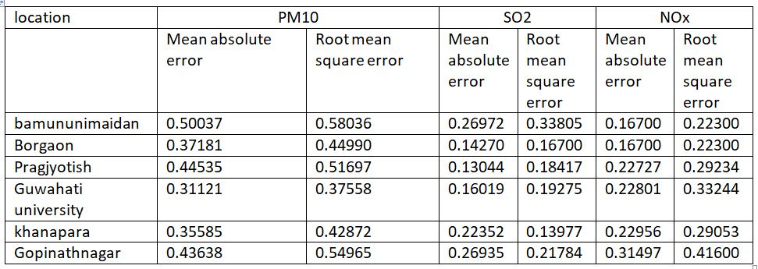

Table 1

CHAPTER 4: CONCLUSION AND FUTURE SCOPE

CONCLUSION

1. From the results obtained we can see that out of all the considered algorithms, the Decision Tree algorithm gives the highest accuracy, hence is most precise in predicting the AQI values of different locations of Guwahati.
2. The PM10 Values were higher than that of SO2 and NOx in all the locations.
3. The actual and predicted values of pollutants are almost linearly comparable.
4. All the stations showed similar accuracy in predicting the pollutant values.

FUTURE SCOPE

In the future, we can have multiple additions and improvements to this project. The data input can be continuous data input with new data being fed into the prediction model as we keep obtaining it from the sensors. Other machine learning and deep learning models can be implemented and their accuracy can be checked, such as RNNs, VGG based models. Hybrid models can also be tested and implemented which consists of combination of two or more than two prediction models. The models can be implemented using historical data as well as continuous data.

The Prediction or future forecasting of Air Quality indexes can be done using IOT based systems, Website, progressive web apps and mobile apps as well. Proper warning can be if the AQI prediction is too much alarming. More pollutants and air particles can also be added based of the availability of sensors.