Famous Paintings Project

select * from artist;  
select * from canvas_size;  
select * from image_link;  
select * from museum;  
select * from museum_hours;  
select * from product_size;  
select * from subject;  
select * from work;  
  
Q1) Fetch all the paintings which are not displayed on any museums?  
select * from work  
where museum_id is null;  
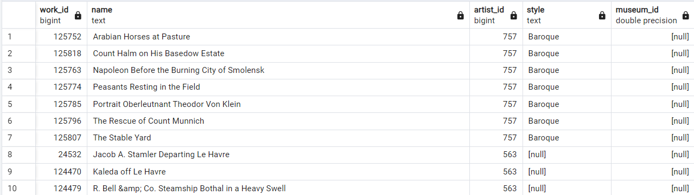

Q2) Are there museum’s without any paintings?  
select *  
from museum m  
LEFT JOIN work w  
ON m.museum_id = w.museum_id  
Where w.work_id is NULL;

–OR-  
select * from museum m  
 where not exists (select 1 from work w  
 where w.museum_id=m.museum_id)

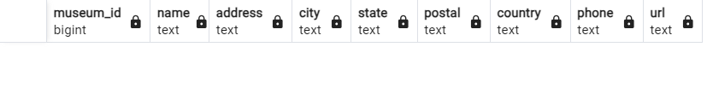

Q3) How many paintings have an asking price of more than their regular price?   
select count(*) as total  
from product_size  
WHERE sale_price > regular_price;

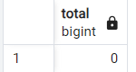

Q4) Identify the paintings whose asking price is less than 50% of its regular price.  
select * from product_size  
where sale_price < (regular_price * 0.5);

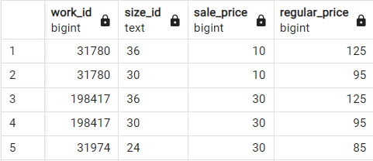

Q5) Which canva size costs the most?  
SELECT c.label as canva, p.sale_price as sale_price  
FROM product_size AS p  
JOIN canvas_size as c ON p.size_id = c.size_id::text  
ORDER BY p.sale_price DESC  
LIMIT 1;  
 --OR --  
select c.label as conva, p.sale_price as sale_price  
from ( select *,  
 rank() over(order by sale_price desc) as rnk  
 from product_size) p  
join canvas_size as c   
on c.size_id = p.size_id::bigint  
where p.rnk=1;

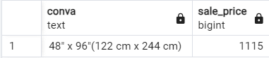  
  
In the product_size table, the size_id is in text format, so we typecast it to bigint to ensure that both size_id columns have the same datatype. This is necessary because the size_id in the canvas_size table is of datatype bigint. By typecasting, we maintain consistent data types for proper comparisons and joins.  
  
Q6) Delete duplicate records from work, product_size, subject and image_link tables  
delete from work

where ctid not in (select min(ctid)

from work

group by work_id );

delete from product_size

where ctid not in (select min(ctid)

from product_size

group by work_id, size_id );

delete from subject

where ctid not in (select min(ctid)

from subject

group by work_id, subject );

delete from image_link

where ctid not in (select min(ctid)

from image_link

group by work_id );  
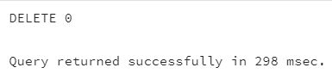

Here,  
ctid is a system column in PostgreSQL that uniquely identifies rows based on their  
physical location in the table. The subquery finds the smallest ctid for each work_id,  
while the DELETE query removes all other rows, ensuring only one instance per work_id remains.  
  
Q7) Identify the museums with invalid city information in the given dataset  
select * from museum   
where city ~ '^[0-9]'  
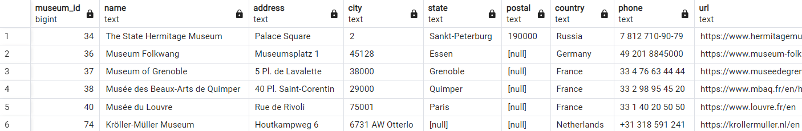The ~ operator checks if city starts with a digit, using ^ to mark the beginning   
and [0-9] to match any digit, returning rows where the city field begins with a number,   
typically indicating invalid city names.

Q8) Museum_Hours table has 1 invalid entry. Identify it and remove it.  
delete from museum_hours   
 where ctid not in (select min(ctid)  
 from museum_hours  
 group by museum_id, day );



Q9) Fetch the top 10 most famous painting subject.  
1ST With Ranking Window Functions (RANK).  
SELECT *  
FROM (  
 SELECT s.subject,   
 COUNT(1) AS no_of_paintings,  
 RANK() OVER (ORDER BY COUNT(1) DESC) AS rnk  
   
 FROM work w  
 JOIN subject s ON s.work_id = w.work_id  
 GROUP BY s.subject  
) x  
WHERE rnk <= 10;

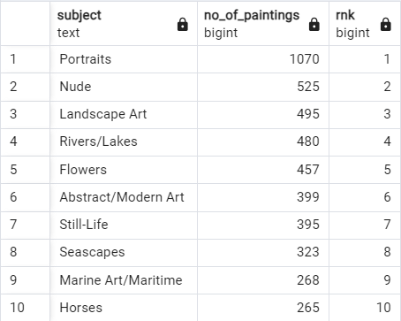

2ND With JOIN and Grouping.  
select distinct subject, count(*) as subject_count  
from subject s  
join work w on s.work_id=w.work_id  
group by subject  
order by subject_count desc  
limit 10;  
  
3rd With Simple Aggregation & Grouping  
SELECT subject, COUNT(*) AS subject_count  
FROM subject  
GROUP BY subject  
ORDER BY subject_count DESC  
LIMIT 10;

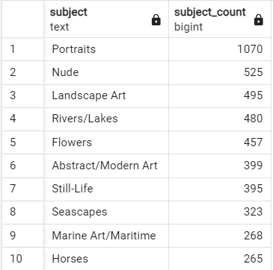

Q10) Identify the museums which are open on both Sunday and Monday. Display museum name, city.  
select m.museum_id, m.name as museum_name, m.city   
from museum_hours mh  
join museum m on m.museum_id = mh.museum_id  
where day='Sunday'  
and exists (select 1 from museum_hours mh2  
 where mh2.museum_id = mh.museum_id  
 and mh2.day='Monday');  
 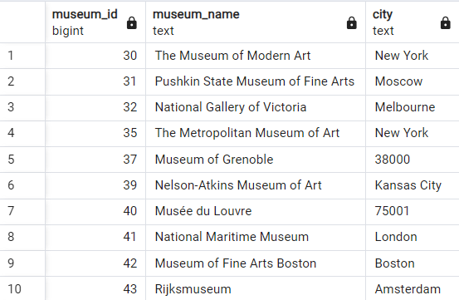EXISTS is used for subquery filtering, checking if a museum_id is open on both 'Sunday' and 'Monday', with SELECT 1 simply confirming row existence.

Q11) How many museums are open every single day?  
select count(*) from (  
 select museum_id, count(*)   
 from museum_hours  
 group by museum_id  
 having count(*) =7) x;

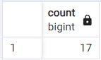

Q12) Which are the top 5 most popular museum? (Popularity is defined based on most no of paintings in a museum)

select m.name as museum, m.city,m.country,x.no_of_painintgs  
from ( select m.museum_id, count(1) as no_of_painintgs  
 , rank() over(order by count(1) desc) as rnk  
 from work w  
 join museum m on m.museum_id=w.museum_id  
 group by m.museum_id) x  
join museum m on m.museum_id=x.museum_id  
where x.rnk<=5;  
  
 --2nd with CTE--  
WITH ranked_museums AS (  
 SELECT m.museum_id,   
 COUNT(1) AS no_of_paintings,  
 RANK() OVER (ORDER BY COUNT(1) DESC) AS rnk  
 FROM work w  
 JOIN museum m ON m.museum_id = w.museum_id  
 GROUP BY m.museum_id  
)  
SELECT m.name AS museum, m.city, m.country, rm.no_of_paintings  
FROM ranked_museums rm  
JOIN museum m ON m.museum_id = rm.museum_id  
WHERE rm.rnk <= 5;

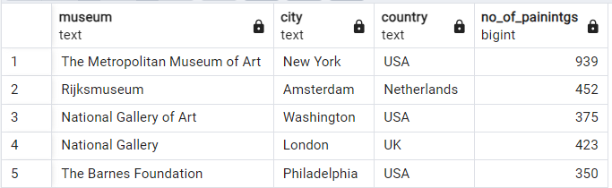

Q13) Who are the top 5 most popular artist? (Popularity is defined based on most no of paintings done by an artist)  
  
SELECT a.full_name AS artist, a.nationality, x.no_of_paintings  
FROM (  
 SELECT a.artist_id, COUNT(1) AS no_of_paintings,  
 RANK() OVER (ORDER BY COUNT(1) DESC) AS rnk  
 FROM work w  
 JOIN artist a ON a.artist_id = w.artist_id  
 GROUP BY a.artist_id  
) x  
JOIN artist a ON a.artist_id = x.artist_id  
WHERE x.rnk <= 5;  
  
 --2nd with CTE--  
  
WITH ranked_artists AS (  
 SELECT a.artist_id,   
 COUNT(1) AS no_of_paintings,  
 RANK() OVER (ORDER BY COUNT(1) DESC) AS rnk  
 FROM work w  
 JOIN artist a ON a.artist_id = w.artist_id  
 GROUP BY a.artist_id  
)  
SELECT a.full_name AS artist, a.nationality, ra.no_of_paintings  
FROM ranked_artists ra  
JOIN artist a ON a.artist_id = ra.artist_id  
WHERE ra.rnk <= 5;

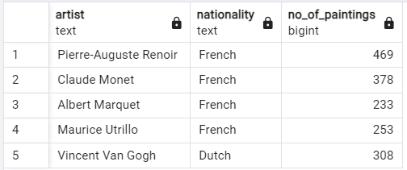

Q14) Display the 3 least popular canva sizes WITH Derived Table.

SELECT label, ranking, no_of_paintings  
FROM (  
 SELECT cs.size_id, cs.label, COUNT(1) AS no_of_paintings,  
 DENSE_RANK() OVER (ORDER BY COUNT(1)) AS ranking  
 FROM work w  
 JOIN product_size ps ON ps.work_id = w.work_id  
 JOIN canvas_size cs ON cs.size_id::text = ps.size_id  
 GROUP BY cs.size_id, cs.label  
) x  
WHERE x.ranking <= 3;  
  
 --2nd with CTE--   
  
WITH ranked_sizes AS (  
 SELECT cs.size_id, cs.label, COUNT(1) AS no_of_paintings,  
 DENSE_RANK() OVER (ORDER BY COUNT(1)) AS ranking  
 FROM work w  
 JOIN product_size ps ON ps.work_id = w.work_id  
 JOIN canvas_size cs ON cs.size_id::text = ps.size_id  
 GROUP BY cs.size_id, cs.label  
)  
SELECT label, ranking, no_of_paintings  
FROM ranked_sizes  
WHERE ranking <= 3;

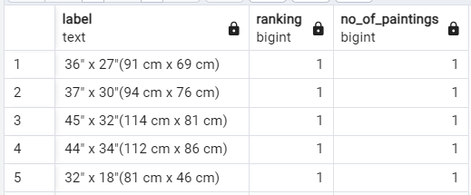

Q15) Which museum is open for the longest during a day. Dispay museum name, state and hours open and which day?  
SELECT museum_name, state AS city, day, open, close, duration  
FROM (  
 SELECT m.name AS museum_name, m.state, day, open, close,  
 to_timestamp(open, 'HH:MI AM') AS open_time,  
 to_timestamp(close, 'HH:MI PM') AS close_time,  
 to_timestamp(close, 'HH:MI PM') - to_timestamp(open, 'HH:MI AM') AS duration,  
 RANK() OVER (ORDER BY (to_timestamp(close, 'HH:MI PM') - to_timestamp(open, 'HH:MI AM')) DESC) AS rnk  
 FROM museum_hours mh  
 JOIN museum m ON m.museum_id = mh.museum_id  
) x  
WHERE x.rnk = 1;  
  
 --2nd with CTE--   
WITH ranked_museum_hours AS (  
 SELECT m.name AS museum_name, m.state, day, open, close,  
 to_timestamp(open, 'HH:MI AM') AS open_time,  
 to_timestamp(close, 'HH:MI PM') AS close_time,  
 to_timestamp(close, 'HH:MI PM') - to_timestamp(open, 'HH:MI AM') AS duration,  
 RANK() OVER (ORDER BY (to_timestamp(close, 'HH:MI PM') - to_timestamp(open, 'HH:MI AM')) DESC) AS rnk  
 FROM museum_hours mh  
 JOIN museum m ON m.museum_id = mh.museum_id  
)  
SELECT museum_name, state AS city, day, open, close, duration  
FROM ranked_museum_hours  
WHERE rnk = 1;

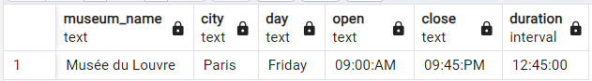

Q16) Which museum has the most no of most popular painting style?  
WITH pop_style AS   
 (SELECT style,  
 RANK() OVER (ORDER BY COUNT(1) DESC) AS rnk  
 FROM work  
 GROUP BY style),  
cte AS  
 (SELECT w.museum_id,  
 m.name AS museum_name,  
 w.style,  
 COUNT(1) AS no_of_paintings,  
 RANK() OVER (ORDER BY COUNT(1) DESC) AS rnk  
 FROM work w  
 JOIN museum m ON m.museum_id = w.museum_id  
 JOIN pop_style ps ON ps.style = w.style  
 WHERE w.museum_id IS NOT NULL  
 AND ps.rnk = 1  
 GROUP BY w.museum_id, m.name, w.style)  
SELECT museum_name, style, no_of_paintings  
FROM cte   
WHERE rnk = 1;

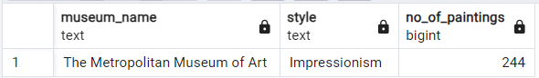

Q17) Identify the artists whose paintings are displayed in multiple countries.  
WITH cte AS (  
 SELECT DISTINCT a.full_name AS artist,  
 m.country  
 FROM work w  
 JOIN artist a ON a.artist_id = w.artist_id  
 JOIN museum m ON m.museum_id = w.museum_id  
)  
SELECT artist, COUNT(1) AS no_of_countries  
FROM cte  
GROUP BY artist  
HAVING COUNT(1) > 1  
ORDER BY no_of_countries DESC;

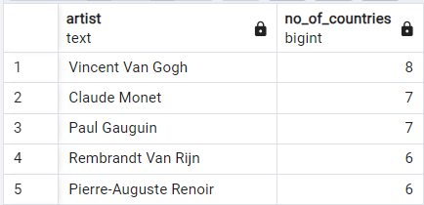

Q18) Display the country and the city with most no of museums. Output 2 seperate columns to mention the city and country. If there are multiple value, seperate them with comma.  
  
WITH cte_country AS (  
 SELECT country,  
 COUNT(1) AS country_count,  
 RANK() OVER (ORDER BY COUNT(1) DESC) AS rnk  
 FROM museum  
 GROUP BY country  
),  
cte_city AS (  
 SELECT city,  
 COUNT(1) AS city_count,  
 RANK() OVER (ORDER BY COUNT(1) DESC) AS rnk  
 FROM museum  
 GROUP BY city  
)  
SELECT   
 STRING_AGG(DISTINCT country.country, ', ') AS countries,  
 STRING_AGG(city.city, ', ') AS cities  
FROM cte_country country  
CROSS JOIN cte_city city  
WHERE country.rnk = 1  
 AND city.rnk = 1;

--WITH SUBQUERY--  
SELECT   
 STRING_AGG(DISTINCT country, ', ') AS countries,  
 STRING_AGG(city, ', ') AS cities  
FROM (  
 SELECT country,   
 COUNT(1) AS country_count,  
 RANK() OVER (ORDER BY COUNT(1) DESC) AS rnk  
 FROM museum  
 GROUP BY country  
) AS country_data  
JOIN (  
 SELECT city,  
 COUNT(1) AS city_count,  
 RANK() OVER (ORDER BY COUNT(1) DESC) AS rnk  
 FROM museum  
 GROUP BY city  
) AS city_data ON country_data.rnk = 1 AND city_data.rnk = 1  
GROUP BY country_data.rnk, city_data.rnk;

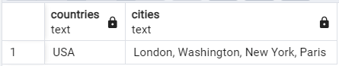

Q19) Identify the artist and the museum where the most expensive and least expensive painting is placed. Display the artist name, sale_price, painting name, museum name, museum city and canvas label.  
SELECT w.name AS painting,  
 ps.sale_price,  
 a.full_name AS artist,  
 m.name AS museum,  
 m.city,  
 cz.label AS canvas  
FROM work w  
JOIN product_size ps ON ps.work_id = w.work_id  
JOIN museum m ON m.museum_id = w.museum_id  
JOIN artist a ON a.artist_id = w.artist_id  
JOIN canvas_size cz ON cz.size_id = ps.size_id::NUMERIC  
WHERE ps.sale_price = (SELECT MAX(sale_price) FROM product_size)   
 OR ps.sale_price = (SELECT MIN(sale_price) FROM product_size);  
  
 --WITH CTE--  
WITH cte AS (  
 SELECT *,  
 RANK() OVER (ORDER BY sale_price DESC) AS rnk,  
 RANK() OVER (ORDER BY sale_price) AS rnk_asc  
 FROM product_size  
)  
SELECT w.name AS painting,  
 cte.sale_price,  
 a.full_name AS artist,  
 m.name AS museum,  
 m.city,  
 cz.label AS canvas  
FROM cte  
JOIN work w ON w.work_id = cte.work_id  
JOIN museum m ON m.museum_id = w.museum_id  
JOIN artist a ON a.artist_id = w.artist_id  
JOIN canvas_size cz ON cz.size_id = cte.size_id::NUMERIC  
WHERE rnk = 1 OR rnk_asc = 1;

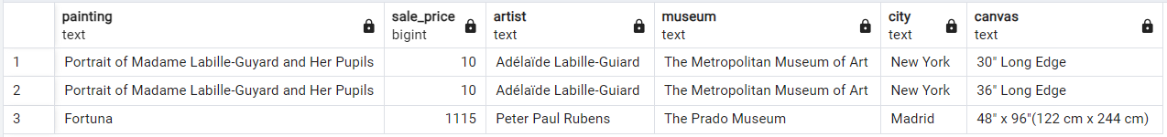  
  
Q20) Which country has the 5th highest no of paintings?  
WITH cte AS (  
 SELECT m.country,  
 COUNT(1) AS no_of_Paintings,  
 RANK() OVER (ORDER BY COUNT(1) DESC) AS rnk  
 FROM work w  
 JOIN museum m ON m.museum_id = w.museum_id  
 GROUP BY m.country  
)  
SELECT country,   
 no_of_Paintings  
FROM cte   
WHERE rnk = 5;

--WITH SUBQUERY--  
SELECT country,  
 no_of_Paintings  
FROM (  
 SELECT m.country,  
 COUNT(1) AS no_of_Paintings,  
 RANK() OVER (ORDER BY COUNT(1) DESC) AS rnk  
 FROM work w  
 JOIN museum m ON m.museum_id = w.museum_id  
 GROUP BY m.country  
) AS ranked_countries  
WHERE rnk = 5;

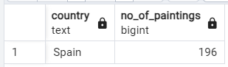  
  
Q21) Which are the 3 most popular and 3 least popular painting styles?  
WITH cte AS (  
 SELECT style,  
 COUNT(1) AS cnt,  
 RANK() OVER (ORDER BY COUNT(1) DESC) AS rnk,  
 COUNT(1) OVER () AS no_of_records  
 FROM work  
 WHERE style IS NOT NULL  
 GROUP BY style  
)  
SELECT style,  
 CASE   
 WHEN rnk <= 3 THEN 'Most Popular'   
 ELSE 'Least Popular'   
 END AS remarks   
FROM cte  
WHERE rnk <= 3  
 OR rnk > no_of_records - 3;

--WITH SUBQUERY--  
SELECT style,  
 CASE   
 WHEN rnk <= 3 THEN 'Most Popular'   
 ELSE 'Least Popular'   
 END AS remarks   
FROM (  
 SELECT style,  
 COUNT(1) AS cnt,  
 RANK() OVER (ORDER BY COUNT(1) DESC) AS rnk,  
 COUNT(1) OVER () AS no_of_records  
 FROM work  
 WHERE style IS NOT NULL  
 GROUP BY style  
) AS ranked_styles  
WHERE rnk <= 3  
 OR rnk > no_of_records - 3;

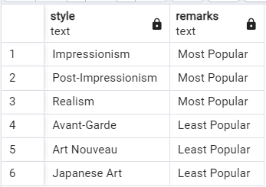

Q22) Which artist has the most no of Portraits paintings outside USA?. Display artist name, no of paintings and the artist nationality.  
WITH artist_paintings AS (  
 SELECT a.full_name,  
 a.nationality,  
 COUNT(1) AS no_of_paintings,  
 RANK() OVER (ORDER BY COUNT(1) DESC) AS rnk  
 FROM work w  
 JOIN artist a ON a.artist_id = w.artist_id  
 JOIN subject s ON s.work_id = w.work_id  
 JOIN museum m ON m.museum_id = w.museum_id  
 WHERE s.subject = 'Portraits'  
 AND m.country != 'USA'  
 GROUP BY a.full_name, a.nationality  
)  
SELECT full_name AS artist_name,  
 nationality,  
 no_of_paintings  
FROM artist_paintings  
WHERE rnk = 1;  
  
 --WITH SUBQUERY--  
SELECT full_name AS artist_name,  
 nationality,  
 no_of_paintings  
FROM (  
 SELECT a.full_name,  
 a.nationality,  
 COUNT(1) AS no_of_paintings,  
 RANK() OVER (ORDER BY COUNT(1) DESC) AS rnk  
 FROM work w  
 JOIN artist a ON a.artist_id = w.artist_id  
 JOIN subject s ON s.work_id = w.work_id  
 JOIN museum m ON m.museum_id = w.museum_id  
 WHERE s.subject = 'Portraits'  
 AND m.country != 'USA'  
 GROUP BY a.full_name, a.nationality  
) AS x  
WHERE rnk = 1;

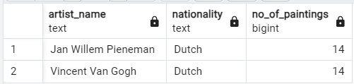  
  
  
**Conclusion**

The **Famous Paintings SQL Analysis Project** offered a comprehensive exploration of a dataset that encompasses various aspects of artworks, including their pricing and the museums that house them. Through the use of SQL queries, I was able to analyze intricate relationships among paintings, artists, and museums, uncovering significant patterns in pricing strategies and geographical distribution.

This project not only provided me with valuable insights into the art market but also allowed me to deepen my analytical capabilities. I gained a better understanding of how different factors influence artwork valuation, including market trends and artist reputation. Furthermore, I recognized the critical importance of data integrity, as accurate and reliable data is essential for drawing meaningful conclusions.

Overall, this project served as a significant learning experience, enabling me to bridge the gap between theoretical knowledge and practical application in data analysis. The skills and insights I acquired throughout this project will undoubtedly inform my future endeavors in data science and analytics, equipping me to tackle more complex challenges in the field.