**Documentation of Requirements for SIH.**

Problem Statement – Unified Portal for Curriculum Development for AICTE.

SIH1465

# [ Curriculum Development Tool ]

- Selection of Course Category

- Selecting students' education level

- Deciding a Long term objective

- Deciding yearly progress

- Deciding Semester Curriculum

Reference: College Curriculum plan.

**Tool features:**

**OPTIONS we need to provide**:

- Add Mandatory Programs(Physical activity, Creative Arts, Universal Human Values (UHV-1), Literary, Lectures by Eminent People, Visits to local Areas, Familiarization to Dept./Branch & Innovation)

- Add Courses: Course Category, title

- Add Courses Common to all branches of UG Engineering & Technology

- Add Type of Course

- Add Course duration

- Set Schedule(hours, lectures, practical)

- Add Subjects(Year vise, sem vise)

- Add sub-Topics(Arranging according to Chapters)

- Add Trending Technologies(For General Knowledge among students)

- Add Faculties(Allocating subject-coordinators according to their expertise)

- Add Projects(Applying knowledge of the subject for Practical experience)

- Practicals List(List of Practicals to be performed)

- Add Credits for each subject

- Add examination weightage for every subject.

- Add Teaching Scheme(NO. of Lectures, no. of Practical, no of tutorials) for each subject.

- Distributation of Theory Marks – R Level, U Level , A Level, N Level, E Level, C LEvel

- Add Textbook for reference option

- Add Course Outcumes subject vise.

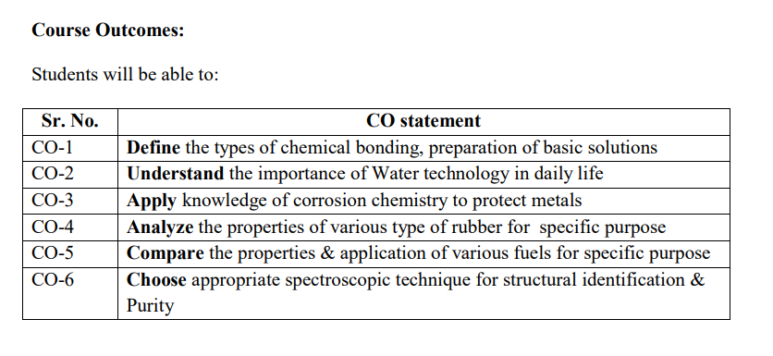

Criteria:

- Must be according to course vise and subject vise.

- Users can set Limit to no. of chapters each subject, it will be set to the most preferred by default.

- Must include no. of hours option for every chapter.

- Program must create dataset for curriculum in a tabular format.

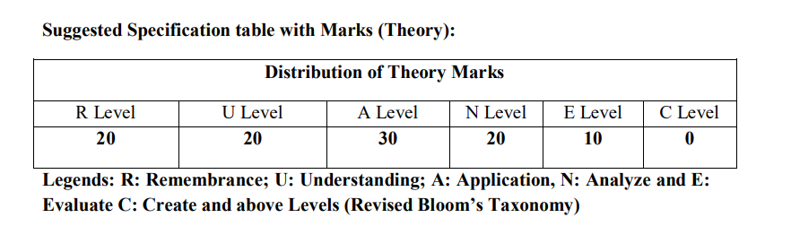

Example :

Stage 1:

- CS

Add all the subjects related to cs, from basic to advanced.

Stage 2:

- Diploma

Add the most basic and essential subjects

: About various Programming Languages, Mark-Up Languages

: About DBMS, DSA, Basic concept of programming

: Practical knowledge of every basic things including Creating and maintaining a directory.

: Introduction to Latest Trends in CS Industries(Just For General Knowledge)

: About Frameworks and Libraries

: Mini-Projects

: etc.

Stage 3:

- Clear Understanding of All basic concepts of Computer Engineering.

Stage 4:

- 1st Year

Basic Subjects

: Binary numbers, ASCII, About Microprocessors(Can show a practical use of microprocessor, by computing on it practically), CPU Components, COA.

: Basic Fundamentals of Programming, C/C++ Lang, Syntax, loop, conditions, I/O operations.

: Mini-Project (Team)

: Internship

- 2nd YEar

Programming Language

: Core - Language, Applying Logic

: Web Technology basics (HTML, CSS, JS)

: Mini-Projects, Extra-Curriculum

: Internship

: Choice of Technology

- 3rd Year

Fundamentals-FrontEnd & BackEnd

: Long Internship

Stage 5:

- Set Time-Table (According to easy subjects & Difficult subjects)

- More time/practice for difficult subjects.