Hashing and Crack Password Lab

|  |
| --- |
| Copyrights 2016-2017 Frank Xu, Bowie State University.  The lab manual is developed for teaching cyber-related courses. Comments and suggestions can be sent to wxu@bowiestate.edu |

**Lab Environment**

We have created two accounts in the VM. The usernames and passwords are listed in the following:

* + User ID: root, Password: seedubuntu.
  + Note: Ubuntu does not allow root to login directly from the login window. You have to login as a normal user, and then use the command su to login to the root account.
  + User ID: seed, Password: dees

**Task 1: MD5 hashing**

1. Use command md5Sum for hashing.
   1. Type md5um --help

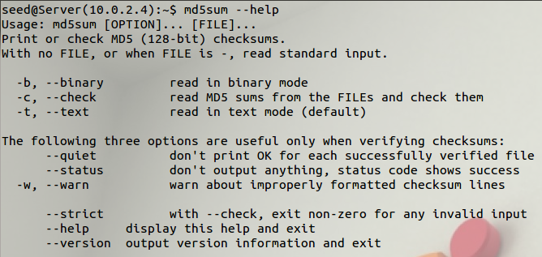

1. echo will normally output a newline, which is suppressed with -n

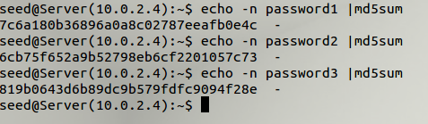

1. Questions:
   1. Find the original password (12345abcd,12345)

|  |  |  |
| --- | --- | --- |
| Original password | MD5 hashed Password | hints |
|  |  |  |
|  |  |  |
|  |  | 5 digits and 4 letters |
|  |  | 4 digits |

1. You need to create a shell program to generate a list of hashed password
   1. Create a shell program, named generatedmd5

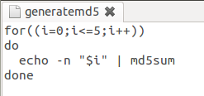

* 1. Make the program executable and run.

