Rainbow Table Attack: Cracking UNIX Passwords

|  |
| --- |
| Copyrights 2016-2017 Frank Xu, Bowie State University.  The lab manual is developed for teaching cyber-related courses. Comments and suggestions can be sent to wxu@bowiestate.edu |

**Lab Environment**

1. Following the tutorial to install Kali Linux. <https://www.youtube.com/watch?v=GpTIM9OroIY>
2. You can set the root as:

* Username: root
* Password: dees

1. Prerequisite

You may need the OpenCL Intel runtime. http://registrationcenter-download.intel.com/akdlm/irc_nas/9019/opencl_runtime_16.1.1_x64_ubuntu_6.4.0.25.tgz. The main page is https://software.intel.com/en-us/articles/opencl-drivers, Just use the Ubuntu version for Kali, It will say its unsupported but will install anyways. And it works!!



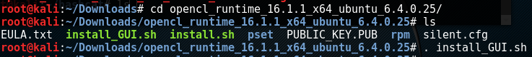

1. Type to check the configuration: hashcat –b

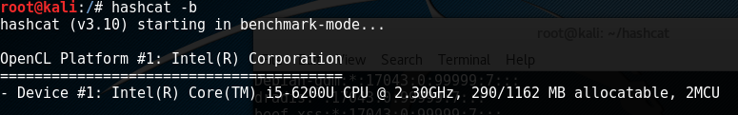

**Task 1: Crack Password Using Rainbow Table**

1. Overview
   1. **rtgen**: generate rainbow tables
   2. **rsort**: sort the rainbow table
   3. **rcrack**: find the password
2. Display command:

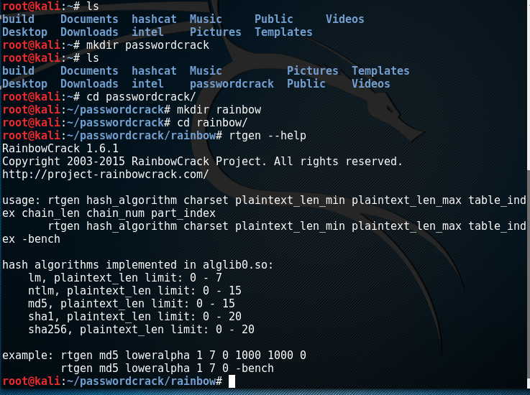

1. Generate a rainbow table
   1. Type : rtgen md5 loweralpha 5 5 0 1000 10000 0

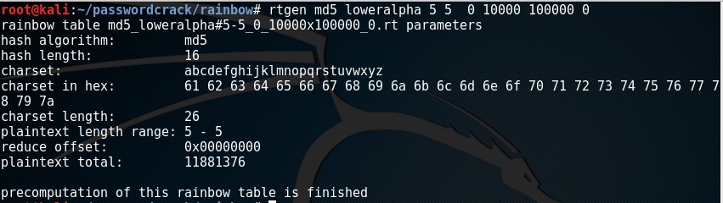

1. Questions
   1. Explain each parameter
2. Find the generated file
   1. The generated file is stored under the folder /usr/share/rainbowcrack

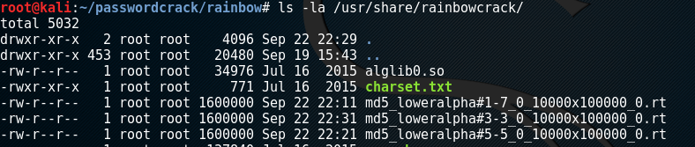

* 1. Sort the rainbow table

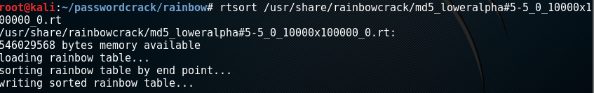

* 1. Find the password
     1. Generate the md4 of the password “abced”
     2. Type rcrack to find the password

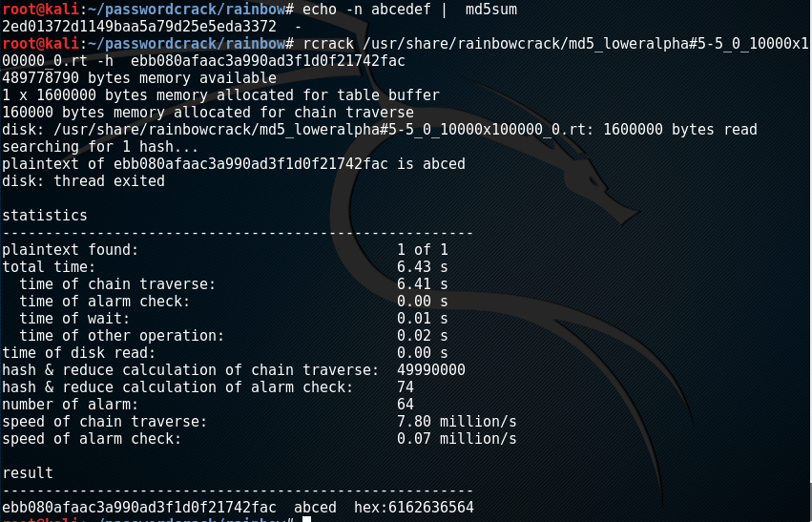

Reference

* https://www.exploit-db.com/docs/104.pdf