Identify Hash Type

**Lab Environment**

1. Following the tutorial to install Kali Linux. <https://www.youtube.com/watch?v=GpTIM9OroIY>
2. You can set the root as:
   1. Username: root
   2. Password: dees

**Steps**

1. Create folders.
   * mkdir hashcat
   * mkdir hashes
   * mkdir passlist

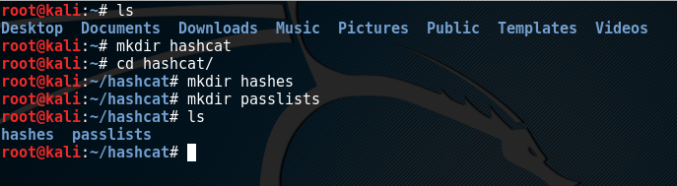

1. Generate Hashes
   * Inside the folder hashcat: cd hashcat
   * Save to a file named: gedit hash.txt

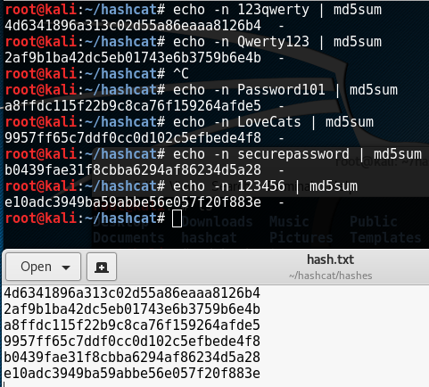

1. Identify the hashing algorithm
   * Type: hash-identifier

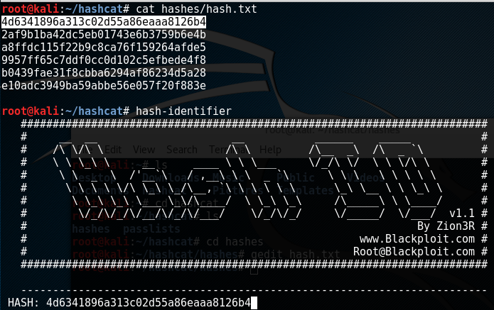

* + Copy and paste one of the hash code

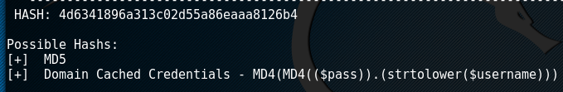

1. Find the password dictionary

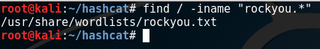

1. Questions:
   * What does the string “/” mean?
   * What does the string “iname” mean?

Reference

https://www.youtube.com/watch?v=fCNOIheD-Is