A Simple Keylogger in Python for Linux

|  |
| --- |
| Copyrights 2016-2017 Frank Xu, Bowie State University.  The lab manual is developed for teaching cyber-related courses. Comments and suggestions can be sent to wxu@bowiestate.edu |

**Introduction**

Keylogger is a program used to monitor keystrokesn typed by users. The keystrokes are stored in a file or send to other location remotely. Let’s say you want to see what other people were doing on your computer, when you were away. You can just start the keylogger and spy on them!

A Keylogger can be used by a hacker to record sensitive information like usernames, password or credit card detail etc.

Warming: The materials are used for education purpose only.

**Lab Environment**

We have created two accounts in the VM. The usernames and passwords are listed in the following:

* + User ID: root, Password: seedubuntu.
  + Note: Ubuntu does not allow root to login directly from the login window. You have to login as a normal user, and then use the command su to login to the root account.
  + User ID: seed, Password: dees

**Task 1: Download pyxhook library**

1. The pyHook library wraps the low-level mouse and keyboard hooks in the Windows Hooking API for use in Python applications.
2. pyxhook -- an extension to emulate some of the PyHook library on linux

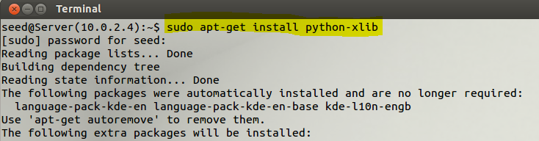

**Task 2: Download source code from Github**

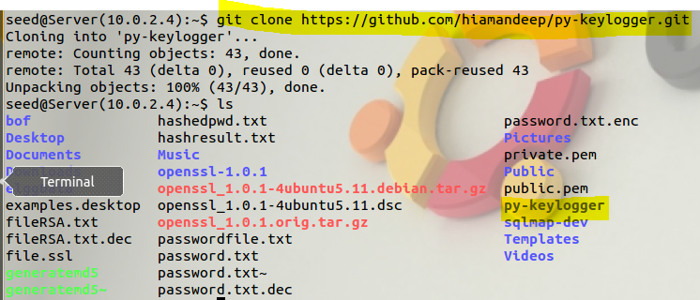

**Task 3: Change the location of the log file**

1. Open Keylogger source code

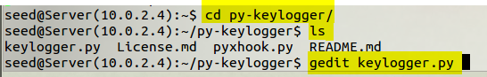

1. Edit the path of the log file

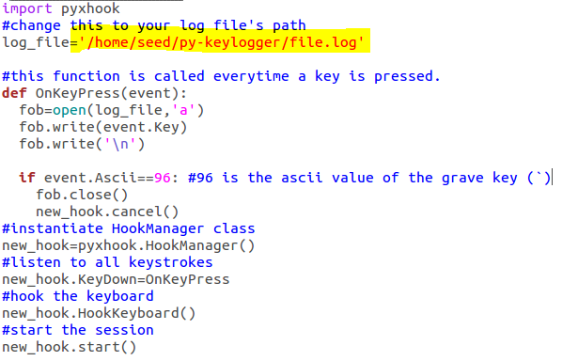

**Task 4: Run the keylogger**

1. Type command

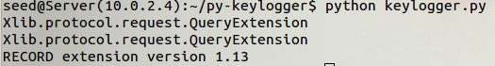

1. Open the second Terminal.
   1. Type test
   2. Type ` Note: **grave key is below Esc key**



**Task 4: Show logged information**

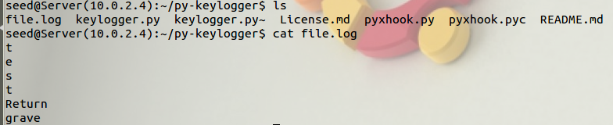

**Task 5: Questions:**

1. Can you capture the mouse movement?
2. Can you send log information to a different machine?

# Reference:

* http://www.techinfected.net/2015/10/how-to-make-simple-basic-keylogger-in-python-for-linux.html