

Engenharia de Domínio

MyRecipe – technical report

Evaristo figueiredo – 1010836

nelson lopes – 1160098

group no. 101 - 2016-2017

Conteúdo

Theoretical Global Plan 1

**1.** **Activity diagram illustrating the envisioned solution** 1

**1.1.** **DESCRIPTION** 1

**2.** **Major concepts to be used in the metamodeL** 3

**2.1.** **Entities** 5

**2.2.** **ServiceS** 5

**2.3.** **REST Componet** 5

**3.** **DRAFT for the ecore DIAGRAM** 7

Theoretical Global Plan

## **Activity diagram illustrating the envisioned solution**

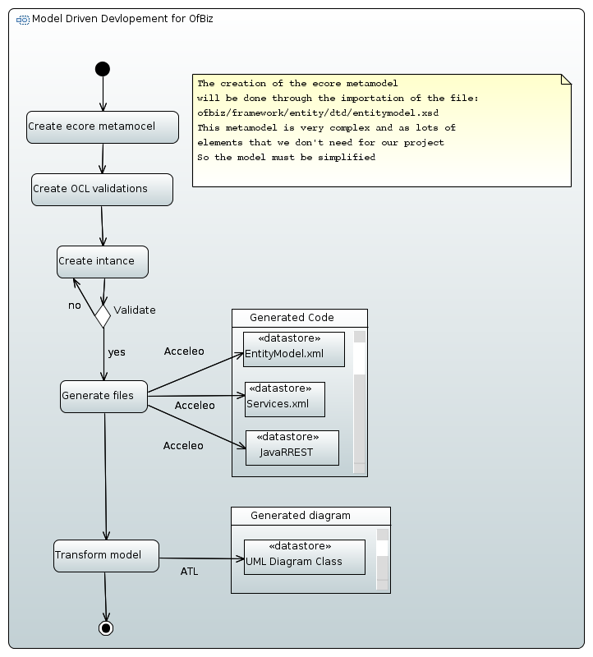

## **DESCRIPTION**

We will start by creating the ecore diagram according to the specifications described in the nest section. The meta-model will only contemplate the classes required for the concrete example MyRecepe and not for all the classes reported in the XSD file. Because it is not possible to infer all the information for the services from the information related with the entities the meta-model will also contain information about the services.

After the creation of the ecore meta-model, we will insert validation conditions in OCL, like restricting the value of the data types allowed for the table fields.

With the instance of the model validated, we will then use the option “create dynamic instance” to generate de XMI file that allows the creation of the model for the MyRecepe project.

To achieve the automatic generation of the xml files for the entities, for the services and for the REST service we will create an ACCELEO project and in the MTL file we will describe the structure for the files.

To finalize the project we will create an ATL project and use the meta-model we have created in the first step along with the meta-model for UML (that already exists), to transform the model for the MyRecipes into a class diagram in UML according to the rules that we will insert in the ATL file of this project.

## **Major concepts to be used in the metamodeL**

Table 1 - Concepts in the meta-model

| **Elements** | | | **Attributes** | **Description** |
| --- | --- | --- | --- | --- |
| **Level 1** | **Level 2** | **Level 3** |
| ofbiz |  |  |  | Root element to aggregate services and entities |
| services |  |  |  | Main element that aggregates all information about the services |
|  |  |  | xmlns:xsi | Type of XSD |
|  |  |  | xsi:noNamespaceSchemaLocation | Location of the XSD file |
|  | description |  |  | String describing the service |
| service |  |  |  |  |
|  |  |  | name | String with the name of the method |
|  |  |  | engine | Java |
|  |  |  | location | String with the path to the Java file where the method can be found |
|  |  |  | invoke | String with the name of the method |
| attribute |  |  |  | Parameters to be passed to the service |
|  |  |  | name | String with the name of the parameter |
|  |  |  | type | String with type of the parameter |
|  |  |  | mode | IN/OUT |
|  |  |  | optional | TRUE/FALSE |
|  | description |  |  | Description of the service |
| entitymodel |  |  |  | Main element that aggregates all information about the entities |
|  |  |  | xmlns:xsi | Type of XSD |
|  |  |  | xsi:noNamespaceSchemaLocation | Location of the XSD file |
|  | title |  |  | String identifying the entity model |
|  | description |  |  | String describing the entity model |
| entity |  |  |  | Entity representing a table |
|  |  |  | entity-name | String with the name of the entity |

| **Elements** | | | **Attributes** | **Description** |
| --- | --- | --- | --- | --- |
| **Level 1** | **Level 2** | **Level 3** |
|  |  |  | package-name | String with the name of the java package where this entity is incorporated |
|  |  |  | Title | Description of the entity |
|  | field |  |  | Columns for the table |
|  |  |  | Name | Name for the column |
|  |  |  | Type | Type of the data that can be inserted in the column |
|  | prim-key |  |  | The primary Key for the table |
|  |  |  | Field | The name of the field that will be used as primary key |
|  | relation |  |  | Foreign keys for the table |
|  |  |  | Type | Cardinality of the relation |
|  |  |  | fk-name | String with name of the relation |
|  |  |  | rel-entity-name | String with the name of the table which this table relates to |
|  |  | key-map |  |  |
|  |  |  | field-name | Foreign name of the primary key of the second table in the relation |
|  |  |  | rel-field-name | ????? |

## **Entities**

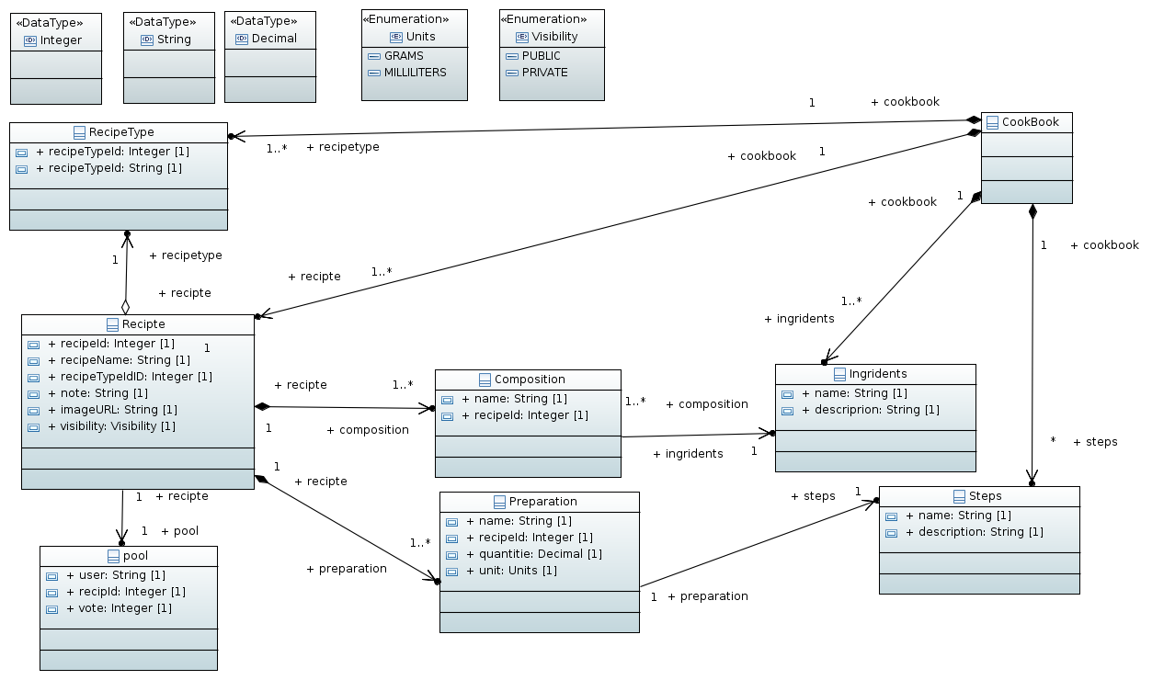

All the information needed to generate the file **entitymodel.xml** can be obtained directly from the ecore meta-model as we can see in table 1.

## **ServiceS**

To declare the services in the file **services.xml** it is also possible to get the information directly from the model, because the meta-model allows for the creation of a model with information about the entities and about the services-

## **REST Componet**

**OFBizRESTApplication.java**,

In the first file it is only needed to add a line for the new component: classes .add( RecipeResource .class);, the variable parte in this line is the name of the component and we can get the name of the class Recipe to build it.

**RecipeResource.java**

We will have to create these methods: create_Recipe, getAll_RecipeTypes, create_RecipeType, getAll_Ingrediants, create_Ingridient, getAll_Steps, create_step, create_Vote.

The information we will need to generate this code is the name of the fields for this entity and the name of the method. The first piece of information can be found in the classes “attribute” of the model and the second one is registered in the attributes for the class “service”.

* **create_recipe**

This method will allow the register of the information about the recipe. To do this this method will need to provide information for the recipe. This information will be passed as parameters.

* **create_Vote**

Because we don’t have to implement the alteration of recipes we only need this method for the pool.

* **getAll**_**RecipeTypes, create_RecipeType, getAll_Ingrediants, create_Ingridient, getAll_Steps, create_step**

Because we assumed that the ingredients, the steps and RecipeType are contained in different tables and can be reused in different recipes, when the user proceeds with introduction of the information for the recipe we will have to present to him, the list of elements that already exist as ingredients, steps and RecipeType. Then he can choose one of the existing or create a new one.

## **DRAFT for the ecore DIAGRAM**

