Git

Solution
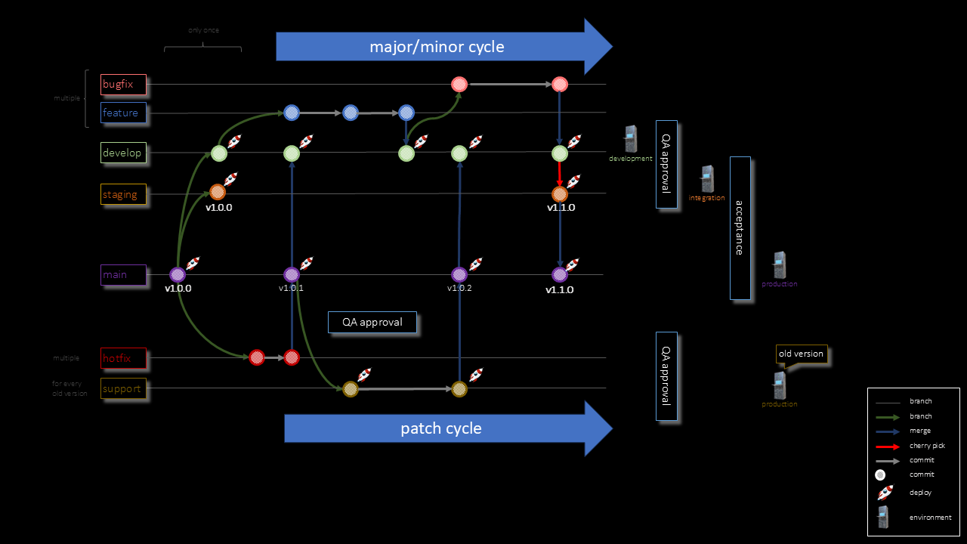
- 3 branches
main

alternatives
- Short-lived feature branches off of main, with frequent merges via PR and automated CI checks.
- Release branches (or “hotfix branch”) usage when stabilizing or patching a specific release headed to staging or production.
- Consistent naming conventions and branch policies that enforce proper review and testing.
- Feature flags for in-progress or risky features to allow early integration.

Why
This preserves the simplicity of GitHub Flow
—keeping main as the trunk—
while providing just enough structure to handle
multiple teams
and multiple deploy stages
in a monorepo environment

1. Context

Context
Current Git branching strategy: GitHub Flow
Short-lived feature branches off of main, with frequent merges via PR and automated CI checks
Four teams commit code
Sequential pipeline deploys DEV → STG → PROD
Testing at each stage
Mono-repository
backend,
frontend x 2,
workers,
DDD components,
tests
Teams may use different technologies and languages
Code and pipelines are managed through Azure DevOps
Deployment to Azure Cloud

2. SOTA

2.1 Trunk

2.1 Trunk
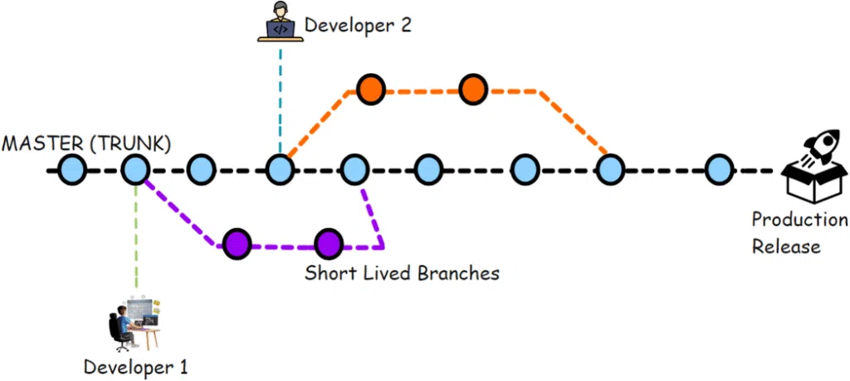
Keep main (or master) as your “always deployable” production branch.
Work in short-lived feature branches that are frequently merged back to main.
In Trunk-Based Development teams, the PR should be on a short-lived feature branch and processed very quickly by reviews towards merging back to trunk/main.
A few minutes for the review is best, and tens of minutes acceptable. More than a hour or two, and you are negatively affecting cycle times.
Use automated checks (linting, testing, etc.) in CI to block merges that introduce defects.
When done consistently, trunk-based development keeps the codebase stable and fosters continuous integration across teams.

2.1.1 Trunk vs git-hub

2.1.1 Trunk vs GitHub

Category | Trunk-Based | GitHub Flow
Branch Lifespan | - feature branches  - extremely short-lived  - hours or a day  - free merges to trunk | - feature branches  - short/medium-lived,  - merged via pull requests.
Integration Frequency | - CI  - very frequent/small merges | - frequent merging  - slightly longer-running branches
Release Management | - relies heavily on  - feature flags  - to merge  - incomplete work  - without blocking  - integration | - no release branches  - clean main branch (PR)
Complexity | branching: minimal  feature flags: high | branching: minimal  pull requests: medium
Philosophy | CI + single, always deployable branch +  feature flags | clean main branch + pull requests.

2.2 Feature flags

2.2 Feature flags
(Feature toggles = Switches)
Instead of trying to keep half-finished features out of main, merge them under a feature flag that’s off by default

What Are Feature Flags?
a simple conditional switch in code
that can be toggled on or off
usually with a configuration or settings file,
or via a feature flag management service
If the flag is switched “off,”
the new or partially completed feature
is effectively hidden/deactivated
no user sees or experiences it
the code still lives in the main branch.
When the feature is sufficiently tested and ready for general use,
the team flips the flag to “on,”
it becomes available to end users
without requiring a separate deploy/merge event

Why in Trunk-Based Development?

Continuous Integration
In trunk-based development, code is merged into the trunk very
frequently
Some teams aim to merge changes multiple times per day
Feature flags allow you to commit and merge “in-progress” code
without disrupting or breaking the main code path for users.

Avoid Long-Lived Branches
By merging code early,
avoid the complexity and risk of merging
large, long-lived feature branches
late in the development cycle
Large merges are more prone to
conflicts, testing issues, and integration headaches.

Incremental Release & Testing:
Teams can test a feature
in smaller increments
or behind the scenes.
QA teams can turn on the flag
in a test or staging environment
or even for a small set of beta customers,
providing early feedback
while protecting production users.

Benefits

Fewer Merge Conflicts
By merging daily or multiple times per day, you minimize the risk of code conflicts piling up.

Faster Feedback
You get immediate information about how partial changes integrate with the rest of the system.

Lower Deployment Risk
Deploying a “flagged off” feature to production has virtually no risk.
The feature code is dormant.
If you encounter a problem upon toggling it on, you can switch it off instantly without rolling back or reverting merges.

Downsides & Mitigations

Code Bloat
Over time, multiple dormant features can crowd the codebase. Mitigation: regularly remove flags for features that are fully released or abandoned.

Flag Management Complexity
With many flags, you need processes or tooling to keep track of which flags exist, their status, and who owns them. Commercial or open-source feature flag management tools help here.

Testing Complexity
Teams need to test all relevant flag states if they want to avoid regressions. Mitigation: set guidelines around how to handle test coverage for flagged features.

Example 1: Incremental UI Overhaul
You’re redesigning the user profile page. The design team has mockups, but you can only implement the new UI in sections.
As soon as you’ve built the first piece of the new UI, you wrap it in a feature flag:
if (isNewUserProfileEnabled) {
// Render the new React component for the profile page
} else {
// Render the existing UI
}
You merge that code back to trunk even though the new UI is incomplete. Nobody in production sees it yet because isNewUserProfileEnabled is false for them.
Over the next few days or weeks, you keep adding new pieces under the same or additional flags. You merge frequently to avoid branching overhead.
When your QA or product managers decide the new UI is ready, they enable the flag for a small percentage of real users. If no issues arise, they progressively roll it out to more users until it replaces the old UI for everyone.

Example 2: Experimental Algorithm
Your data science team is developing a new recommendation algorithm, which is only partially implemented.
They embed it in the codebase behind a feature flag, for instance useNewRecommender.
The trunk remains stable—by default, the existing recommender is used for production traffic.
Data scientists merge their incremental improvements to the new recommender every day or two, using a short-lived branch each time, then flipping the flag on in a controlled environment (like a staging server) to test it with real or synthetic data.
Once it’s proven to work consistently, they turn on the flag in production to a small subset of users for A/B testing. Over time, they expand its usage to everyone, effectively retiring the old algorithm.

Conclusion
In short, feature flags are the enabler that lets you merge incomplete work into the trunk without harming mainline stability.
They reduce branching complexity, speed up feedback cycles, and allow for continuous integration and deployment—even when new code isn’t fully ready to show to end users.

2.3 Release branches

Release branches
lightweight
for staging and production
With a straightforward GitHub Flow, teams often merge straight to main and deploy continuously.
In practice—especially with multiple environments and multiple teams—
It can be helpful to have a short-lived branch
that represents the “version” of the code currently in staging
or about to go to production.

For example:
Create a release branch from main whenever you are ready to freeze features and test them in staging.
Deploy that release branch to STG.
Continue to merge small fixes into that release branch if needed.
Once the release branch is stable, merge it into main and deploy main to PROD.
Delete the release branch when the production release is complete.

This pattern maintains the simplicity of GitHub Flow
Allowing to “lock” changes for a release,
Give QA a stable code base,
Quickly fix urgent defects without blocking new development in main.

5. Checks and approvals

Checks and approvals
Use automated checks and approvals tailored to each environment
Tying these checks to the corresponding branches (or pipeline stages) ensures each environment only receives code that meets the right quality bar.

Dev
Emphasize quick feedback
Automated
Unit tests,
Integration tests
Manual QA
Code style checks
Etc.

Stg
Automated
Regression
End-to-end
Acceptance PM

Prod
Require sign-off from designated “release managers”
or
an automated gate (e.g., an approval stage in Azure DevOps pipelines).

5.1 Code ownership

Code ownership
Implement “code ownership” or required reviews per domain
This ensures the right teams must review PRs that touch their domain code.

For cross-functional or multi-language repos
set code owners
for
each domain/area.

In Azure DevOps,
you can define branch policies
that require
certain reviewers
depending on the paths changed

4. Naming conventions

Naming conventions
Standardize and rules across teams
Agree on a clear, consistent naming scheme
This consistency helps everyone navigate the repo more easily, especially in a large monorepo.

Feature branches
feature/<team-or-component>/<short-description>).

hotfix, bugfix, release branches
release/<version>, hotfix/<description>

3. Approutch

Approach

Pull Requests
Pull requests (PRs) are a convenient formal mechanism for code review, especially with multiple teams and components in a monorepo.
Pure trunk-based development often implies committing straight to trunk (or having very short-lived branches).
That can work fine for small or closely coordinated teams, but larger teams often need structured PRs to ensure proper reviews and approvals.

Release branches

Freeze period
Release branches give you a buffer if you need to stabilize, test, or patch specific versions before going to production—without blocking or slowing trunk development.
In pure trunk-based development, you’d rely heavily on feature flags and “always be ready to ship,” but some teams prefer having a short “freeze” period for final QA or compliance checks.
A release branch is a lightweight way to isolate that process.

Naming conventions
Naming conventions (feature branches named after teams, components, or domains) help multiple teams coordinate changes in a large monorepo.
If you have a small codebase or a single team, naming conventions might feel like overkill.
But for cross-functional development, consistent naming helps track who owns or is working on what.

Transition
Pure trunk-based development with flags is extremely effective in environments that are mature in automated testing, continuous integration, and feature-flag discipline.
However, organizations that are transitioning from more traditional workflows (with QA phases, multiple stages, or compliance requirements) often find it easier to adopt a hybrid approach first.
For instance, if you need additional gates (like manual approvals, extra testing, or sign-offs) before hitting production, having a “release” branch stage can help formalize that.

Risk Management & Rollback Simplicity
If a critical bug surfaces at the last minute, a short-lived release branch makes it easier to apply a hotfix without having to cherry-pick or revert code from trunk.
You can patch the release branch, deploy, and merge back into trunk afterward.
While feature flags also reduce risk (you can turn off a broken feature), you might still need urgent fixes for unrelated code.
A release branch can be less disruptive than partial reverts in trunk.
- Incremental Change & Adoption
  - Organizations that move toward trunk-based development often do so incrementally. Retaining some “traditional” elements (like a release branch, or structured PR reviews) helps teams adopt trunk-based practices without changing everything at once.

Bottom Line
Trunk-based development + feature flags alone is a solid model for highly efficient, continuous integration. However, real-world teams often add:
- Pull requests for code review and collaboration
- Release branches for stable deployments, hotfixes, and freeze periods
- Naming conventions for clarity in large, multi-team repos
This “mixed” approach preserves agility while providing enough structure to handle complex organizational needs, multiple environments, and cross-team coordination.

6. Steps
- Create DEVELOPMENT branch
- Create STAGING branch
- Only allow Merges to Main from STG
- Only allow Merges to STG from DEV
- Force naming conventions
  - Commits
  - PR
  - Features/Fix etc branches
- Allow tester block DEV (to prepare release )
- Deployments
  - DEV -> DEV
  - STG -> INT
  - MAIN -> PROD
  - Automatic
  - Independent
  - Redo pipelines
- Tests
  - DEV
    - Integration
    - Unit
  - STG
    - Regression
    - End-2-End
    - Load/Performance (future)

