Information Architecture
Structure, role flows, and journey map of the IEQ Occupant Index
Supplementary material for: The Indoor Environmental Quality Occupant Index: A Role-Tiered Tool for Channeling Anonymous Occupant Feedback into Green Building Certification Decisions.

1. Positioning against the standard GRIHA workflow
The tool sits alongside, rather than replacing, the existing GRIHA credit assessment and building administration workflows.
Layer | Components | Gap addressed by the tool
GRIHA Framework (standard) | Credit Assessment -> IEQ Domain Scoring (prescriptive thresholds; objective measurement) -> Certification Award | No occupant-derived weighting; no post-occupancy feedback loop
Building Admin (standard) | Facilities Management -> Performance Records (point-in-time data) | No drift tracking
Tool intervention | Role selector (single entry point) routing to role-tiered interfaces on a shared scoring engine | See Section 2

2. Role-tiered interfaces
Role | Screens and components (in flow order)
Role selector | Single entry point routing each user to their interface
Occupant | Introduction screen (building and location ID; anonymity statement) -> 5-domain survey (thermal, visual, acoustic, IAQ, spatial; 7-point scale) -> Comment field [post-testing addition: per-domain question; qualifies numeric rating] -> Submission (pooled, anonymous)
Administrator | Domain dashboard (5 cards with subtotals; radar chart summary) -> Badge tracker (Health Leadership; Microclimate Champion; Digital Adaptation) -> Drift report (current vs prior cycle; survey-period filter; domain-level change) -> Pre-submission preview [post-testing addition: graphical summaries; GRIHA / performance pack download] -> Submit to Council
GRIHA Council / certifying reviewer | Portfolio view (per-building submission; portfolio-level tab) -> Decision screen (occupant % + objective measure; dual-gate logic per domain) -> Schema validation (weight holding verdict; adopt / guidance / continue) -> Climate-zone leaderboard [post-testing addition: mean credit per zone; role management]
Reviewer / assessor (assigned by the Council) | No separate interface: reviewers are added to the Council review panel as lead, technical, or observer reviewers and work within the Council interface. Evidence review per submission (documentary vs operational evidence; ownership) -> Verify / flag (staleness; counts). Findings feed the Council accept / return decision
Remediation loop | Identify shortfall (per sub-requirement; credit gap quantified) -> Remediate (prioritised recommendation; re-measure recorded) -> Re-submit (numbered attempt; trajectory reviewed). The Council decision returns to administrator drift tracking for the next review cycle

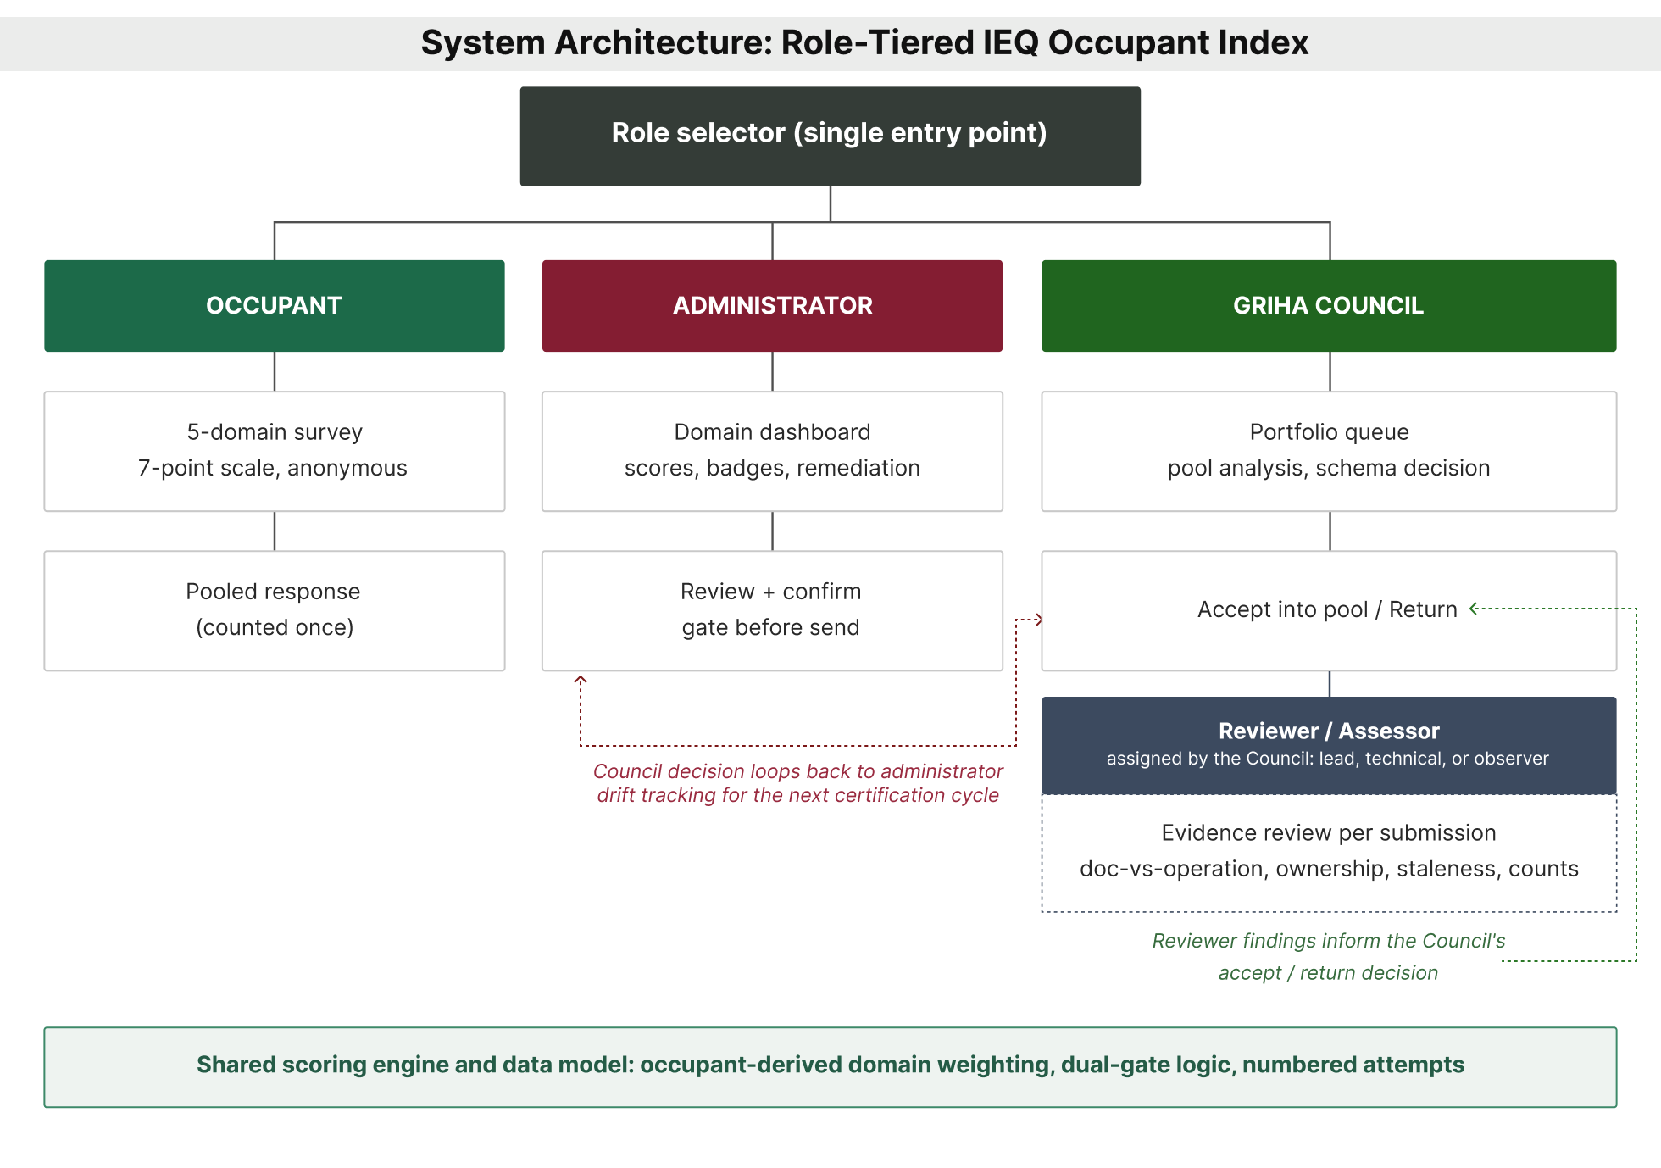
Figure S1. System architecture: three interfaces on a shared scoring engine, with reviewers assigned by the Council (manuscript Figure 1).

3. Journey map
Stage | Occupant (anonymous, single page) | Administrator (institution side, 6 tabs) | GRIHA Council (national oversight) | Reviewer (assessment, single page)
Flow start | Open survey (lands on building page) | Scope period (project and survey period) | - | -
Stage 1: response collected | Rate 5 domains (7-point scale) -> Gate: all five domains rated -> Submit (counter increments) | Record evidence (objective measurements and badges) -> Read results (domain cards, sub-criteria) | - | -
Stage 2: assessment prepared | - | Remediate (act on recommendations) | Open queue (latest attempt per building); assign evaluator; Return | Portfolio queue -> Evidence review (doc-vs-operation)
Stage 3: attempt submitted | - | Review summary (5-domain ring + checklist) -> Confirm gate -> Send attempt (numbered to Council) | Accept (institution owns scores) -> Pool analysis | Verify / flag (domain dashboard, badges, remediation) -> Return or Accept
Flow end | In the pool (response counted once) | Credit logged (attempt appended) | Check pool (zones and strategies): accept into pool / wait | Accept

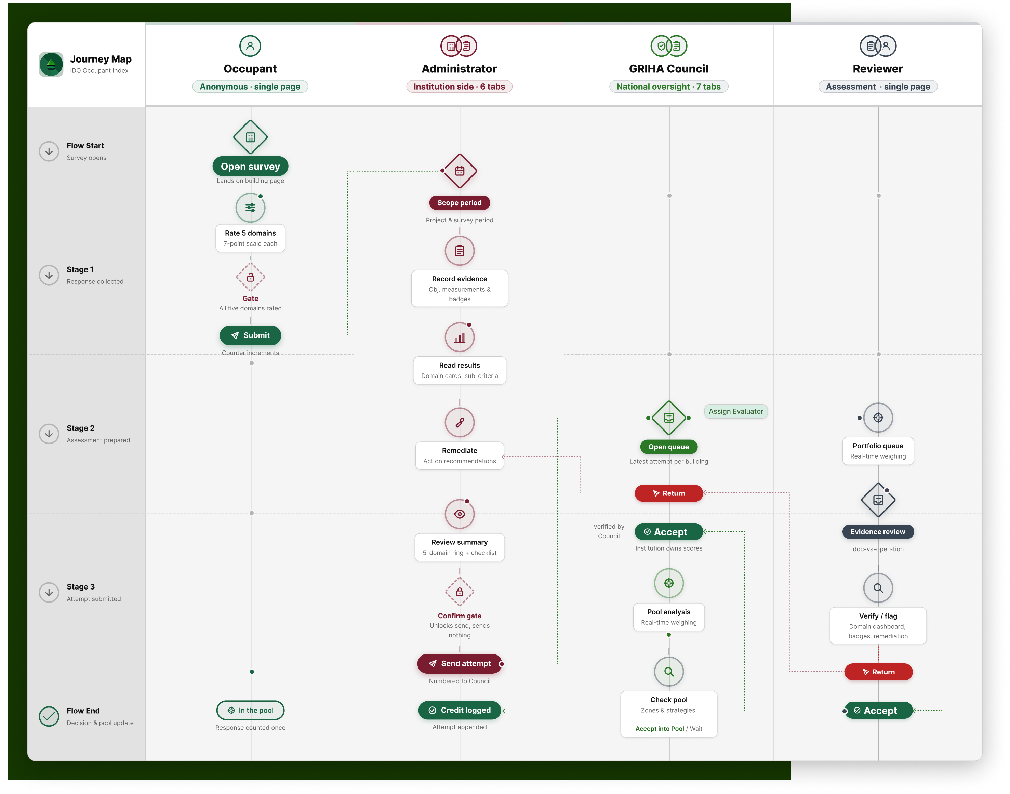
Figure S2. Role-tiered journey map (manuscript Figure 2).

