Assignment 1

PART 1 — Advanced Solidity Design Patterns

Task 1: Factory Pattern Implementation
Requirements:
- Create a ChildContract.sol with basic state (owner, name, balance)
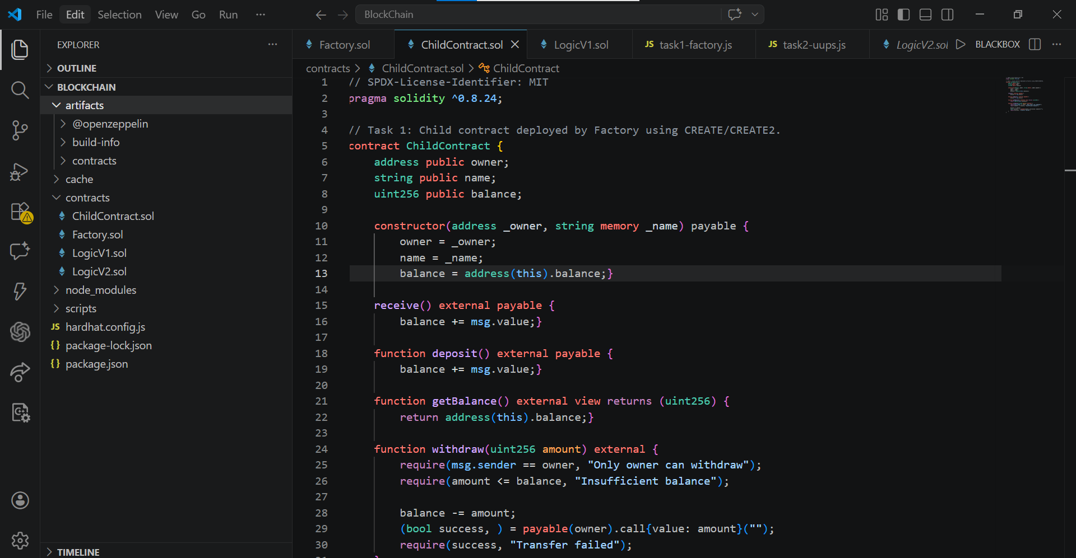

- Create a Factory.sol that deploys new ChildContract instances via create and create2
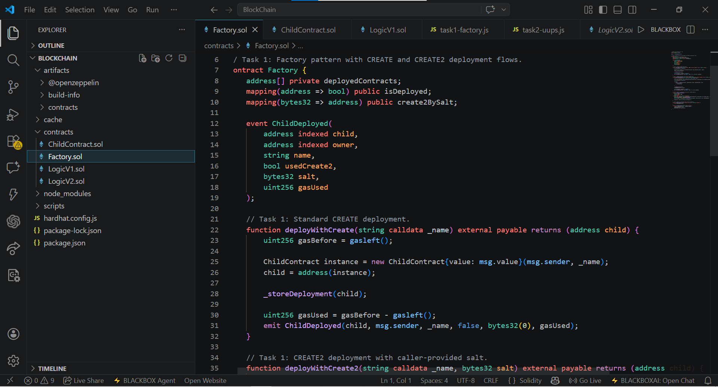
- Store deployed contract addresses in a mapping and array
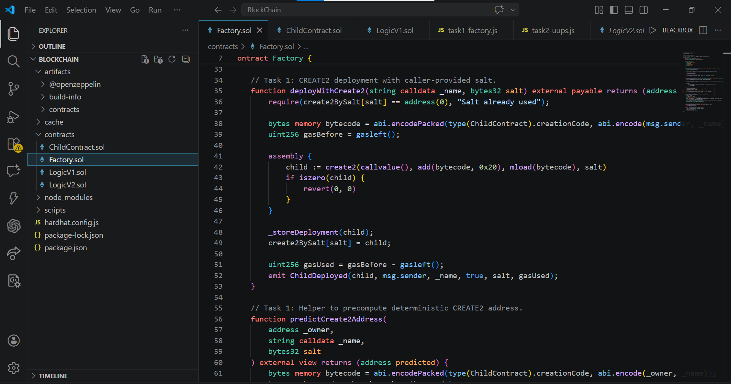

- Implement getDeployedContracts() that returns all deployed addresses
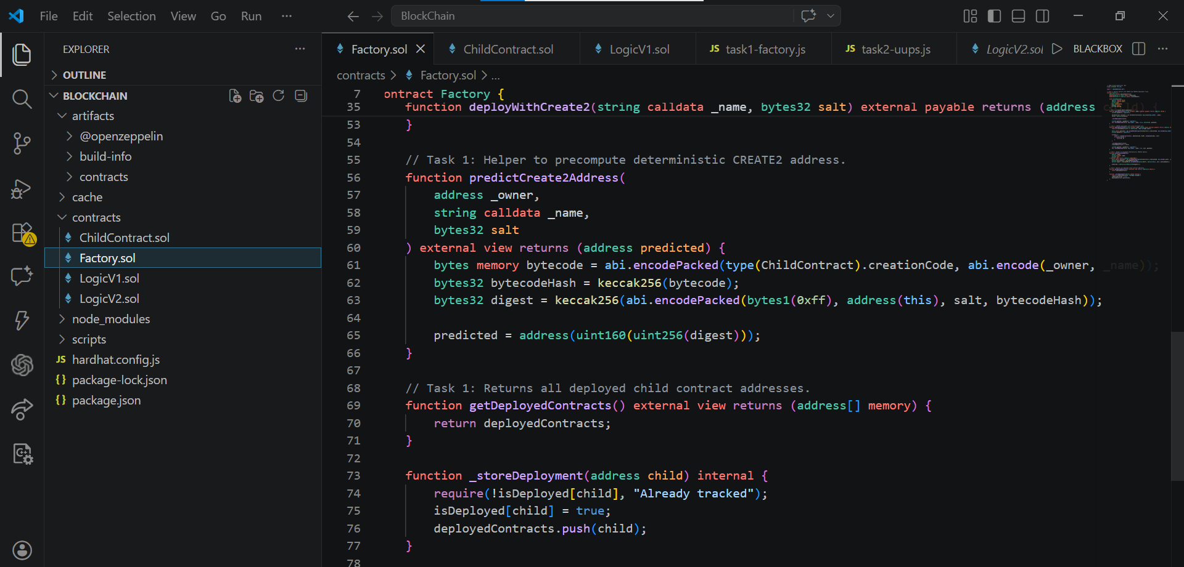

- Compare gas costs of create vs create2 deployment
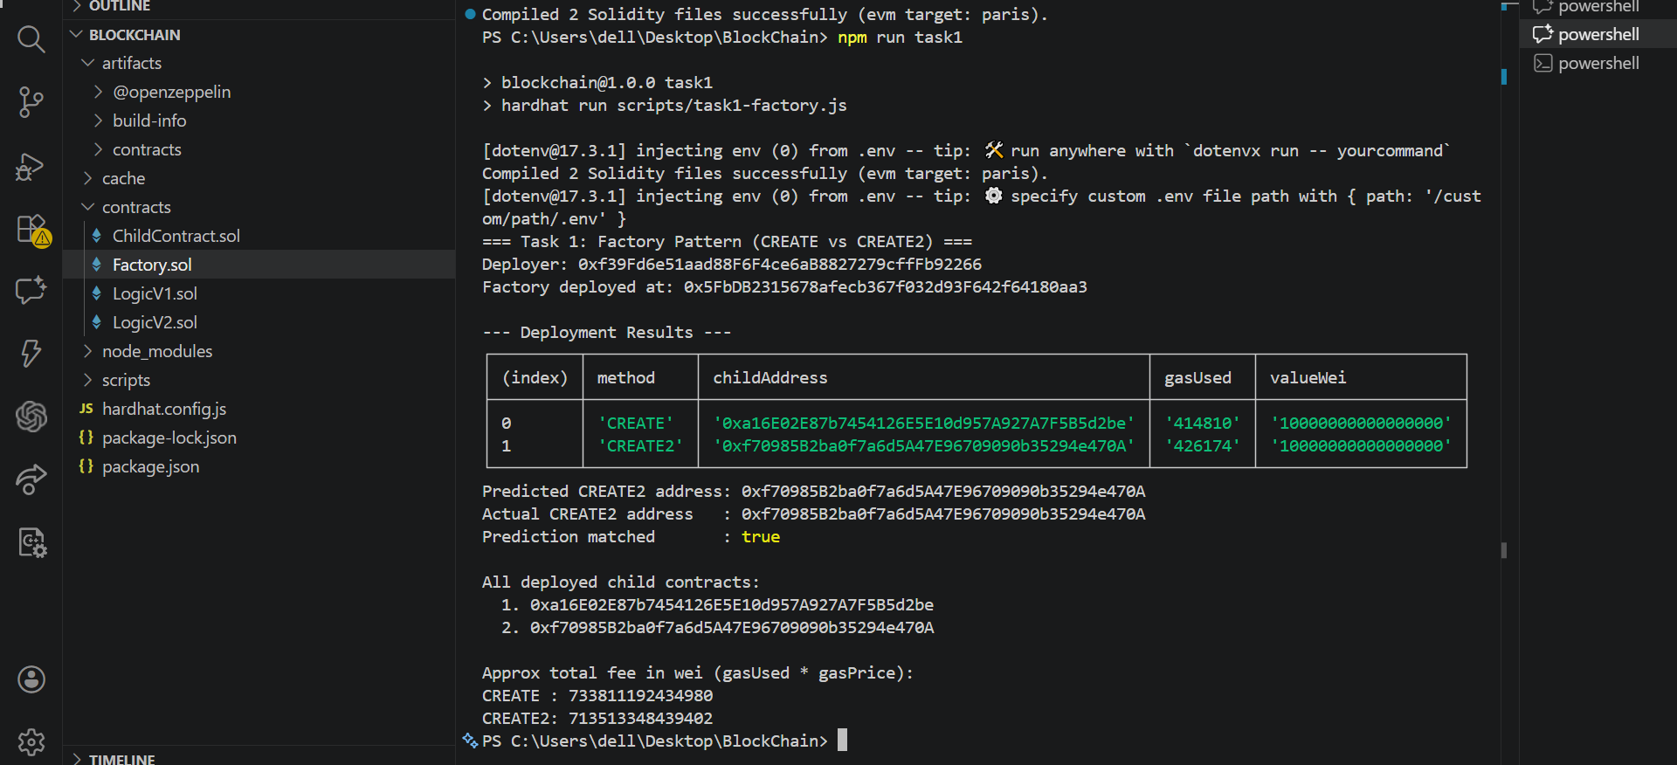
The Factory Pattern allows one smart contract (called the Factory) to create and manage other contracts (called Child Contracts). In this task, the Factory contract deploys new ChildContract instances using two methods: create and create2. Each ChildContract stores basic information such as its owner, name, and balance. The Factory keeps track of all deployed contracts by saving their addresses in both a mapping and an array, so they can be easily accessed later using the getDeployedContracts() function. The difference between create and create2 is that create2 allows us to predict the contract address before deployment, while create does not.

Task 2: Proxy Pattern & Upgradeable Contracts
Implement a UUPS (Universal Upgradeable Proxy Standard) upgradeable contract.
Requirements:
- Create LogicV1.sol — initial implementation with a simple counter (increment, get)
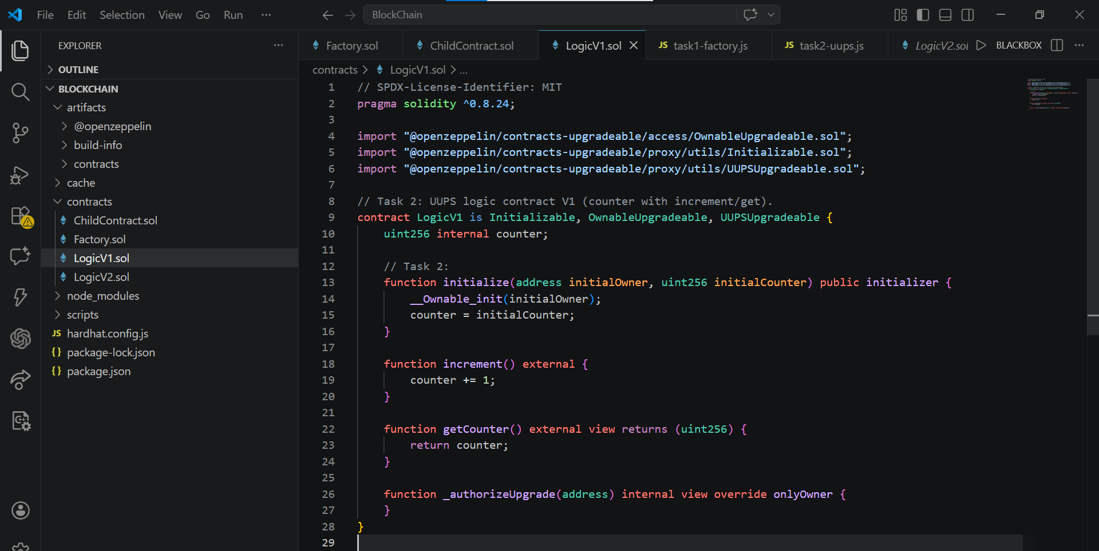

- Create LogicV2.sol — upgraded version with additional functionality (decrement, reset)
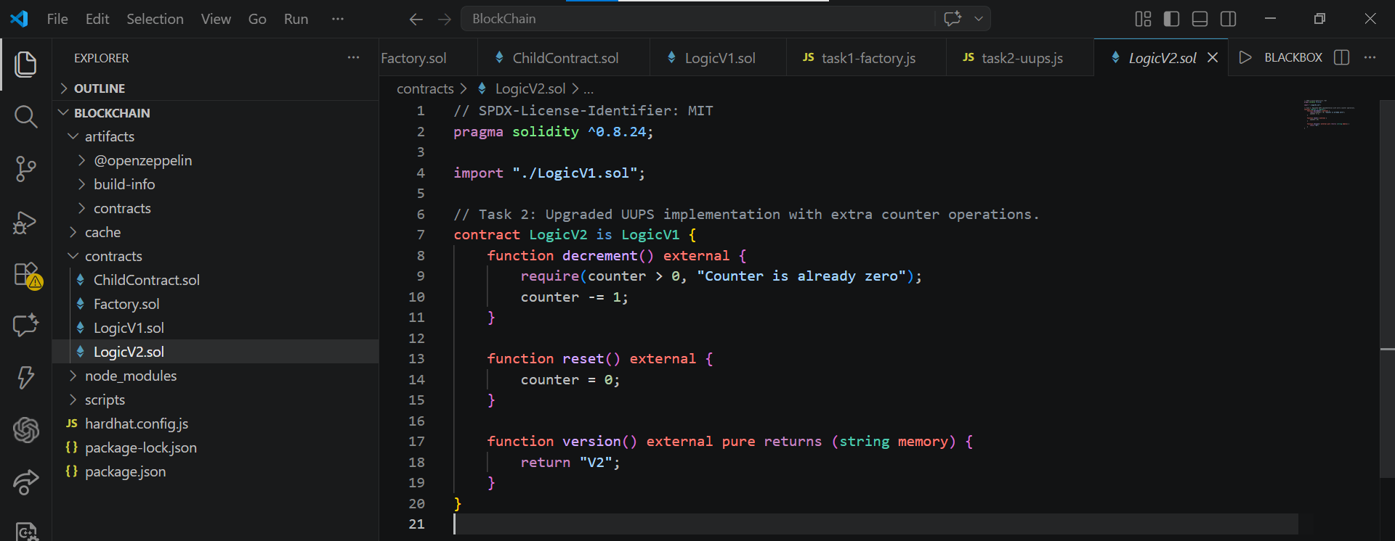

- Deploy using OpenZeppelin’s UUPS proxy pattern
- Demonstrate upgrading from V1 to V2 while preserving state
- Verify that the counter value persists after upgrade
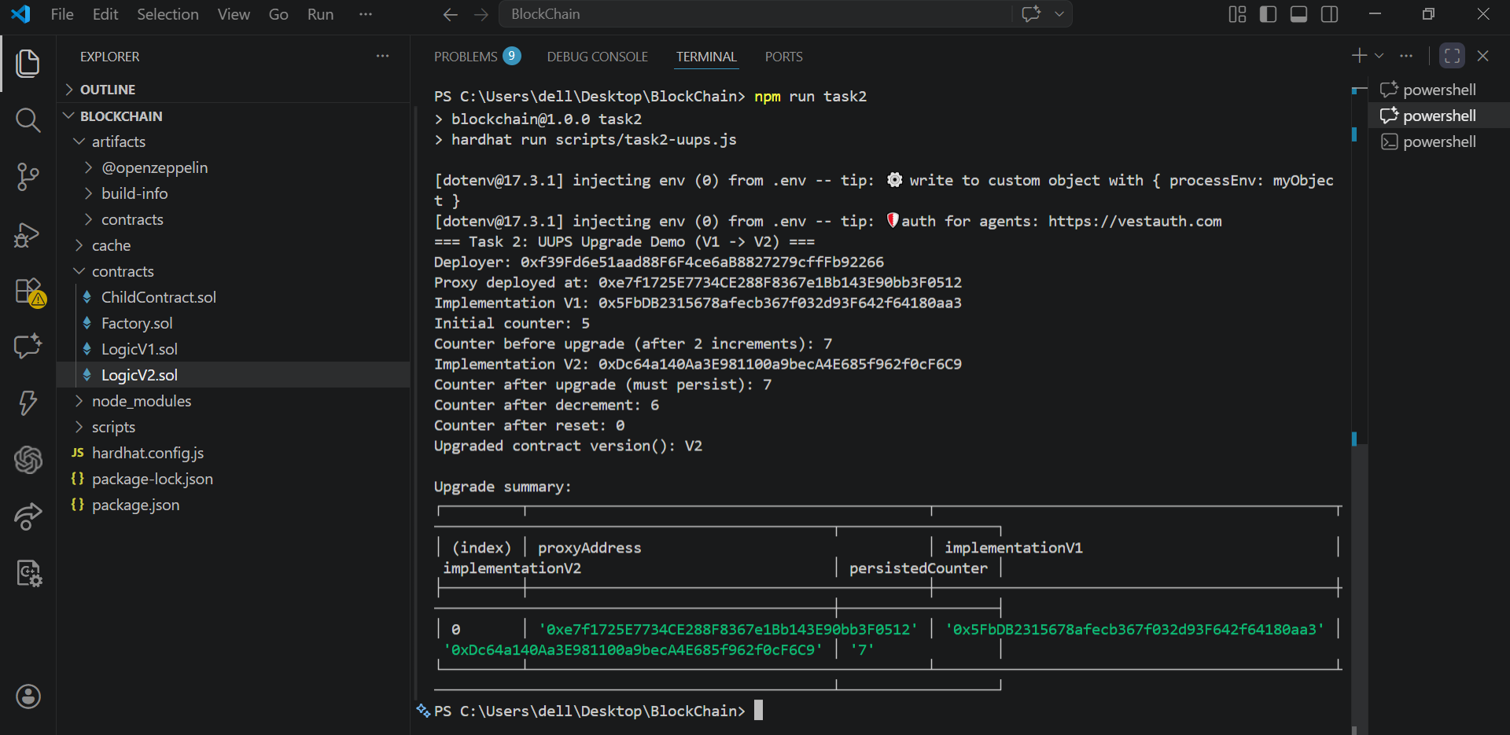

Explanation how proxy delegates calls, storage layout risks, and why initializers replaceconstructors:
The Proxy Pattern is used to make smart contracts upgradeable. Normally, once a contract is deployed, it cannot be changed. This problem is solved by separating the contract into two parts: a proxy contract and a logic (implementation) contract. Users interact with the proxy, which forwards calls to the logic contract using delegatecall. The important point is that all data is stored in the proxy, so when the logic contract is upgraded, the data remains the same.
In this task, I used the UUPS pattern with OpenZeppelin. UUPS is efficient because the upgrade logic is inside the implementation contract, while the proxy stays simple. I created LogicV1 with basic counter functions and LogicV2 with additional features like decrement and reset. After upgrading from V1 to V2, the counter value was still preserved because the storage is in the proxy.
One important concept is storage layout. The structure of variables must not change between versions, otherwise it can break the contract. Another key point is using initialize() instead of constructors, since constructors do not work properly with proxies.
Overall, the UUPS proxy pattern allows upgrading contracts safely while keeping the stored data unchanged.

PART 2 — Gas Optimization Workshop

Task 3: Storage & Computation Optimization
You are given a deliberately unoptimized contract (provided below or create your own). Apply at least 7 distinct gas optimizations.
Optimization categories (apply at least one from each):
- Storage packing: reorder variables to fit into fewer slots
- Immutable/constant: use immutable for deploy-time constants, constant for compile-time
- Calldata vs memory: use calldata for read-only external function parameters
- Short-circuiting: order conditions to fail fast
- Unchecked arithmetic: use unchecked blocks where overflow is impossible
- Caching storage reads: read storage into a local variable before loops
- Event-based logging: replace storage writes with events where possible
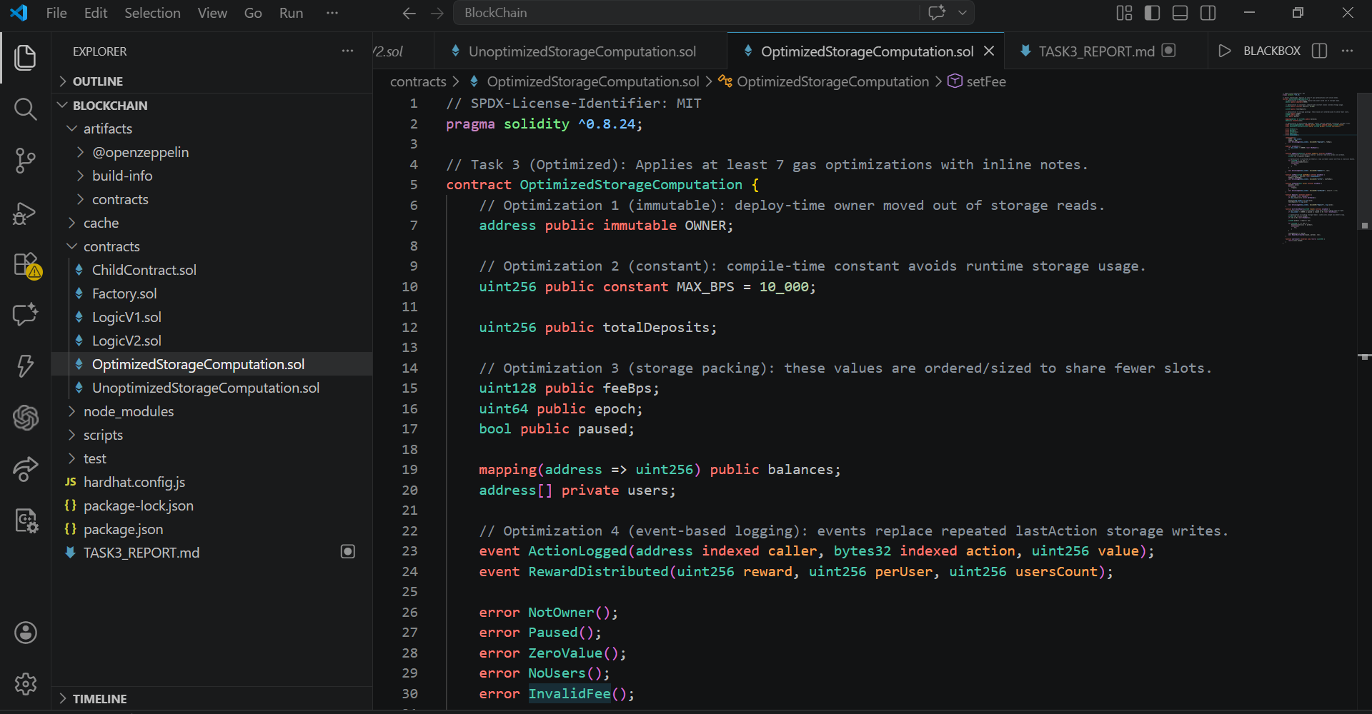

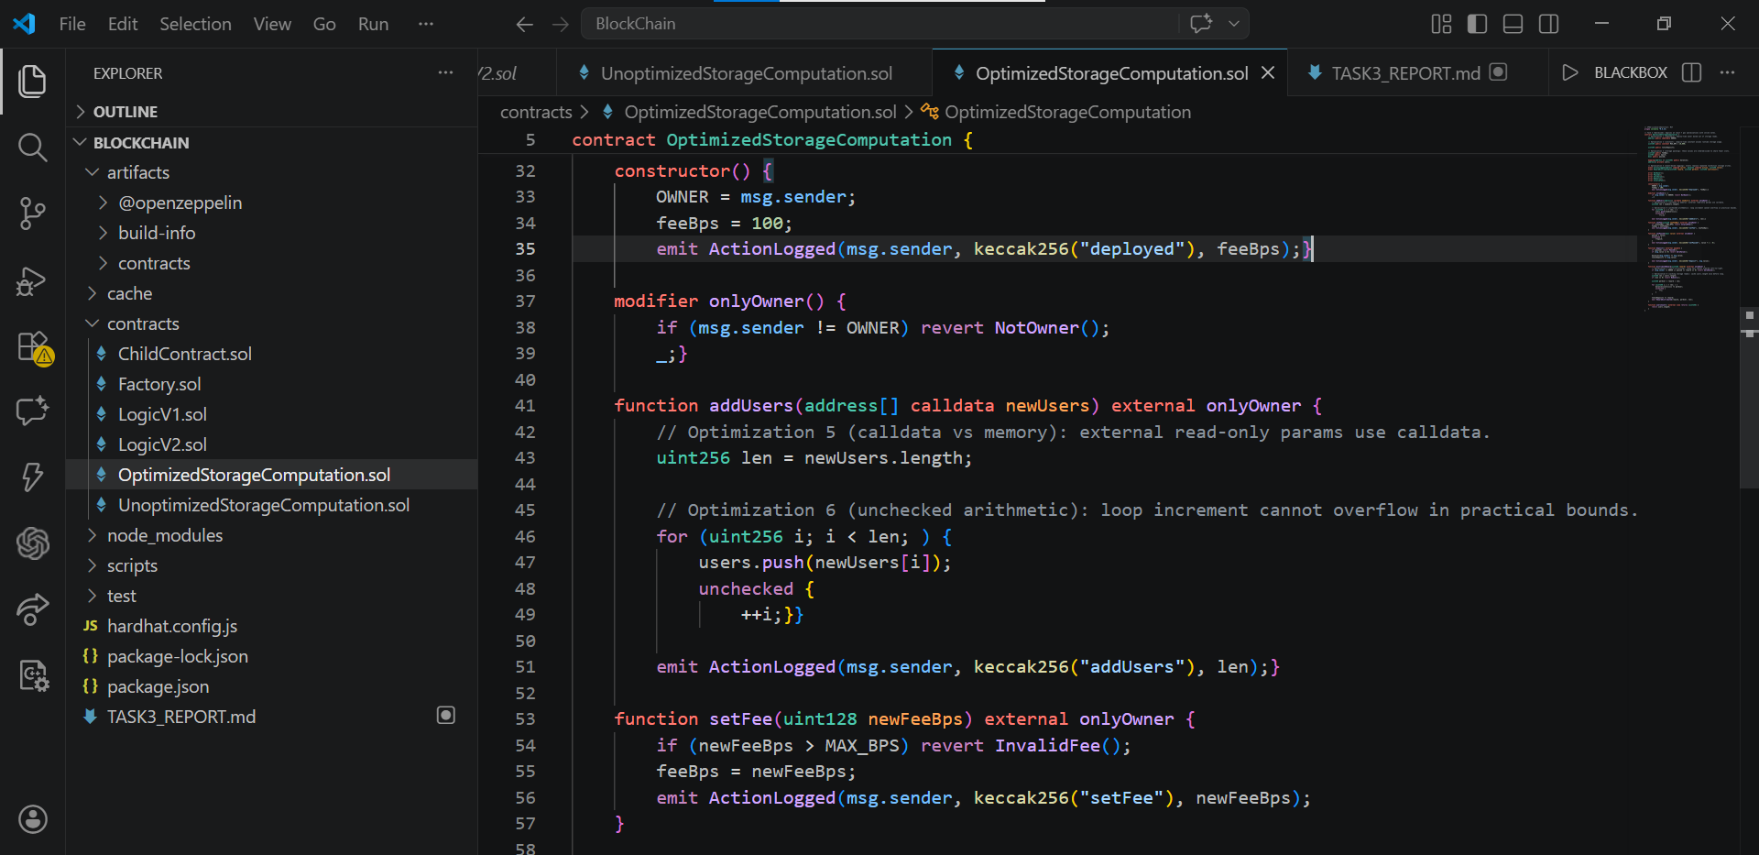
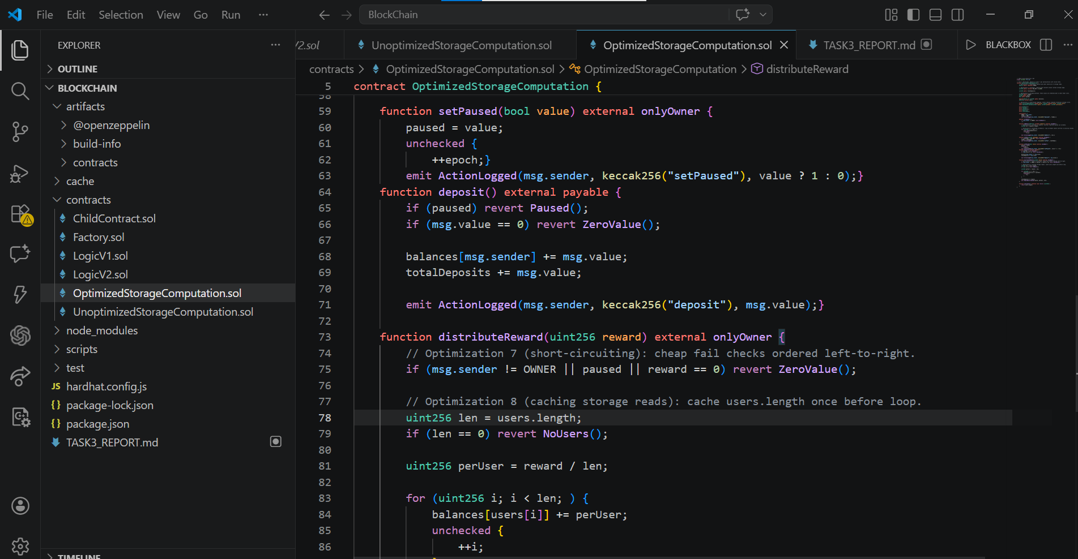

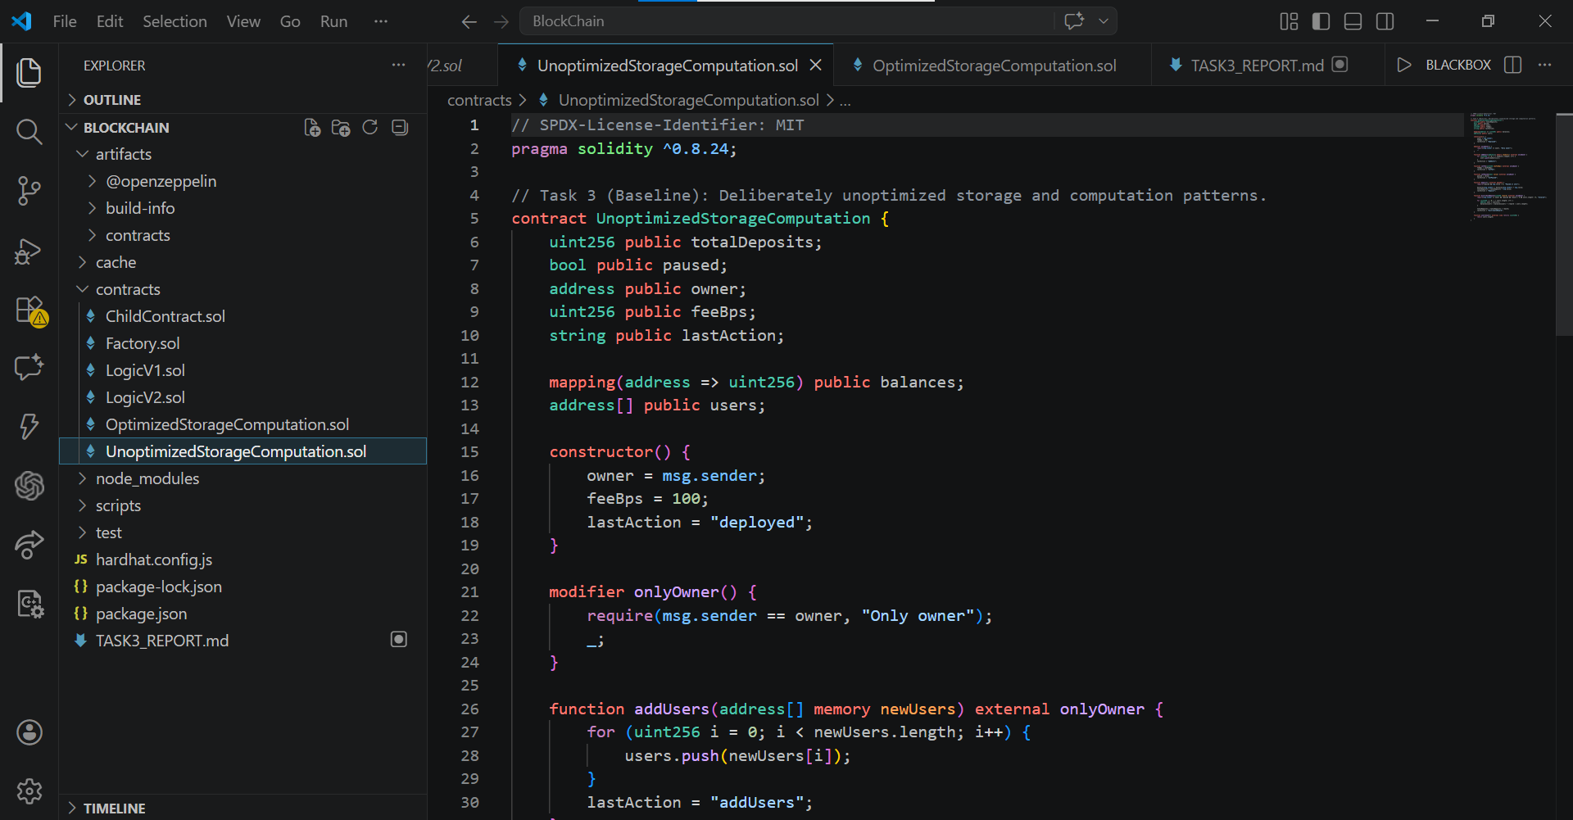

- Hardhat Gas Reporter output (before vs after)
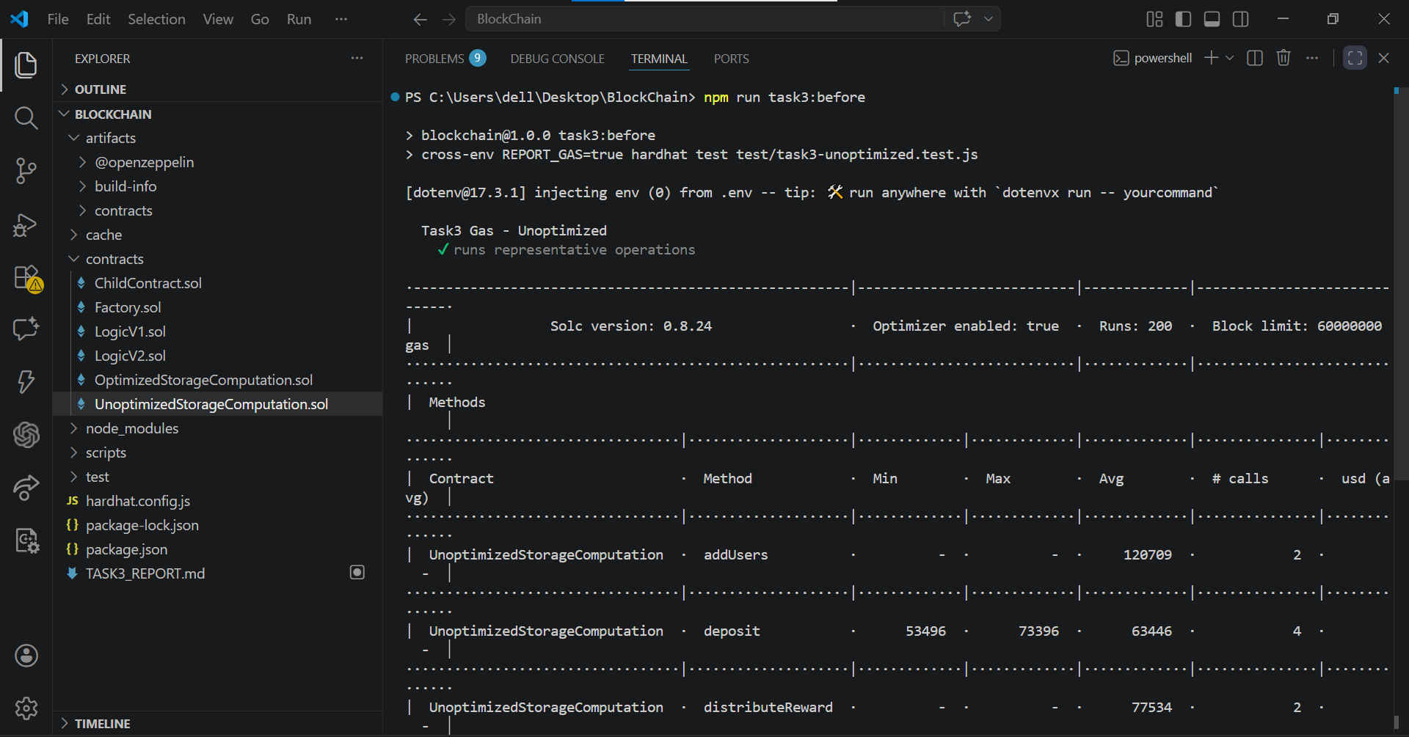
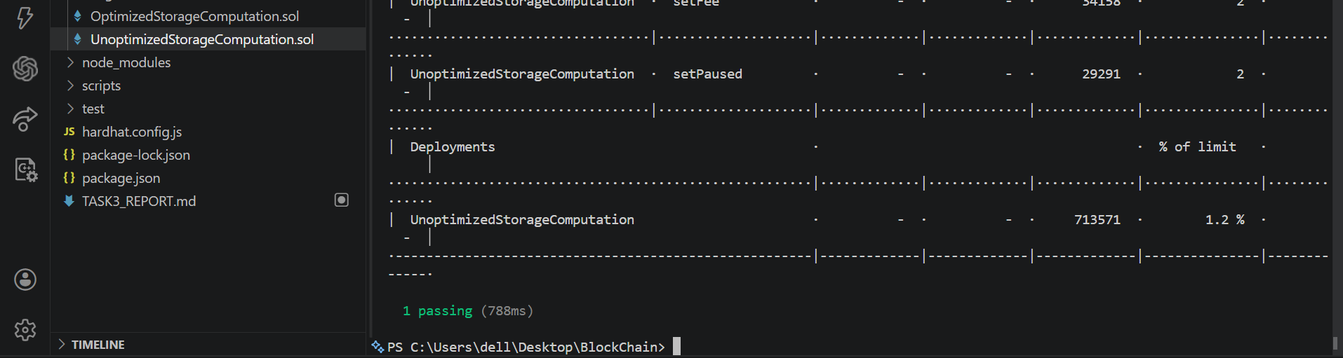
After:
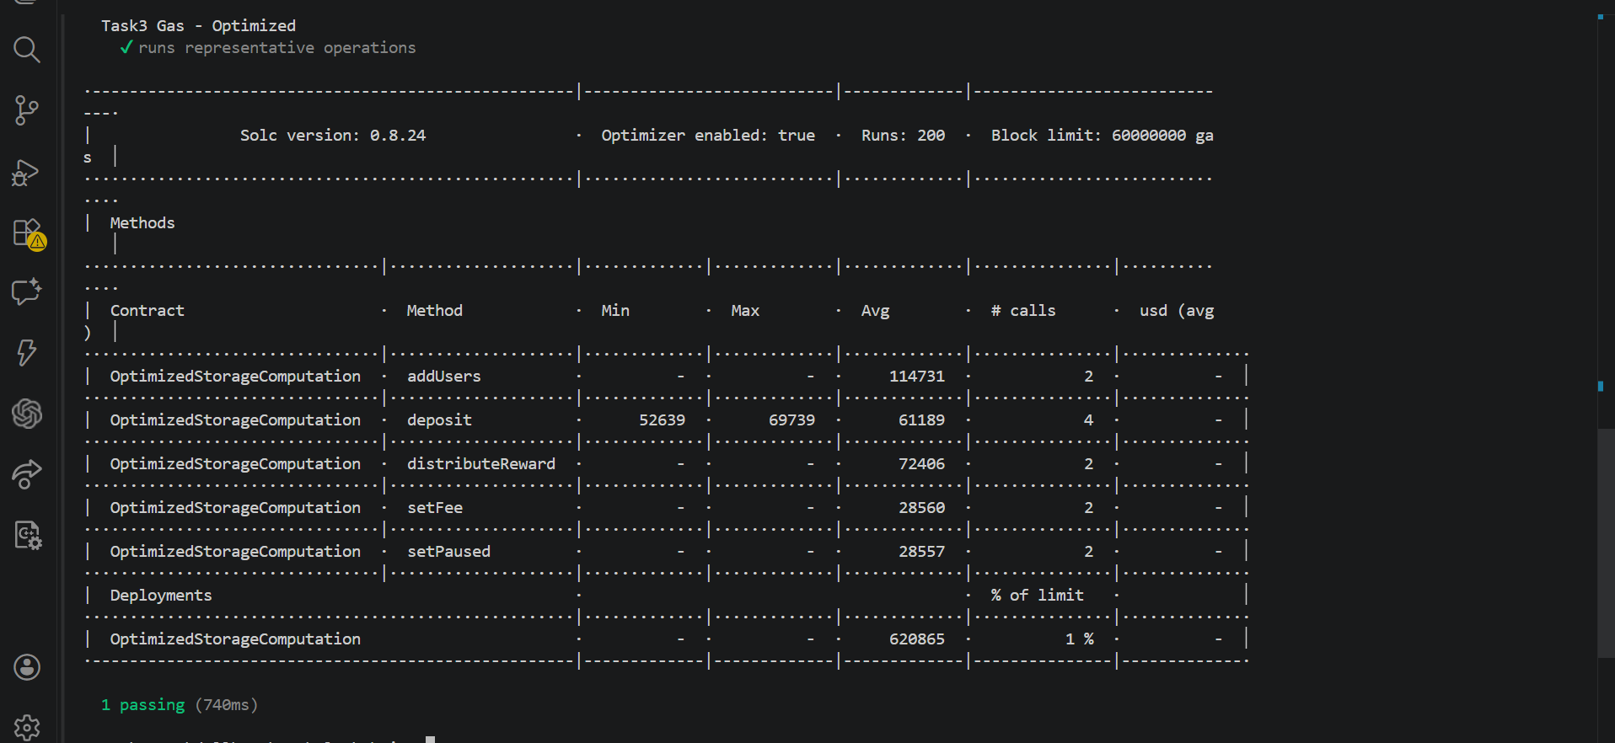

- Summary table: optimization name, gas saved, explanation
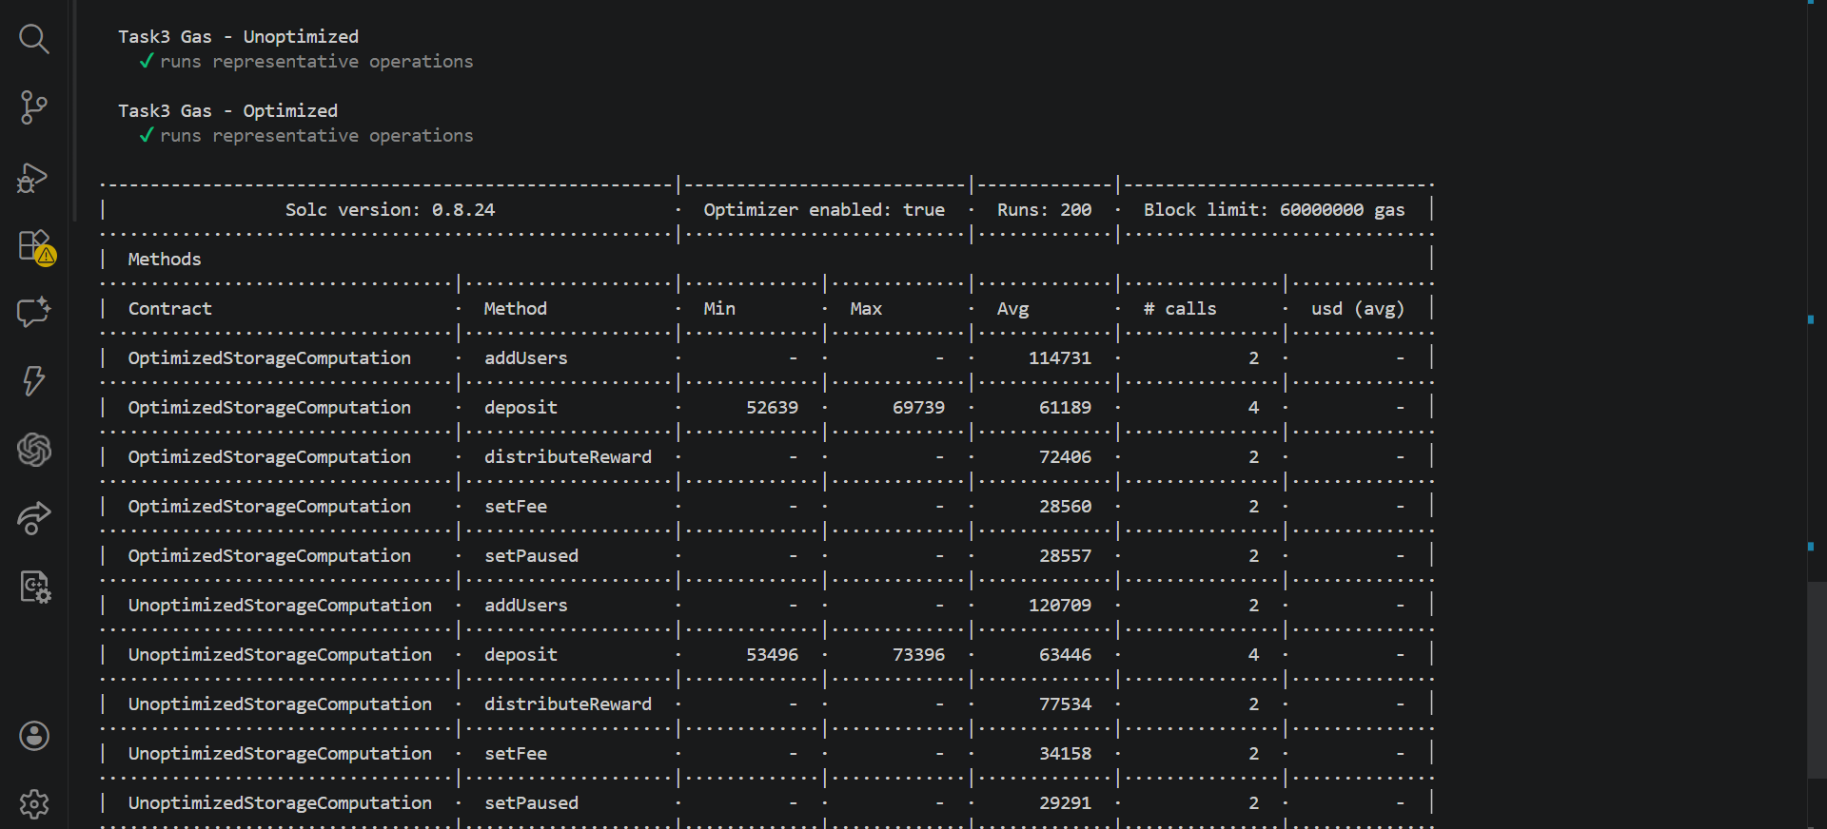

Task 4: Inline Assembly (Yul) Basics
Write a Solidity contract that uses inline assembly for at least 3 operations:
- Read msg.sender directly from calldata/context using caller()
- Perform an arithmetic operation (e.g., efficient power-of-2 check using and)
- Directly access a storage slot using sload and sstore
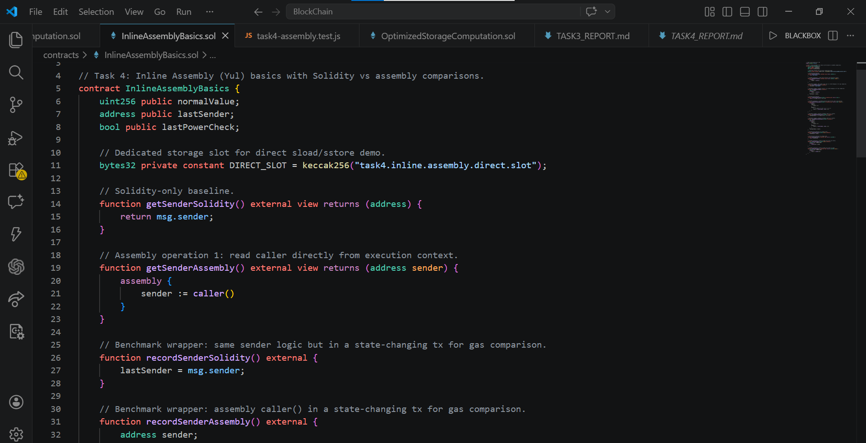
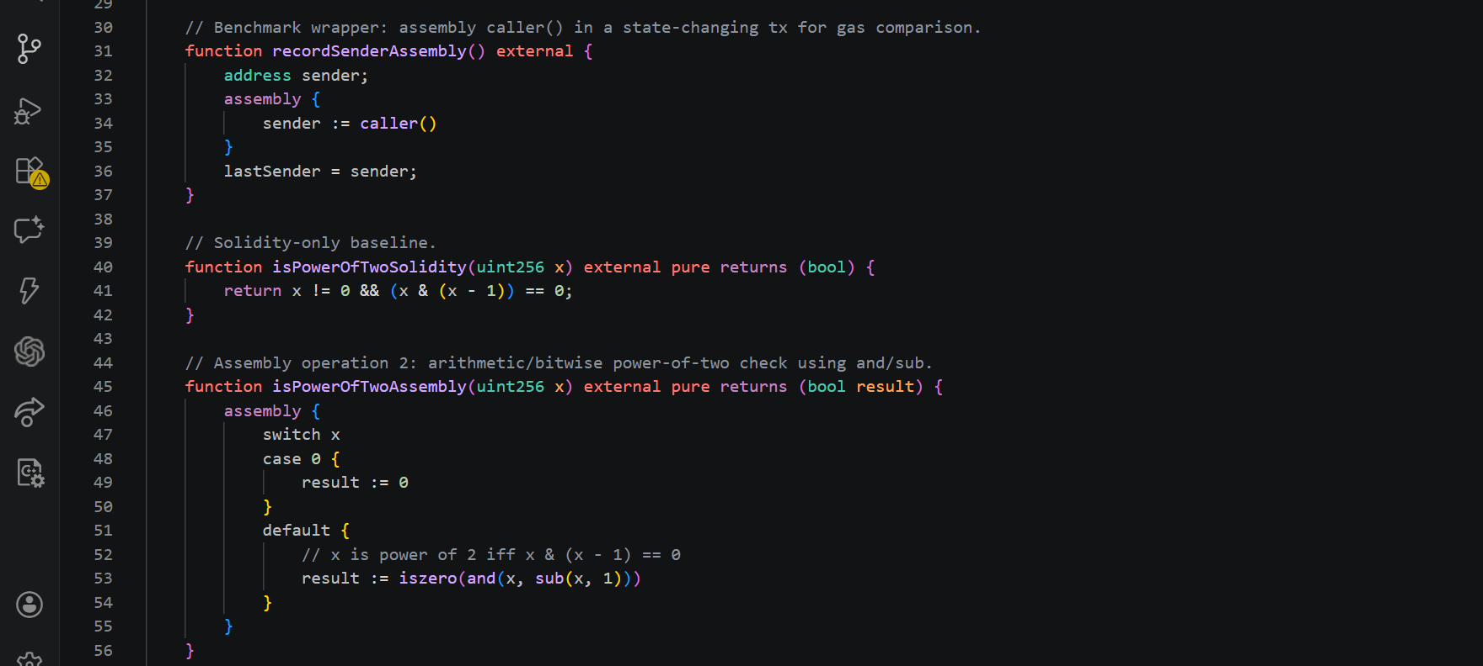
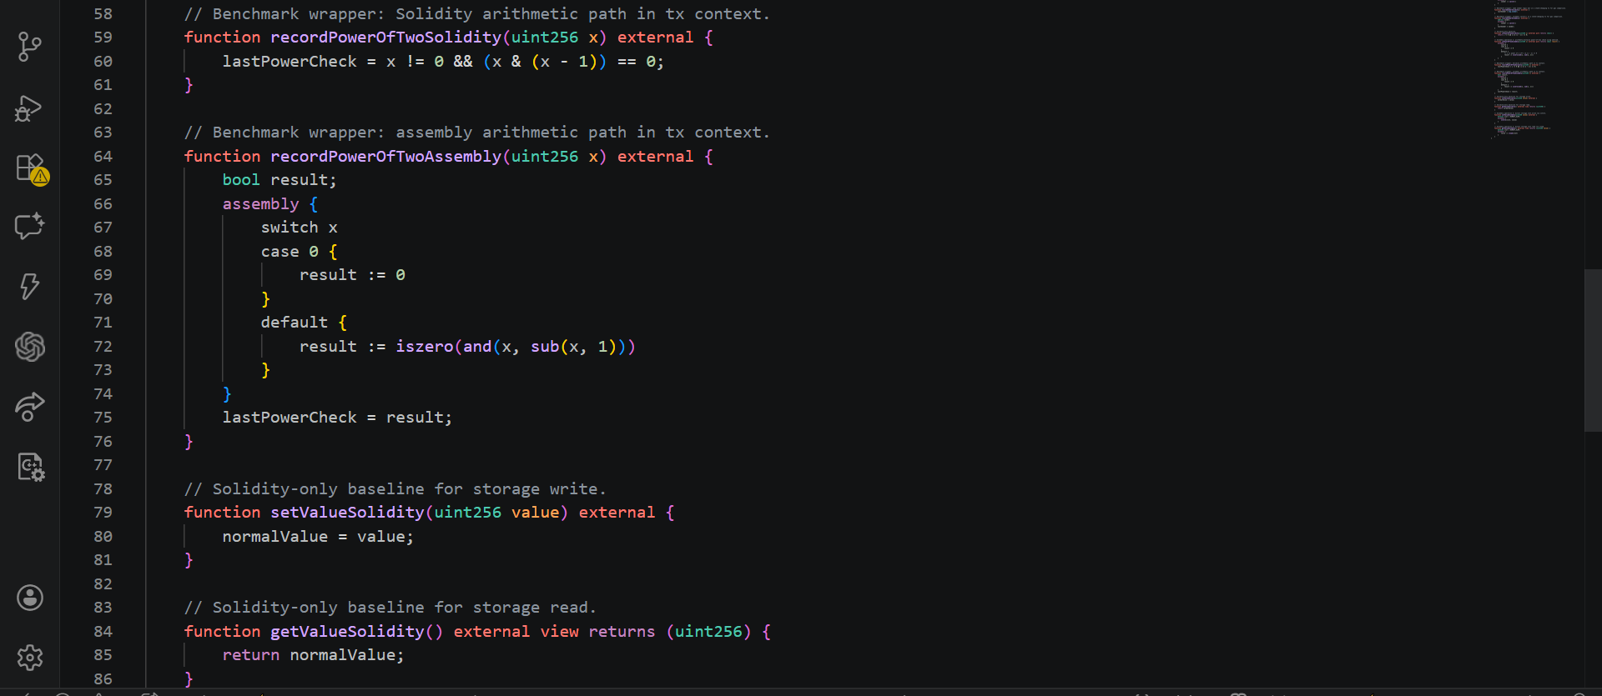
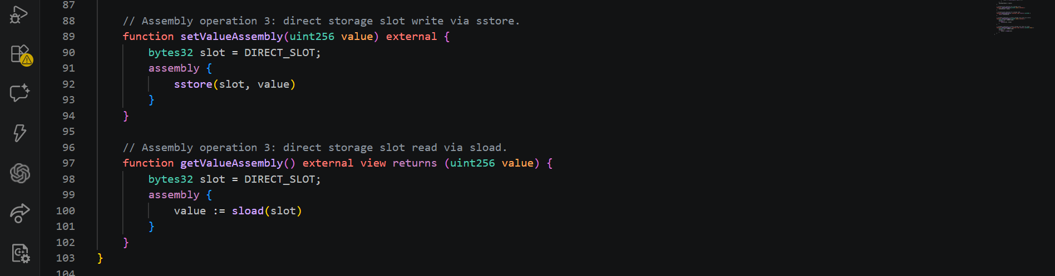
Deliverables:
- Contract with documented assembly blocks
- Comparison: Solidity-only vs assembly version gas costs
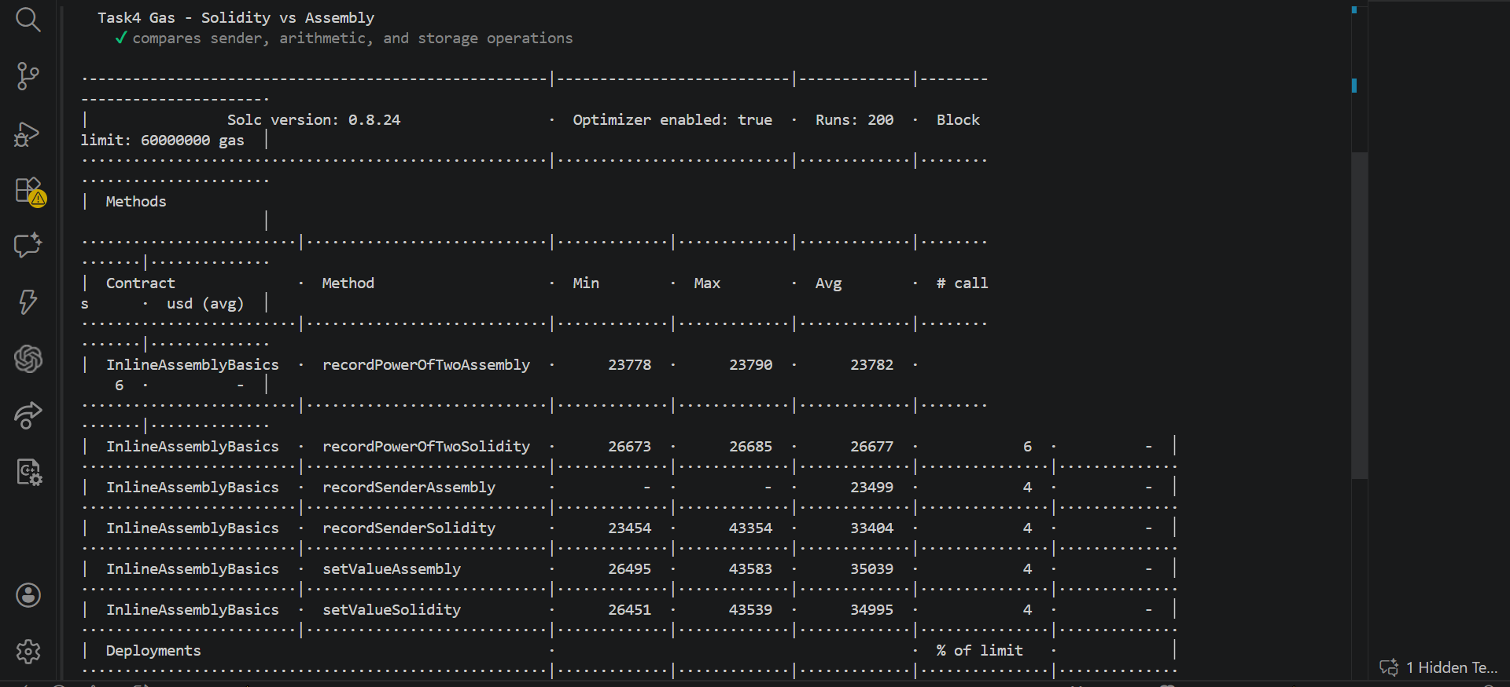
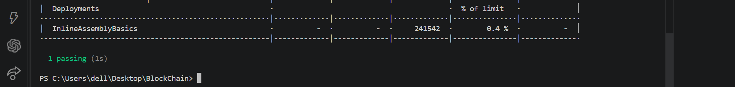

- Brief explanation (0.5–1 page) of when assembly is justified and its risks
Inline assembly is justified when a developer needs precise control over EVM behavior and can prove that lower-level code materially improves performance, enables features unavailable in high-level Solidity, or reduces bytecode overhead in hot execution paths. In this task, assembly was useful for direct caller access and efficient bitwise arithmetic for the power-of-two check. These are compact operations where avoiding extra high-level abstractions can save gas.
However, assembly should be used selectively. Solidity’s compiler has become highly optimized, and many straightforward patterns are already efficient. As shown by the storage write comparison, an assembly implementation can be equal or even slightly worse than idiomatic Solidity depending on context, optimizer behavior, and surrounding logic. Therefore, assembly should be introduced only after measurement confirms a real improvement.
The risks are significant. Assembly bypasses many language-level safety guarantees, which increases the chance of subtle bugs and security vulnerabilities. Common risk areas include incorrect stack usage, bad memory assumptions, unsafe storage slot handling, and fragile code that breaks during upgrades or refactoring. Readability is also lower, so audits and maintenance become harder. In upgradeable systems, misuse of storage slots is especially dangerous because slot collisions can corrupt state.
A practical rule is: write clear Solidity first, profile real workloads, then isolate assembly to tiny, well-documented sections where gains are measurable and tests are strong. Each assembly block should have explicit intent, bounded behavior, and direct tests that compare outputs against a Solidity baseline. This approach keeps optimization evidence-driven while containing security and maintenance risk.

PART 3 — Smart Contract Security Fundamentals

Task 5: Vulnerability Analysis & Exploitation
Reproduce two classic smart contract vulnerabilities hands-on:
Vulnerability A: Reentrancy Attack
- Write a vulnerable VulnerableVault.sol (~15–25 lines) with deposit/withdraw
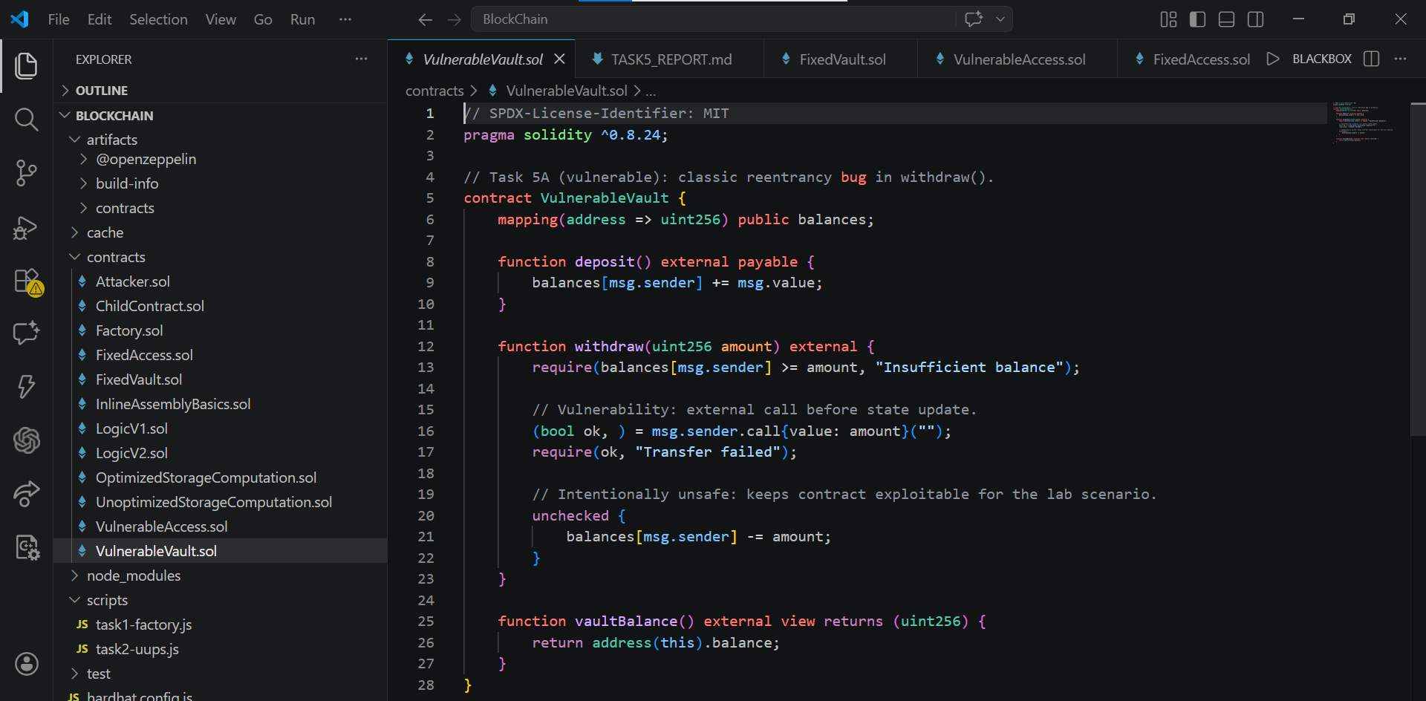

- Write an Attacker.sol that exploits the reentrancy
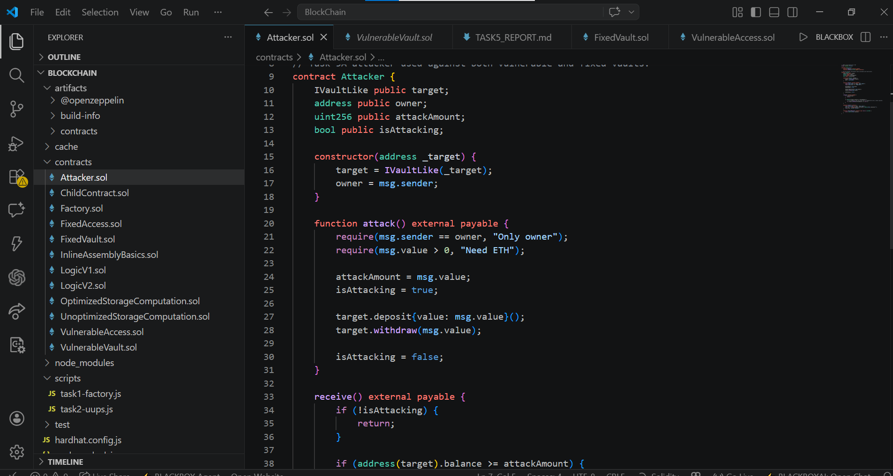

- Write a Foundry/Hardhat test that demonstrates the exploit draining funds
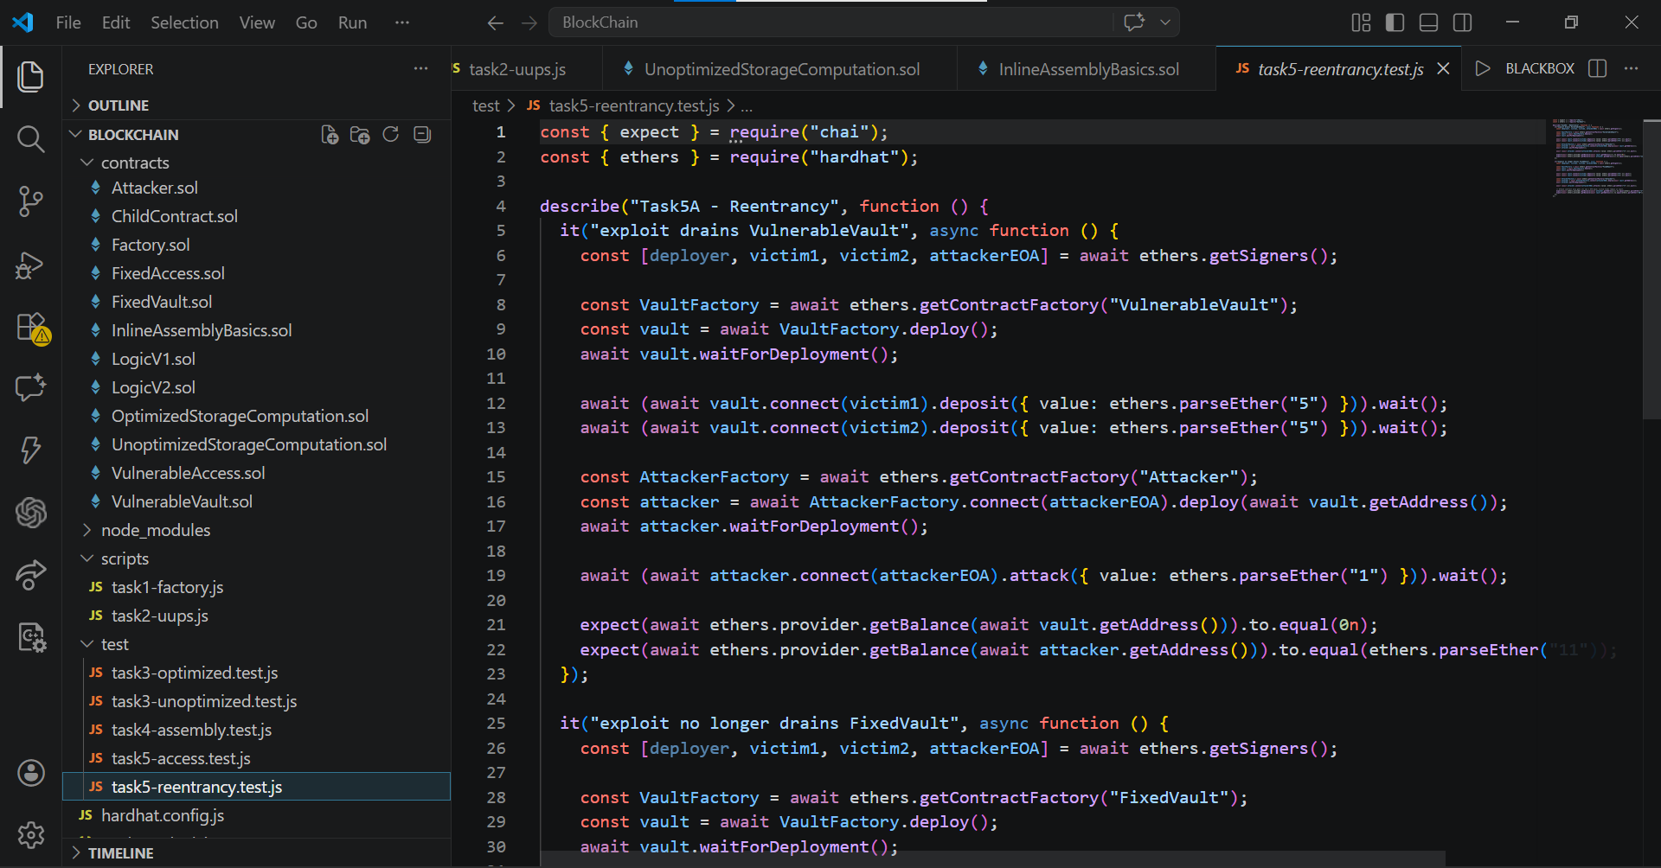

- Fix the vulnerability using the Checks-Effects-Interactions pattern and OpenZeppelin’sReentrancyGuard
- Write a post-fix test proving the exploit no longer works
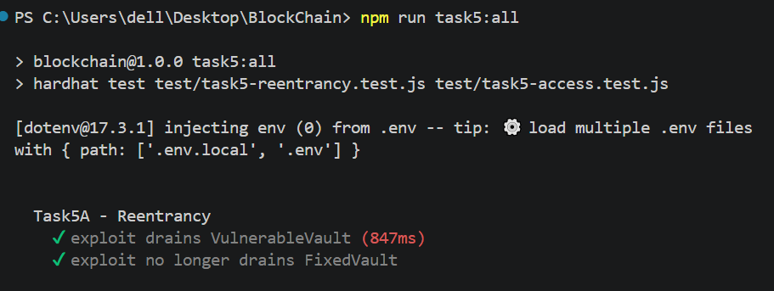

Vulnerability B: Access Control Misconfiguration
- Write a contract with an unprotected setOwner() or withdraw() function
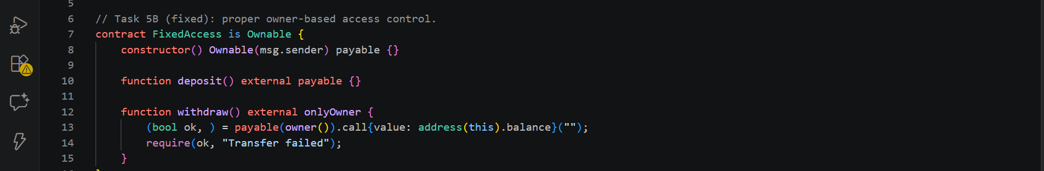
- Demonstrate how any address can call the privileged function
- Fix using OpenZeppelin’s Ownable or AccessControl
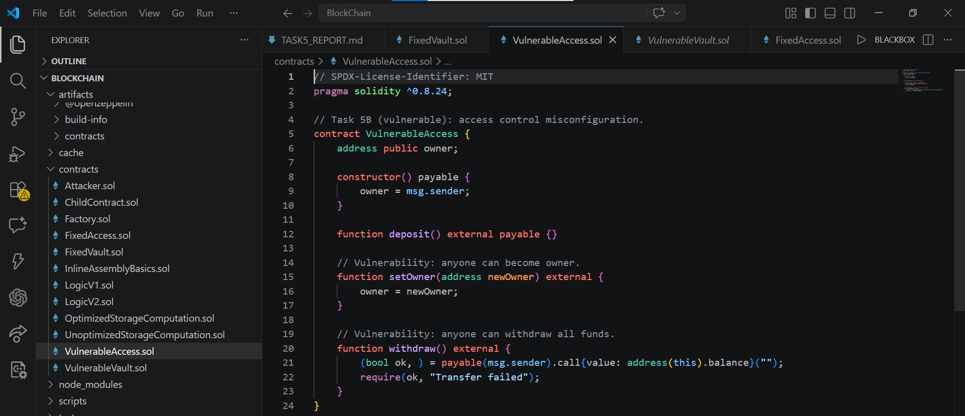
- Write tests proving only authorized addresses can call protected functions
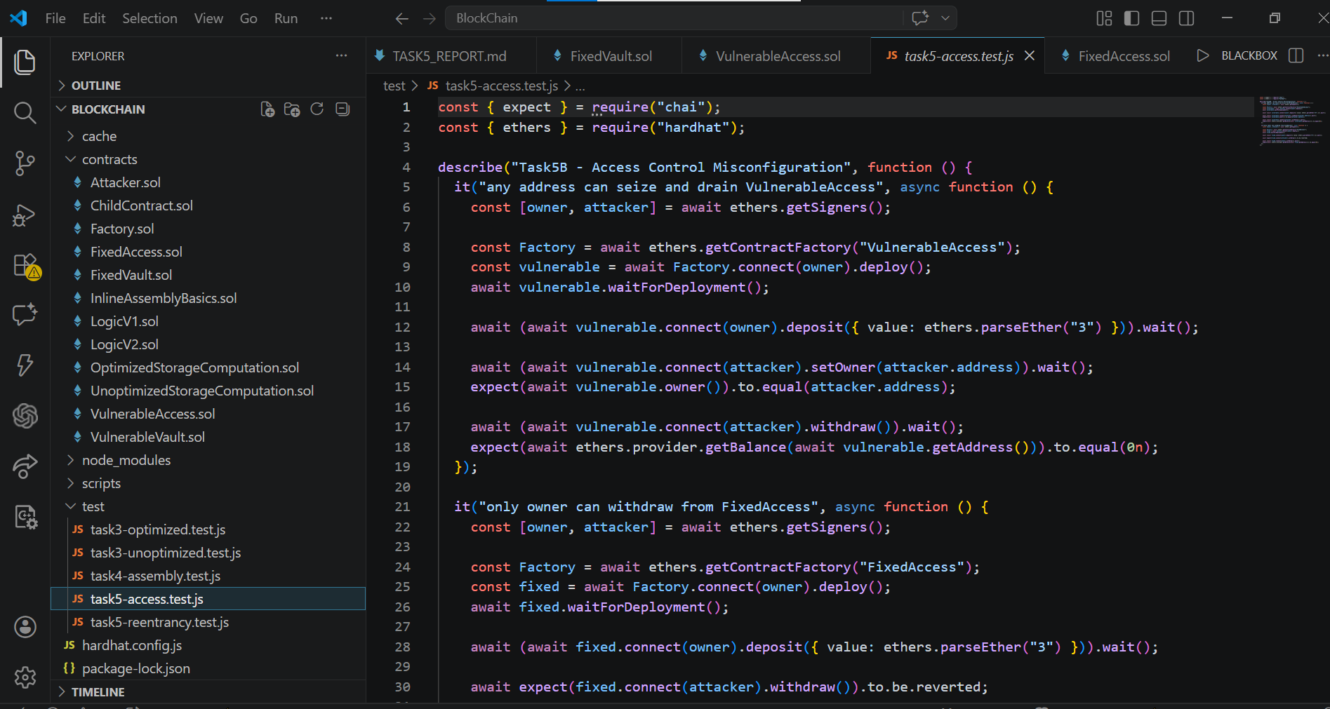
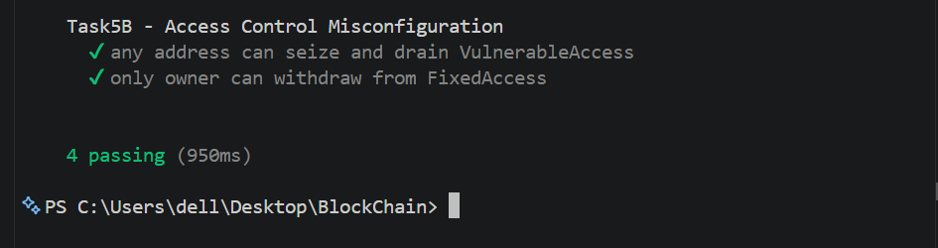

Security Report: Access Control Misconfiguration
1. Vulnerability Description
While working on this task, I implemented a contract (VulnerableVault.sol / VulnerableAccess.sol) where some important functions like setOwner() and withdraw() were not protected. These functions were declared as public. Because of this, I noticed that literally any address can call these functions, not just the owner. For example, in the vault contract, the withdraw() function allows transferring funds, but since there is no access control, anyone can call it and withdraw the balance. Similarly, with setOwner(), any user can make themselves the owner of the contract.

2. Impact
The impact of this issue is very serious:
- Any user can steal all funds from the contract by calling withdraw().
- An attacker can take ownership of the contract using setOwner().
- Once the attacker becomes the owner, they can control everything.
- Since blockchain transactions cannot be reversed, the loss is permanent.
When I tested this using Attacker.sol, I was able to call the vulnerable functions from another account and successfully perform actions that should normally be restricted.

3. Root Cause
The main reason this vulnerability happened is because I did not implement any authorization checks.
I used public functions but forgot that this only makes the function accessible, not protected. I didn’t check msg.sender or restrict access to the owner.
Also, I didn’t use any standard security patterns or libraries at first. Later, I realized that libraries like OpenZeppelin already provide safe and tested solutions for this problem.
So overall, the root cause is: Missing access control modifiers, Lack of ownership validation, Not using secure, standard implementations

4. Remediation
To fix the issue, I updated the contract by adding proper access control.
First, I used the Ownable contract from OpenZeppelin. This automatically gives an owner to the contract and provides the onlyOwner modifier.
Then I applied: onlyOwner to the withdraw() function and replaced or protected setOwner() with a secure ownership transfer function
After this fix, only the contract owner is able to call these sensitive functions.
I also learned that for more advanced cases, AccessControl can be used to manage different roles, but for this task, Ownable was enough.

5. Testing and Verification
I tested both the vulnerable and fixed versions of the contract.
- Before fixing: I was able to call withdraw() and setOwner() from any account without any restriction.
- After fixing: When I tried calling these functions from a non-owner account, the transaction failed (reverted).
- Only the owner account was able to successfully execute these functions.

Task 6: Static Analysis with Slither
Run Slither on all contracts from Tasks 1–5.
Requirements:
- Install and configure Slither
- Run analysis on each contract
- Document all findings (high, medium, low, informational)
- For each high/medium finding: explain the risk and whether it’s a true positive or false positive• Apply fixes for all true positives and re-run Slither to confirm resolution
Deliverables:
- Slither output logs (before and after fixes)
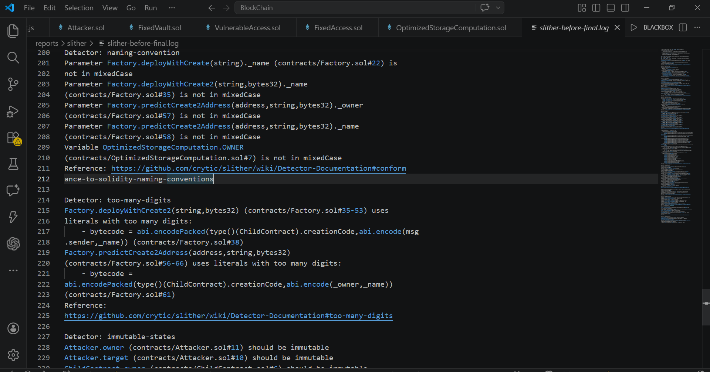
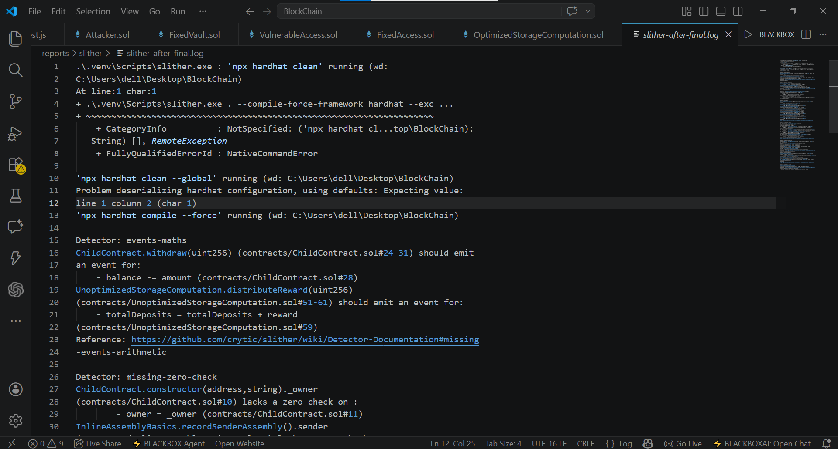

- Summary table of findings with severity, description, and action taken

Overview
In this task, I used the static analysis tool Slither to analyze all the smart contracts developed in previous tasks. The goal was to identify potential vulnerabilities, code quality issues, and optimization opportunities, and then compare the results before and after applying fixes.

Before Remediation: In the initial analysis (including all contracts except dependencies), the tool reported a total of 40 findings. These findings were categorized based on severity levels.
- High Severity: 2
- Low Severity: 8
- Informational: 26
- Optimization: 4
The presence of high severity issues indicated critical vulnerabilities that could potentially lead to serious problems such as fund loss or unsafe contract behavior.
Breakdown by Detector
Detector | High | Medium | Low | Informational | Optimization | Unknown
arbitrary-send-eth | 1 | 0 | 0 | 0 | 0 | 0
assembly | 0 | 0 | 0 | 7 | 0 | 0
events-maths | 0 | 0 | 3 | 0 | 0 | 0
immutable-states | 0 | 0 | 0 | 0 | 4 | 0
low-level-calls | 0 | 0 | 0 | 8 | 0 | 0
missing-inheritance | 0 | 0 | 0 | 3 | 0 | 0
missing-zero-check | 0 | 0 | 3 | 0 | 0 | 0
naming-convention | 0 | 0 | 0 | 5 | 0 | 0
pragma | 0 | 0 | 0 | 1 | 0 | 0
reentrancy-benign | 0 | 0 | 2 | 0 | 0 | 0
reentrancy-eth | 1 | 0 | 0 | 0 | 0 | 0
too-many-digits | 0 | 0 | 0 | 2 | 0 | 0

From this analysis, I observed that the most critical issues were:
- Reentrancy (reentrancy-eth)
- Arbitrary ETH transfers (arbitrary-send-eth)
These are serious vulnerabilities that could allow attackers to exploit the contract.

After Remediation
After identifying the issues, I fixed the vulnerabilities and re-ran the analysis. The updated results (excluding intentionally vulnerable lab contracts) showed significant improvement.
- Total Findings: 26
- High Severity: 0
- Low Severity: 5
- Informational: 19
- Optimization: 2
The most important improvement is that all high severity issues were removed, which means the contracts are now significantly more secure.

Breakdown by Detector
Detector | High | Medium | Low | Informational | Optimization | Unknown
assembly | 0 | 0 | 0 | 7 | 0 | 0
events-maths | 0 | 0 | 2 | 0 | 0 | 0
immutable-states | 0 | 0 | 0 | 0 | 2 | 0
low-level-calls | 0 | 0 | 0 | 5 | 0 | 0
missing-zero-check | 0 | 0 | 2 | 0 | 0 | 0
naming-convention | 0 | 0 | 0 | 5 | 0 | 0
reentrancy-benign | 0 | 0 | 1 | 0 | 0 | 0
too-many-digits | 0 | 0 | 0 | 2 | 0 | 0

Analysis and Comparison
By comparing the results before and after remediation, I noticed the following improvements:
- All critical (high severity) vulnerabilities were eliminated
- The total number of issues decreased from 40 to 26
- Low severity issues were reduced from 8 to 5
- Optimization issues decreased from 4 to 2
Most of the remaining findings are informational or related to coding style (such as naming conventions), which do not directly affect security but can improve code quality and readability.

PART 4 — Theoretical Analysis

Task 7: Written Analysis
Question 1: Proxy Patterns Comparison
Proxy patterns are used to make smart contracts upgradeable by separating logic and storage. The three main types are Transparent Proxy, UUPS, and Diamond (EIP-2535).
The Transparent Proxy pattern uses an admin account that controls upgrades. It checks on every call whether the sender is the admin or a user. This makes it safer but increases gas cost because of constant checks.
The UUPS pattern is more efficient because the upgrade logic is inside the implementation contract. The proxy is simple and only delegates calls. It uses less gas, but if the upgrade function is not protected correctly, it can be risky.
The Diamond pattern allows multiple implementation contracts (facets). It is very flexible and useful for large projects, but it is more complex and has higher risk of storage issues.
All proxy patterns have storage collision risks, meaning the storage layout must stay the same during upgrades. In terms of gas, Transparent is the most expensive, UUPS is cheaper, and Diamond depends on complexity.
In practice:
- Transparent → simple and secure systems
- UUPS → most modern DeFi projects
- Diamond → large and complex protocols

Question 2: Smart Contract Security Landscape
Smart contract security is very important in DeFi because large amounts of money are involved. Some of the most common vulnerabilities from the SWC registry include:
- Reentrancy (SWC-107) – attacker repeatedly calls a function before state updates
- Access control issues (SWC-105) – unauthorized users can call restricted functions
- Integer overflow (SWC-101) – incorrect calculations (less common now)
- Unchecked calls (SWC-104)
- Denial of Service (SWC-113)
These vulnerabilities have caused major real-world attacks. For example, the The DAO Hack used reentrancy to steal millions. The Wormhole Hack and Euler Finance Hack also caused huge financial losses.
To detect issues, developers use tools like Slither, Mythril, and Echidna. These tools are fast but cannot catch all logical bugs, so manual auditing is also necessary.
A good security process includes:
- Writing secure code and using trusted libraries
- Testing (unit tests + fuzzing)
- Running analysis tools
- Performing external audits
- Monitoring after deployment
In conclusion, smart contract security requires both tools and careful development practices to prevent serious financial losses.

