Task 2.2 Evidence

Create Record method

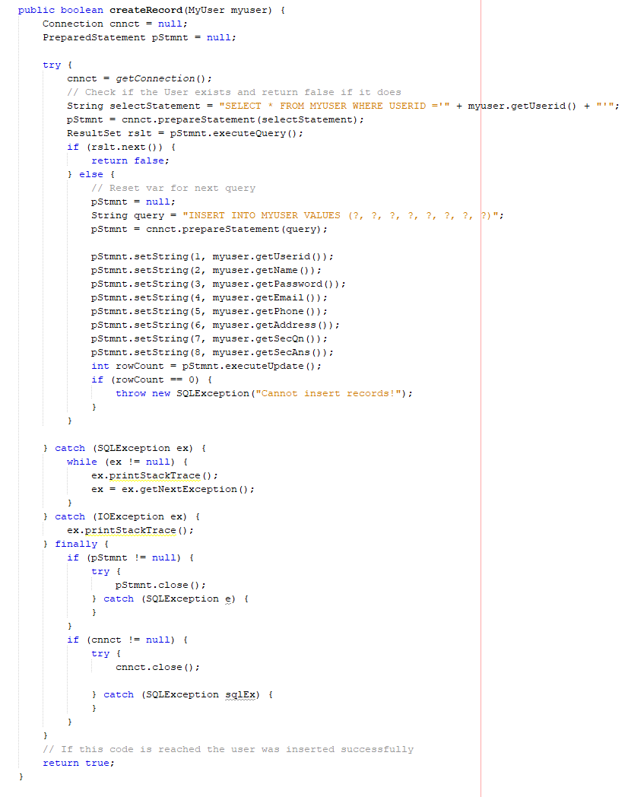

Get Record Method

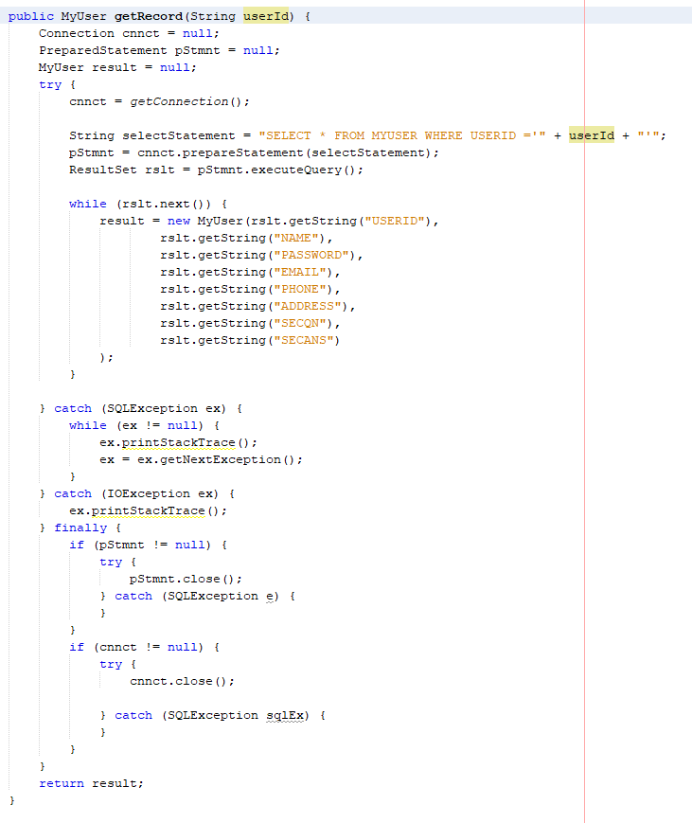

Update Record Method

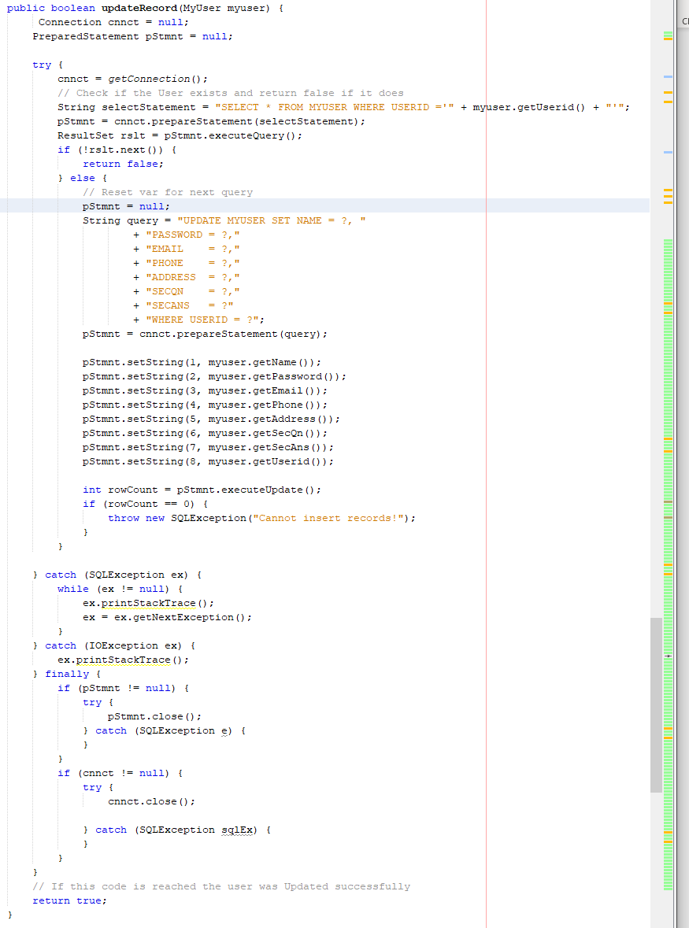

Delete Record Method

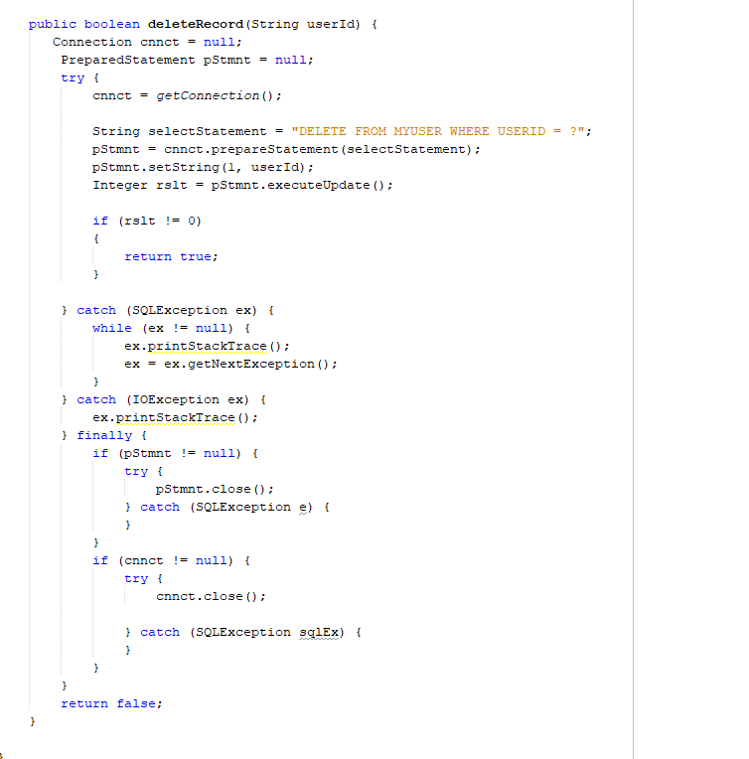

GUI

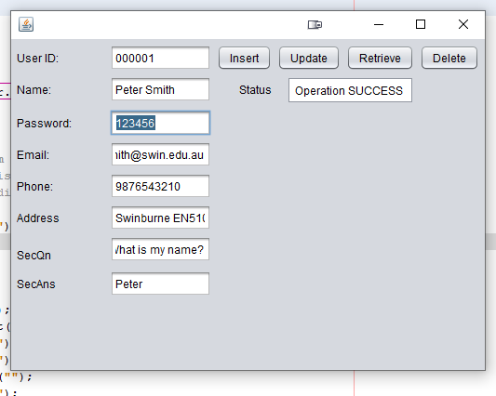

Task 4 : Questions

4.1:

The myuser class is neither a DAO or DTO as it provides no means of sending changes to the database. It’s merely a representation of the user entity in the database as an object.

4.1.1:

From Wikipedia: “a DAO is a pattern that provides an abstract interface to some kind of database”. The purpose of a DAO is to provide means to access information in the database without exposing database operations.

Here the database object acts as a DAO because it provides methods for storing and retrieving data in the database and does NOT expose the queries themselves to outside objects.

4.2 & 4.3

The answer to both of these is no. The setName() method is an automatically generated setter method for the user object. The setter methods only change the internal value of the name property of the object calling the method.