3.1P

1. METHOD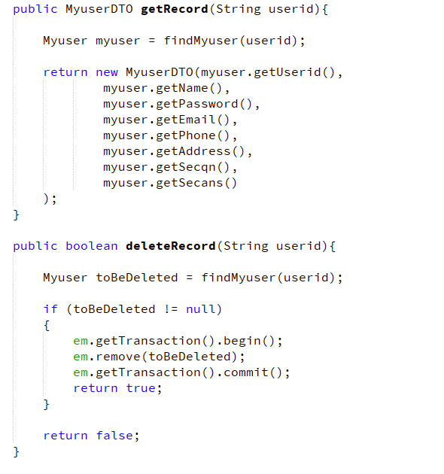

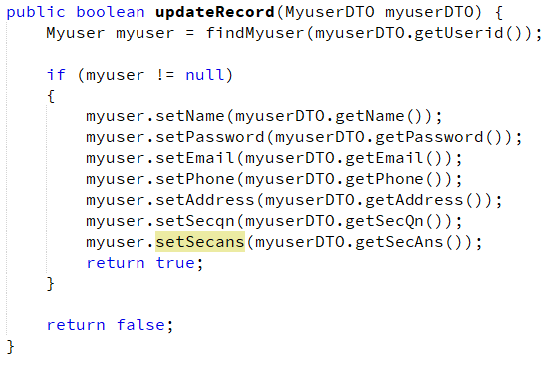

Test harness

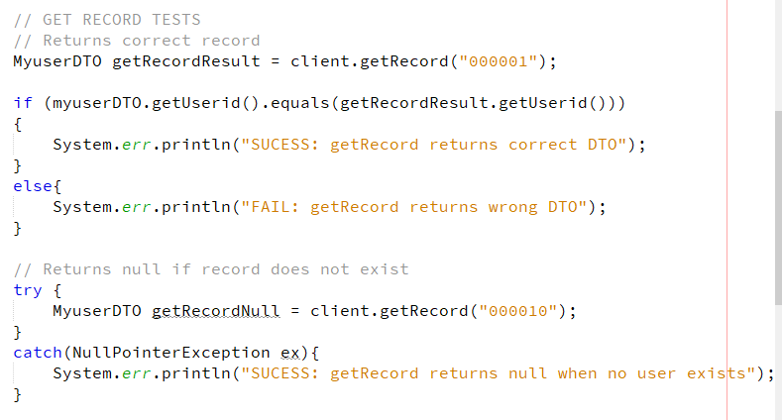

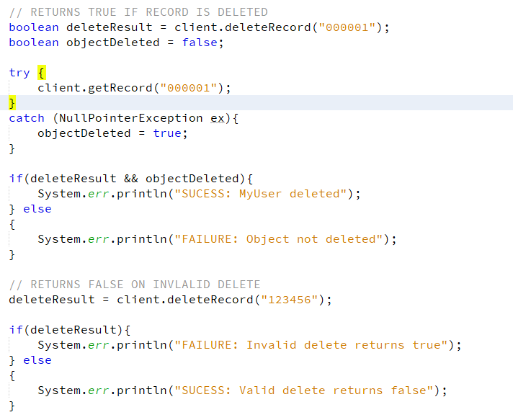

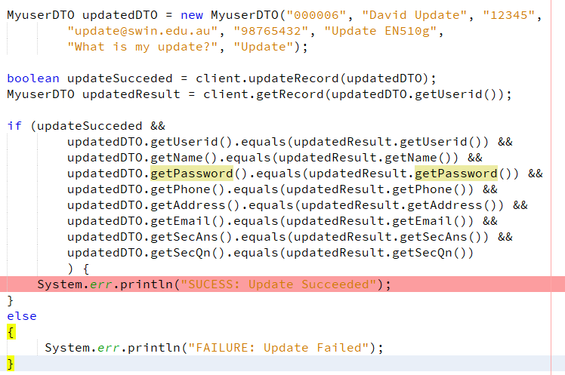

Questions

**4.1. Which class is responsible for doing all the ORM work? MyuserDB / Myuser? Justify your answer**

Myuser is responsible for the object relation mapping as it is an entity. Entities define the database tables using the object properties.

This is why myuser uses the @column tag on its properties

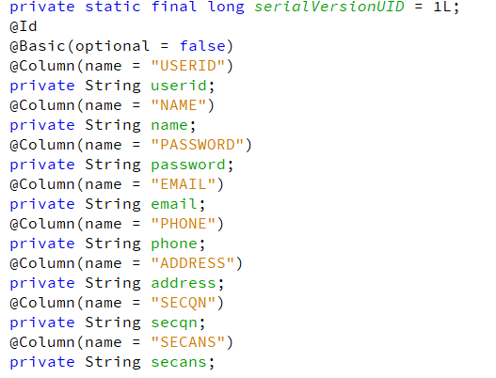

**4.2. Is the role of the Myuser entity class here different from that of the “Myuser” class in the application in Lab 02. Why? Justify your answer.**

It is significantly different here as an entities fields are persisted to the database. This means that altering a field from a Myuser object returned from the EntityManager will alter that field in the database. This means that Myuser in lab 3 takes on the role of DAO whereas in lab 2 it was only a POJO.

**4.3. Why Myuser entity class in this application domain is different from that in the Lab 02 (in the JDBC domain)?**

Its role was different here as the javax persistence library requires us to define entity objects in order to interact with the database.