4.1P

1. Crud operations in MyuserFacade

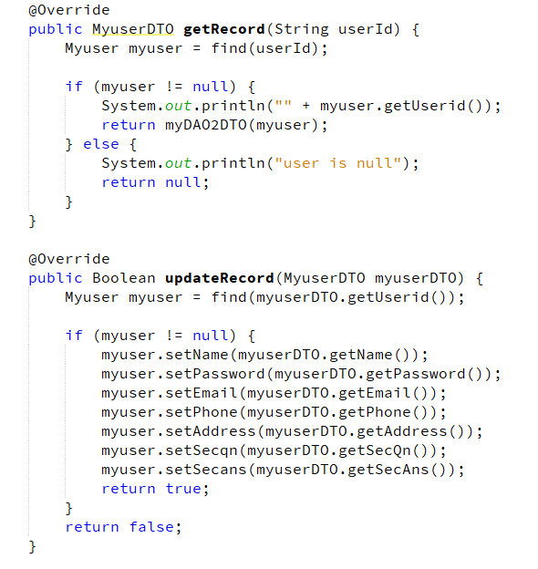

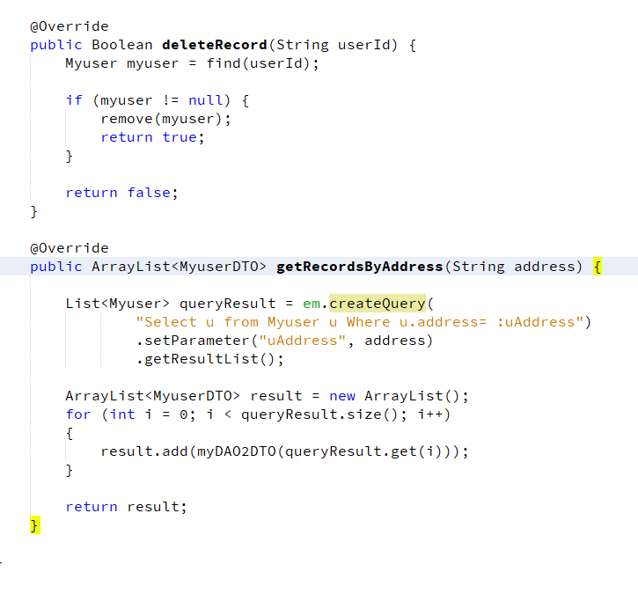

2. Testing

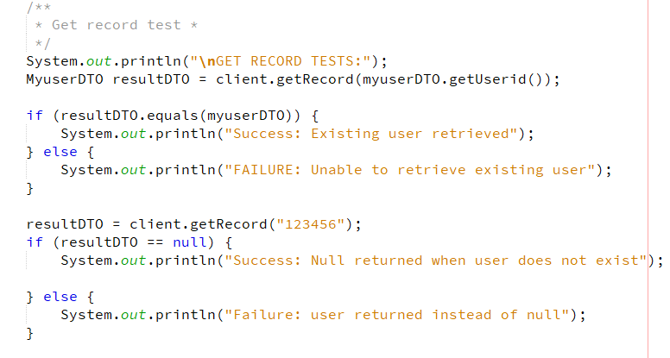

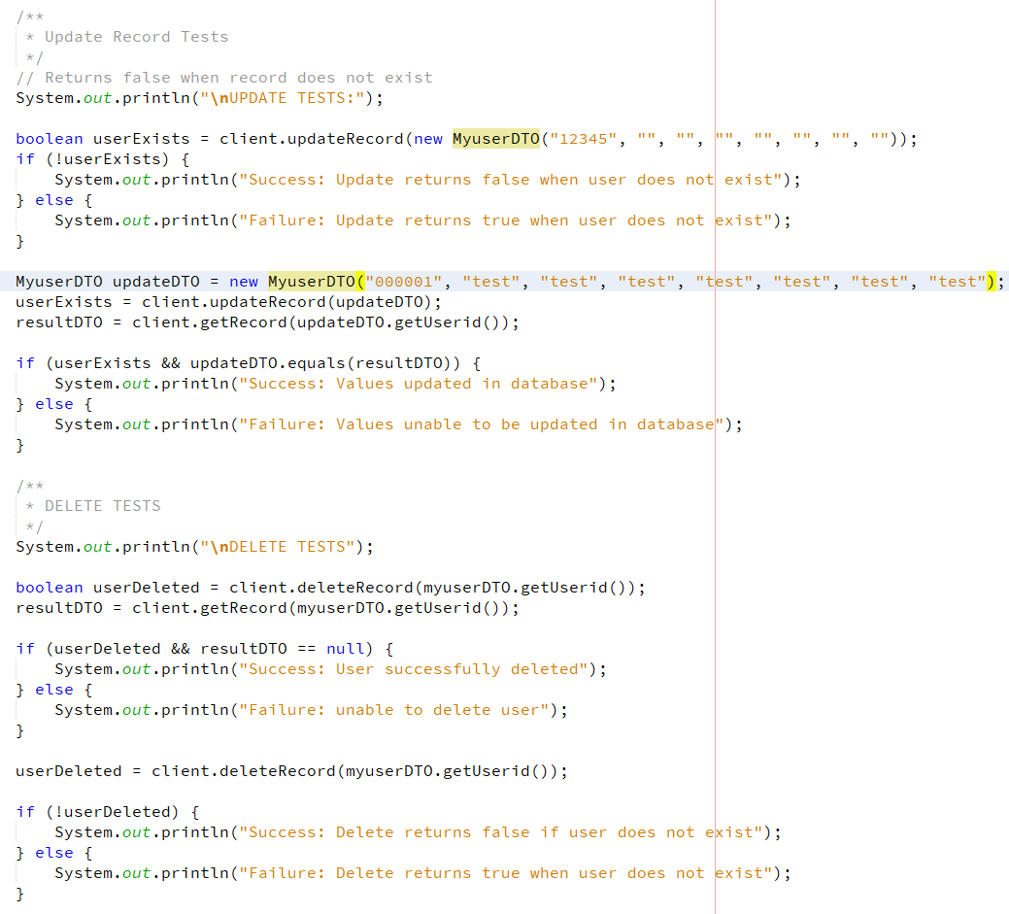

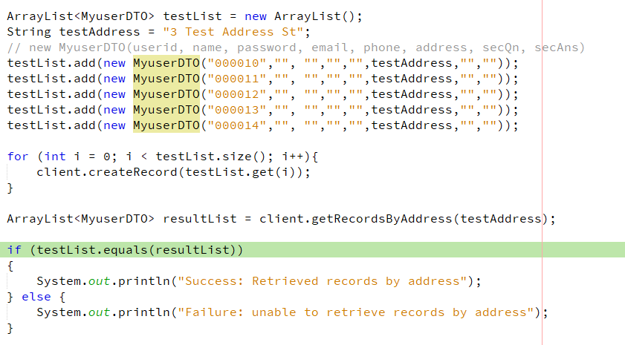

3. Questions

1. Who is doing the ORM work in this project?

The ORM work will always be performed by the entity classes that map their properties onto the database. As a result the Myuser class is performing the ORM work here alongside the java persistence library.

Intuitively you may say that MyuserFacade is performing the work as it defines the methods for interacting with the database, however these are actually just business methods, as the interaction with the database is done indirectly via the Entity manager class provided by the java persistence library.

2.