5.2C

Task 1. Analysis

1. User id length
2. Password complexity

JSF has a set of standard validator tasks that can do both of these very easily.

F:validateLength allows me to set the minimum & maximum size of a string.

F:validateRegex lets me write a regex pattern for the string to match.

These are both appropriate as they’re standard JSF tags and will be extremely simple to implement.

1. Passwords Match

JSF also has a F:Validator tag which lets me point to a custom validator class to validate the input. A custom validator class is necessary here as I need to programmatically compare the two values of two input fields.

Task 2. Programming

**Length validation:**



**Complexity validation for password:**

I used a regex testing website to write a regex that would only accept a 6 character string that contained at least 1 capital letter, 1 lower case letter, 1 number, and one special character (-, +, *)

The ‘at least 1’ condition is met with the following pattern: (?=.*[])

?= means look ahead, and .* means any character except line break, and [] contains the character we want to search for. So its looking ahead for any character that exists in the square brackets.  
This pattern is repeated for each of the characters we want at least one of.



**Passwords Match validation:**

I created the following class to validate that the passwords match:

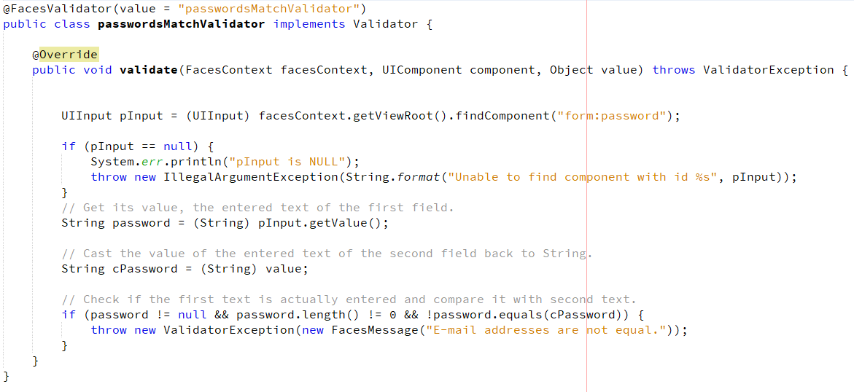

Its attached to the custom password field so it needs to grab the password input to compare.   
To do this it uses the findcomponent method with the passwords id with its containers id in front of it. Here our form has the id of ‘form’ and our password has the id of ‘password’ so we find the component using ‘form:password’.

If its not null then it grabs the string value inside, and the string value in the confirm password field.   
It then compares the two and throws an error if they are not the same.

To attach this to the field I use the following tag:



3. Test cases

**Password length**

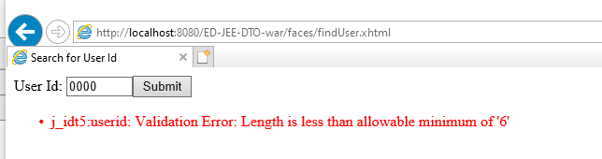

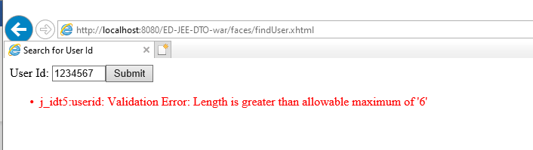

**Password Complexity:**

To test if my regex works, I used the tester on the website. <https://regexr.com/>

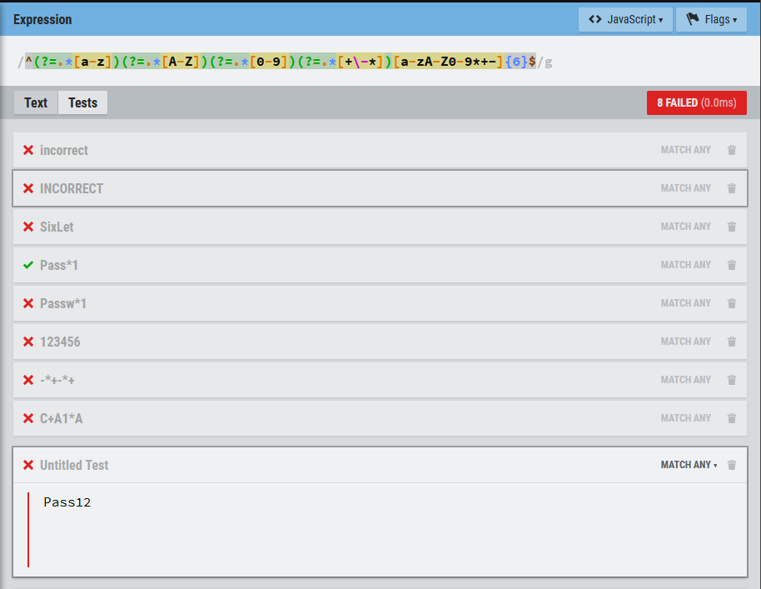

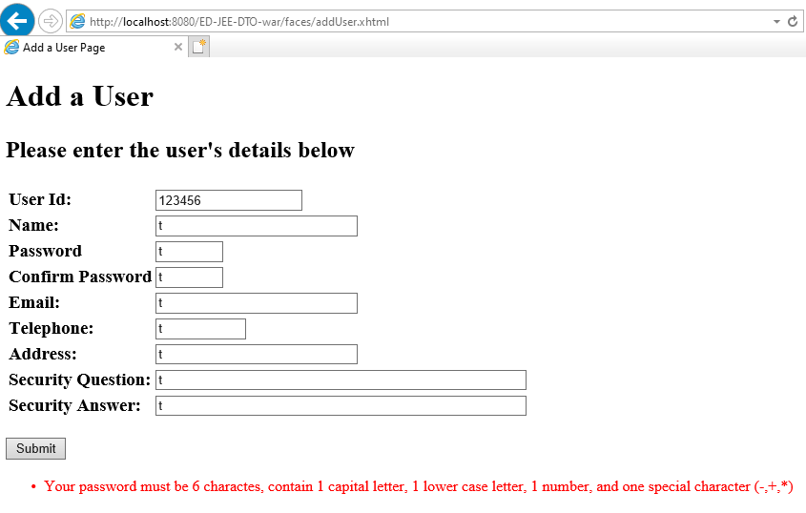

Passwords Matching:

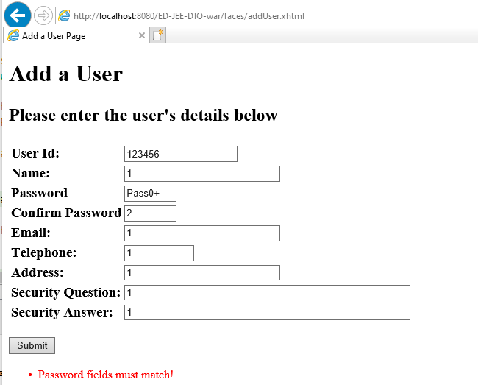

Task 4. Learning

A quick google search led me to this page: <https://www.tutorialspoint.com/jsf/jsf_validation_tags.htm>   
From this I quickly implemented the length and regex validation.   
Then for the custom validator I found this stackoverflow post <https://stackoverflow.com/questions/2909021/jsf-2-0-validate-equality-of-2-inputsecret-fields-confirm-password-without-wr> and basically copied the implementation.

Task 5. Research

Apparently it is possible to have multiple tags for each. <https://stackoverflow.com/questions/4980616/multiple-validators-for-one-input>