Student ID: 101603439

Name: Steven Nguyen

# Task 1 Screenshot

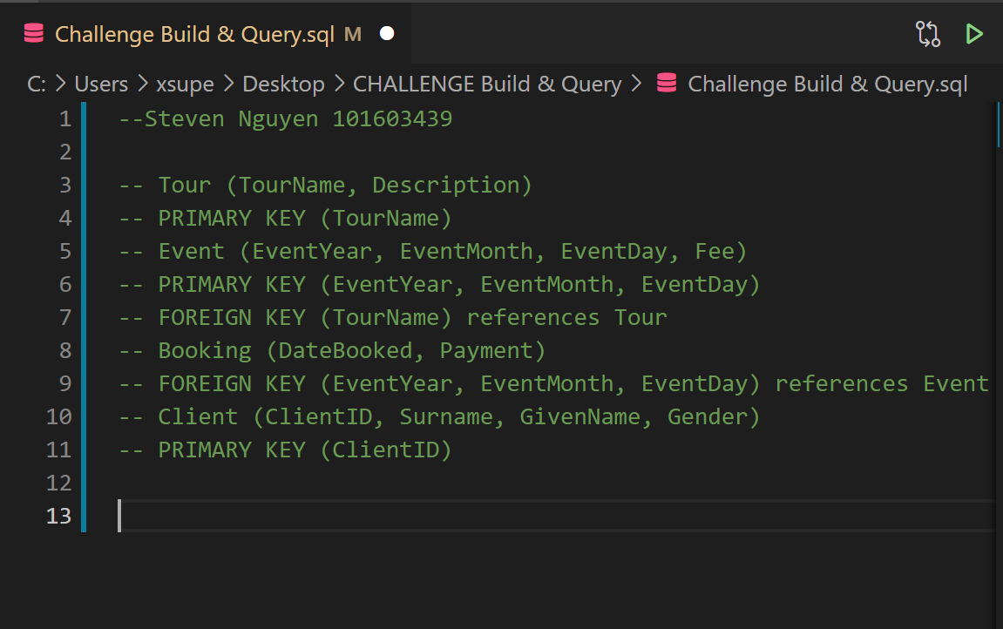

# Task 2 Screenshot

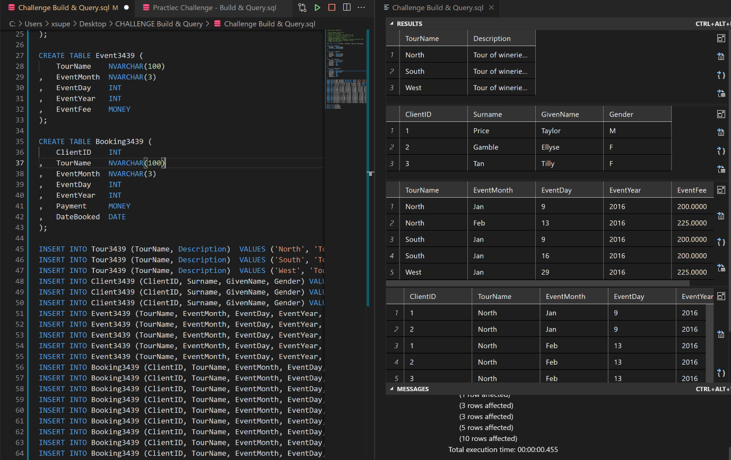

# Task 3 Screenshot

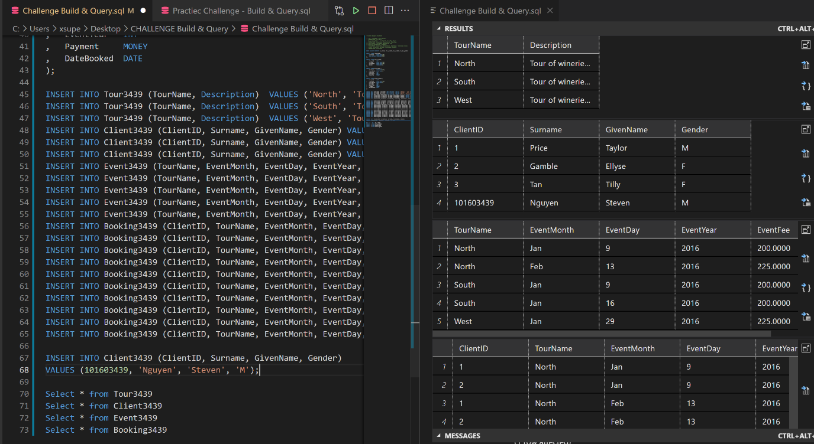

# Task 4Q1 Screenshot

