Student ID: 101603439

Name: Steven Nguyen

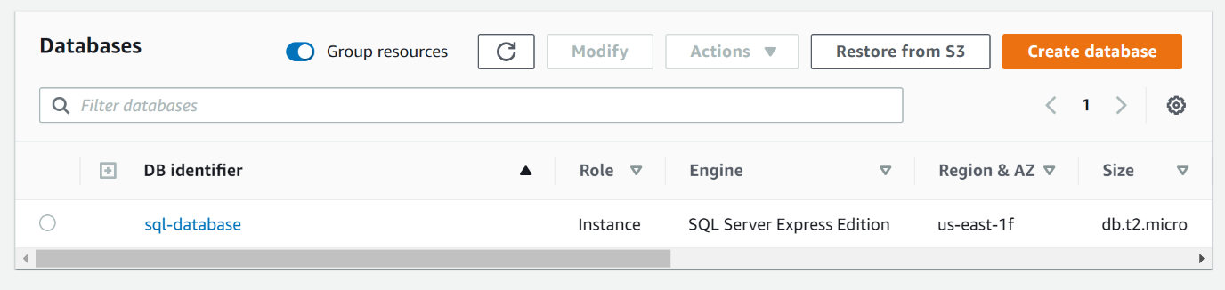

# Task 1 Screenshot

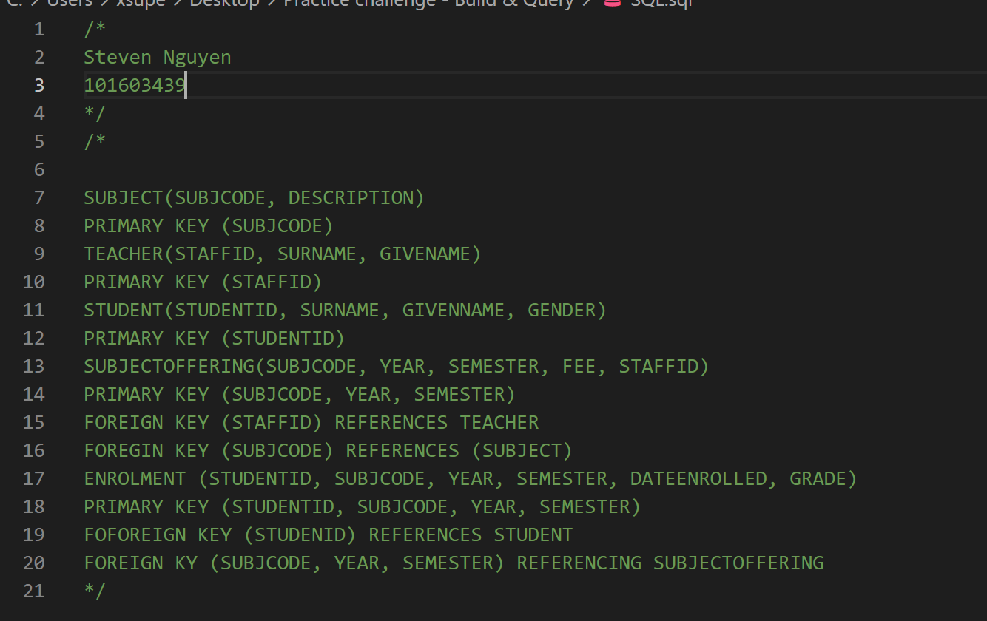

# Task 2 Screenshot

# Task 3 Screenshot

# Task 4Q1 Screenshot