Student ID: 101669460

Name: Dylan Dinsdale

# Setup Screenshot

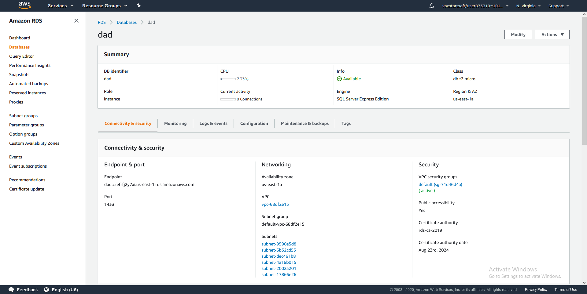

# Task 2 Screenshot









# Task 3 Screenshot

