年度表字段统一

alter table dwd_annual_average_price change index byear string;

年度统计信息表 ，包含年度总销售额，总销售面积，平均价格

create table dws_annual_static

as

select

total_sales_area.byear as byear,

total_sales_area.annual_total_sales_area as annual_total_sales_area,

total_sales_revenue.annual_total_sales_revenue as total_sales_revenue,

average_price.annual_average_price as average_price

from dwd.dwd_annual_total_sales_area total_sales_area

join dwd.dwd_annual_total_sales_revenue total_sales_revenue

on total_sales_area.byear = total_sales_revenue.byear

join dwd.dwd_annual_average_price average_price

on total_sales_area.byear = average_price.byear;

列名过于冗余，稍作修改

alter table dws_annual_static change annual_total_sales_area sales_area double;

alter table dws_annual_static change total_sales_revenue sales_revenue double;

最后结果

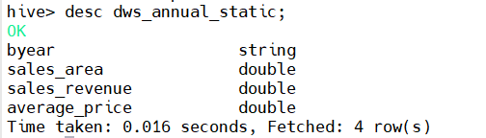

负债表，和dwd层没有变化，直接从dwd层复制表结构

create table dws_assets_liabilities as select * from dwd.dwd_assets_liabilities;

房地产业务收入表，也没有变化，本就是汇总过的

create table dws.dws_business_operations as select * from dwd.dwd_business_operations;