Submitted by : Vijayshree Sewsagar

Submitted to : ALENTARIS

Date : 11/05/13

# Answers:

## Spring

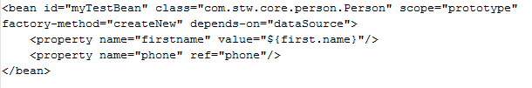

A bean creation by using a static factory method, along with the class attributes which specifies the class containing the factory method and another attribute named factory-method is needed to specify the name of the factory method itself.

The id attribute allows you to specify one id for the bean and the ID must be unique. Prototype mode of a bean results in creating a new instance every time a request for that specific bean is done.

For most situations, the fact that a bean is a dependency of another is expressed simply by the fact that one bean is set as a property of another. Depends-on element may be used to explicitly force one or more beans to be initialized.

The myTestBean.firstname has a value equal to firstname property of the ‘myTestBean’ bean. Using ref element allows setting the value of the specified property to be a reference to another bean managed by the container.

## Fib

Advantages of using non-recursive functions:

* It is very easy to write a non recursive function because the statements are written within the loop
* It is easy to debug due to the simple programming constructs

## 3.0 Code Sample

A code sample link is provided where the code is considered to be production ready, elegant and high quality by using the concept of KISS (Keep It Simple Stupid).

https://github.com/appium/appium/tree/master/sample-code/examples/java