Notes
A Typical AI chatbot needs:
- Architecture: Neural network
- Training
- Fine tuning
- Deployment
Our product:
- Architecture
- Training
- Fine tuning
- Connect database (RAG)
- Deployment

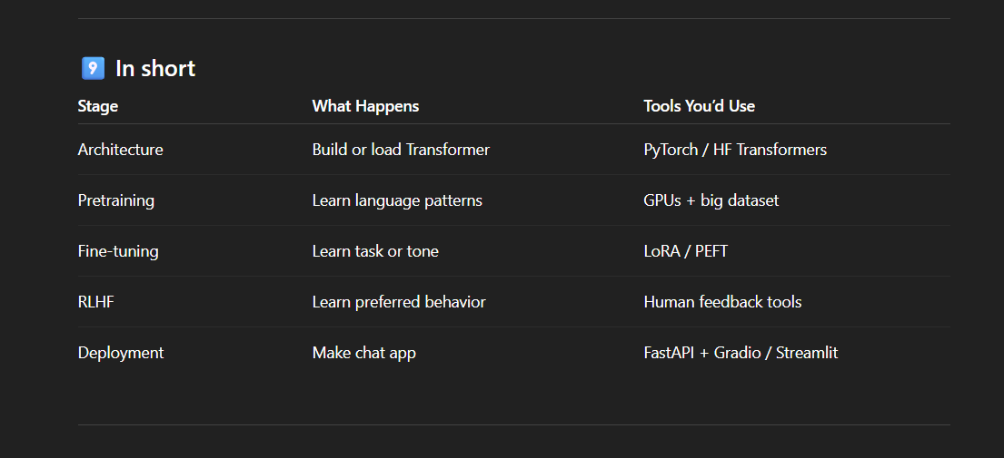
RAG: (Retrieval-Augmented Generation.)
It’s a method where an AI model (like ChatGPT) is connected to a database or document store, so it can “look up” real information before answering instead of just guessing from memory.

Why it matters
Normal language models sometimes hallucinate — they make up facts.
RAG fixes that by giving the model fresh, factual context right before it answers.

In our model: Farmer’s question → retrieve relevant agriculture data → feed both into LLM → return practical answer
(This highlighted part is how our AI basically work nothing complicated.)

TechStack for our AI:
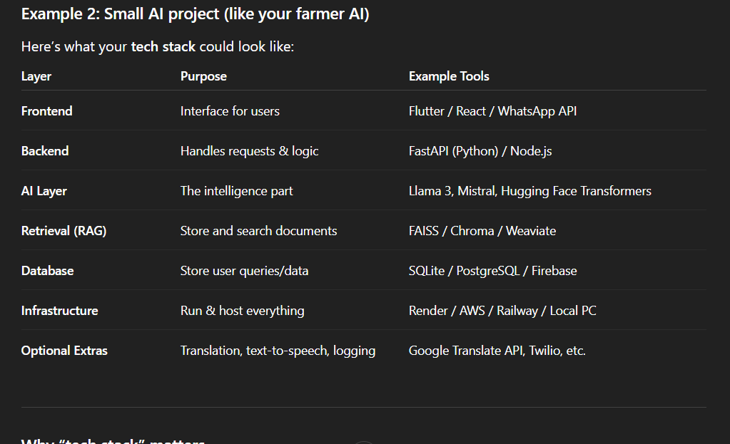

This is a small project which I tried to test my understanding of a working AI CHATBOT.

