DBMS Exp-5
1. Find the names of all employees who work for First Bank Corporation.
Ans- π p_name (σ c_name=="FBC"(works))
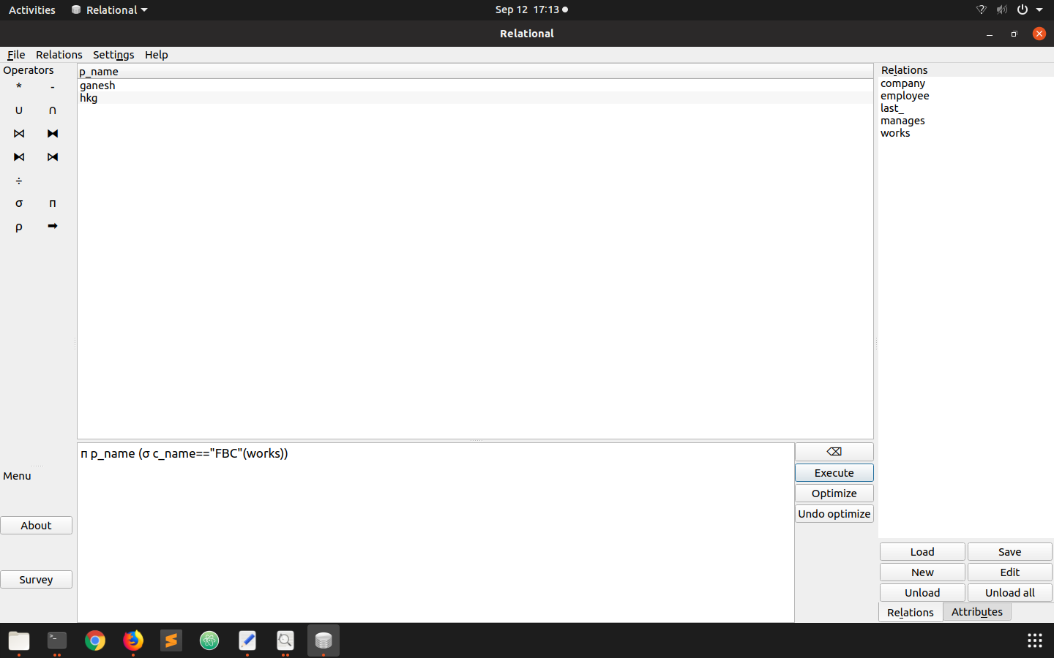
2. Find the names and cities of residence of all employees who work for First Bank Corporation.

