Problem Statement: Implement/Simulate Ricart-Agarwala's distributed mutual exclusion algorithm using C/C++. You can consider a single machine/node and no. of processes on that machine.

Ricart-Agrawala’s Algorithm
It is an algorithm to for mutual exclusion in a distributed system. This algorithm is an extension and optimization of Lamport’s Distributed Mutual Exclusion Algorithm. It follows permission based approach to ensure mutual exclusion.
- The algorithm uses two types of messages: Request and Reply. And communication channels are assumed to follow FIFO order.
- A node sends a Request message to all other nodes to request their permission to enter the critical section. A node sends a Reply message to a node to give its permission to that node.
- A timestamp is given to each critical section request using Lamport’s logical clock.
- Timestamp is used to determine priority of critical section requests. Smaller timestamp gets high priority over larger timestamp. The execution of critical section request is always in the order of their timestamp.
- Each node maintains a Deferred queue, which is initially empty.

Code Implementation:
- Used TCP Socket.
- To implement this algorithm on same machine, used 3 different port as 3 different nodes on same address or machine.
- Passed 3 parameter command line as Server_port, remote_port, Delay time.
- To bind a address to 3 ports at once, used Socket option of setsockopt(sd,SOL_SOCKET,SO_REUSEADDR|SO_REUSEPORT,&opt,sizeof(opt)
- After establishment of connection, node will send request messsege to all other nodes to access Critical Section (CS).
- Initialized Empty Defered Queue.
- A request message contains Timestamp, socket desciptor or id of that node, and type of message.
- Used 4 threads to make connection, send request, receive reply and access CS.
- When a node n1 receives a Request message from a node n2, it sends a Reply message to that node iif it is neither requesting nor executing the CS, or if it is also requesting but node n2 request’s timestamp is smaller than its own request’s timestamp. Otherwise, the request of n2 is inserted in the Deferred queue.
- When the node receives reply from all other nodes from which it requested, It will enter in CS.
- When it will enter the CS, it will the restrict the access of other nodes in CS by setting the bool variable access_granted=true.
- In CS, It will write its port number and timestamp in the shareable file “CS_File.txt”.
- After delay of 1 second, It will exit the CS and set the access_granted=false.
- When a node exits the CS, it will sends Reply messages to all the nodes in the Deferred queue and deletes the entries in the Deferred queue.
- To use logical clock in program, used system clock.

Code:
#include<iostream>
#include<inttypes.h>
#include<cstring>
#include<string.h>
#include<thread>
#include<mutex>
#include<vector>
#include<sys/time.h>
#include<unistd.h>
#include<stdio.h>
#include<arpa/inet.h>
#include<sys/types.h>
#include<sys/socket.h>
#include<stdlib.h>

#define int_type1 int8_t
#define int_type2 uint8_t
#define int_type3 uint16_t
#define int_type4 uint32_t
#define int_type5 uint64_t
#define data_size 26
#define REQUEST 1
#define REPLY 2
#define OFFSET_SEC 0
#define OFFSET_USEC 8
#define OFFSET_FD 16
#define OFFSET_MSG_TYPE 24
#define OFFSET_EOM 25
#define Server_nos 2
#define Rec_node_ 1
#define Send_node_ 0

using namespace std;

struct node{
int_type5 timestamp_seconds;
int_type5 timestamp_useconds;
int_type1 *arr;
struct node *next;
};
class post_queue{
struct node *head;
public:
post_queue();
bool isEmpty();
void insert(int_type1*);
int_type1* pop();
};

post_queue *queue_ = new post_queue();
int_type4 *Sno_arr = new int_type4[Server_nos];
bool *reply_received = new bool[Server_nos];
int_type5 server_sd;
int_type5 req_seconds;
int_type5 req_useconds;
bool access_granted;
bool interested_cs;
int_type5 millis(){
struct timeval temp;
gettimeofday(&temp,0);
return temp.tv_usec;
}
int_type5 seconds(){
struct timeval temp;
gettimeofday(&temp,0);
return temp.tv_sec;
}
void delay(int_type5 s, int_type5 us){
struct timeval t;
t.tv_sec=s,t.tv_usec=us;
select(0,0,0,0,&t);
}
int_type1* Req_msg(int_type5 sd){
int_type1 *arr=new int_type1[data_size];
int_type5 sec=seconds(),usec=millis();
int_type1 type=REQUEST;
memcpy(arr+OFFSET_SEC,(void*)&sec,8),memcpy(arr+OFFSET_USEC,(void*)&usec,8),memcpy(arr+OFFSET_FD,(void*)&sd,8),memcpy(arr+OFFSET_MSG_TYPE,(void*)&type,1);
return arr;
}
int_type1* Rep_msg(int_type5 sd){
int_type1 *arr=new int_type1[data_size];
int_type5 sec=seconds(),usec=millis();
int_type1 type=REPLY;
memcpy(arr+OFFSET_SEC,(void*)&sec,8),memcpy(arr+OFFSET_USEC,(void*)&usec,8),memcpy(arr+OFFSET_FD,(void*)&sd,8),memcpy(arr+OFFSET_MSG_TYPE,(void*)&type,1);
return arr;
}
int_type5 get_fd_msg(int_type1 *arr){
int_type5 sd;
memcpy((void*)&sd,arr+OFFSET_FD,8);
return sd;
}
int_type5 get_timestamp_seconds(int_type1 *arr){
int_type5 time;
memcpy((void*)&time,arr+OFFSET_SEC,8);
return time;
}
int_type5 get_timestamp_useconds(int_type1 *arr){
int_type5 time;
memcpy((void*)&time,arr+OFFSET_USEC,8);
return time;
}
int_type1 get_msg_type(int_type1* arr){
int_type1 mtype;
memcpy((void*)&mtype,arr+OFFSET_MSG_TYPE,1);
return mtype;
}
post_queue::post_queue(){
head = nullptr;
}
bool post_queue::isEmpty(){
return head==nullptr;
}
void post_queue::insert(int_type1 *arr){
struct node *new_node = new node;
new_node->timestamp_seconds = get_timestamp_seconds(arr);
new_node->timestamp_useconds = get_timestamp_useconds(arr);
new_node->arr = new int_type1[data_size];
memcpy(new_node->arr,arr,data_size);
new_node->next = nullptr;
if(head==nullptr){
head = new_node;
return;
}
struct node *temp = head;
while(temp->next!=nullptr&&(temp->next->timestamp_seconds<new_node->timestamp_seconds||(temp->next->timestamp_seconds==new_node->timestamp_seconds&&temp->next->timestamp_useconds<new_node->timestamp_useconds))) temp = temp->next;
new_node->next = temp->next;
temp->next = new_node;
return;
}
int_type1* post_queue::pop(){
if(isEmpty()) return nullptr;
int_type1 *temp=new int_type1[data_size];
memcpy(temp,head->arr,data_size);
struct node *rm=head;
head=head->next;
delete(rm);
return temp;
}
void Reply_Recvr(int_type4 sd, int_type4 *in_conn){
struct sockaddr_in remote_addr;
if((*in_conn=accept(sd,(struct sockaddr *)&remote_addr,(socklen_t*)&remote_addr))<0) exit(EXIT_FAILURE);
return;
}
void Req_Sender(int_type3 port, int_type4 *remote_sd){
struct sockaddr_in remote_addr;
*remote_sd=0;
memset(&remote_addr, 0, sizeof(remote_addr));
remote_addr.sin_family=AF_INET;
remote_addr.sin_addr.s_addr = inet_addr("127.0.0.1");
remote_addr.sin_port = htons(port);
if((*remote_sd=socket(AF_INET, SOCK_STREAM, 0))<0) return;
while(connect(*remote_sd, (struct sockaddr *)&remote_addr, sizeof(remote_addr))<0) perror("Error in establishing connection Retrying...");
return;
}
void CS_Req(int_type5 sec,int_type3 server_port){
int_type1 *req_msg;
int_type1 *reply_msg;
int_type5 reply_fd;
int_type3 retry;
while(true){
interested_cs = false;
delay(sec,0);
interested_cs = true;
cout<<"Started Requesting Critical Section.\n";
req_msg=Req_msg(server_sd);
req_seconds=get_timestamp_seconds(req_msg);
req_useconds=get_timestamp_useconds(req_msg);
for(int i=0;i<Server_nos;i++){
reply_received[i]=false;
send(Sno_arr[i],req_msg,data_size,0);
}
for(int i=0;i<Server_nos;i++){
retry=1;
while(!reply_received[i]){
if(retry>6){
send(Sno_arr[i],req_msg,data_size,0);
retry = 1;
}
delay(0,500);
retry++;
}
}
cout<<"Critical Section has been Acquired.\n";
access_granted=true;
FILE *file;
file=fopen("CS_File.txt","a");
fprintf(file,"Inside CS, Port: %ld at %2ld\n",server_port,seconds());
delay(1,0);
fprintf(file,"Exiting CS, Port: %ld at %2ld\n\n",server_port,seconds());
fclose(file);
access_granted = false;
cout<<"Released CS and Replying to Nodes Request of the Deferred Queue.\n";
reply_msg = Rep_msg(server_sd);
while(!queue_->isEmpty()){
reply_fd = get_fd_msg(queue_->pop());
send(reply_fd,reply_msg,data_size,0);
}
}
}
void Msg_Rec(int_type3 re){
int_type1 *reply_msg,*received_msg = new int_type1[data_size];
int_type3 msg_type;
int_type5 recv_seconds,recv_useconds;
while(true){
cout<<"msg receiving has started.\n";
read(Sno_arr[re],received_msg,data_size);
msg_type=get_msg_type(received_msg);
if(msg_type==(int_type3)REPLY){
cout<<"A -Reply- msg has been received from "<<re<<"\n";
reply_received[re] = true;
}else if(msg_type==(int_type3)REQUEST){
cout<<"A -Request- msg has been received from "<<re<<"\n";
reply_msg=Rep_msg(server_sd);
if(!interested_cs&&!access_granted){
cout<<"Not Interested in Critical Section at the moment.\n";
delay(0,100);
send(Sno_arr[re],reply_msg,data_size,0); //cond1: reply if neither requesting nor executing the CS
cout<<"Reply msg has been sent to: "<<re<<"\n";
}else if(interested_cs && !access_granted){
recv_seconds = get_timestamp_seconds(received_msg);
recv_useconds = get_timestamp_useconds(received_msg);
if(recv_seconds<req_seconds||(recv_seconds == req_seconds && recv_useconds < req_useconds)){
cout<<"Interested in Critical Section but have greater Time stamp than "<<re<<"\n";
send(Sno_arr[re],reply_msg,data_size,0); //cond2: reply if requesting but have higher timestamp
cout<<"Reply msg has been sent to: "<<re<<"\n";
}else{
queue_->insert(received_msg); //cond3: inserting the request in the Deferred queue
cout<<"Interested in Critical Section and have lesser Time stamp than "<<re<<", So pushed request in Queue.\n";
}
}
}
}
}
void Req_Listener(){
vector<thread> threads;
for(int i=0;i<Server_nos;i++) threads.push_back(thread(Msg_Rec,i));
for(vector<thread>::iterator itr = threads.begin(); itr != threads.end() ; itr++) itr->join();
}
int main(int argc, char *args[]){
if(argc<4) exit(EXIT_FAILURE);
int_type3 server_port = stoi(args[1]); //string to integer
int_type3 remote_port = stoi(args[2]);
int_type5 sec = stoull(args[3]); //Hexadecimal string to unsigned long long
int32_t sd;
struct sockaddr_in addr;
sd=socket(AF_INET,SOCK_STREAM,0);
if(sd==0) exit(EXIT_FAILURE);
int opt=1;
if(setsockopt(sd,SOL_SOCKET,SO_REUSEADDR|SO_REUSEPORT,&opt,sizeof(opt))) exit(EXIT_FAILURE);
memset(&addr,0,sizeof(addr));
addr.sin_family=AF_INET;
addr.sin_addr.s_addr = inet_addr("127.0.0.1"); //connecting on same machine
addr.sin_port = htons(server_port); //converts the unsigned short integer hostshort from host byte order to network byte order.
if(bind(sd,(struct sockaddr *)&addr,sizeof(addr))<0) exit(EXIT_FAILURE);
cout<<"binded to server"<<endl;
if(listen(sd, 3)<0) exit(EXIT_FAILURE);
cout<<"listening to server"<<endl;
server_sd=sd;
cout<<"Server has started on port no: "<<server_port<<"\n";
thread t1(Req_Sender,remote_port,&Sno_arr[Send_node_]),t2(Reply_Recvr,server_sd,&Sno_arr[Rec_node_]); //for connection establishment
t1.join(),t2.join();
//system("clear");
cout<<"Node has established the Connection.\n";
thread t3(CS_Req,sec,server_port),t4(Req_Listener);
cout<<"**************************************\n";
t3.join(),t4.join();
}

Output:
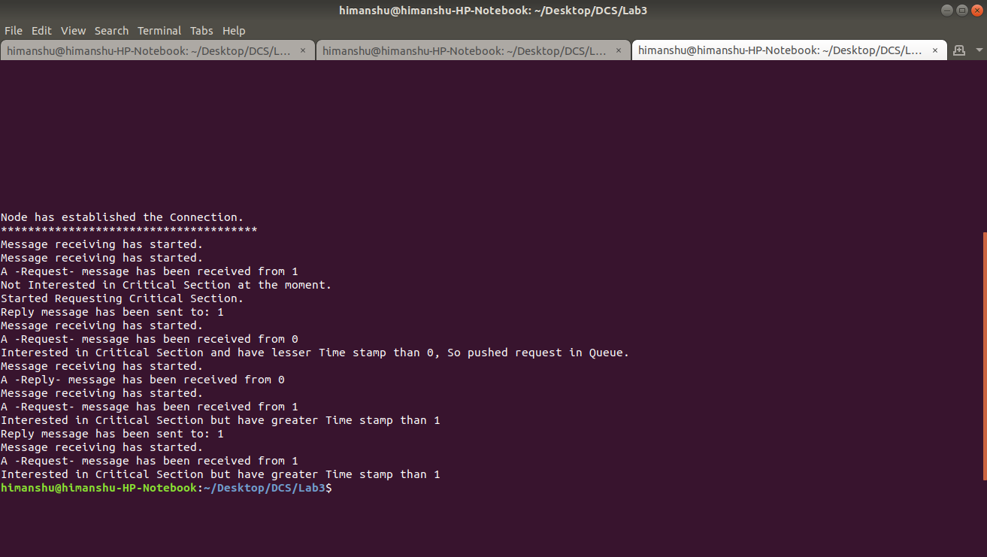
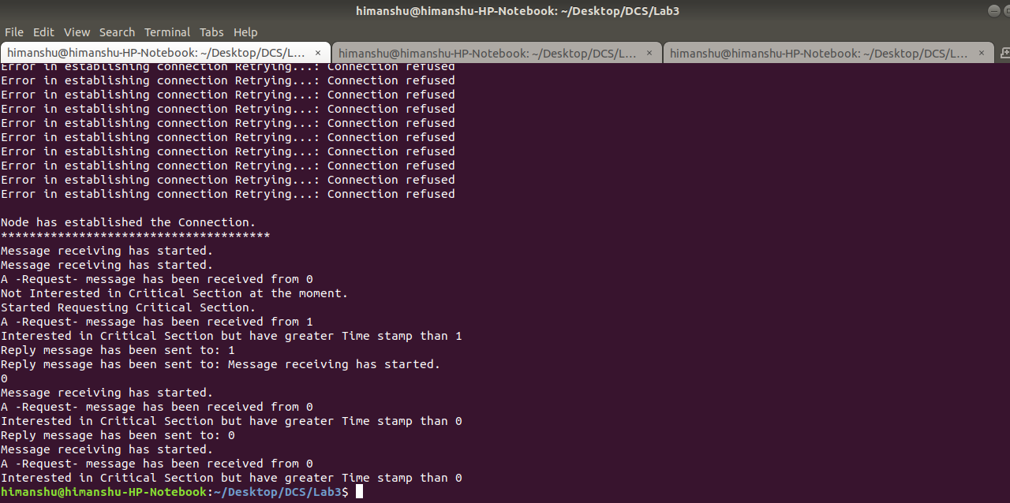

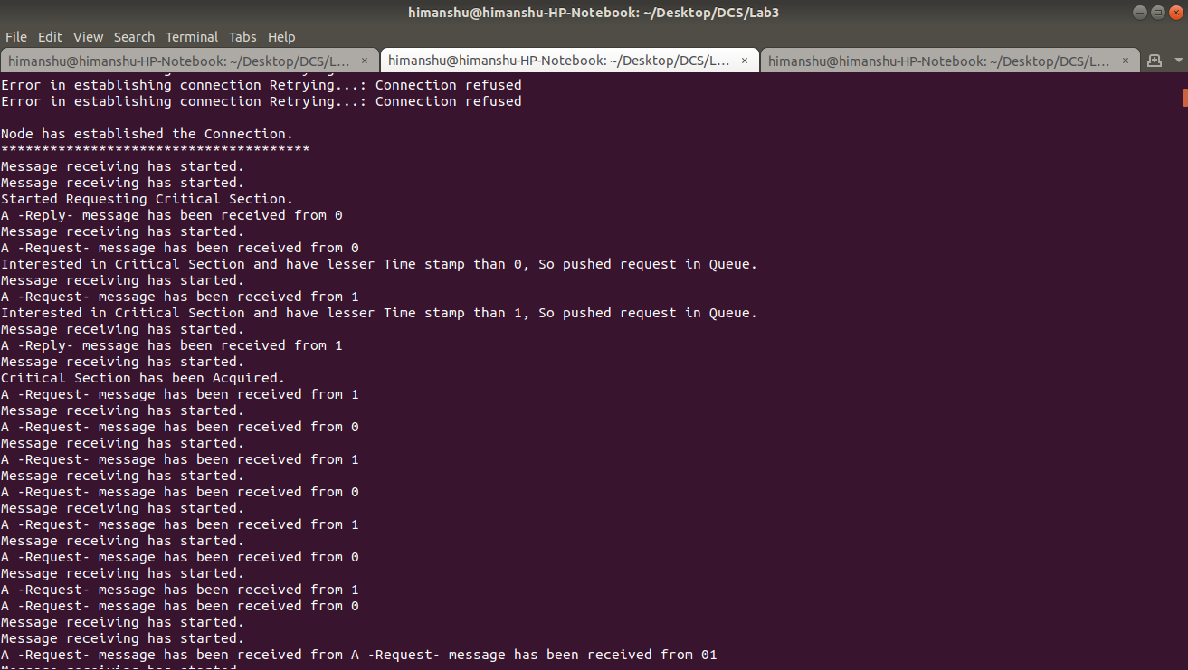
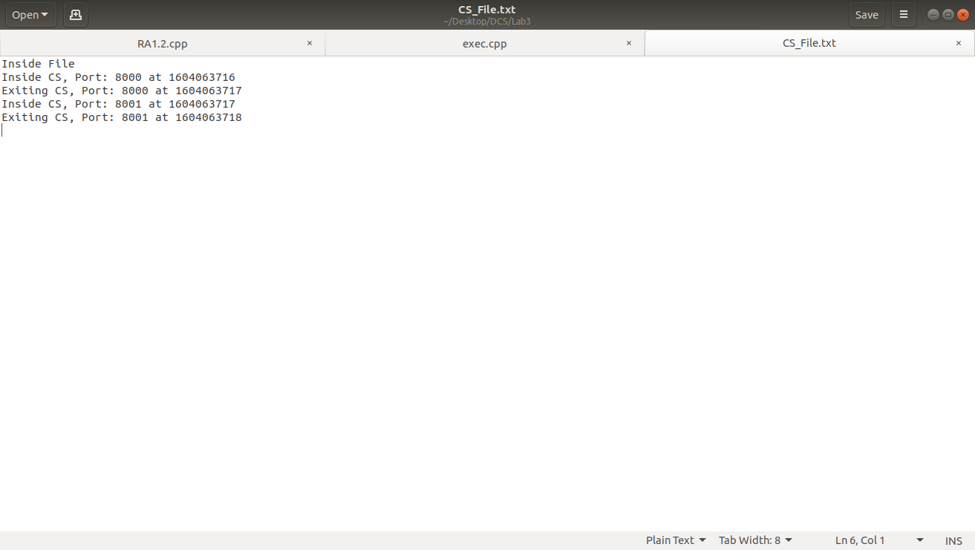

By,
Piyush Ojha(bt17cse084)
Himanshu Gupta(bt17cse093)
samyak Borkar(bt17cse103)

