Algorithms/ Methods:
- Matrix Factorization: It is a collaborative filtering solution for recommendations. Since factorization is the method of expressing something big as a product of smaller factors.
Similarly, Matrix Factorization finds two rectangular matrices with smaller dimensions to represent a big rating matrix (RM). These factors retain the dependencies and properties of the rating matrix. One matrix can be seen as the user matrix (UM) where rows represent users and columns are k latent factors or preferences. The other matrix is the item matrix (IM)where rows are k latent factors and columns represent items.
In real-life scenarios, every user wouldn’t have listen all possible songs. So the rating matrix will look more empty - Sparse Matrix.

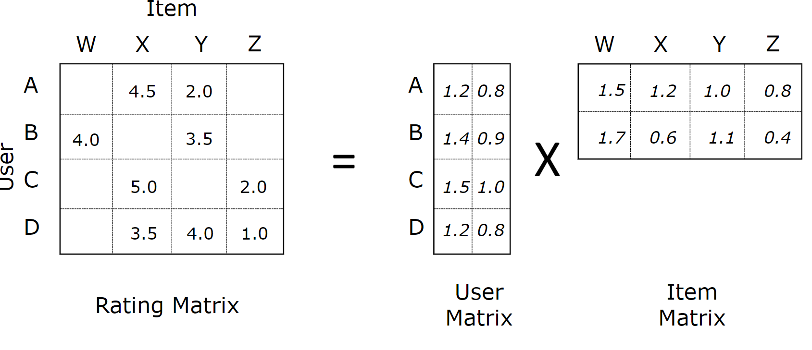
The latent factors are otherwise called as features. Features are characteristics of an item. In our case, features of the song can be its genre, artist,album, year etc. The features chosen by the Matrix Factorization is irrelevant to the solution. Now the rating matrix is represented as a dot product of user and item matrix.

- After getting rating matrix, We will apply following Machine Learning method:
  - Neighbourhood Method:
  - User oriented: After Matrix factorization is done,We may have some users having similarities. So, if a User U1 likes 3 songs I1,I2,and I3. To make prediction for him, the system finds similar users who also liked those songs and determines which other songs they liked. Let there is other user U2 who likes songs I1,I2,I3,I4 and I5. So, based on simliarities with User U2, songs I4 and I5 can be recommanded to U1.
  - Item Oriented: After Matrix factorization is done,We may have some songs having similarities. So, if a song I1 is liked by a user U1. To make more prediction for him, the system finds similar songs/items having similarities in genre, album, artist or year.
  - Root Mean Square Error (RMSE): After Matrix factorization is done, squared error is calculated for every song rating in the rating matrix and the root value of the mean of squared error values are minimized. To minimize RMSE to learn the factors, Gradient Descent and Alternating Least Squares can be used.

