Q.1. Collect the following basic information about your machine using proc. How many CPU cores does the machine have? How much memory, and what fraction of it is free? How many context switches has the system performed since bootup? How many processes has it forked since bootup?

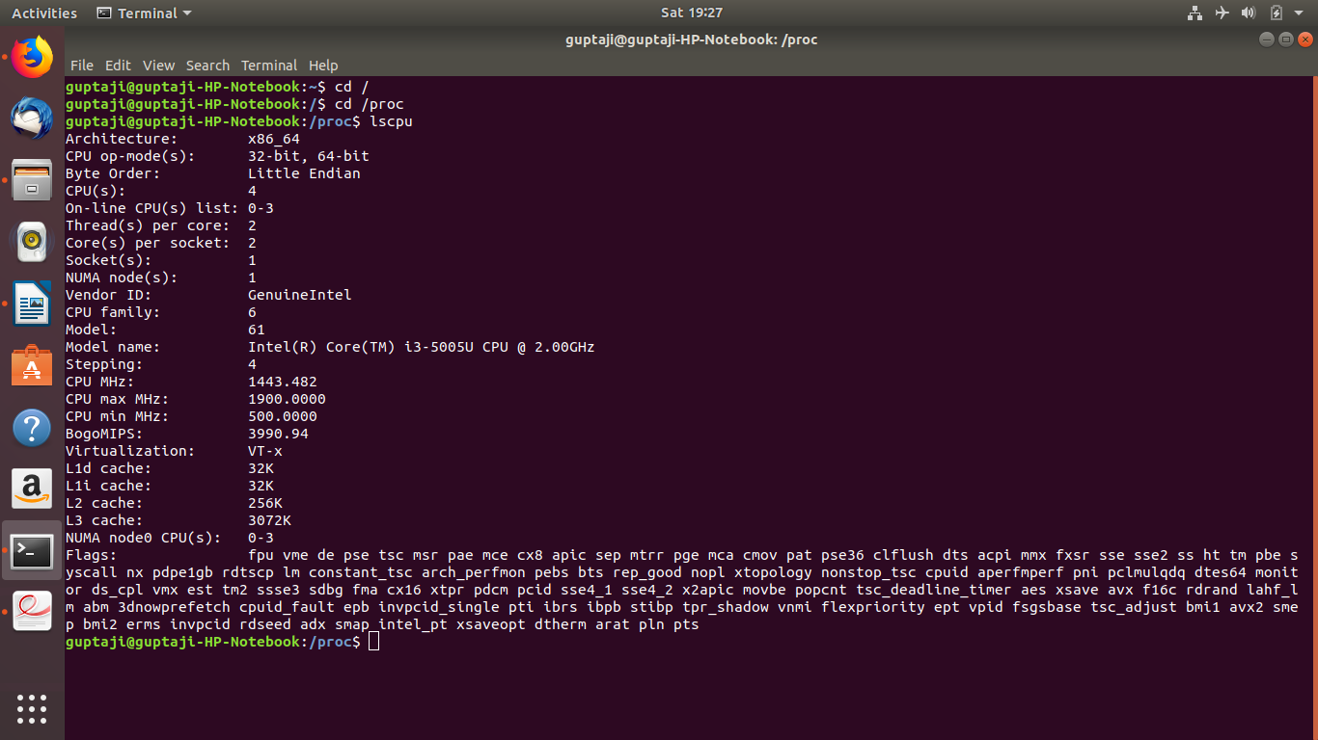
SOL.
A. CPU cores
command- lscpu

cpu cores= no. Of Thread* no. Of cores per socket* no. Of sockets
= 2*2*1
= 4
B. Memory size
command-cat proc/meminfo

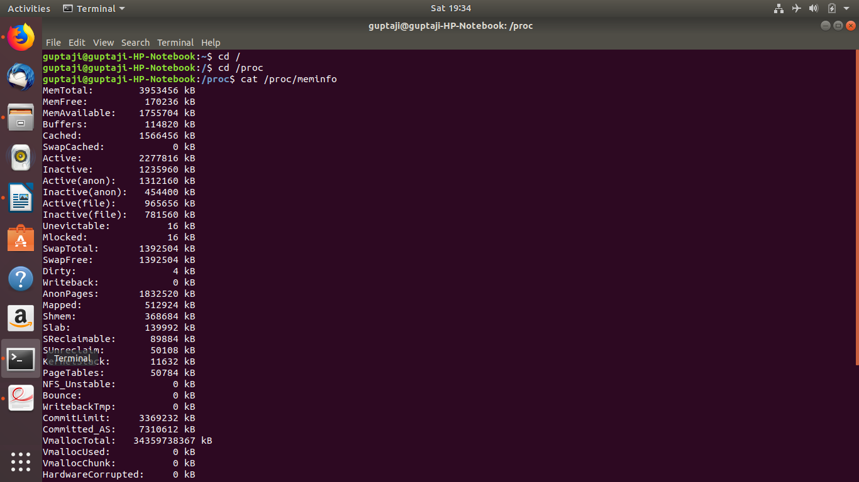
memory free=170236kb
C. Context switches a system has performed-
Command- pidstat -w

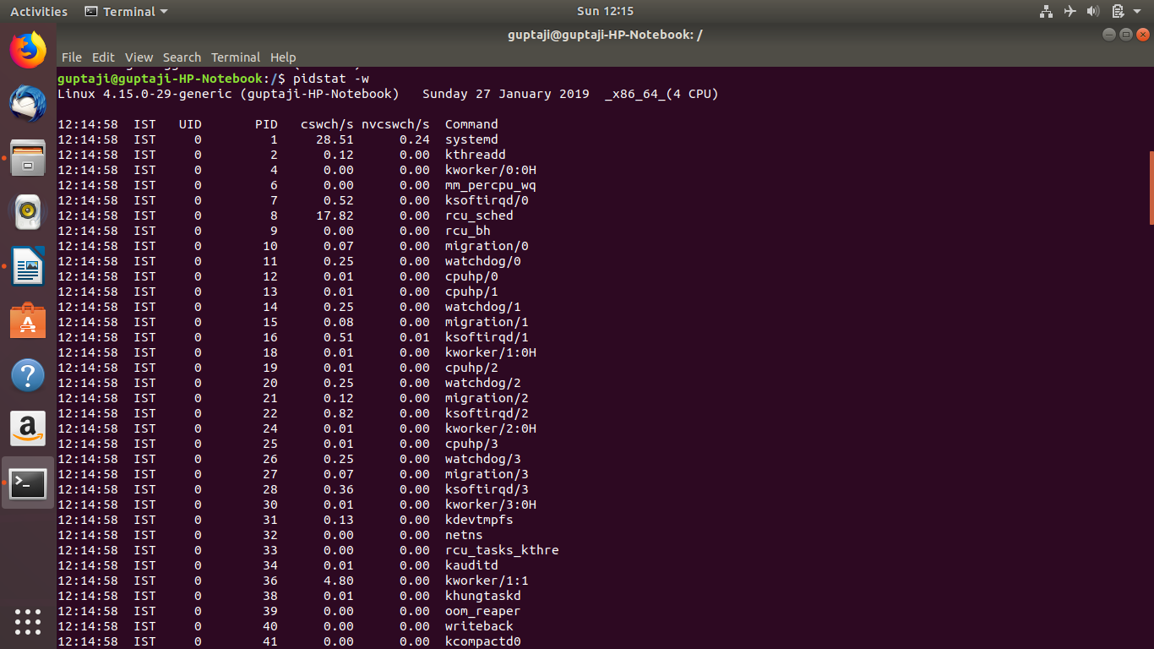

D. forks after bootup:
command- vmstat -f

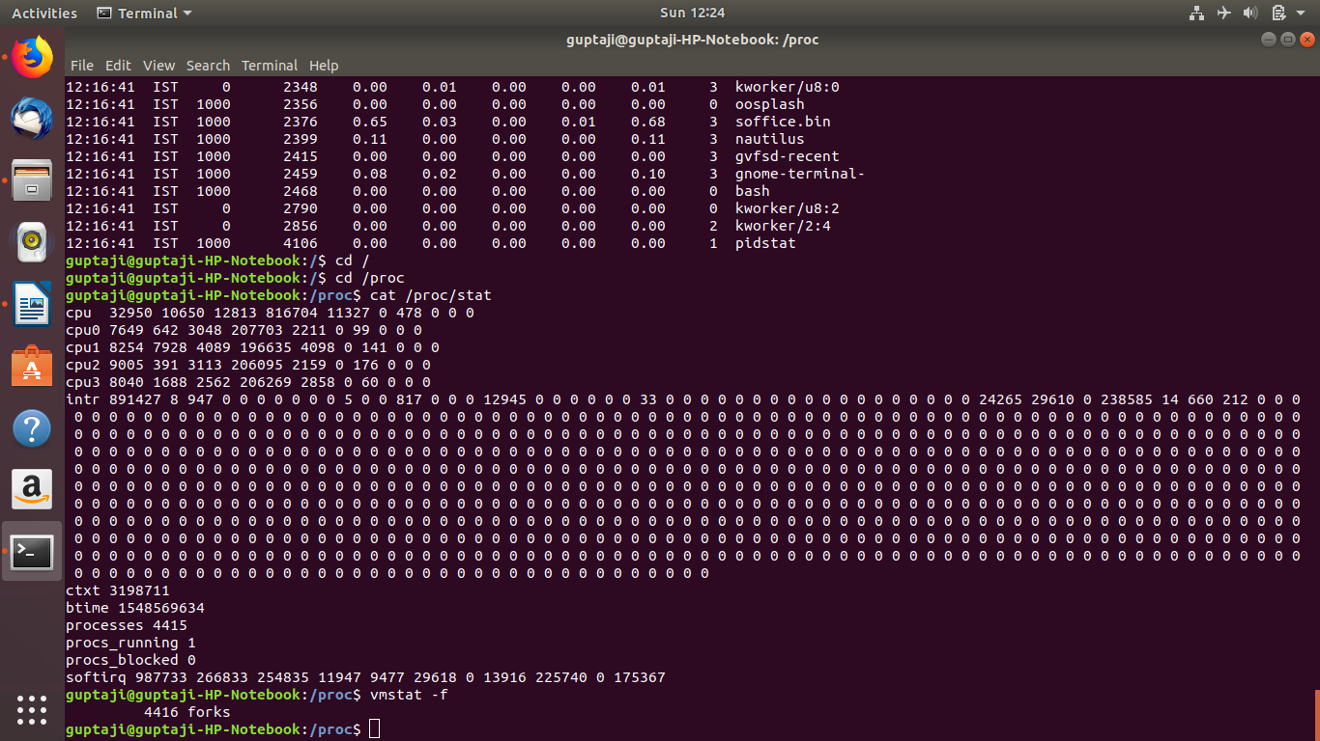

Q.2. Recall that every process runs in one of two modes at any time: user mode and kernel mode. It
runs in user mode when it is executing instructions / code from the user. It executes in kernel
mode when running code corresponding to system calls etc. Compare (qualitatively) the
programs cpu and cpu-print in terms of the amount of time each spends in the user mode and
kernel mode, using information from the proc file system. For examples, which programs spend
more time in kernel mode than in user mode, and vice versa? Read through their code and
justify your observations.
Sol. For cpu-print.c
First execute the file cpu-print.c.
then open new terminal and run command “top”.it will show the pid of execution process of cpu-print.c .
copy this pid and run following command- cat /proc/pid/stat.
It shows folloing outputs:

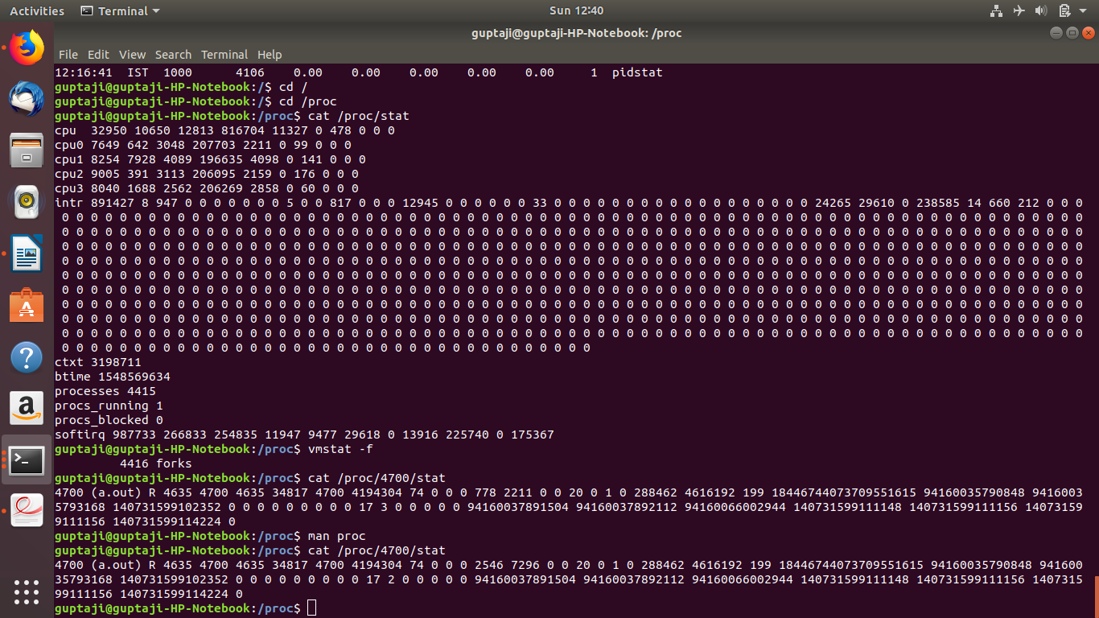
Now open man proc command, go to proc/pid/stat
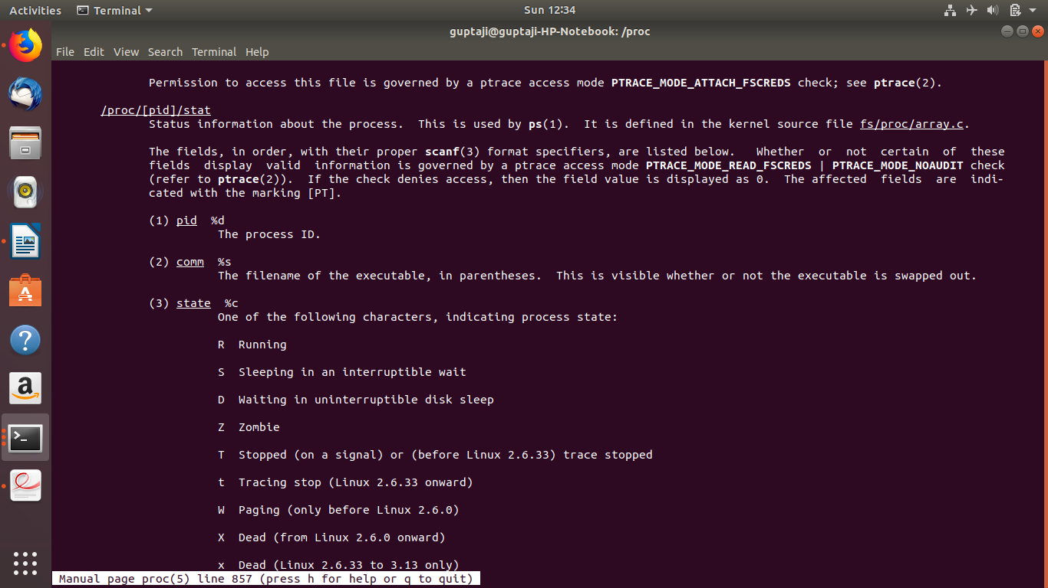
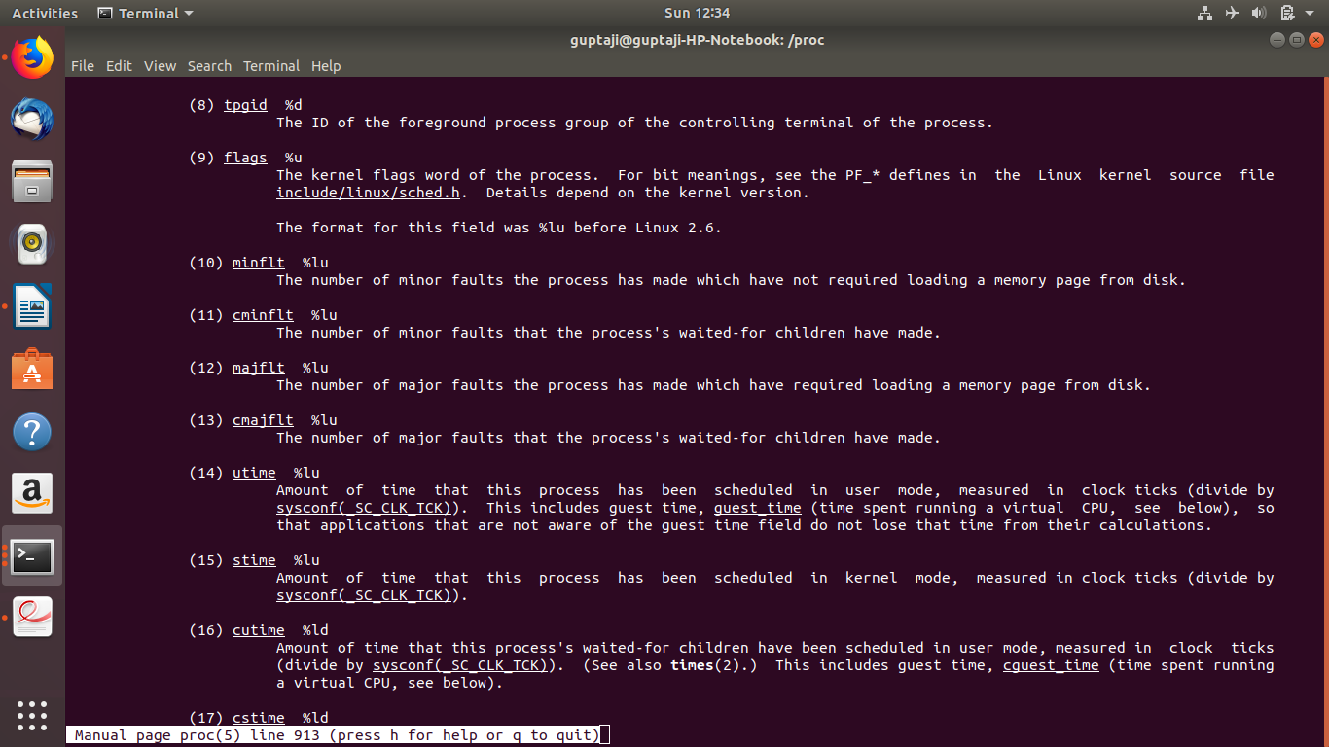
user time=2546 clock ticks
Kernel time=7296 clock ticks

For cpu.c
User time= 2331 clock ticks
Kernel time=0 clock ticks

Q.3. Open a bash shell. Find its pid. Write down the process tree starting from the first init process
(pid = 1) to your bash shell, and describe how you obtained it. You may want to use the pstree
command.
Sol.
First command ‘ps’ on termunal and get pid of bash shell.
Then command-”pstree -s -p pid”

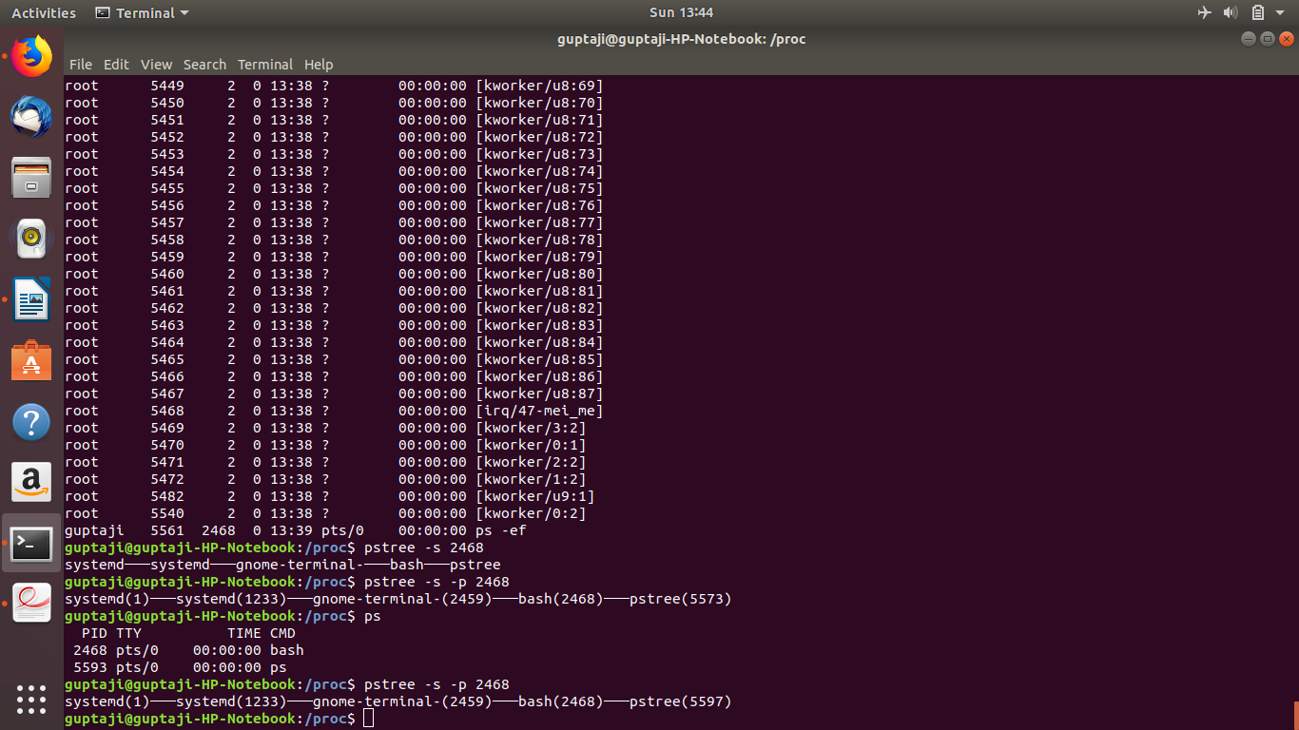
pstree= show the tree of running processes.
-s=show parent processes of the specified process.
-p=show pid in parantheses.

Q.4. Consider the following commands that you can type in the bash shell: cd, ls, history, ps.
Which of these are system programs that are simply executed by the bash shell, and which are implemented by the bash code itself?
Sol.
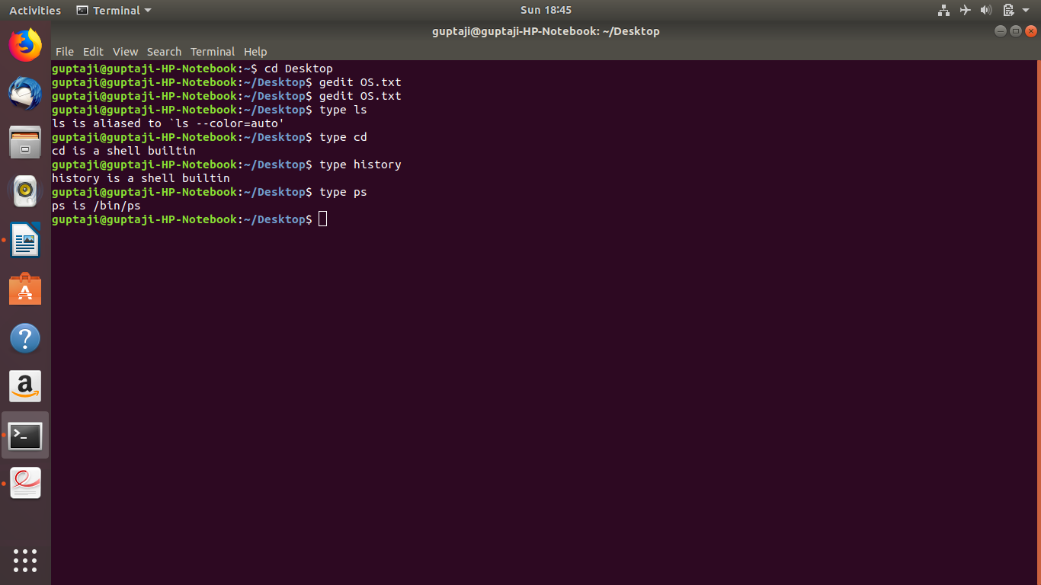
system programs that are simply executed by the bash shell:cd, history.
Commands implemented by the bash code itself are: ls,ps.

Q.5. Run the following command in bash.
$./cpu-print > /tmp/tmp.txt &
Find out the pid of the new process spawned to run this command. Go to the proc folder of this process, and describe where its I/O file descriptors 0, 1, 2 are pointing to. Can you describe how
I/O redirection is being implemented by bash?
Sol.

First run the following command-”gcc o cpu-print cpu-print.c”
then run command-”./cpu-print>/tmp/tmp.txt”
after that run command-”top” to get pid of process cpu-print
The I/O file descriptor are in fd folder of particaular process directory on listing the contents of fd follong output was obtained.

guptaji@guptaji-HP-Notebook:~/Desktop$ cd /proc
guptaji@guptaji-HP-Notebook:/proc$ cd 3399
guptaji@guptaji-HP-Notebook:/proc/3399$ cd fd
guptaji@guptaji-HP-Notebook:/proc/3399/fd$ ls
0 1 2
guptaji@guptaji-HP-Notebook:/proc/3399/fd$ ls -a
. .. 0 1 2
guptaji@guptaji-HP-Notebook:/proc/3399/fd$ ls -al
total 0
dr-x------ 2 guptaji guptaji 0 Jan 27 19:04 .
dr-xr-xr-x 9 guptaji guptaji 0 Jan 27 19:04 ..
lrwx------ 1 guptaji guptaji 64 Jan 27 19:04 0 -> /dev/pts/1
l-wx------ 1 guptaji guptaji 64 Jan 27 19:04 1 -> /tmp/tmp.txt
lrwx------ 1 guptaji guptaji 64 Jan 27 19:04 2 -> /dev/pts/1
A file descriptor is a number that uniquely identifies an open file. There are always 3 default files open- stdin(the keyboard),stdout(the screen),stderr(error messages output to screen). These files can be redirected simply mean by capturing output from a file, command,program,or script.
Each open file assigned a file descripter.
The file descriptor of stdin is 0, stdout is 1, and stderr is 2.
for additional files there remains descriptor 3-9.

Q.6. Run the following command with cpu-print.
$./cpu-print | grep hello
Once again, identify which processes are spawned by bash, look at the file descriptor information in their proc folders, and use it to explain how pipes work in bash.
Sol.
On running the command-./cpu-print| grep hello
two processes start with a pipeline between them.

guptaji@guptaji-HP-Notebook:~$ top

top - 19:38:50 up 1:27, 1 user, load average: 1.10, 0.53, 1.00
Tasks: 244 total, 2 running, 194 sleeping, 0 stopped, 0 zombie
%Cpu(s): 24.5 us, 3.5 sy, 0.0 ni, 71.8 id, 0.1 wa, 0.0 hi, 0.1 si, 0.0 st
KiB Mem : 3953456 total, 1754320 free, 1097620 used, 1101516 buff/cache
KiB Swap: 1392504 total, 1392504 free, 0 used. 2282860 avail Mem

PID USER PR NI VIRT RES SHR S %CPU %MEM TIME+ COMMAND
4018 guptaji 20 0 4508 812 748 R 100.0 0.0 0:49.24 cpu-print
4019 guptaji 20 0 21536 1052 956 S 15.6 0.0 0:07.40 grep
A linux pipeline provides a one way flow for data between them, where output of first process is fed into the input of second process.
Cpu-print print the data which is fed into grep process. So both process keep running simultenously.

