基于图神经网络的深度强化学习求解集成工艺规划与调度问题

N

Hongpei Li¹、Han Zhang¹、Ziyan He¹、Yuankai Jia²、Bo Jiang¹、Xiang Huang²
和Dongdong Ge³
、

¹上海财经大学
²计算机基础运算
³上海交通大学
⁴AAAI 2025. arXiv:2409.00968, [math.OC] 2 Sep 2024
*通信人：Hongpei Li<ishongpeili@gamil.comjiang gmail.com>

基于图神经网络的深度强化学习求解集成工艺规划与调度问题

摘要

集成工艺规划与调度 (Integrated Process Planning and Scheduling, IPPS) 问题将工艺路线规划与车间调度结合起来，以实现制造效率和资源利用率的最大化，是现代制造系统的关键。传统的混合整数线性规划(MILP)和启发式算法在求解IPPS时不能很好地平衡解的质量和速度。在本文中，我们提出了一种新的端到端深度强化学习 (DRL)方法。我们将IPPS问题建模为马尔可夫决策过程(MDP)，并使用异构图神经网络(GNN)来捕获操作、机器和作业之间的复杂关系。为了优化调度策略，我们使用邻近策略优化 (PPO)。实验结果表明，与传统方法相比，该方法显著提高了大规模IPPS实例的求解效率和质量，为现代智能制造系统提供了更优的调度策略。

关键词：图神经网络；深度强化学习；工艺规划与调度

SOLVING INTEGRATED PROCESS PLANNING AND SCHEDULING PROBLEM VIA GRAPH NEURAL NETWORK BASED DEEP REINFORCEMENT LEARNING

ABSTRACT

The Integrated Process Planning and Scheduling (IPPS) problem combines process route planning and shop scheduling to achieve high efficiency in manufacturing and maximize resource utilization, which is crucial for modern manufacturing systems. Traditional methods using Mixed Integer Linear Programming (MILP) and heuristic algorithms can not well balance solution quality and speed when solving IPPS. In this paper, we propose a novel end-to-end Deep Reinforcement Learning (DRL) method. We model the IPPS problem as a Markov Decision Process (MDP) and employ a Heterogeneous Graph Neural Network (GNN) to capture the complex relationships among operations, machines, and jobs. To optimize the scheduling strategy, we use Proximal Policy Optimization (PPO). Experimental results show that, compared to traditional methods, our approach significantly improves solution efficiency and quality in large-scale IPPS instances, providing superior scheduling strategies for modern intelligent manufacturing systems.

KEY WORDS: graph neural networks; deep reinforcement learning; process planning and scheduling

目 录

前言 5
第1章 相关工作 6
§1.1 传统IPPS方法 6
§1.2 基于DRL的调度方法 6
第2章 基本内容介绍 7
§2.1 基于图形的IPPS问题 7
第3章 动机和新成分 8
第4章 MDP公 式 9
§4.1 简述 9
§4.2 行动空间 9
§4.3 状态转换 10
§4.4 奖励 10
§4.5 政策 10
第5章 神经网络与决策 11
§5.1 图形表示 11
§5.2 政策设计 11
第6章 实 验 12
§6.1 数据集 12
§6.2 实施细节 12
§6.3 基线 12
§6.4 评价 12
§6.5 结果与分析 12
第7 章 结 论 14
附录 15

前 言

深度强化学习(DRL)是一种在复杂问题中学习顺序决策的流行技术，将强化学习与深度学习相结合，在机器人、交通信号控制和推荐系统等多个领域取得了成功的应用。将DRL应用于NP难组合优化问题 (COPs)，以在可接受的时间内找到合理的解决方案，如旅行商问题 (TSP)和调度问题，如作业车间调度 (JSP)和柔性作业车间调度问题 (FJSP)。由于DRL继承了动态规划和马尔可夫决策过程(MDP)的基本框架，因此它非常适合求解由复杂产品系统转化而来的多阶段决策问题。
受上述成功应用的启发，我们将DRL引入到集成工艺规划与调度 (IPPS)问题中，这是一个典型的NP-hardCOP问题，对智能制造至关重要。IPPS结合了制造系统中最重要的两个子系统：工艺规划和车间调度，前者在优先约束下规划最优工艺路线，后者基于已知工艺路线调度机器分配、作业顺序和开始时间。传统上，这两个子系统按顺序执行。然而，单独执行它们可能会导致资源瓶颈、优化目标冲突和机器负载不平衡。相反，IPPS在特定约束和目标(如完成时间)下同时优化工艺路线和调度计划。因此，IPPS已成为当前生产研究的热门课题。IPPS已广泛应用于汽车、造船、化工、冶金和航空航天制造领域，这些领域要求现代制造系统能够高效、动态地快速响应产品需求不断变化。然而，作为一个典型的NP-hard问题，传统的求解IPP的方法，如混合整数线性规划和启发式遗传算法，由于其计算复杂性，难以快速适应动态的、具有意外中断的真实世界环境。因此，确保IPPS解决方案的效率已成为一个具有挑战性的问题。
在类似于IPPS的组合优化问题中，DRL方法在效率和精度上表现出优势。以FJSP为例，DRL将调度过程建模为MDP，使用神经网络模型收集生产环境信息并输出调度优先级。使用源自专家经验的优先级调度规则 (PDR)，并采用深度Q网络来解决FJSP端到端问题。为了充分利用FJSP的图结构，将FJSP的状态建模为异构图，将图神经网络与注意力机制相结合，在大规模问题上表现良好。与启发式方法不同，DRL具有强大的迁移学习能力，能够快速适应新问题，并提供高质量的解决方案。
然而，目前的研究很少使用DRL来解决IPPS。现有的用于FJSP的DRL方法不能直接应用于IPP，因为在同时解决工艺路线选择和资源调度时，IPP的决策和表示增加了复杂性。因此，在本文中，我们提出了一种新颖的端到端DRL方法。我们将IPPS问题建模为MDP，并使用异构图神经网络 (HGNN)来捕获操作、机器和作业之间的复杂关系。为了优化调度策略，我们使用邻近策略优化 (PPO)。
据我们所知，本文是第一篇应用DRL来解决IPPS问题的文章。我们通过合并一个空动作来表示在决策点的等待，为IPP制定了一个等价的MDP。将当前状态表示为异构图，使用GNN进行特征提取，并通过DRL结构生成操作-机器对进行下一步处理。
探索效率：我们在行动空间缩减策略中引入了组合的概念完成工作所必需的一组操作。虽然组合的数量相对较少，但避免了与多个生产路径相关联的无效勘探成本。
稳定性和泛化：我们的状态转换过程从异构图中删除已完成或不可行的操作及其连接，减少噪音并关注关键调度任务。此外，我们还提出了一种基于估计完成时间的稠密奖励函数，其性能优于与实际完成时间相关的朴素稀疏奖励。总之，我们的模型可以通过稳定的训练过程有效地推广到各种调度环境中。
有竞争力的数字性能：在不超过6个作业的小规模问题上进行培训，我们的DRL方法在大规模问题上表现出色，特别是在超过16个作业、超过30,000个变量的问题上，与OR工具相比，提高了11.35%。

第1章 相关工作

1.1 传统IPPS方法
传统的IPPS解决方案包括精确方法，如MILP和约束编程 (CP)。使用网络表示为IPPS开发了MILP模型，并使用CPLEX解决。使用基于逻辑的 Benders分解来迭代解决子问题，但这些方法难以解决大规模问题。因此，研究已转向启发式方法。
使用共生进化算法建立基准数据集。引入模拟退火进行优化，提高了 Kim数据集的性能。其他混合方法，如t群优化、禁忌搜索、可变邻域搜索和和声搜索，已应用于IPPS。虽然比精确算法更快，但这些方法缺乏最优性保证。

1.2 基于DRL的调度方法
为了提高求解效率和质量，DRL已被应用于类似于FJSP的调度问题。将基于专家的优先级调度规则 (PDR)与用于动态FJSP的深度Q网络相结合，而提出了使用三部图的端到端DRL方法。然而，这些方法忽略了调度问题中的图结构。
最近的研究结合了图神经网络 (GNN)来捕获FJSP中的独特图形信息。使用交错图和DRL来学习高质量的PDR，而将FJSP建模为具有异质图的MDP以及国家代表的注意力机制。利用多策略生成和具有PDR的PPO来限制动作空间，在大规模实例中实现了强大的性能。
大多数相关工作集中于将DRL用于FJSP，但这些方法不能直接应用于IPPS。利用日间行车灯改进IPP的求解仍然是一个重要的研究课题。

第2章 基本内容介绍

2.1 基于图形的IPPS问题
IPPS实例由一组N个作业J={J, JJ, …, Jn}和一组m个机器M={m, mm, …, mm}。对于每个工件j∈J, J有一组操作O={O, O{i，……Oi中的每个操作 Oij可以在属于一组机器Mij⊆M的机器上处理。时间机器 Mk处理操作 Oi；记为pijk∈R。用于最小化IPPS问题的最常见的目标函数是 Makespan, 其被定义为 Maxi, jTij, 其中 Tij是 Oij的完成时间。
为了完成每个作业ji∈J，O中的操作；必须遵循某些优先约束，这些优先约束可以在AND/OR图中表示。在AND/OR图中，每个作业以开始节点和结束节点开始和结束，中间节点表示OI中的每个操作。连接节点的箭头表示它们之间的优先级。属性为“或”的箭头称为“或-链接”，“或-链接”的开始节点是“或-连接符”。从OR-LINK开始并在与其他路径合并时结束的操作路径称为OR-LINK路径。处理作业时，只选择以相同OR连接器开头的OR路径中的一条路径。对于不在任何OR路径中的节点，应访问所有节点。根据上述规则，我们定义了完成作业所必需的一组操作，而不考虑操作之间的优先关系。Ci=UCiH是 Ji的所有可能组合的集合。

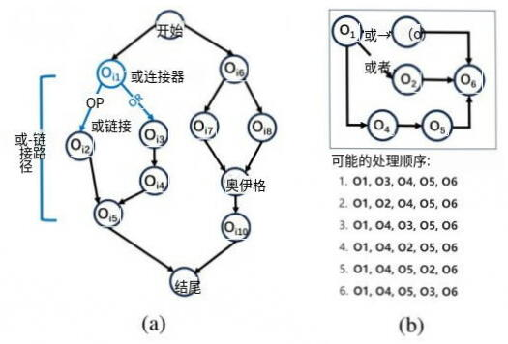
图2-1 IPPS作业的AND/OR及单个实例的所有可能的处理序列

第3章 动机和新成分

动机：事实上，DRL已经被用来解决一些更简单的调度问题，如JSP和FJSP，但不能适用于IPPS。特别地，FJSP中的每个作业具有已知的单个处理序列，但是IPPS中的每个作业的处理序列可以具有O (n！)排列如图3-1所示。如果我们考虑IPPS中所有可能的序列，那么求解一个IPPS可以简化为求解O (n！)FJSP，即使FJSP的DRL很快，这在计算上也是不可行的。因此，将以前的FJSP的DRL方法直接应用于IPPS是不切实际的。
新颖的成分：在我们的工作中，我们将IPPS建模为等价的MDP公式，这在附录A中得到了证明。虽然以前关于FJPS的工作只能处理单个序列，但我们设计了一个新的基于上述AND/OR图的异构图来表示IPPS中的状态，结合组合节点类别来从处理步骤集合中提取信息，并且我们使用异构GNN来提取信息，并使用设计模型来进行决策。为了防止多条生产路径造成的无效探索成本，我们提出了一种基于组合的动作空间缩减，确保每条轨迹恰好选择一个加工序列。此外，我们提出了一种基于IPPS估计完成时间的奖励函数，实验表明它比朴素的奖励函数表现更好。

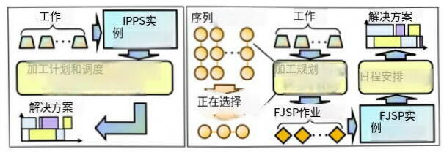
图3-1 IPP (左)和加工计划加调度 (右)之间的比较

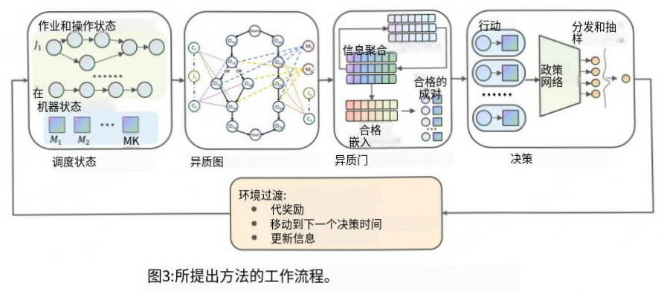
图3-2 工作流程图

第4章 MDP公 式

为了定义IPPS问题的马尔可夫决策过程(MDP)，我们将状态空间、动作空间、状态转移和奖励函数公式化如下。在操作完成后的每个决策点，代理根据当前状态提取合格的操作-机器对，并决定下一步执行哪一对。
请注意，所有决策点 (或时间步长)都在操作的完成时间。只要没有操作可以处理，或者我们选择等待到下一个时间步长，我们就会跳到下一个时间步长，这是离当前时间最近的完成时间。异构图的结构如下所示。我们将在附录A中证明以下定理：
定理1引入的MDP公式与原问题的最优解是等价的。

4.1 简述
在每个步骤t，状态ST表示在当前时间t的IPPS问题作业完成的状态。我们使用动态异构图来制定状态，这是一种由各种类型的节点和边组成的有向结构，旨在通过GNN提取信息。先前关于FJSP的研究通常包括异构图中的三种类型的节点，这不能直接应用于IPPS问题，因为IPPS另外需要在选择每个OR-连接器操作之后选择组合。因此，我们在图中引入表示组合和作业的节点，以在GNN的信息聚合期间从操作中捕获信息，这将在后续章节中详细介绍。
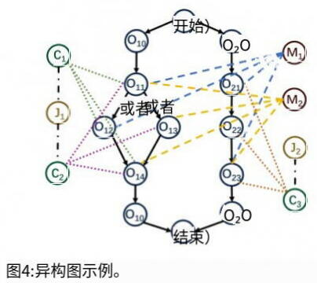
图4-1 异构图示例
边缘类型：
（1）0→0：表示先决条件的关系，这意味着仅当 Oij是Oij的最后一个所需的前驱操作时，才存在从 Oij到 Oij的有向边。
（2）O←C: 当Oij∈CIH时, Oij与CIH之间存在无向边。
（3）C←J: 当CIH⊂Ji时, CIH和 Ji之间存在无向边。
（4）0→M: 当MK可以处理 Oij时, Oij和MK之间存在无向边。
图中特征的详细信息如附录B所示。图5-1是简单IPPS问题(或初始状态)的异质图。注意，“开始”和“结束”点仅用于表示目的，并且标记为OTO的节点是表示作业 Ji开始和结束的超级节点，其中所有机器的处理时间为0。

4.2 行动空间
在本文中，一个动作AT被定义为一个可行的操作-机器对(O-M对)，即选择一个操作和一台机器来处理它。然而，由于有许多不合格的操作，代理的探索成本很高。因此，我们使用两种动作空间缩减策略。
策略一：减少动作空间的第一个策略是检测可行性，类似于以前的FJSP工作，特别地，在决策阶段，候选机器被限制为涉及可行操作和相关空闲机器的O-M对，其中可行操作是那些尚未被调度并且所有直接先决条件任务都已完成的操作。
策略二：IPPS问题具有更复杂的结构，其中每个工件的生产线是一个有向无环图。正如前面所描述的，我们用几个组合来总结每个作业，很明显，将来可能选择的组合的数量，我们称之为“合格的”，在调度过程中是不增加的。受此启发，我们的第二个减少策略是基于检测合格的组合。更详细地说，我们维护C*，它是一组合格的组合。当选择OR-连接器中的一个分支时，包含此OR-连接器中其他分支的所有组合都将从 City中删除，并且我们将只考虑属于C*中至少一个组合的操作。
最重要的是, 在时间步长t, 动作空间。AT定义为: {waiting}∪{ (Oij, mk) |Oij∈ (UP{CE}p) ∩RT, mk∈IₜPij}，其中{CT}p是CT (合格组合的集合)的第p个分量，RT是可行操作的集合，它是T的空闲机器的集合，Pij是可以处理 Oij的机器的集合。

4.3 状态转换
在每个时间步长中，根据以下规则更新异质图：
·按照前面所述更新图形中的特征。
·删除已完成的操作节点以及连接到这些已删除操作节点的所有弧。
·当选择OR-连接器中的分支时，根据“动作空间缩减”中描述的规则，删除组合节点和操作节点，以及连接到这些被删除节点的所有弧。
·删除不再与任何弧连接的机器节点和作业节点。

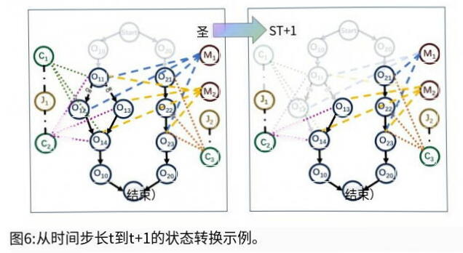
图4-3 从时间不长t到t+1的状态转换示例
图4-3说明了状态转换的简单示例。在时间步骤t，O被调度但尚未完成，并且M开始处理O begins。在T+1之前，没有选择O-M对，因为唯一可行的操作O₂只能由M处理，而M正忙于处理O。一旦O完成，则删除对应的节点O及其相关的弧。O完成后，O和O变得可行，M变得空闲。ATT+1，M被分配给进程O，使C不合格。因此，删除O₁及其相关弧。相应地更新功能。请注意，超级节点不会影响进程，因为它们在被调度后立即完成。

4.4 奖励
奖励功能在MDP中至关重要，它通过提供关于当前策略有效性的反馈来指导代理。
朴素奖励：最初，我们定义了一个朴素奖励函数RO (ST，AT，ST+)=T(ST)-T(ST+1)，它表示部分调度的实际完成时间的变化。没有折扣的累积朴素奖励对应于负的最大完工时间。然而，由于不同IPP问题之间的显著差异，这种类型的累积奖励波动很大，使得难以评估当前政策的绩效。
建议奖励：为了解决这个问题，我们提出了几个高级奖励函数，旨在基于相对改进而不是绝对完成时间来评估策略结束时间，and=Max；T；或∑IESTT；作为整个问题的估计结束时间，其中J*表示在t未完成的作业。在每一步，我们使用实际处理时间更新组合和问题的估计结束时间，并将估计结束时间的变化记录为报酬R (ST，AT，ST++ $1)=T\left(S_{2}\right)−T\left(ST+1\right)。$

4.5. 政策
策略将状态空间映射到动作空间上的概率分布。对于给定的状态S，策略π (S)提供了在该状态下可能的动作A的概率。
在数学上，它可以表示为：π：S→P (A)其中S是状态空间，P(A)是动作空间A上的概率分布。

第5章 神经网络与决策

在本节中，我们将介绍用于特征提取的方法和用于策略生成的算法。

5.1 图形表示
DRL利用神经网络来提取状态信息。我们工作中的状态是结构化的，并且具有不同数量的节点和边，这些节点和边不能表示为固定形状的张量。因此，我们使用图神经网络(GNN)，其在具有结构化特征的多个领域中具有更高的性能，例如组合优化 (Co)和推荐系统。最流行和有效的GNN之一是图注意力网络(GATS) , 我们在这里应用GATv2, GATv2是GAT的修改版本，在多个领域显示出更高的效率。GATv2是一种基于聚合的GNN，它使用动态注意力机制来聚合由边连接的邻居的信息。
其中N (I)是节点I的第一跳邻居的集合，X；是节点I和X的输入特征 (嵌入)；是输出嵌入，θ，θ，θ。是分别用于起点特征、终点特征和边缘特征的独立线性变换。在我们的工作中，我们在异构图中使用GATv2，通过对每个边类型独立地执行上述聚合步骤 (参数也是独立的)来提取嵌入，我们称之为HGAT。

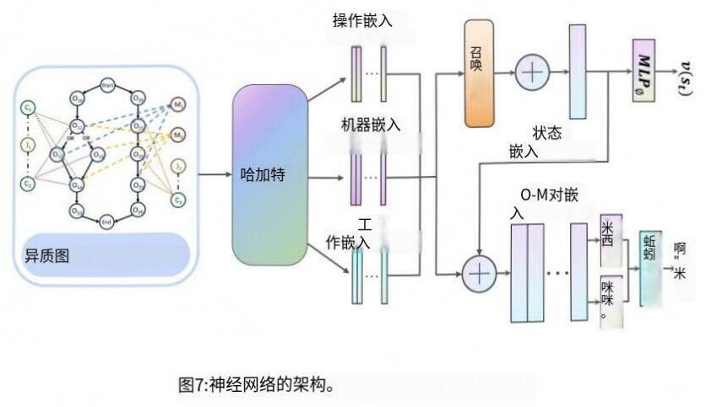
图5-1 神经网络的架构

5.2 政策设计
策略πO (AT|S) (或参与者)是从状态空间S到动作空间AT上的概率分布的映射。最近策略优化 (PPO)算法是我们选择的训练代理的方法之一，它也需要一个价值网络V。 (ST) (或批评家)。在我们的框架中，HGAT作为一个编码器，其参数在演员和评论家之间以不同的方式共享。我们的神经网络的整个结构如图5-1所示。
首先，HGAT从异构图中捕获信息，并为每种类型的节点生成节点嵌入：HO，H，HM。注意，在后面的步骤中不使用组合的节点嵌入。定义可行操作的集合，因为RT和FT是未计划的操作的集合，并且没有未计划的立即先决条件操作。

第6章 实 验

6.1 数据集
为了评估我们的方法的效率，我们在两个不同规模的合成数据集和来自的公共基准数据集上进行了3个实验。
合成数据集：基于AND/OR图的结构，通过计算有向无环图和递归添加OR路径来生成作业。在一定的分布下，将机器和相应的加工时间分配给每个工序后，我们随机组合各种IPPS问题的工件。有关详细信息，请参阅附录D。
公共数据集：由引入的IPPS研究中广泛认可的基准。Kim数据集包含24个具有不同灵活性的实例。

6.2 实施细节
设N，NN，N是训练、验证和测试实例的数量，M×N表示问题规模，其中M和N分别是工作和机器的数量。训练实例是从1000个具有相应机器编号的作业中生成的，这些作业实际上由n=(作业编号)个问题组成。我们训练了三个模型，每个模型都基于不同问题规模的合成数据集：4×5，5×3和6×5，这些数据集都相对较小但复杂，并且验证规模为I $N_{2}=20。$
在实验1中，我们在与训练集具有相同大小和分布的对称数据集上评估模型。为了评估训练策略的泛化性能，实验2和3分别在公共数据集和规模为16×20A和20×25的大规模生成数据集上进行。在所有实验中，所有测试集的大小为N=50，并且我们使用DRL-G (仅选择具有最高概率的动作)和DRL-S(根据概率分布选择动作)来评估策略性能。有关基础架构和配置的详细信息。

6.3 基线
我们将我们的模型与两种类型的基线算法进行比较。
OR-Tools: OR-Tools是 Google的一个开源工具箱, 其中包括CP-SAT求解器, 这是一个强大的约束编程求解器, 以其在工业调度中的强大性能而闻名。在本文中，我们使用CP-SAT求解器来实现中附录C所示的MILP模型，以在1800秒(实验3为3600s)内获得精确解。
贪婪：调度规则在IPPS问题中显示出巨大的潜力。我们分别为操作排序和机器分配选择规则。对于操作选择，我们使用的规则包括剩余工作最多 (MWKR)、剩余操作最多 (MOR)、先进先出 (FIFO)和中描述的概率。计算机分配基于根据最短处理时间 (SPT)、最早完成时间 (EFT)和最少利用的计算机 (LUM)计算的优先级。在每个问题中，我们为每个作业随机选择一个组合，将复杂的IPPS问题简化为简化的FJSP问题。然后，在每一步，下一个操作和相应的机器由它们在一定的调度规则下的等级决定。

6.4 评价
为了从效率和质量两方面比较方法性能，我们使用 Makespan、Gap和 Time作为评价指标，其中 Makespan是指平均最终优化目标，Gap是与OR工具的 Makespan相比的平均相对差异，Time衡量平均计算时间。对于DRL采样方法，我们将每个实例运行50次，并选择最佳值作为最终结果。对于贪婪算法，我们为每个数据集选择最佳优先级调度规则的结果。

6.5 结果与分析
如表6-1所示，在所有训练规模中，实验1表明我们的模型在解决方案质量方面始终优于贪婪方法，同时也比所有基线方法更快。与贪婪方法相比，我们的方法始终实现了与OR工具之间较小的差距，减少了3%到25%，突出了我们方法的有效性。

表6-1 培训规模实例评估
 | 尺寸 | 工具 | DRL-G | DRL-S | 最贪婪的
 | 最大完工时间 | 389.99 | 423.6 | 403.19 | 429.73
4×5 | 差距 | — | 7.43% | 2.92% | 8.79%
 | 时间 (秒) | 1769.31 | 7.65 | 10.23(0.20)* | 91.01(1.82)*
 | 最大完工时间 | 452.36 | 505.2 | 474.44 | 590.76
5×3 | 差距 | — | 11.68% | 4.88% | 30.60%
 | 时间 (秒) | 1789.79 | 7.90 | 15.54(0.31) | 48.45(0.97)
 | 最大完工时间 | 442.14 | 487.94 | 462.04 | 506.63
6×5 | 差距 | — | 10.36% | 4.50% | 14.59%
 | 时间 (秒) | 1798.84 | 8.37 | 14.68(0.29) | 139.76(2.80)

表6-2 在公共基准 Kim数据集上的性能
数据集 |  | Kim
 |  | 最大完工时间差距 |  | 时间(秒)
磅* |  | 387.93
或者工具 |  | 392.08 | 1.07% | 1796.37
DRL-G | 4×5 | 445.17 | 14.76% | 11.94
 | 5×3 | 451.33 | 16.34% | 17.79
 | 6×5 | 444.25 | 14.52% | 12.12
DRL-S | 4×5 | 416.42 | 7.34% | 23.31(0.97)
 | 5×3 | 417 | 7.49% | 34.32(0.67)
 | 6×5 | 416.21 | 7.29% | 23.87(0.48)
最贪婪的 |  | 458.38 | 18.16% | 82.24(1.64)

表6-3 大型实例的泛化性能
数据集 | 方法 |  | 最大完工时间 |  | 差距 | 时间 (秒)
 |  |  | 可行* | All⁺
 | 工具 |  | 566.07 |  | — | 1800 (7/50暂停)
 |  | 4×5 | 538.37 | 537.84 | -4.89% | 19.77
 | DRL-G | 5×3 | 543.17 | 542.22 | -4.05% | 32.67
16×20 |  | 6×5 | 542.2 | 539.54 | -4.22% | 21.89
 |  | 4×5 | 518.22 | 527.06 | -8.45% | 40.59(0.81)
 | DRL-S | 5×3 | 517.07 | 515.48 | -8.66% | 65.15(1.30)
 |  | 6×5 | 518.63 | 517.06 | -8.38% | 41.00(0.82)
 | 最贪婪的 |  | 544.80 | 544.89 | -3.76% | 148.66(2.97)
 | 工具 |  | 547.03 |  | — | 3600 (16/50暂停)
 |  | 4×5 | 508.85 | 518.28 | -7.00% | 26.87
 | DRL-G | 5×3 | 510.94 | 519.86 | -6.60% | 42.37
20×25 |  | 6×5 | 512.00 | 519.10 | -6.40% | 28.23
 |  | 4×5 | 484.97 | 495.26 | -11.35% | 56.34(1.13)
 | DRL-S | 5×3 | 486.15 | 496.84 | -11.13% | 87.25(1.75)
 |  | 6×5 | 485.67 | 495.24 | -11.21% | 56.88(1.14)
 | 最贪婪的 |  | 513.83 | 524.09 | -6.10% | 186.42(3.73)

将我们的模型应用于公共数据集，表6-2中实验2的结果显示了与实验2相似的优势，反映了我们方法的泛化能力。此外，如附录H中Kim数据集的详细结果所示，我们的优势随着问题规模的增加而变大。
实验3 (见表6-3)进一步证实了我们在大规模问题上的优势。虽然OR-Tools甚至无法找到可行的解决方案，但DRL的求解时间不到一分钟。此外，在OR-Tools可行问题中，DRL的性能优于OR-Tools，高达11.35%。在小型和中型实例中学习的强有力的证明模式在解决较大的问题时仍然有效。

第7章 结 论

IPPS问题是现代制造系统组合优化中的一个关键挑战。在本文中，我们提出了一种新的DRL方法来求解IPPS，与贪婪算法相比，该方法减少了探索状态空间，加快了求解速度，并减少了最大完工时间间隔。在合成数据集和基准数据集上的大量实验证明了该方法的有效性，特别是在大规模问题中。

附 录

附录1 MDP公式化
以往提出的相关DRL算法虽然达到了竞争性能，但它们都忽略了等待的价值，尽可能快地安排可行的OPE-MA对，这使得它们在某些情况下无法达到最优。首先，我们提出了一个简单的例子来证明这一点，并随后表明我们的公式等价于原始的IPPS问题。
有一个简单的例子 (FJSP或IPPS)解释了为什么没有等待的策略可能会错过(接近)最优解。在这个问题中，我们只有2个工作，2台机器和3个操作。工单1和工单2的工序分别是{Opel，Ope2}和{Ope3}，它们的加工时间在上面。该问题的最优调度是{ (OPE1, MAL) , (OPE3, MA2) , (OPE2, MA2) },它有一个等待决策, 最大完工时间为3。然而, 在无等待策略中，如果存在可行对，我们将安排一个OPE-MA对。因此，该算法将在t=0时处理 Opel和Ope3，并且作业1将在t=1时再次可用。 由于等待时间的损失和Ope3的长处理时间，Ope2将被安排到与 Opel相同的机器上，这意味着每个作业只能在一台机器上处理。由于两个工件在MAL上的总加工时间均为4，因此无等待算法下的最优完工时间为4，不能达到最优性。
在这里, 我们证明了我们的MDP等价于原来的IPPS问题。我们将IPPS解决方案定义为D={D, S, E}, 其中D={D|I=1, 2, …,|D|}是调度的集合，其中D；是第l个调度分配操作O；属于J；到机器MI。函数S (D；)和E (D；)表示D；的开始和结束时间，以及最大完工时间 $M=Max\left\{E\left(D_{2}\right)∣D∈D\right\}。$我们可以假设S (D₂)不随I递减。
附录2 图形特征
节点的原始特征：
（1）操作：先决条件操作的数量；此操作是否已计划；操作是否可行；可行操作的等待时间 (=0表示不可行操作)；计划的处理操作的剩余时间 (=0表示未计划的操作)。
（2）机器：相邻操作的数量；本机进入空闲状态的时间；利用率：非闲置时间与总生产时间的比率；机器是否工作；从可用时间到现在的空闲时间。工作机器完成工作操作的剩余时间。
（3）组合：这些组合的预计完成时间；与同一作业关联的组合的估计结束时间与估计最小结束时间的比率。
（4）工作岗位：所有作业的预计结束时间与最大预计结束时间的比率；边缘的原始特征。
（5）操作⇔机器：机器用于处理操作的处理时间。

附录3 MILP模型
为了获得最优解，我们使用OR-Tools (由 Google开发的开源优化库)的CP-SAT求解器来实现建议的MILP (混合整数线性规划)模型。
如果选择了作业I的组合H，则组合中工序的总和等于1，否则等于0。
如果不选择组合H，则组合中所有操作的完成时间为0。
$A⋅Y_{ih}≥C_{ihj},∀i,h∈K_{i},j∈R_{ih}$
保证操作的正确完成时间。
$C>C_{i}+∑X_{ih^{'}k^{'}}P$

$∀i,h∈K_{i},j,j^{'}∈R_{ih},j≠j^{'},V_{ij^{'}}=1$

$Z_{ijj^{'}}+Z_{ij^{'}j}=1,∀i,j,j^{'}∈n_{i},Q_{ijj^{'}}+Q_{ij^{'}j}=0,j≠j$

$C_{ihj^{'}}≥C_{ihj}+\sum_{k^{'}∈M_{v}}{}X_{ihj^{'}k^{'}}P_{ij^{'}k^{'}}−A\left(1−Z_{ijj^{'}}\right),$

$∀i,h∈K_{i},j,j^{'}∈R_{ih},j≠j^{'}$
保证同一台机器上操作的处理顺序。
$C_{ih^{'}j^{'}}≥C_{ihj}+X_{i^{'}h^{'}j^{'}k^{'}}P_{i^{'}k^{'}}$
$−A\left(1−W_{ijj^{'}j^{'}}\right)−A\left(2−X_{ihjk}−X_{i^{'}h^{'}j^{'}k^{'}}\right),$
$C_{ihj}≥C_{ih^{'}j^{'}}+X_{ihjk}P_{ijk}−A⋅W_{ijj^{'}j^{'}}$
$−A\left(2−X_{ihjk}−X_{ih^{′}j^{′}k^{′}}\right),$
$∀1,1′,|≠I^{'},h∈Ki,H^{'}v,j∈Rih,$
Makespan是所有操作的最大完成时间。
附录4 问题生成方法
基于AND/OR图的结构，通过计算有向无环图和递归添加OR路径来生成作业。在一定的分布下，将机器和相应的加工时间分配给每个工序后，我们随机组合各种IPPS问题的工件。
这里，我们将OR-LINK路径定义为子路径，将不是OR-LINK路径的路径定义为主路径。
在以下两个场景中，子路径和主路径之间存在链接，因此无法通过定义来确定操作顺序。
- 从主路径到子路径的链接：不清楚操作12是否可以执行，因为它必须在操作7和11之后完成，而操作12在OR-LINK路径中 。
2、 从子路径到主路径的链接：不清楚当操作6未完成时，操作12是否可以完成。 (如图附4-1所示)。
为了避免上述主路径和子路径中的操作相关联的情况，我们采用嵌套方法来增量地生成问题。具体步骤如下。
定义明确的IPPS问题生成：
步骤1：构造有向无环图 (DAG)作为主路径
·输入：主路径中的操作次数范围，最大出度..
·初始化开始节点和结束节点，然后根据输入要求在开始节点和结束节点之间建立操作节点序列。
步骤2：将子路径添加到主路径
·输入：OR-Connector的个数，总操作数和每条子路径中的操作数的范围，OR-Connector的最大出度个数
·从主路径中随机选择n条边作为或子路径的起始点和整合点，生成m条K的子路径；最初选择的边I之间的节点。nm，K是在输入要求下随机决定的。
·每次将路径插入到选定的边时，如果选择了连接节点 (其中出现两个子路径)的边，我们会自动在新的子路径的末端创建一个超级节点，然后连接到原始连接节点。
·检查总操作次数是否满足约束。如果没有，则生成新作业。否则，保存定义良好的作业。
步骤3：机器和加工时间的分配
·输入：机器数量、加工时间范围和一台机器分配给每道工序的概率。
·对于每个工序，使用输入概率将机器随机分配给该工序，加工时间由加工时间范围统一生成。
步骤4：将作业组合到定义明确的问题
·输入：作业和机器的数量
·使用所需的机器数量，随机组合所需的明确定义的作业数量。
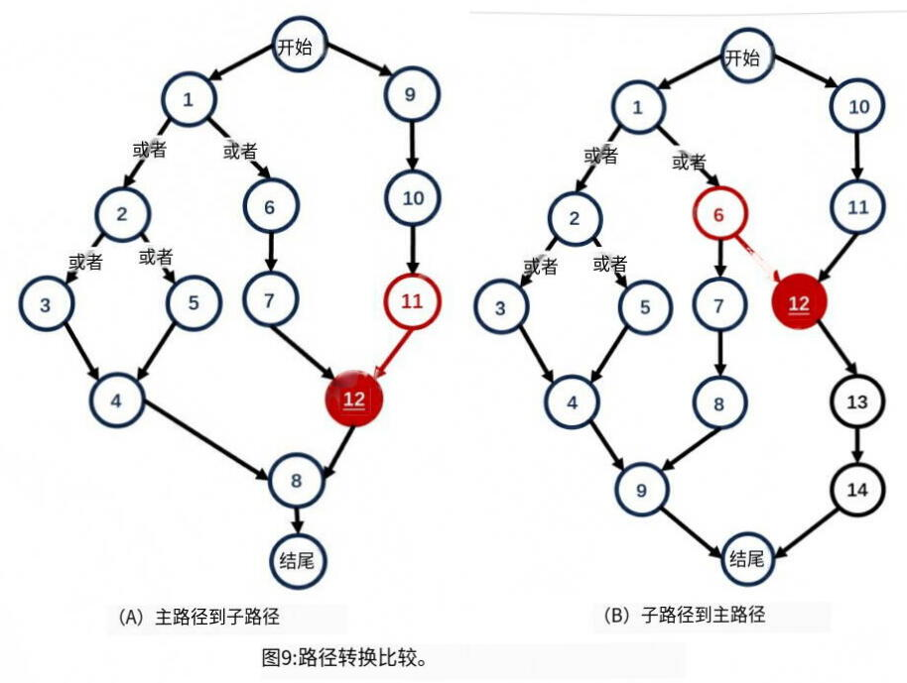
图附4-1 路径转换比较
附录5 基础架构和配置
- 基础设施
我们使用一台配备第11代 Intel (R) Core (TM) i7-11800H@2.30GHzCPU和NVIDIAGeForceRTX3070GPU的机器, 用于DRL和贪婪调度规则。为了通过OR-Tools CP-SAT求解器求解MILP, 我们使用 Intel Xeon Platinum 8469C的32个内核, CPU为2.60GHz, RAM为512GB。我们的核心功能是使用PyTorch和PyTorch Geometric (PyG)实现的。
- 神经网络参数
下面是我们神经网络的基本设置。请注意，隐藏 DIMS或NUM HEADS的值列中的列表长度表示深度。
- 环境参数
我们以批处理方式并行运行3个实例，验证集的大小设置为20。
- 训练参数
下面是培训配置。学习率 (LR) 和β是 Adam优化器的基本参数。PPO-CLIP中的参数EPS CLIP是通过添加乘数 (CLIP MULTI) 和上限 (CLIP UB)以将其增加到上限来调整的。值得注意的是，IR、伽马和并行 ITER (变化实例的间隔)被调整，并且我们确定了在我们的调整实验中产生竞争性结果的范围。在我们最终训练的模型中，我们分别选择了5E-4、0.99和20的值。

表附5-1 参数与价值
参数 | 价值
LR | 5E-5-5E-4
贝塔斯 | [0.9,0.999]
Gamma (折扣奖励) | 0.95-0.995
A_系数 (保单损失权重) | 1
剪辑_UB | 0.5
K_时期 (PPO中的更新时期) | 3
EPS_夹 | 0.3
VF_系数 (价值损失权重) | 0.5
卡夹_多个 | 1.002
_系数 (熵损失权重) | 0.05
并行_ITER | 20-50
保存_时间步长 (验证时间间隔) | 10
最大_迭代次数 | 30000
小批量 (在PPO中更新批量) | 512
更新_时间步长 (更新间隔) | 5
熵_折扣 | 0.997

附录6 更多实验结果
- 消融实验
为了证明我们的奖励函数设计以及异质图和更新设计的有效性，我们使用如前所述的数据集 (5个作业，3台机器)进行了两个消融实验。在这些消融实验中，所有曲线保持相同的配置，并运行1500个训练时期，我们评估验证曲线 (每10个时期)。
图附6-1左给出了朴素奖励和我们的基于估计的奖励之间的比较，朴素奖励利用了计划操作的最大完成时间的差异。我们的奖励功能显示了改进的稳定性和竞争力。
图附6-1右给出了三种不同的基于图的状态表示的比较：O-M图，它利用只有两种类型的节点操作和机器的图；不合格或不必要，以及我们提出的具有四种类型节点的图，该图专门保留了先前详述的合格节点。提议的图表显示了增强的竞争力和稳定性。此外，由于减少了邻域信息的聚集，它实现了比非残差图更快的推理速度。
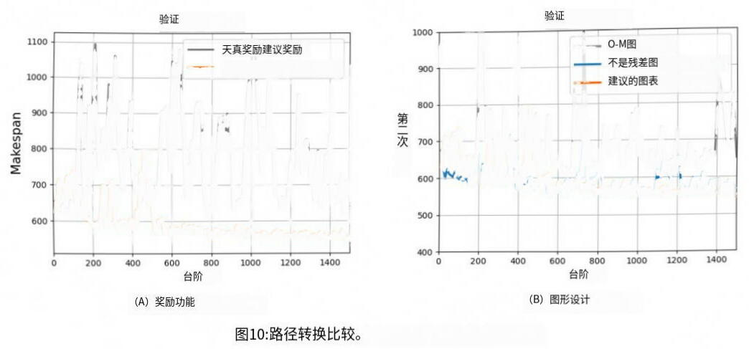
图附6-1 路径转换
- 大规模问题中的附加实验
DRL和 Greedy的结果之间的差异随着问题规模的增加而减小，这表明我们的方法对于大规模问题特别有效。在正文中，我们展示了来自两个相对较大的生成数据集 (16×20和20×25)的实验结果。为了进一步评估我们的效率，我们在10个实例上进行了额外的实验，每个实例有25个作业和20台机器。结果如表7所示，进一步证实了我们的方法在解决大规模问题方面具有巨大的潜力。
附录7 贪婪调度规则的详细信息
- 选择操作规则
我们利用IPPS中已建立的FJSP贪婪规则。为了实现这些FJSP规则，我们最初在应用之前为每个作业选择单个组合，因为该规则只能用一个特定的组合来执行。
此外，我们使用建议的为IPP设计的贪婪规则，我们称之为 Muhammad。
·先进先出 (FIFO)，处理机器队列中要处理的最早操作。
·剩余工作最多 (MWKR)，处理剩余工作量最大的工作。
·剩余工序数最多 (MOR)，处理剩余任务数最多的作业。

表附7-1
条件 | C
Tm≥0.95Tc | 5
0.85Tc≤Tm<0.95Tc  0.70Tc≤Tm<0.85Tc  0.50Tc≤Tm<0.70Tc  TM<0.5Tc | 432
 | 1
为了分配优先级，将每个工件的加工时间TM与 to进行比较，并计算临界值C；根据表中列出的条件进行分配。
- 选择机器规则
对于机器选择标准，考虑了以下规则：
·最短处理时间 (SPT)，为操作分配具有最短处理时间的机器。
·最早结束时间 (EET)，选择操作可以最早开始的机器。
·最低利用率机器 (LUM)，选择负载最小的机器。
- 工作流程
算法1显示贪婪规则的工作流程。每次选择O-M对时，我们将其开始时间指定为它可以开始处理的最早可能时刻。

SOLVING INTEGRATED PROCESS PLANNING AND SCHEDULING
PROBLEM VIA GRAPH NEURAL NETWORK BASED DEEP
REINFORCEMENT LEARNING
arXiv:2409.00968v1 [math.OC] 2 Sep 2024 | Hongpei Li1,∗ | Han Zhang1,∗ | Ziyan He1 | Yunkai Jia2 | Bo Jiang1 | Xiang Huang2
Dongdong Ge3
1Shanghai University of Finance and Economics
2Cardinal Operations
3Shanghai Jiao Tong University
ABSTRACT
The Integrated Process Planning and Scheduling (IPPS) problem combines process route planning and shop scheduling to achieve high efficiency in manufacturing and maximize resource utilization, which is crucial for modern manufacturing systems. Traditional methods using Mixed Integer Linear Programming (MILP) and heuristic algorithms can not well balance solution quality and speed when solving IPPS. In this paper, we propose a novel end-to-end Deep Reinforcement Learning (DRL) method. We model the IPPS problem as a Markov Decision Process (MDP) and employ a Heterogeneous Graph Neural Network (GNN) to capture the complex relationships among operations, machines, and jobs. To optimize the scheduling strategy, we use Proximal Policy Optimization (PPO). Experimental results show that, compared to traditional methods, our approach significantly improves solution efficiency and quality in large-scale IPPS instances, providing superior scheduling strategies for modern intelligent manufacturing systems.
Introduction
Deep Reinforcement Learning (DRL) is a popular technique to learn sequential decision-making in complex problems, combining reinforcement learning with deep learning [1], which has achieved successful applications in various areas including robotics, traffic signal control, and recommendation systems. There is a growing interest in applying DRL to NP-hard combinatorial optimization problems (COPs) [2] to find a reasonable good solution within an acceptable time such as the Traveling Salesman Problem (TSP) and scheduling problems such as Job Shop Scheduling (JSP) and Flexible Job Shop Scheduling Problem (FJSP) [3,4,5]. Since DRL inherits the fundamental framework of dynamic programming and Markov Decision Process (MDP), it is naturally suitable for solving multi-stage decision problems transformed from COPs.
Inspired by the successful applications mentioned above, we introduce DRL to the Integrated Process Planning and Scheduling (IPPS) problem, a typical NP-hard COP that is crucial for intelligent manufacturing. IPPS combines two of the most important subsystems in manufacturing systems: process planning and shop scheduling, where the former plans the optimal process route under precedence constraints, and the latter schedules machine assignments, sequences of jobs, and start times based on the known process route. Traditionally, these two subsystems execute sequentially. However, performing them separately can lead to bottleneck resources, conflicts in optimization objectives, and unbalanced machine loads [6]. In contrast, IPPS simultaneously optimizes both process routes and scheduling plans under specific constraints and objectives, such as completion time [7]. Therefore, IPPS has become a popular topic in current production research.
IPPS has been widely applied in the automotive, shipbuilding, chemical, metallurgy, and aerospace manufacturing areas [8,9,10] which require modern manufacturing systems with efficiently and dynamically responding to rapidly
*These authors contributed equally to this work.
†Correspondence to: Hongpei Li<ishongpeili@gamil.com>, Bojiang<isyebojiang@gmail.com>

PREPRINT. UNDER REVIEW.
changing product demands[11]. However, as a typical NP-hard problem, traditional methods for solving IPPS, such as mixed-integer linear programming and heuristic genetic algorithms [12, 13,14, 15], struggle to quickly adapt to dynamic, real-world environments with unexpected disruptions due to their computational complexity. Therefore, ensuring the efficiency of IPPS solutions has become a challenging issue.
In combinatorial optimization problems similar to IPPS, DRL methods show advantages in efficiency and accuracy. Taking the FJSP as an example, DRL models the scheduling process as an MDP, using neural network models to collect production environment information and output scheduling priorities. [16] use Priority Dispatching Rules (PDRs) derived from expert experience and employ deep Q-networks to solve FJSP end-to-end. To fully exploit the graph structure of FJSP, [17,18] model the state of FJSP as a heterogeneous graph, combining graph neural networks with attention mechanisms, which perform well on large-scale problems. Unlike heuristic methods, DRL has strong transfer learning capabilities, quickly adapts to new problems, and provides high-quality solutions.
However, current research rarely uses DRL to solve IPPS. The existing DRL methods used for FJSP cannot apply to IPPS directly due to additional complexity in the decision-making and representation of IPPS while simultaneously solving process route selection and resource scheduling. Thus, in this paper, we propose a novel end-to-end DRL method. We model the IPPS problem as an MDP and employ a Heterogeneous Graph Neural Network (HGNN) to capture the complex relationships among operations, machines, and jobs. To optimize the scheduling strategy, we use Proximal Policy Optimization (PPO).
Contributions To the best of our knowledge, this article is the first to apply DRL to solve the IPPS problem. We formulate an equivalent MDP for IPPS by incorporating an empty action to represent waiting at decision points. Presenting the current state as a heterogeneous graph, we use GNN for feature extraction and generate an operation-machine pair to process next by DRL structure.
• Exploration Efficiency: We introduce the concept of combination—a set of indispensable operations for finishing the job—into our action space reduction strategy. While the number of combinations is relatively small, ineffective exploration costs associated with multiple production paths are avoided.
• Stability and Generalization:Our state transition process prunes completed or infeasible operations and their connections from the heterogeneous graph, reducing noise and focusing on critical scheduling tasks. Moreover, we propose a dense reward function based on estimated completion times, which outperforms a naive sparse reward related to the actual completion time. Together, our model can generalize effectively across various scheduling environments through a stable training process.
• Competitive Numerical Performance:Training on small-size problems with no more than 6 jobs, our DRL approach substantially outperforms in large-scale problems, particularly those with more than 16 jobs over 30,000 variables, achieving an improvement of 11.35% compared to OR-Tools.
2 Related Work
2.1 Conventional IPPS Methods
Traditional IPPS solutions include exact methods like MILP and Constraint Programming (CP). [12] developed MILP models for IPPS using network representations, solved with CPLEX. [13] used logic-based benders decomposition to iteratively solve sub-problems, but these approaches struggle with large-scale problems. Consequently, research has shifted towards heuristic methods.
[14] establish a benchmark dataset using a symbiotic evolutionary algorithm. [19] introduce simulated annealing for optimization, improving performance on Kim’s dataset. Other hybrid methods, such as ant colony optimization [20], tabu search [21], variable neighborhood search [15], and harmony search [22], have been applied to IPPS. While faster than exact algorithms, these approaches lack optimality guarantees.
2.2 DRL-based Scheduling Methods
To enhance solution efficiency and quality, DRL has been applied to scheduling problems like FJSP. [16] combined expert-based Priority Dispatching Rules (PDR) with deep Q-Networks for dynamic FJSP, while [23] proposed an end-to-end DRL method using tripartite graphs. However, these approaches overlook graph structures in scheduling problems.
Recent studies incorporate Graph Neural Networks (GNNs) to capture unique graph information in FJSP. [24] used interlaced graphs and DRL to learn high-quality PDR, while [17] modeled FJSP as an MDP with heterogeneous graphs

PREPRINT. UNDER REVIEW.
and attention mechanisms for state representation. [18] utilized multi-strategy generation and PPO with PDR to restrict the action space, achieving strong performance in large-scale instances.
Most related works focus on using DRL for FJSP, but these methods can’t be directly applied to IPPS. Improving solving IPPS with DRL remains a crucial research topic.
3 | Preliminaries
3.1 |  | Graph-based IPPS Problem
An IPPS instance is defined by a set of n jobs J = {J1, J2, . . . , Jn} and a set of m machines M = {M1, M2, . . . , Mm}. For each job Ji ∈ J, Ji has a set of operations Oi = {Oi1, Oi2, . . . , Oil}, and each opera-tion Oij in Oi can be processed on machines belonging to a set of machines Mij ⊆ M. The time machine Mk
processes the operationOij is denoted aspijk ∈ R+. The most common objective function used to minimize an IPPS problem is makespan, which is defined asmaxi,j Tij whereTij is the completion time ofOij.
To complete each jobJi ∈ J, operations inOi must follow certain precedence constraints, which can be represented in an AND/OR graph [25]. In an AND/OR graph, each job begins and ends with a starting node and an ending node, and intermediate nodes represent each operation inOi(see Figure 1a). The arrows connecting the nodes represent the precedence between them. Arrows with the attribute ’OR’ are called OR-links, and the start nodes of OR-links are OR-connectors. An operation path that begins at an OR-link and ends when it merges with other paths is called an OR-link path. When processing jobs, only one path in OR-paths beginning with the same OR-connectors is chosen. For nodes that are not in any OR-path, all of them should be visited. Following the rules above, we define the set of indispensable operations for finishing the job without considering precedence relationships between operations as a combination.Ci =�Cih is the set of all possible combinations ofJi.
h
Remark 1 The definition of a combination is proposed by [12]. We mainly focus on combination without precedence relationships rather than each processing sequence which shows a specific processing order in this paper, because the number of combinations is much less than the processing sequences that can be up toO(n!), and provides an effective exploration space.

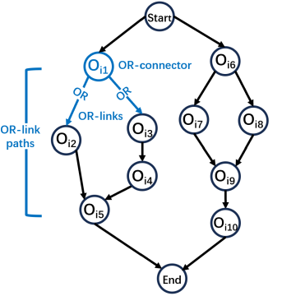

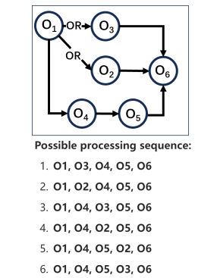

(a) (b)
Figure 1: (a) AND/OR graph of an IPPS job. (b) All possible processing sequences for a single instance.
4 Motivation and Novel Ingredient
Motivation:In fact, DRL has been utilized to solve some easier scheduling problems like JSP and FJSP, which however can not be adapted to IPPS. In particular, each job in FJSP has a known single processing sequence, but the processing sequence for each job in IPPS could haveO(n!)permutations (see Figure 1b). If we consider all possible sequences in IPPS, then solving one IPPS can be reduced to solvingO(n!)FJSP, which becomes computationally infeasible even if DRL for FJSP is fast. Thus directly applying previous DRL methods of FJSP to IPPS is impractical.
Novel Ingredient: In our work, we model IPPS to equivalent MDP formulation, which is proved in Appendix A. While previous works on FJPS could only handle a single sequence, we designed a new heterogeneous graph based on the mentioned AND/OR graph to represent the state in IPPS, incorporating the Combination node category to extract information from the set of processing steps, and we use heterogeneous GNN to extract information and use the

PREPRINT. UNDER REVIEW.
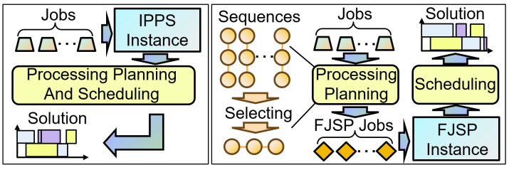
Figure 2: Comparison between IPPS (left) and Processing Planing plus Scheduling (right).
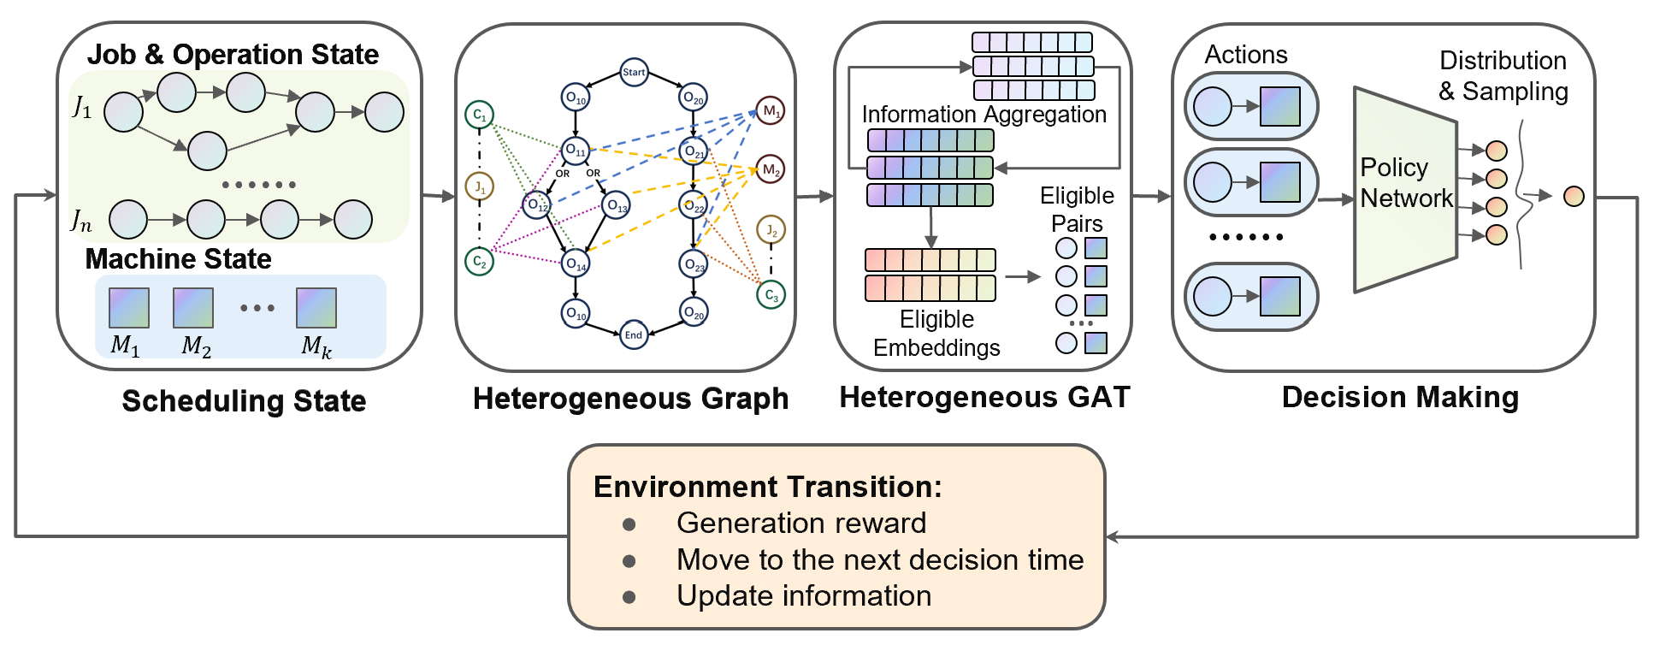
Figure 3: The workflow of the proposed method.
designed model to make decisions. To prevent the ineffective exploration costs caused by multiple production paths, we proposed an action space reduction based on the combination, ensuring that each trajectory selects exactly one processing sequence. Furthermore, we propose a reward function based on the estimated completion time for IPPS, and experiments show that it performs better than the naive reward function.
5 MDP Formulation
To define the Markov Decision Process (MDP) for the IPPS problem, we formulate the state space, action space, state transitions, and reward function as follows. At each decision point, following the completion of an operation, the agent extracts eligible operation-machine pairs based on the current state and decides which pair to perform next.
Notice that all decision points (or time-step) are at an operation’s completion time. Whenever no operation can be processed or we choose to wait until the next time-step, we’ll jump to the next time-step, which is the nearest completion time from the current time. The structure of the heterogeneous graph is illustrated as follows. We will prove the following theorem in Appendix A:
Theorem 1The introduced MDP formulation is equivalent to the original problem in terms of their optimal solutions.
5.1 State
At each stept, the statest represents the status of IPPS problem job completion at the current timet. We formulate the state using a dynamic heterogeneous graph, a directed structure composed of various types of nodes and edges, designed to extract information via GNNs. Previous studies on FJSP [17, 26] usually include three types of nodes in heterogeneous graphs which cannot apply to IPPS problem directly since IPPS additionally requires selecting a combination following the choice of each OR-connector operation. Accordingly, we introduce nodes representing combinations and jobs within our graph to capture information from operations during GNN’s information aggregation, which will be detailed in subsequent sections.
Node types:
• Operations (O):Oij ∈ O denotes thei-th job’sj-th operation.
• Machines (M):Mk ∈ Mdenotes thek-th machines.
• Combinations (C):Cih ∈ C denote a combinationhof jobi, which is a set of operations.• Jobs (J):Ji ∈ J denotes thei-th job.

PREPRINT. UNDER REVIEW.
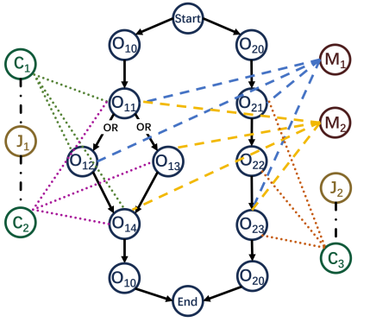
Figure 4: Example of heterogeneous graph.
Edge types:
• O −→ O: represent the relationship of prerequisites, which means there is a directed edge fromOij toOij′ if and only ifOij is the last required predecessor operation ofOij′.
• O ←→ C: there is an undirected edge betweenOij andCih whenOij ∈ Cih.
• C ←→ J: there is an undirected edge betweenCih andJi whenCih ⊂ Ji.
• O ←→ M: there is an undirected edge betweenOij andMk whenMk can processOij.
The details of the features in the graph are shown in Appendix B. Figure 4 is a heterogeneous graph of a simple IPPS problem (or initial state). Note that the "start" and "end" points are for representation purposes only, and the nodes markedOt0 are supernodes representing where the jobJi begins and ends with 0 processing time for all machines.
5.2 Action Space
In this paper, an actionat is defined as a feasible operation-machine pair (O-M pair), which means selecting an operation and a machine to process it. However, with numerous ineligible actions, there is a high cost to the agent’s exploration. Therefore, we use two action space reduction strategies.
Strategy I:The first strategy to reduce the action space is detecting feasibility, similar to previous FJSP works, such as [17] and [27]. Specifically, candidates during the decision phase are restricted to O-M pairs that involve feasible operations and relevant idle machines, where feasible operations are those that have not been scheduled and all immediate prerequisite tasks have been completed.
Strategy II:The IPPS problem has a more complex structure in which each job’s production line is a directed acyclic graph. As described before, we conclude each job with several combinations, and it’s evident that the number of combinations that might be chosen in the future, which we call "eligible", is non-increasing during dispatching. Inspired by this, our second reduction strategy is based on detecting eligible combinations. In more detail, we maintain C∗t ,
which is a set of eligible combinations. When one of the branches in the OR-connector is selected, all combinations containing other branches in this OR-connector will be removed fromC∗t , and we will only consider operations that
belong to at least one combination inC∗. Figure5 is a simple example that illustrates this strategy.
Above all, at time stept, the action spaceAt is defined as:{waiting} ∪ {(Oij, Mk)|Oij ∈(Up{C∗t }p)∩Rt, Mk ∈It ∩Pij}, where{C∗t }p is thep-th component ofC∗t (set of eligible combinations),Rt is the set of feasible operations,
It is the set of idle machines att, andPij is the set of machines that can processOij.
5.3 State Transitions
In each time step, the heterogeneous graph is updated according to the following rules:
• Update the features in the graph as described previously.
• Delete the finished operation nodes along with all arcs connected to these deleted operation nodes.
• When a branch in an OR-connector is selected, delete the combination nodes and operation nodes according to the rule described in "action space reduction", as well as all arcs connected to these deleted nodes.
• Delete machine nodes and job nodes that are no longer connected with any arcs.

PREPRINT. UNDER REVIEW.
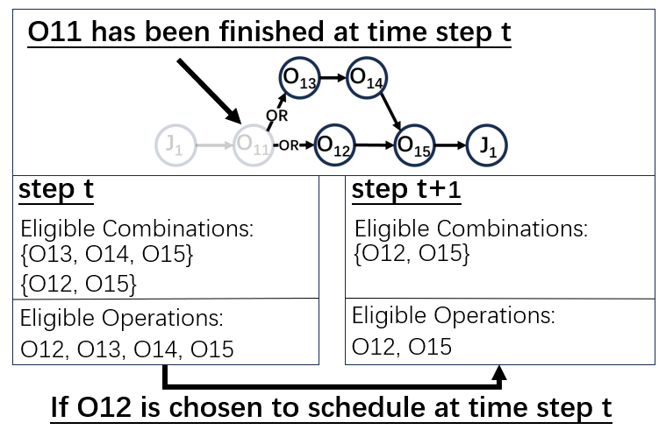
Figure 5: Example of action space reduction strategy II.
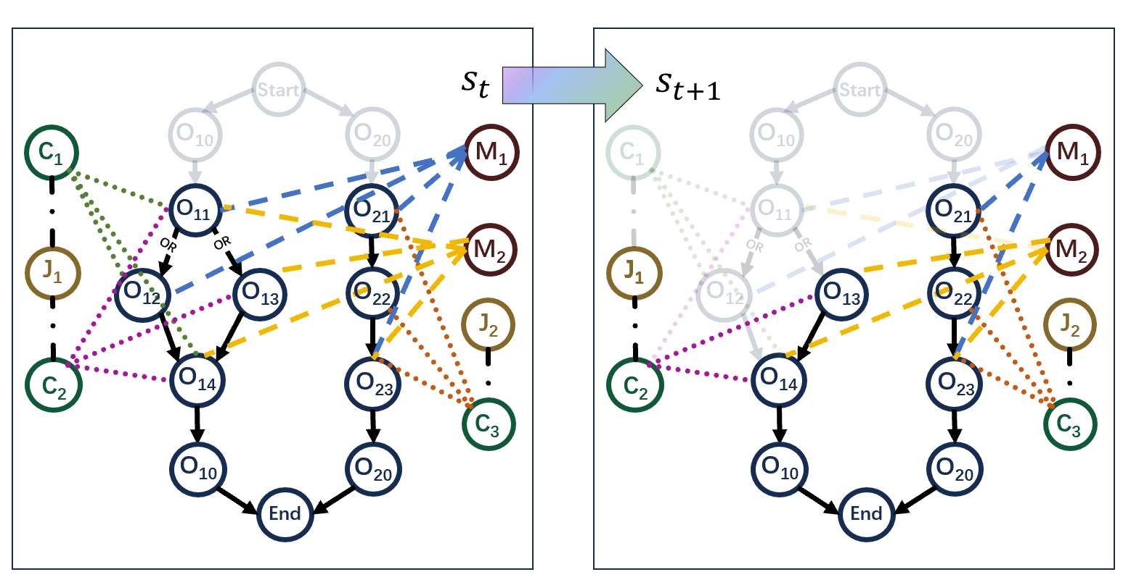
Figure 6: Example of state transition from time-stepttot+ 1.
Figure 6 illustrates a simple example of state transitions. At time stept,O11 is scheduled but not yet completed, and M1 begins processingO12. Beforet+ 1, no O-M pair is selected because the only feasible operation,O21, can only be processed byM1, which is busy processingO11. OnceO11 is completed, the corresponding nodeO11 and its related arcs are deleted. PostO11’s completion,O12 andO13 become feasible, andM1 becomes idle. Att+ 1,M1 is assigned to processO13, renderingC1 ineligible. Consequently,O12 and its related arcs are deleted. The features are updated accordingly. Note that super nodes do not impact the process as they finish immediately after being scheduled.
5.4 Reward
The reward function is critical in the MDP, guiding the agent by providing feedback on the effectiveness of the current policy.
Naive Reward:Initially, we define a naive reward functionr0(st, at, st+1) = T(st)−T(st+1), which represents the change in the actual completion time of the partial schedule. The cumulative naive reward without discount corresponds to the negative makespan. However, due to the significant variation among different IPPS problems, this type of cumulative reward fluctuates greatly, making it difficult to assess the current policy’s performance.
Suggested Reward:To address this issue, we propose several advanced reward functions designed to evaluate policies based on relative improvement rather than absolute makespan. For initialization, we set the estimated processing time of each operation as ˆpij = mink∈Pij pijk or∑k∈Pij pijk/∥Pij∥, and aggregate these times by combinations to estimate their ending times ˆTih. We then set ˆTi = minh∈Ji ˆTih or∑h∈Ji ˆTih/∥Ji∥as the estimated ending time of jobs and ˆT = maxi ˆTi or∑i∈J∗t ˆTi/∥J∗t ∥as the estimated ending time of the entire problem, whereJ∗t denotes jobs unfinished att. At each step, we update the estimated ending times of combinations and the problem using the real processing time
and record the changes in estimated ending time as the rewardr(st, at, st+1) = ˆT(st)− ˆT(st+1). Our experiments demonstrate the effectiveness of this approach; see Appendix F.

PREPRINT. UNDER REVIEW.
5.5 Policy
The policy maps the state space to a probability distribution over the action space. For a given states, the policyπ(s) provides the probabilities of the possible actionsain that state.
Mathematically, it can be expressed as:π :S → P(A)whereS is the state space,P(A)is the probability distribution over the action spaceA. We’ll detail the policy design later.
6 Neural Networks and Decision Making
In this section,we introduce the method we use for feature extraction and algorithm for policy generation.
6.1 Graph Representation
DRL utilizes neural networks to extract state information. The states in our work are structured and have a variant number of nodes and edges, which cannot be represented as fixed-shaped tensors. Thus, we use graph neural networks(GNNs), which are shown to have higher performance in multiple fields with structured features, such as Combinatorial Optimization (CO) [28,29] and the recommendation system[30]. One of the most popular and effective GNNs is graph attention networks (GATs), we apply GATv2[31] here, a modified version of GAT that shows higher efficiency in multiple fields. GATv2 is an aggregation-based GNN that uses dynamic attention mechanisms to aggregate information from neighbors connected by edges. The attention scoreαij is calculated as:
αi,j = |  | exp(eij)  ∑k∈N(i)∪{i} exp(eik), where
eij = | a⊤ LeakyReLU(Θsxi +Θtxj), if no edge features  a⊤ LeakyReLU(Θsxi +Θtxj +Θeeij), else
The new feature vector for nodeiis calculated as :
x′i = | ∑ | αi,jΘtxj
j∈N(i)∪{i}
whereN(i)is a set of the first-hop neighbors of node i, xi is input features(embedding) of node i andx′i is output
embedding,Θs,Θt,Θe are independent linear transformations for features of start point, features of endpoint and edge features respectively. In our work, we use GATv2 in the heterogeneous graph by doing the aggregation steps described above for each edge type independently (the parameters are also independent) to extract embeddings, which we call HGAT.
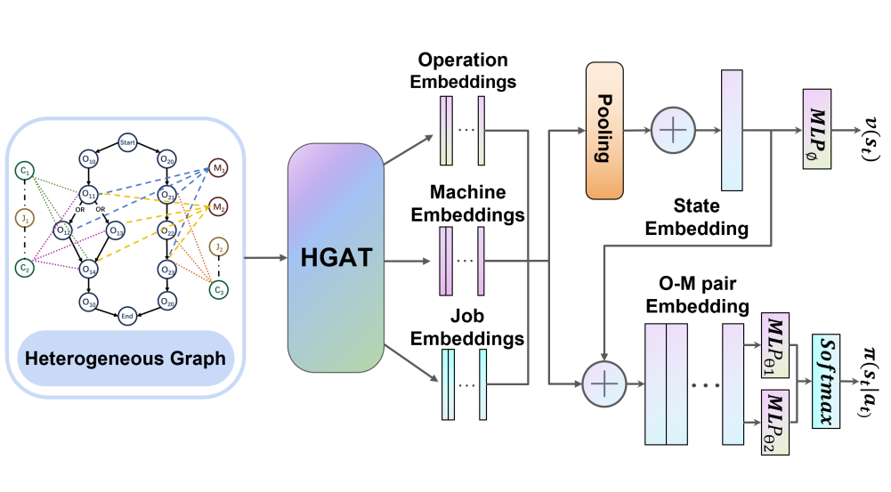
Figure 7: Architecture of neural network.

PREPRINT. UNDER REVIEW.
6.2 Policy Design
A policy πθ(at|st)(or actor) is a mapping from state space S to probability distribution over action space At. The Proximal Policy Optimization (PPO) algorithm [32] is one of our selected methods to train the agent, which also needs a value networkvϕ(st)(or critic). In our framework, the HGAT functions as an encoder, with its parameters being shared between the actor and critic albeit in distinct manners. The whole structure of our neural network is shown in Figure 7.
First, HGAT captures information from the heterogeneous graph and generates node embeddings for each type of nodes: hOij,hJi,hMk. Note that node embeddings of combinations are not used in later steps. Define the set of feasible operations asRt andFt is the set of operations that are not scheduled and do not have unscheduled immediate prerequisite operations.
To derive the action probabilities in the actor, let the set of eligible O-M pairs at time-steptbe:
E = {(Oij, Mk)|Oij ∈( U{C∗t }p)∩Rt, Mk ∈It ∩Pij}
p
To evaluate the waiting action, define future eligible O-M pairs as those with feasible operations and relevant machines processing other tasks:

The state embedding is:

E′ = {(Oij, Mk)|Oij ∈ (U | {C∗t }p)∩Ft, Mk ∈Pij}
p
ht = |    1  |O| | ∑ | HOij|| 1  |M| | ∑ | hM||k 1  |J | | ∑ | hJi | 
 |  |  |  |  |  |  |  | 
 |  | ij |  | k |  | i

Also, we define the embedding of an O-M pair as:
Hijk = | hOij∥hMk∥hJi∥ht
The priorityγ of each eligible pair(Oij, Mk) ∈ Eis calculated as:
γ(at|st) = MLPθ1(Hijk)
and the waiting priorityγ is calculated as:
γ(at|st) = | ∑ | αijkMLPθ2(Hijk)
(Oij,Mk)∈E′
where the attention scoreαijk is calculated as follows:
αijk = | exp [MLPθ1 (Hijk)]  ∑|(Oi′j′,M′k)∈E′ exp [MLPθ1 (Hi′j′k′)]
It should be noted that the independent parametersθ1 andθ2 are utilized to process eligible pairs and waiting actions, respectively. In addition,θ1 is used to determine the weighting of each future eligible pair for the priority of waiting. This is because the importance of each future eligible pair varies, andMLPθ1 can be used to assess the importance of each eligible pair, which in turn informs the weighting of future eligible pairs when calculating the priority of waiting actions.
The probabilities for each action at are calculated by a softmax layer over priorities, which is actually the actor πθ(at|st):
πθ(at|st) = | exp[γ(at|st)]  ∑a′t∈At exp[γ(a′t|st)]

The criticvϕ(st)is derived from the state embedding using
a MLP:
vϕ(st) = MLPϕ(ht)

PREPRINT. UNDER REVIEW.
7 Experiments
7.1 Dataset
To evaluate the efficiency of our method, we conduct 3 experiments on two synthetic datasets of different scales and a public benchmark dataset from [14].
Synthetic Dataset: Based on the structure of AND/OR graph, we generate jobs by computing direct acyclic graphs and add OR-paths recursively. After assigning machines and corresponding processing time to each operation under a certain distribution, we randomly combine jobs for various IPPS problems. For details, refer to Appendix D.
Public Dataset: A widely recognized benchmark in IPPS research introduced by [14]. Kim dataset contains 24 instances with different flexibility.
7.2 | Implementation Details
LetN1, N2, N3 be the number of training, validation and testing instances, andm×ndenotes the problem size where m and n are the number of jobs and machines, respectively. Training instances are generated from 1000 jobs with corresponding machine numbers, which actually consist ofN1 = ( 1000 )problems. We train three models, each
jobnumber
based on synthetic datasets of different problem sizes: 4 × 5, 5×3, and 6×5, which are all relatively small yet complicated and have a validation size ofN2 = 20.
In Experiment 1, we evaluat the models on symmetric datasets that draw on the same size and distribution as the training set. To assess the generalization performance of the trained policies, Experiments 2 and 3 are conducted on a public dataset and on large-scale generated datasets with sizes16×20and20×25, respectively. In all experiments, the size of all test sets isN3 = 50, and we use DRL-G (only choose actions with the highest probability) and DRL-S (choose actions according to the probability distribution) to evaluate policy performance.For details on infrastructure and configurations, please refer to Appendix E.
7.3 Baseline
We compare our model with two types of baseline algorithms.
• OR-Tools: OR-Tools is an open source toolbox by Google [33], which includes the CP-SAT solver, a powerful constraint programming solver known for its strong performance in industrial scheduling [34]. In this paper, we use the CP-SAT solver to implement the MILP model, which is shown in Appendix C, from [12] to obtain exact solutions in 1800 seconds (3600s for Experiment 3).
• Greedy: Dispatching rules have shown significant potential in IPPS problems [35]. We select rules for operation sequencing and machine assignment, respectively. For operation selection, we use rules including Most Work Remaining (MWKR), Most Operations Remaining (MOR), First In First Out (FIFO), and probability described in [35]. Machine assignment is based on the priority calculated from the Shortest Processing Time (SPT), Earliest Finish Time (EFT), and Least Utilized Machine (LUM). In each problem, we randomly choose a combination for each job, reducing a complex IPPS problem to a simplified FJSP problem. Then, at each step, the next operation and the corresponding machine are determined by their rank under certain dispatching rules. Details are attached in Appendix G.
7.4 Evaluation
In order to compare method performance from both efficiency and quality, we use Makespan, Gap, and Time as evaluation metrics, where Makespan refers to the average final optimization objective, Gap is the average relative difference compared to Makespan of OR-Tools, and Time measures the average computation time. For the DRL-Sampling method, we run each instance 50 times and select the best value as the final result. For greedy algorithms, we choose the result of the best priority dispatching rules for each whole dataset.
7.5 Results and Analysis
As shown in Table 1, in all training sizes, Experiment 1 demonstrates that our model consistently outperforms the Greedy method in terms of solution quality, while also being faster than all baseline methods. Our method consistently achieves a smaller gap in relation to OR-Tools compared to the Greedy method, with reductions ranging from 3% to 25%, highlighting the effectiveness of our approach.

PREPRINT. UNDER REVIEW.
Table 1: Evaluation on instances of training sizes.
4×5 | Size | OR-Tools | DRL-G | DRL-S | Best Greedy
 | Makespan | 389.99 | 423.6 | 403.19 | 429.73
 | Gap† | - | 7.43% | 2.92% | 8.79%
 | Time (s) | 1769.31 | 7.65 | 10.23(0.20)* | 91.01(1.82)*
5×3 | Makespan | 452.36 | 505.2 | 474.44 | 590.76
 | Gap† | - | 11.68% | 4.88% | 30.60%
 | Time (s) | 1789.79 | 7.90 | 15.54(0.31) | 48.45(0.97)
6×5 | Makespan | 442.14 | 487.94 | 462.04 | 506.63
 | Gap† | - | 10.36% | 4.50% | 14.59%
 | Time (s) | 1798.84 | 8.37 | 14.68(0.29) | 139.76(2.80)
* The value in parentheses is the time for a single epoch. We ran multiple times and selected the Makespan.
† Gap is relative to OR-Tools.
Table 2: Performance on the Public Benchmark Kim dataset.
Dataset | 4×5  5×3  6×5  4×5  5×3  6×5 | Makespan | Kim | Time(s)
 |  |  | Gap†
LB*  OR-Tools |  | 387.93  392.08 | -  1.07% | -  1796.37
DRL-G |  | 445.17  451.33  444.25  416.42  417  416.21  458.38 | 14.76%  16.34%  14.52%  7.34%  7.49%  7.29%  18.16% | 11.94  17.79  12.12  23.31(0.97)  34.32(0.67)  23.87(0.48)  82.24(1.64)
DRL-S
Best Greedy
* LB indicates the lower bound on the makespan.
† Gap is relative to the OR-Tools makespan.
Applying our model to the public dataset, the result of Experiment 2 in Table 2 shows similar advantages as Experiment 2, reflecting the generalization capability of our approach. Moreover, as shown by the detailed results of Kim dataset in Appendix H, our advantages get larger as the problem size increases.
Experiment 3 (see Table 3) further confirms our advantages in large-scale problems. Although OR-Tools cannot even find a feasible solution, the solving time of DRL is less than one minute. Also, DRL outperforms than OR-Tools in OR-Tools-feasible problems up to11.35%. Strongly proving patterns learned in small and medium instances remain effective in solving larger problems.
Due to page limitations, please refer to Appendix F for more numerical experiments.
8 Conclusions
The IPPS problem is a critical challenge in combinatorial optimization in modern manufacturing systems. In this paper, we propose a novel DRL approach to solving IPPS, which results in a reduced exploration state space, faster solving speed, and smaller makespan gaps compared to greedy algorithms. Extensive experiments on synthetic and benchmark datasets demonstrate the efficiency of our method, particularly in large-scale problems.

PREPRINT. UNDER REVIEW.
Table 3: Generalization performance on large-sized instances.
Dataset | Method | 4×5  5×3  6×5 | Makespan |  | Gap‡ | Time(s)
 |  |  | Feasible* | All†
 | OR-Tools |  |  |  | - | 1800 (7/50 time out)
 |  |  | 566.07 | -
16×20 | DRL-G |  | 538.37 | 537.84 | -4.89% | 19.77
 |  |  | 543.17 | 542.22 | -4.05% | 32.67
 |  |  | 542.2 | 539.54 | -4.22% | 21.89
 | DRL-S | 4×5  5×3  6×5 | 518.22 | 527.06 | -8.45% | 40.59(0.81)
 |  |  | 517.07 | 515.48 | -8.66% | 65.15(1.30)
 |  |  | 518.63 | 517.06 | -8.38% | 41.00(0.82)
 | Best Greedy
 |  |  | 544.80 | 544.89 | -3.76% | 148.66(2.97)
20×25 | OR-Tools | 4×5  5×3  6×5 | 547.03 | - | - | 3600 (16/50 time out)
 |  |  | 508.85 | 518.28 | -7.00% | 26.87
 | DRL-G
 |  |  | 510.94 | 519.86 | -6.60% | 42.37
 |  |  | 512.00 | 519.10 | -6.40% | 28.23
 | DRL-S | 4×5  5×3  6×5 | 484.97 | 495.26 | -11.35% | 56.34(1.13)
 |  |  | 486.15 | 496.84 | -11.13% | 87.25(1.75)
 | Best Greedy |  | 485.67 | 495.24 | -11.21% | 56.88(1.14)
 |  |  | 513.83 | 524.09 | -6.10% | 186.42(3.73)
* Problem set that is feasible to OR-Tools.
‡ Gap is relative to OR-Tools.
References
[1] Ashish Kumar Shakya, Gopinatha Pillai, and Sohom Chakrabarty. Reinforcement learning algorithms: A brief survey. Expert Systems with Applications, 231:120495, 2023.
[2] Quentin Cappart, Thierry Moisan, Louis-Martin Rousseau, Isabeau Prémont-Schwarz, and Andre A Cire. Com-bining reinforcement learning and constraint programming for combinatorial optimization. InProceedings of the AAAI Conference on Artificial Intelligence, volume 35, pages 3677–3687, 2021.
[3] Rongkai Zhang, Anatolii Prokhorchuk, and Justin Dauwels. Deep reinforcement learning for traveling salesman problem with time windows and rejections. In2020 International Joint Conference on Neural Networks (IJCNN), pages 1–8. IEEE, 2020.
[4] J.D. Zhang, Z. He, W.H. Chan, and C.Y. Chow. Deepmag: Deep reinforcement learning with multi-agent graphs for flexible job shop scheduling. Knowledge-Based Systems, 259:110083, 2023.
[5] Y. Liu, X. Zuo, G. Ai, and Y. Liu. A reinforcement learning-based approach for online bus scheduling. Knowledge- Based Systems, 271:110584, 2023.
[6] Qihao Liu, Xinyu Li, Liang Gao, and Guangchen Wang. Mathematical model and discrete artificial bee colony algorithm for distributed integrated process planning and scheduling. Journal of Manufacturing Systems, 61:300–310, 2021.
[7] Rakesh Kumar Phanden, Ajai Jain, and J. Paulo Davim, editors. Integration of Process Planning and Scheduling Approaches and Algorithms. Elsevier, 2021.
[8] Gang Du Yujie Ma and Yingying Zhang. Dynamic hierarchical collaborative optimisation for process planning and scheduling using crowdsourcing strategies. International Journal of Production Research, 60(8):2404–2424, 2022.
[9] Premaratne Samaranayake and Sampath Kiridena. Aircraft maintenance planning and scheduling: an integrated framework. Journal of Quality in Maintenance Engineering, 18(4):432–453, 2012.
[10] Maria LR Varela, Goran D Putnik, Vijay K Manupati, Gadhamsetty Rajyalakshmi, Justyna Trojanowska, and José Machado. Integrated process planning and scheduling in networked manufacturing systems for i4. 0: a review and framework proposal. Wireless Networks, 27:1587–1599, 2021.
[11] J. Zhou, Y. Zhou, B. Wang, and J. Zang. Human-cyber-physical systems (hcpss) in the context of new-generation intelligent manufacturing. Engineering, 5(4):624–636, 2019.

PREPRINT. UNDER REVIEW.
[12] Liangliang Jin, Qiuhua Tang, Chaoyong Zhang, Xinyu Shao, and Guangdong Tian. More milp models for integrated process planning and scheduling. International Journal of Production Research, 54:4387 – 4402, 2016.
[13] R. Barzanji, B. Naderi, and M. A. Begen. Decomposition algorithms for the integrated process planning and scheduling problem. Omega, 93, 2020.
[14] Y. K. Kim, K. Park, and J. Ko. A symbiotic evolutionary algorithm for the integration of process planning and job shop scheduling. Computers & Operations Research, 30(8):1151–1171, 2003.
[15] Y. Li, L. Gao, Q. K. Pan, L. Wan, and K.-M. Chao. An effective hybrid genetic algorithm and variable neighborhood search for integrated process planning and scheduling in a packaging machine workshop. IEEE Transactions on Systems, Man, and Cybernetics: Systems, 49(10):1933–1945, 2018.
[16] S. Luo, L. Zhang, and Y. Fan. Dynamic multi-objective scheduling for flexible job shop by deep reinforcement learning. Computers & Industrial Engineering, 159:107489, 2021.
[17] Wen Song, Xinyang Chen, Qiqiang Li, and Zhiguang Cao. Flexible job-shop scheduling via graph neural network and deep reinforcement learning. IEEE Transactions on Industrial Informatics, 19(2):1600–1610, 2023.
[18] I. Echeverria, M. Murua, and R. Santana. Solving the flexible job-shop scheduling problem through an enhanced deep reinforcement learning approach. arXiv preprint arXiv:, 2023.
[19] W. D. Li and C. A. McMahon. A simulated annealing-based optimization approach for integrated process planning and scheduling. International Journal of Computer Integrated Manufacturing, 20(1):80–95, 2007.
[20] C. Leung, T. Wong, K.-L. Mak, and R. Y. Fung. Integrated process planning and scheduling by an agent-based ant colony optimization. Computers & Industrial Engineering, 59(1):166–180, 2010.
[21] X. Li, X. Shao, L. Gao, and W. Qian. An effective hybrid algorithm for integrated process planning and scheduling. International Journal of Production Economics, 126(2):289–298, 2010.
[22] X. Wu and J. Li. Two layered approaches integrating harmony search with genetic algorithm for the integrated process planning and scheduling problem. Computers & Industrial Engineering, 2021.
[23] B. Han and J. Yang. A deep reinforcement learning based solution for flexible job shop scheduling problem. International Journal of Simulation Modelling, 20(2):375–386, 2021.
[24] C. Zhang, W. Song, Z. Cao, J. Zhang, P. S. Tan, and X. Chi. Learning to dispatch for job shop scheduling via deep reinforcement learning. Advances in Neural Information Processing Systems, 33, 2020.
[25] YC Ho and CL Moodie. Solving cell formation problems in a manufacturing environment with flexible processing and routing capabilities. International Journal of Production Research, 34(11):2901–2923, 1996.
[26] Runqing Wang, Gang Wang, Jian Sun, Fang Deng, and Jie Chen. Flexible job shop scheduling via dual attention network based reinforcement learning, 2023.
[27] I. Echeverria, M. Murua, and R. Santana. Leveraging constraint programming in a deep learning approach for dynamically solving the flexible job-shop scheduling problem. arXiv preprint arXiv:2403.09249, 2024.
[28] Maxime Gasse, Didier Chételat, Nicola Ferroni, Laurent Charlin, and Andrea Lodi. Exact combinatorial optimiza- tion with graph convolutional neural networks, 2019.
[29] Tianhao Liu, Shanwen Pu, Dongdong Ge, and Yinyu Ye. Learning to pivot as a smart expert. Proceedings of the AAAI Conference on Artificial Intelligence, 38(8):8073–8081, March 2024.
[30] Chen Gao, Yu Zheng, Nian Li, Yinfeng Li, Yingrong Qin, Jinghua Piao, Yuhan Quan, Jianxin Chang, Depeng Jin, Xiangnan He, and Yong Li. A survey of graph neural networks for recommender systems: Challenges, methods, and directions, 2023.
[31] Shaked Brody, Uri Alon, and Eran Yahav. How attentive are graph attention networks? ArXiv, abs/2105.14491, 2021.
[32] John Schulman, Filip Wolski, Prafulla Dhariwal, Alec Radford, and Oleg Klimov. Proximal policy optimization algorithms. arXiv preprint arXiv:1707.06347, 2017.
[33] Google. Or-tools.https://github.com/google/or-tools, 2024. Accessed: 2024-07-30.
[34] G. Da Col and E. C. Teppan. Industrial size job shop scheduling tackled by present day cp solvers. InInternational Conference on Principles and Practice of Constraint Programming, pages 144–160. Springer, 2019.
[35] Muhammad Farhan Ausaf, Liang Gao, Xinyu Li, and Ghiath Al Aqel. A priority-based heuristic algorithm (pbha) for optimizing integrated process planning and scheduling problem. Cogent Engineering, 2(1):1070494, 2015.

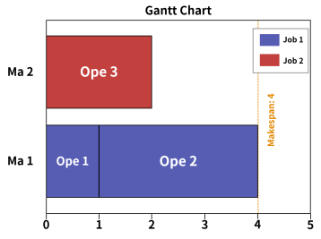
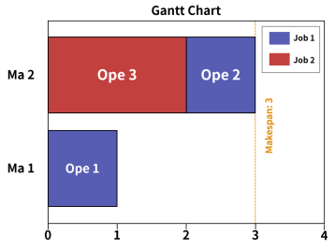
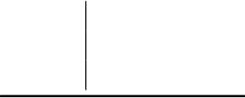

PREPRINT. UNDER REVIEW.
[36] Adam Paszke, Sam Gross, Francisco Massa, Adam Lerer, James Bradbury, Gregory Chanan, Trevor Killeen, Zeming Lin, Natalia Gimelshein, Luca Antiga, et al. Pytorch: An imperative style, high-performance deep learning library. Advances in neural information processing systems, 32, 2019.
[37] Matthias Fey and Jan Eric Lenssen. Fast graph representation learning with pytorch geometric. arXiv preprint arXiv:1903.02428, 2019.
A Properties of MDP Formulation
Although relevant DRL algorithms proposed before have reached competitive performance, they all neglect the value of waiting and arrange feasible ope-ma pairs as soon as possible, which makes them impossible to reach optimality in some cases. Initially, we present a straightforward example to demonstrate this and subsequently show that our formulation is equivalent to the original IPPS problem.
A.1 Example
There’s a simple example (FJSP or IPPS) explaining why the policy without waiting may miss the (near) optimal solution.
ope1 | ma1 | ma2
 | 1 | 1
ope2 | 3 | 1
ope3 | 4 | 2
In this problem, we have only 2 jobs, 2 machines and 3 operations. Operations for job 1 and 2 is {ope1, ope2} and {ope3} respectively and their processing times are above. The optimal schedule for this problem is {(ope1,ma1),(ope3,ma2),(ope2,ma2)}, which has a waiting decision and makespan of 3. However, in the policy without waiting, we would arrange an ope-ma pairly if there exists feasible pairs. Hence, the algorithm would process ope1 and ope3 att = 0and job1 would be available again att = 1. Due to the loss of waiting and ope3’s long processing times, ope2 would be arranged to the same machine as ope1, which means that each job can only be processed on a single machine. Because the total processing times of two jobs on ma1 are both 4, the best makespan under algorithm without waiting would be 4 and cannot reach the optimality.
(a) Optimal (b) No waiting
Figure 8
A.2 Proof of Theorem 1 (Equivalence)
Here we prove that our MDP is equivalent to the original IPPS problem. We define an IPPS solution asD ={d, s, e}, where d = {di|i = 1,2, . . . ,|d|} is the set of schedules, with di being the i-th schedule allocating operation Oi
belonging toJi to machineMi. The functionss(di)ande(di)represent the start and end times ofdi, and the makespan M = max{e(di)|di ∈ d}. We can assumes(di)are non-decreasing withi.
Recall: A scheduledi = (Oi, Mi, Ji)is eligible ⇐⇒ all prerequisite operations of operationOi have been finished, all operations that belong to jobJi and are not prerequisite forOi hasn’t been scheduled and machineMi and jobJi

PREPRINT. UNDER REVIEW.
are idle, which is equivalent to:
∀Om ∈ P(Oi)∃dj s.t.Oj ∈di & e(dj) ≤ s(di)
∀Om ∈ A(Oi)∀dj ∈ {dp|s(dp) ≤ s(di)}, Om ̸= dj
e(dt) ≤ s(di),∀dt s.tMi = Mt, t≤ i
e(dt) ≤ s(di),∀dt s.tJi =Jt, t ≤ i
whereP(Oi)is the set of prerequisite operations of operationOi, andA(Oi)is the set of operations belong to same job withOi and not inP(Oi). For convenient discussion, we defineRi = {(Oh, Mh, Jh)|Oh =Oi ⋁Mh = Mi}for
di = (Oi, Mi, Ji)as the set of schedules containing prerequisite operations ofOi,Mi andJi and the condition above will be:
∀Om ∈ P(Oh)∃dj ∈ Ri s.t.Om = Oj  e(dt) ≤ s(di),∀dt ∈ Ri  ∀Om ∈ A(Oh)∀dj ∈ {dp|s(dp) ≤ s(di)}, Om ̸= Oj | (1)  (2)  (3)
Lemma 1:for∀IPPS solutionD with makespanM,∃D′ with makespanM′ that satisfies:
∀i ∃j s.t.s(di) = e(dj)  M′ ≤ M | (4)  (5)
Proof:Consider an IPPS solutionD that does not satisfy (4). Assumedi is the first schedule that∃!j s.t.s(di) =e(dj). Notice that all schedules in a solution are eligible, we have:
∀dj ∈ Ri, e(dj) < s(di)
We createD′ fromD by following rule:
• d′ =d
• s′(d′i) = min{e(dj)|dj ∈ Ri} < s(di)
• e′(d′i) =s(d′i) +processing time ofdi < e(di)
• s′(d′t) = s(dt), e′(d′t) = e(dt),∀t ̸= i
Then,D′ is also a solution because all schedules also satisfy (1) and (2) andd′i satisfies (4). (1) holds becaused′ = d.
And the reason that (2)(3) holds for all schedules inD′ is:
• From our construction,d′i satisfies (2).
• d′i satisfies (3), because | {dp|s′(dp) ≤ s′(di)} ⊆ {dp|s(dp) ≤ s(di)}
• Fort ̸=i,d′t satisfies (2) because:
– if∀j d′j ∈ Rt,e′(d′j) ≤ e(dj)≤ s(dt) = s′(d′t)
– else,e′(d′j) = e(dj) ≤ s(dt) = s′(d′t)
• Fort ̸=i,d′t satisfies (3) because (assume the operation ind′i, d′t areOm, On respectively):
– ifOm ̸∈ A(On), (3) holds as everything doesn’t change.
– else, we only need considerdi as:
d′j = dj, s′(d′j) =s(dj), e′(d′j) = e(dj), j ̸= i
we knows(dt) < s(di)from (3) anddt ∈ Ri, which means
s′(d′t)< e′(d′t) ≤ s′(d′i)
So, (3) holds
Also, ase′(d′j) ≤ e(dj),∀j,M′ ≤ M. Keep following the procedure described above, we can find a solution ˆDsatisfies
(4)(5).
Lemma 2:For any solutionDsatisfying (4), it can be attained by MDP.

PREPRINT. UNDER REVIEW.
Proof:In our MDP formulation described before, a scheduledi = (Oi, Mi, Ji)is eligible in the time steptif (1) (2) (3) holds when s(di) = t, so we need to prove that all s(di) can be attained in MDP. Notice that the support set of {s(dj)|dj ∈ D}can be written as a non-decreasing sequence0 = s0, s1, . . . sN. We prove by induction:
(1)Basic case, start time 0 can be attained by MDP and MDP can schedule as same asD fordi withs(di) = 0, which is obvious.
(2) Assume∀si ∈ {st|st ≤ sk, k < N}can be attained by MDP, and MDP have same schedules with start time≤sk
with original solutionD.Notice We must has a completion time that equalssk+1 as all schedules with start time≤ sk is as same asDand we can keep waiting until time equalssk+1 because each time-step is a completion time. Then from (4), we can knowSk+1 can be attained and MDP have same schedules with start time≤ sk + 1with original solution D.
A trajectory given from MDP must be a feasible solution because the action space design guarantee (1)(2)(3) must hold. Also, from Lemma 1 and Lemma 2, we know that for any optimal solution in original problem, we can get another optimal solution that can be given by MDP by a simple adjustment. So, it’s equivalent to optimize original problem and MDP formulation problem.
B Graph Features
Raw features for Nodes:
• Operations:
– Number of prerequisite operations.
– Whether this operation is scheduled.
– Whether operation is feasible.
– Waiting time for a feasible operation(=0 for infeasible operations).
– Time remained for the processing operation that is scheduled(=0 for unscheduled operation).
• Machines:
– Number of neighboring operations.
– The time when this machine becomes idle.
– Utilization: ratio of the non-idle time to the total production time.
– Whether the machine is working.
– Idle time from available time to now.
– Time remained for working machine to finish the working operation.
• Combinations:
– Estimated completion time for these combinations.
– Ratio of estimated end time to estimated min end time for combinations associated to the same job.
• Jobs:
– Ratio of estimated end time to max estimated end time for all jobs.
Raw features for edges:
• Operations⇔Machines:
– Processing time used by the machine to process the operation.
C MILP Model
To attain the optimal solution, we implement the MILP (Mixed Integer Linear Programming) model suggested by[12] using the CP-SAT solver of OR-Tools, an open source optimization library developed by Google. For more details, please refer cited paper.

PREPRINT. UNDER REVIEW.
Signal:
• i, i′: Job indices,1 ≤ i ≤ |n|
• j, j′: Operation indices,1≤j ≤ |ni|
• k, k′: Machine indices
• h: Combination index
• Oij: Thejth operation of theith job
• Oihj: Thejth operation of thehth combination of theith job
Sets and Parameters:
• A: A very large positive number.
• Pijk: Processing time of jobOij on machinek.
• Rh: The set of jobs contained in thehth combination of jobi.
• Ki: The set of all combinations of jobi.
• n: The set of jobs.
• ni: The set of all jobs in the network diagram of jobi.
• Mij: The set of all candidate machines for jobOij.
• Qijj′: Equals 1 if jobOij is processed ly or directly before jobOij′; equals 0 otherwise.
Variables:
• Xihjk: Equals 1, if OperationOihj is allocated to Machinek.
• Cihj: The completion time of the operationOihj.
• Cmax: Maximum makespan.
• Yih: Equals 1 if thehth combination of jobiis selected; equals 0 otherwise.
• Zijj′: Equals 1 if jobOij is processed directly or indirectly before jobOij′; equals 0 otherwise.
Constraints:
For each jobi, exactly one combinationhmust be selected.
∑ | Yih = 1, | ∀i
h∈Ki
If combinationhfor jobiis selected, the sum of operations in the combination is equal to 1, else it equals 0.
∑ | Xihjk = Yih, | ∀i, h∈Ki, j ∈ Rih
k∈Mij
If combinationhis not selected, the completion time of all operations in the combination is 0.
A·Yih ≥ Cihj, ∀i, h ∈ Ki, j ∈ Rih
Guarantee correct completion time of operations.
Cihj′ ≥ Cihj + | ∑ | Xihj′k′Pij′k′,
k′∈My′
∀i, h ∈ Ki, j, j′ ∈Rih, j ̸=j′, Vij′ = 1

Zijj′ +Zij′j = 1,

∀i, j, j′ ∈ ni, Qijj′ +Qij′j = 0, j ̸= j′

PREPRINT. UNDER REVIEW.
Cihj′ ≥ Cihj + | ∑ | Xihj′k′Pij′k′ −A(1−Zijj′),
k′∈Mv
∀i, h ∈ Ki, j, j′ ∈Rih, j ̸=j′
Guarantee the processing order of operations in the same machines.
Cih′j′ ≥Cihj +Xi′h′j′k′Pi′k′
−A(1−Wijj′j′)−A(2−Xihjk −Xi′h′j′k′),
Cihj ≥Cih′j′ +XihjkPijk −A·Wijj′j′
−A(2−Xihjk −Xih′j′k′),
∀i, i′, i̸= i′, h ∈ Ki, h′ ∈ Ki′, j ∈ Rih,
j′ ∈ Ri′h′, k, k′ ∈ Mij ∩Mij′, k = k′
Makespan is the maximum completion time of all operations.
D | Cmax ≥ Cihj, | ∀i, h ∈ Ki, j ∈ Rih
 | Problem Generation Approach
Based on the structure of AND/OR graph, we generate jobs by computing direct acyclic graphs and add OR-paths recursively. After assigning machines and corresponding processing time to each operation under a certain distribution, we randomly combine jobs for various IPPS problems.
Here, we define OR-link path as the sub-path, a path that is not the OR-link path as the main-path.
D.1 Non-Conforming Situations
In the following 2 scenarios, there are links between sub-paths and main-path such that the order of operation cannot be determined by definition.
• Link from main-path to sub-path: It is unclear whether operation 12 can be executed as it must be completed after operation 7 and 11 while operation 12 is in an OR-link path (as shown in Figure 9a).
• Link from sub-path to main-path: It’s unclear that operation 12 can be done when operation 6 is not completed. (as shown in Figure 9b).
To avoid the scenarios above where operations in the main path and sub-path are linked, we employ a nested approach to generate the problem incrementally. The specific steps are as follows.
Well-Defined IPPS Problems Generation
Step 1: Construct Directed Acyclic Graph (DAG) as Main-path
• Input: Range of the number of operations in main-path, Maximum Out-degree...
• Initialize the start node and end node, then establish a sequence of operation nodes between the start and end nodes under input requirements.
Step 2: Add Sub-path to Main-path
• Input: The number of OR-connector, range of the number of total operations and operations in each sub-path, Maximum number of OR-connector’s out-degree
• Randomly selectnedges from the main path as initiation and integration points for the OR sub-paths, then generatemi sub-paths withki nodes between originally chosen edgei.n, m, k is randomly decided under input requirements.
• For each added OR-path, randomly add and-path into it by selecting edges in sub-paths then generate and-path between the chosen edge.

PREPRINT. UNDER REVIEW.

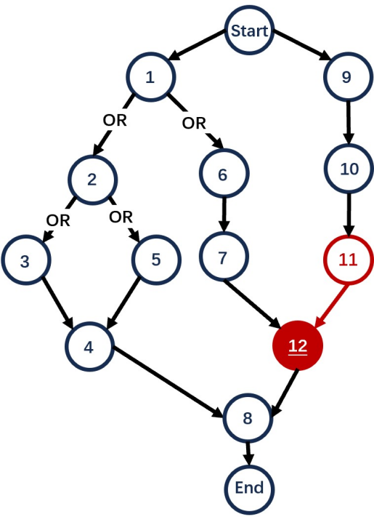
(a) Main path to sub-path

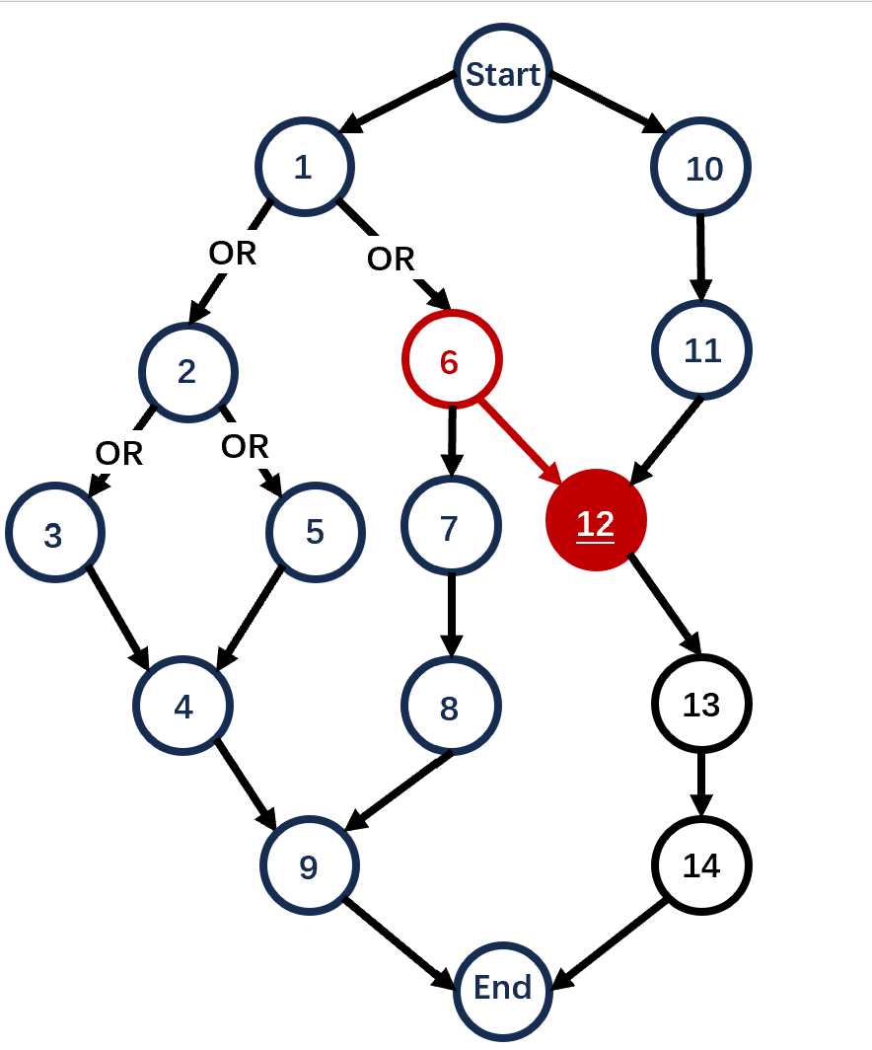
(b) Sub-path to main path

Figure 9: Comparison of path transitions.
• Every time insert paths to a chosen edges, if an edge of a join-node (where two sub-path emerge) is chosen, we automatically create a supernode at the end of the new sub-path, which then connects to the original join node.
• Check if the number of total operations meets the constraint. If not, generate a new job. Otherwise, save the well-defined job.
Step 3: Assignment of Machine and Processing Time
• Input: The number of machines, the range of processing time and the probability that one machine is assigned to each operation.
• For each operation, randomly assign machines to the operation using input probabilities with processing time uniformly generated by range of processing time.
Step 4: Combine Jobs to a Well-defined Problem
• Input: The number of jobs and machines
• Randomly combine required jobs number of well-defined jobs using the required number of machines.
E Infrastructure and Configuration
E.1 Infrastructure
We use a machine with an 11th Gen Intel(R) Core(TM) i7-11800H @ 2.30GHz CPU and NVIDIA GeForce RTX 3070 GPU for DRL and greedy dispatching rules. For solving MILP by OR-tools CP-SAT Solver, we use 32 cores of an Intel Xeon Platinum 8469C at 2.60 GHz CPU with 512 GB RAM. Our core functions are implemented using PyTorch[36] and PyTorch Geometric(PyG)[37].
E.2 Neural Networks Parameters
Below are the essential settings for our neural networks. Note that the length of lists in the Value column for hidden_dims or num_heads indicates the depth.



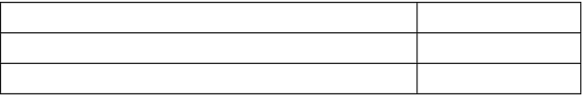
PREPRINT. UNDER REVIEW.
Parameter Value
actor hidden_dims (layers) [64, 32]
critic hidden_dims (layers) [64, 32]
GNN pooling_method mean
GNN jumping_knowledge max
GNN model GAT
GNN num_heads (layers) [2, 2, 2]
GNN hidden_dim 64
E.3 Environment Parameters
We run 3 instances in a batch parallel and the size of validation set is set to 20.
Parameter Value
batch_size 3
valid_batch_size 20
E.4 Training Parameters
Below are the training configurations. The learning rate (lr) and betas are fundamental parameters of the Adam optimizer. The parameter eps_clip in PPO-clip is adjusted by adding a multiplier (clip_multi) and an upper bound (clip_ub) to increase it to the upper bound. It’s important to note that lr, gamma, and parallel_iter(interval of changing instances) were tuned, and we identified a range that yielded competitive results in our tuning experiment. In our final trained model, we selected values of 5e-4, 0.99, and 20 respectively.
Parameter Value
lr 5e-5 - 5e-4
betas [0.9, 0.999]
gamma (Discounting rewards) 0.95 - 0.995
A_coeff (weight of policy loss) 1
clip_ub 0.5
K_epochs (update epoch in PPO) 3
eps_clip 0.3
vf_coeff (weight of value loss) 0.5
clip_multi 1.002
entro_coeff (weight of entropy loss) 0.05
parallel_iter 20 - 50
save_timestep (validate interval) 10
max_iterations 30000
minibatch (update batchsize in PPO) 512
update_timestep (update interval) 5
entropy_discount 0.997
F More Experiment Results
F.1 Ablation Experiments
To demonstrate the effectiveness of our reward function design along with the heterogeneous graph and updating design, we perform two ablation experiments using datasets with (5 jobs, 3 machines) as described previously. In these ablation experiments, all curves maintain the same configurations and run for 1500 training epochs, and we assess the validation curve (per 10 epochs).
Figure10a presents a comparison between the Naive Reward, which utilizes the difference in the maximum finished time of the scheduled operations, and our estimation-based Reward. Our reward function shows improved stability and competitiveness.
Figure10b presents a comparison of three distinct graph-based state representations: theO-M graph, which utilizes a graph with only two types of nodes — operation and machine, theNot-residual graphthat retains nodes which are

PREPRINT. UNDER REVIEW.

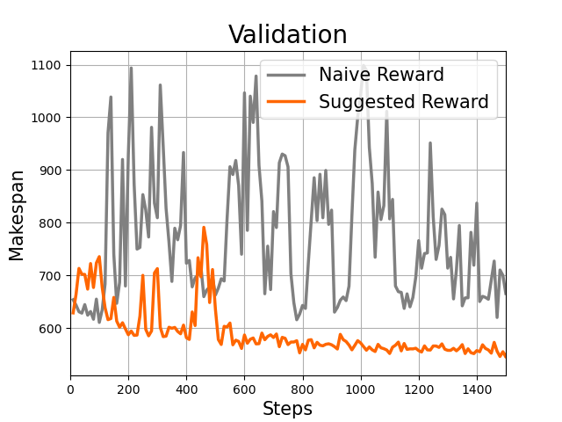

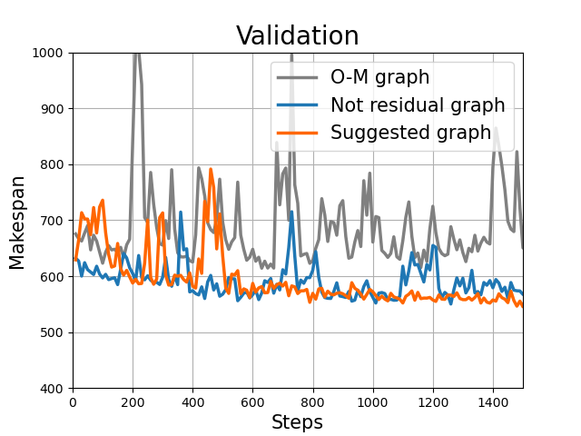

(a) Reward Function (b) Graph Design
Figure 10: Comparison of path transitions.
ineligible or unnecessary, and our proposed graph with four types of nodes, which exclusively keeps eligible nodes as previously detailed. The proposed graph shows enhanced competitiveness and stability. Furthermore, it achieves a faster inference speed than theNot-residual graphdue to the reduced aggregation of neighborhood information.
F.2 Additional Experiment in Large-scale Problem
As shown in Table 4, the difference between the results of DRL and Greedy decreases as the size of the problem increases, indicating that our methods are particularly effective for large-scale problems. We present experimental results from two relatively large, generated datasets: 16 × 20 and 20 × 25 in the main text. To further assess our efficiency, we conduct an additional experiment on 10 instances, each with 25 jobs and 20 machines. The results, shown in Table 7, further confirm that our method has significant potential for large-scale problem solving.
G Details of Greedy Dispatching Rules
G.1 Selecting Operation Rules
We utilize established greedy rules for FJSP within IPPS. To implement these FJSP rules, we initially choose a single combination for each job before application, as the rule is only executable with one specific combination.
In addition, we use a greedy rule designed for IPPS suggested by [35], which we call Muhammad.
• First In First Out (FIFO), which handles the earliest operation in a machine’s queue to be processed.
• Most Work Remaining (MWKR), which handles the job that has the largest amount of work left to be done.
• Most Operation Number Remaining (MOR), which handles the job with the greatest number of remaining tasks.
• Muhammad, which selects a job according to the following probability:
Pi = | Ci  ∑i Ci
whereCi is determined based on the ratio of the estimated finish time of the jobTm to the critical timeTc. The definitions ofTm andTc are as follows:
Tm refers to the minimum machining time calculated by summing the shortest processing times for all operations in a job, and the job with the largestTm is identified as the critical job, with its machining time defined as the critical timeTc.
The values ofCi are then assigned according to the following conditions:

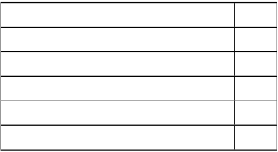
PREPRINT. UNDER REVIEW.
Condition  Tm ≥ 0.95Tc  0.85Tc ≤ Tm <0.95Tc  0.70Tc ≤ Tm <0.85Tc  0.50Tc ≤ Tm <0.70Tc  Tm < 0.5Tc | C  5  4  3  2  1
To assign priorities, each job’s machining timeTm is compared withTc, and a critical valueCi is assigned based on the conditions outlined in the table.
G.2 Selecting Machine Rules
For the machine selection criteria, the following rules have been considered:
• Shortest Processing Time (SPT), which assigns a machine with the shortest processing time for an operation. • Earliest Ending Time (EET), which selects the machine where an operation can start earliest.
• Least Utilized Machine (LUM), which selects the machine with least load.
G.3 Workflow
The Algorithm 1 displays the workflow of greedy rules. Each time an O-M pair is selected, we assign its start time to the earliest possible moment it can begin processing.
Algorithm 1Geedy Dispatching Rules
Require: Repeat timesN.
1: Loading instances and Initializing environment
2: forn= 1,2, . . . ,N do
3: whilest is not terminaldo
4: Use Greedy Rules to select a O-M pair.
5: | Schedule the pair at the earliest possible time.
6:  7: | Receive rewardrt and enter the next statest+1.  Update environment.
8: | end while
9: end for
10: Choose the solution with min makespan.
11: return
H | Experiment Details in Open Benchmarks
H.1 | Algorithms
In this section, we present a detailed training and testing process.
H.1.1 Training Phase
For training, we use the PPO-clip algorithm. The pseudo-code of PPO algorithm is as follows.
H.1.2 Inference Phase
DRL-Sample (DRL-S) and DRL-Greedy (DRL-G) are two methods used during the inference phase. Specifically, DRL-G selects actions based on the highest probability, whereas DRL-S selects actions according to the probability distribution determined by the actor. The pseudo-code of these methods are as follows:
H.2 Results
The complete results of the Kim dataset are shown in Table 5 and Table 6.

PREPRINT. UNDER REVIEW.
Algorithm 2Training procedure of PPO-clip
Require: Total training epoch isT, the interval of changing instances isP and the interval of updating isU
1: Initializing trainable parametersω of HGAT, policy networkActorθ and ValueCriticϕ network.
2: Initializing Data-Generator or preparing set of IPPS instances.
3: foriter= 1,2, . . . ,T do
4: Loading data to a batch and Initializing environment
5:  6:  7: | forb = 1,2, . . . ,P do  whilest is not terminaldo  Extract embeddings of O-M pairs.
8:  9:  10: | Sampleat ∼ Actorθ(·|st)  Receive rewardrt and enter next statest+1  Update environment and memory.
11: | end while
12:  13: | ifb modU = 0then  Flatten states in memory.
14: | Calculate PPO loss.
15: | Update network parameters.
16: | end if
17: | end for
18: end for
19: return
Algorithm 3DRL-G
Require: Repeat timesN.
1: Load the models that have already been trained.
2: Loading instances and Initializing environment
3: forn= 1,2, . . . ,N do
4: whilest is not terminaldo
5: Extract embeddings of O-M pairs.
6:  7:  8: | Selectat = argmax(Actorθ(·|st))  Get the next statest+1  Update environment.
9: | end while
10: end for
11: Choose the solution with min makespan.
12: return
Algorithm 4DRL-S
Require: Repeat timesN.
1: Load the models that have already been trained.
2: Loading instances and Initializing environment
3: forn= 1,2, . . . ,N do
4: whilest is not terminaldo
5: Extract embeddings of O-M pairs.
6:  7:  8: | Sampleat ∼ Actorθ(·|st)  Get next statest+1  Update environment.
9: | end while
10: end for
11: Choose the solution with min makespan.
12: return

PREPRINT. UNDER REVIEW.
Size |  |  |  | DRL-G |  |  |  | DRL-S
4×5 |  |  |  | 5×3 |  | 6×5 |  | 4×5 |  | 5×3 |  |  | 6×5
6×15 6.04% 7.23% 7.19% 0.13% -0.18% 0.63%
9×15 -0.08% 2.17% -1.05% -6.25% -5.75% -6.29%
12×15 -1.84% 0.09% -3.60% -9.80% -10.15% -10.70%
15×15 -6.29% -9.19% -5.79% -14.62% -12.80% -14.42%
18×15 -10.71% -4.54% -6.72% -10.16% -10.34% -11.07%
Table 4: Average Gap Across Different Problem Sizes in the Kim dataset. The gap is relative to the best greedy rule for each problem.
Greedy rules | MWKR |  |  | MOR |  |  |  | FIFO |  | Muhammad |  |  |  |  |  | BCI
SPT |  | EFT | LUM | SPT | EFT |  | LUM | SPT | EFT | LUM |  | SPT |  | EFT | LUM
problem01 | 452 | 523 | 543 | 427 | 532 |  | 518 | 475 | 544 | 538 | 427 |  |  | 472 | 494 | 427
problem02 | 422 | 475 | 460 | 387 | 392 |  | 393 | 438 | 435 | 431 | 398 |  |  | 376 | 387 | 376
problem03 | 417 | 473 | 447 | 385 | 422 |  | 420 | 469 | 491 | 504 | 374 |  |  | 388 | 378 | 374
problem04 | 369 | 381 | 359 | 319 | 329 |  | 331 | 382 | 361 | 371 | 311 |  |  | 330 | 336 | 311
problem05 | 419 | 555 | 455 | 386 | 388 |  | 392 | 423 | 388 | 414 | 375 |  |  | 364 | 369 | 364
problem06 | 571 | 537 | 509 | 558 | 508 |  | 491 | 504 | 536 | 572 | 526 |  |  | 505 | 489 | 489
problem07 | 447 | 500 | 571 | 434 | 401 |  | 434 | 443 | 456 | 483 | 425 |  |  | 392 | 388 | 388
problem08 | 536 | 448 | 429 | 432 | 393 |  | 401 | 443 | 403 | 414 | 427 |  |  | 378 | 395 | 378
problem09 | 494 | 523 | 505 | 544 | 511 |  | 535 | 427 | 533 | 518 | 429 |  |  | 486 | 474 | 427
problem10 | 540 | 537 | 521 | 492 | 510 |  | 489 | 567 | 553 | 564 | 505 |  |  | 506 | 509 | 489
problem11 | 536 | 513 | 495 | 463 | 420 |  | 433 | 502 | 470 | 521 | 447 |  |  | 442 | 446 | 420
problem12 | 446 | 477 | 465 | 402 | 353 |  | 399 | 505 | 398 | 445 | 391 |  |  | 377 | 400 | 353
problem13 | 653 | 610 | 596 | 563 | 500 |  | 503 | 641 | 566 | 618 | 564 |  |  | 521 | 503 | 500
problem14 | 555 | 614 | 617 | 517 | 441 |  | 487 | 496 | 521 | 540 | 500 |  |  | 456 | 461 | 441
problem15 | 494 | 571 | 505 | 555 | 499 |  | 511 | 490 | 514 | 537 | 483 |  |  | 496 | 485 | 483
problem16 | 581 | 583 | 586 | 533 | 490 |  | 507 | 601 | 585 | 627 | 570 |  |  | 529 | 547 | 490
problem17 | 614 | 618 | 551 | 543 | 452 |  | 490 | 551 | 547 | 517 | 540 |  |  | 518 | 517 | 452
problem18 | 503 | 533 | 512 | 488 | 391 |  | 429 | 524 | 476 | 476 | 454 |  |  | 445 | 457 | 391
problem19 | 677 | 663 | 654 | 604 | 513 |  | 540 | 655 | 606 | 637 | 596 |  |  | 559 | 566 | 513
problem20 | 618 | 590 | 571 | 539 | 475 |  | 488 | 579 | 552 | 571 | 577 |  |  | 532 | 543 | 475
problem21 | 662 | 669 | 621 | 614 | 508 |  | 512 | 565 | 574 | 648 | 563 |  |  | 506 | 538 | 506
problem22 | 709 | 721 | 718 | 673 | 535 |  | 557 | 640 | 622 | 693 | 630 |  |  | 587 | 601 | 535
problem23 | 642 | 662 | 628 | 579 | 487 |  | 517 | 621 | 639 | 641 | 562 |  |  | 566 | 570 | 487
problem24 | 770 | 756 | 740 | 709 | 551 |  | 607 | 754 | 714 | 716 | 696 |  |  | 636 | 648 | 551
Average | 546.95 563.83 544.08 506.08 458.38 474.33 528.96 520.17 541.50 490.47 473.63 479.21 458.38
Table 5: Greedy Result for Kim.
In Table 4, we compare the gap relative to the best greedy result for each problem across different sizes. It is evident
that the gap between the results of DRL and Greedy decreases as the problem size increases. This suggests that our
method demonstrates significant potential in solving large-scale problems.

PREPRINT. UNDER REVIEW.
Problem | 4×5 | DRL-G | 6×5 | 4×5 | DRL-S | 6×5 | Greedy |  | OR-tool | LB*
 |  | 5×3 |  |  | 5×3 |  | Best | Best
 |  |  |  |  |  |  | One† | Choice‡

problem01 | 523 | 496 | 486 | 462 | 468 | 484 | 532 | 427 | 427 | 427
problem02 | 377 | 413 | 421 | 360 | 363 | 364 | 392 | 376 | 343 | 343
problem03 | 372 | 375 | 390 | 372 | 363 | 367 | 422 | 374 | 346 | 344
problem04 | 334 | 364 | 325 | 318 | 312 | 315 | 329 | 311 | 306 | 306
problem05 | 343 | 338 | 345 | 332 | 330 | 331 | 388 | 364 | 318 | 318
problem06 | 528 | 496 | 533 | 483 | 474 | 487 | 508 | 489 | 427 | 427
problem07 | 396 | 403 | 392 | 374 | 383 | 385 | 401 | 388 | 372 | 372
problem08 | 397 | 407 | 404 | 362 | 360 | 356 | 393 | 378 | 343 | 343
problem09 | 493 | 495 | 506 | 484 | 484 | 479 | 511 | 427 | 427 | 427
problem10 | 517 | 544 | 500 | 474 | 486 | 474 | 510 | 489 | 427 | 427
problem11 | 371 | 441 | 404 | 367 | 367 | 368 | 420 | 420 | 344 | 344
problem12 | 357 | 338 | 367 | 338 | 334 | 332 | 353 | 353 | 318 | 318
problem13 | 525 | 498 | 492 | 478 | 479 | 485 | 500 | 500 | 427 | 427
problem14 | 407 | 429 | 405 | 383 | 385 | 384 | 441 | 441 | 372 | 372
problem15 | 517 | 503 | 488 | 483 | 488 | 481 | 499 | 483 | 427 | 427
problem16 | 510 | 518 | 505 | 483 | 478 | 475 | 490 | 490 | 427 | 427
problem17 | 392 | 419 | 405 | 377 | 372 | 373 | 452 | 452 | 382 | 344
problem18 | 411 | 390 | 385 | 350 | 353 | 344 | 391 | 391 | 322 | 318
problem19 | 504 | 557 | 502 | 472 | 473 | 477 | 513 | 513 | 427 | 427
problem20 | 439 | 424 | 434 | 399 | 389 | 387 | 475 | 475 | 385 | 372
problem21 | 518 | 529 | 496 | 474 | 480 | 475 | 508 | 506 | 427 | 427
problem22 | 538 | 496 | 506 | 473 | 487 | 473 | 535 | 535 | 427 | 427
problem23 | 423 | 433 | 457 | 401 | 406 | 403 | 487 | 487 | 534 | 372
problem24 | 492 | 526 | 514 | 495 | 494 | 490 | 551 | 551 | 455 | 427
Table 6: DRL Result For Kim. †Best One refers to the result of greedy rule that has a minimum average makespan while‡Best Choice is the best greedy result for each problem. *LB refers to lower bound of Kim dataset demonstrated in [6]
Problem | 4×5 | DRL-S | 6×5 | 4×5 | DRL-G | 6×5 | Best | Greedy | OR-tool
 |  | 5×3 |  |  | 5×3 |  |  | Best
 |  |  |  |  |  |  | One† | Choice‡

problem01 | 412 | 424 | 415 | 427 | 446 | 438 | 480 | 480 | 621
problem02 | 417 | 412 | 423 | 424 | 438 | 781 | 473 | 473 | 1659
problem03 | 421 | 419 | 415 | 496 | 438 | 499 | 483 | 483 | 692
problem04 | 418 | 413 | 423 | 459 | 444 | 452 | 479 | 479 | 1045
problem05 | 417 | 421 | 419 | 537 | 420 | 434 | 480 | 480 | 1134
problem06 | 421 | 417 | 414 | 448 | 449 | 430 | 479 | 479 | 887
problem07 | 417 | 419 | 416 | 429 | 421 | 429 | 472 | 472 | 481
problem08 | 420 | 420 | 419 | 465 | 440 | 442 | 476 | 476 | 1152
problem09 | 422 | 419 | 418 | 438 | 432 | 452 | 465 | 465 | 884
problem10 | 419 | 410 | 425 | 445 | 439 | 455 | 473 | 473 | 469
Average Gap | - | - | - | - | - | - | - | - | -
 | 46.32% | 46.43% | 46.28% | 41.82% | 44.01% | 40.46% | 38.93% | 38.93%
Table 7: Performance in problems of size 25×20. †Best One refers to the result of greedy rule that has a minimum average makespan while ‡Best Choice is the best greedy result for each problem.

