**NATIONAL INSTITUTE OF** **TECHNOLOGY, TIRUCHIRAPPALLI**

**Tamil Nadu-620015**



# Database Management System LAB

**PROJECT REPORT**

Submitted By: Submitted To:

**Dr. U. Vignesh**

**Sumit Patil**

**Roll No.-205119101**

**MCA-II semester ‘A’**

**NATIONAL INSTITUTE OF TECHNOLOGY,**

**TIRUCHIRAPPALLI-15**



## **CERTIFICATE**

*This is to certify that* ***Mr. Sumit Patil,*** *student of 2nd semester MCA (batch 2019-2022) of National Institute of Technology, Tiruchirappalli has successfully completed the project*

**Employee Payroll Processing System**

*in* ***Tkinter(Python)/MySQL*** *under the guidance of* ***Dr. U. Vignesh***

Signature

***Dr. U. Vignesh***

**ACKNOWLEDGEMENT**

I have taken efforts in this project. However, it would not have been possible without the kind support and help of many individuals and organizations. I would like to extend my sincere thanks to all of them.

I am highly indebted to NIT, Trichy for their guidance and constant supervision as well as for providing necessary information regarding the project & also for their support in completing the project.

I would like to express my gratitude towards **Dr. U. Vignesh** for his kind co-operation and encouragement which help me in completion of this project.

**Dr. U. Vignesh**

(Department of Computer Applications)

INDEX

1. **ABSTRACT**
2. **INTRODUCTION**
3. **SCOPE**
4. **DEFINITION, ACRONYMS AND ABBREVIATION**
5. **DATA FLOW DIGRAM**
6. **DEFINITION OF THE PROBLEM**
7. **ADMIN REQUIRMENTS**
8. **HARDWARE SPECIFICATION**
9. **SOFTWARE SPECIFICATION**
10. **SYSTEM ANALYSIS**
11. **DESGIN AND ANALYSIS**
12. **GRAPHICAL OVERVIEW**

**Abstract**

Abstract

The payroll management system is a set of processes that helps you streamline salaries, bonuses, deductions, taxes, and other necessary aspects of the net pay of all the employees in your organization.

There are two primary objectives of the payroll management system in India. One is the macro objective, which is related to sales, strategy, revenue, etc. Another is micro, which is associated with the daily tasks of the business.

You don’t have to worry about handling, managing, and creating paylips, salaries, and deductions of the employees. The tax deductions are also automated or handled by the outsourcing team. You only have to focus on major tasks such as the efficiency of sales, revenue, strategy, etc.

The project “**Employee payroll system**” is developed in Python (tkinter GUI) and MYSQL , which focuses on basic operations like adding new member, generate salary slip, and updating information, searching employee and members and and facilitated to see the transaction detail.

**The software** “**Employee payroll system**”  **main modules.**

* Generating the salary slip on weekly bases.
* Store the information of transaction.
* Searching information of Employee with the ID.
* Holding information about Employee.
* Adding information of new Employee.
* Updating information of Employee.
* Displaying the list of all employee

# INTRODUCTION

A database management system (DBMS) refers to the technology for creating and managing databases. Basically DBMS is a software tool to organize (create, retrieve, update and manage) data in a database.

The main aim of a DBMS is to supply a way to store up and retrieve database information that is both convenient and efficient. By data, we mean known facts that can be recorded and that have embedded meaning. Normally people use software such as DBASE IV or V, Microsoft ACCESS, or EXCEL to store data in the form of database.

Database systems are meant to handle large collection of information. Management of data involves both defining structures for storage of information and providing mechanisms that can do the manipulation of those stored information. Moreover, the database system must ensure the safety of the information stored, despite system crashes or attempts at unauthorized access.

This project is aim at computerizing the manual process of Payroll system. Front end and backend are implemented using ‘Tkinter’ and ‘MySQL’ respectively. The project consists of different forms(entity) namely Add, Update, Billing which are used for maintaining Employee Data and Transaction details. The forms have number of entries. As well as each entry will be used to hold the information of Employee in organization.

Definition, Acronyms and abbreviations

**Admin:** He is able to add new employee/generate a payslips /

Manipulate the data and Charges and remove data from database**.**

**Employee Detail:** Detail of Employee such as ID,name contact,gender, DOB.

**Transaction detail**: Detail of each transaction like date,amount,employee id ,name,.

**Python (tkinter):** It is used to provide graphical user

Interface.

**MySQL :** MySQL database is database managment system that

delivers a flexible and free database platform.

### **Display information**

In this particular project, we have taken Tkinter as a front end in order to display the information which are stored in the backend database called MySQL.

Tkinter is the standard GUI library for Python. Python when combined with Tkinter provides a fast and easy way to create GUI applications. Tkinter provides a powerful object-oriented interface to the Tk GUI toolkit.

Creating a GUI application using Tkinter is an easy task. All you need to do is perform the following steps −

* Import the Tkinter module.
* Create the GUI application main window.
* Add one or more of the above-mentioned widgets to the GUI application.
* Enter the main event loop to take action against each event triggered by the user.

### **User Interfaces**

Our interactions with computers has become dominated by a visual paradigm that includes windows, buttons, menus, pointing device, such as a mouse. Although we are familiar with the syntax of MySQL, advances in MySQL have made possible other forms of advantages.

**What is MySQL?**

MySQL is multithreaded, multi user SQL database management System (DBMS). The basic program run as server providing multiuser access to a number of databases. The project’s source code is available under terms of the GNU(General Public Union), as well as under a variety of property arguments. MySQL is a database. The data in a MySQL is stored in a Database objects called tables. A table is a collection of related data entries and it consists of columns and rows. The databases are useful when storing information categorically.

MySQL is a central components of the LAMP open source web application software stack (and other “AMP” stacks). LAMP is an acronym for Linux, Apache, MySQL, Perl/PHP/Python. Application that use the MySQL database include PyCharm, TYP03, MODx, Joomla, WordPress, PHPBB, MyBB and Drupal. MySQL is also used in many high profile, large scale web sites, including Google(Though not for the searches).

**MySQL Command Syntax**

As you might have observed from the simple program in the previous section, MySQL uses mainly uses six commands in which SELECT is used to retrieve rows selected from one or more tables. FROM refers to the table from which we need to select the attributes. WHERE clause, if given, indicates condition or conditions that rows must satisfy to be selected. where_ condition is expression that evaluates to true for each row to be selected. This statement selects all rows if there is no where clause. GROUP BY clause used to group the values of the attributes provided that values must be same. HAVING clause is applied nearly last, just before items are sent to the client, with no optimization. If the HAVING clause refers to a column that is ambiguous, warning occurs. ORDER BY clause is used for the purpose of sorting the values of the attributes in a result. If you use GROUP BY, output rows are sorted according to GROUP BY columns as if you had an ORDER BY for the same columns.

**Scope**

The scope of the project is managing a consistency and storage of data by dedicated data administrator. It provides most of the features that a Database Management System should have. It is developed by using MySQL database. It has been implemented in WINDOWS platform.

## **Software specification**

MySQL Libraries

MySQL Client Server

PhyCham 3.7

Operating system : Windows O.S.

**1.python(tkinter):**

Python offers multiple options for developing GUI (Graphical User Interface). Out of all the GUI methods, tkinter is the most commonly used method. It is a standard Python interface to the Tk GUI toolkit shipped with Python. Python with tkinter is the fastest and easiest way to create the GUI applications. Creating a GUI using tkinter is an easy task.  
**To create a tkinter app:**

1. Importing the module – tkinter
2. Create the main window (container)
3. Add any number of widgets to the main window
4. Apply the event Trigger on the widgets.

**MYSQL:**

MYSQL is a freely available RDBMS. Which fully joined the open source community only recentli, when it was released under the GNU public license(GPL). Even before it want free, you didn’t need a license unless you wanted to make money out of it, or run the server on the windows platform.(the windows version of mysql was shareware). Because you now don’t have to pay a dime to use it, this alone makes mysql a solidcandidate for developing application. If the GPL worries you for any reason, or you need to incorporate mysql into a commercial application, you can still buy a commercially licensed version from the developers at [www.mysql.com](http://www.mysql.com).

DATA FLOW DIAGARAM

ADMINISTRATOR

EMPLOYEE

BOOK DETAILS

PAYROLL

MEMBER INFO.

PAYSHIP/TRANSACTIONS

MEMBER INFO.

EMPLOYEE PAYROLL SYSTEM

BOOK DETAILS

## **DESIGN OF THE PROJECT**

This project has been developed using MySQL software which is queries oriented. Changes at the queries and the way in which it uses a system state may cause anticipated changes in the behaviour of other result.

# Schema and Tables Description

1. **Admin table**

CREATE TABLE IF NOT EXISTS admin(admin_user varchar(20) PRIMARY KEY,pasword text);

|  |  |  |  |  |  |
| --- | --- | --- | --- | --- | --- |
| Field | Type | Null | Key | Default | Extra |
| Admin_user | Varchar(20) | NO | PRI | NULL |  |
| password | text | yes |  | NULL |  |

2.Employee Detail Table.

create table if not exists employee(emp_id int primary key,emp_name varchar(50) not null,emp_contact varchar(50) not null unique,emp_dob date,emp_Gender varchar(2),emp_hiredate date);

|  |  |  |  |  |  |
| --- | --- | --- | --- | --- | --- |
| Field | Type | Null | Key | Default | Extra |
| emp_id | int | no | PRI | NULL |  |
| emp_name | Varchar(50) | no |  | NULL |  |
| emp_contact | Varchar(50) | no | UNI | NULL |  |
| emp_dob | date | Yes |  | NULL |  |
| Emp_gender | Varchar(2) | Yes |  | NULL |  |
| Emp_hiredate | date | Yes |  | NULL |  |

3.TRANSACTION TABLE.

create table if not exists transaction(trans_id int primary key AUTO_INCREMENT,emp_id int, FOREIGN KEY(emp_id) references employee(emp_id),date_of_transaction date,working_hrs decimal(9,2),hourly_rat decimal(8,2),bonus int,tax decimal(9,2),gross_salary int,net_salary int);

|  |  |  |  |  |  |
| --- | --- | --- | --- | --- | --- |
| FIELD | Type | Null | Key | Default | extra |
| trans_id | Inintt | No | PRI | NULL | Auto_increament |
| emp_id | Int | Yes | mul | NULL |  |
| Date_of_transaction | Date | Yes |  | NULL |  |
| Working_hrs | decimal(9,2) | Yes |  | NULL |  |
| hourly_rat | decimal(8,2) | Yes |  | NULL |  |
| emp_bonus | int | Yes |  | NULL |  |
| emp_tax | int | Yes |  | NULL |  |
| gross_salary | int | Yes |  | NULL |  |
| net_salary | int | Yes |  | NULL |  |

**Graphical overview:**

**LOGIN PAGE:**

**IF NO ADMIN IS NOT REGISTERED**

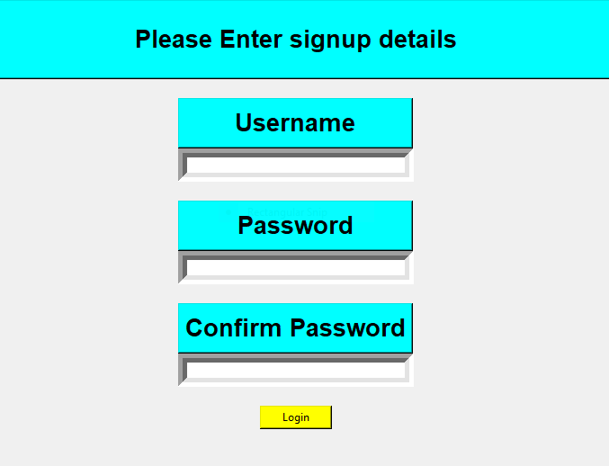

**IF ADMIN IS ALREADY REGISTERED:**

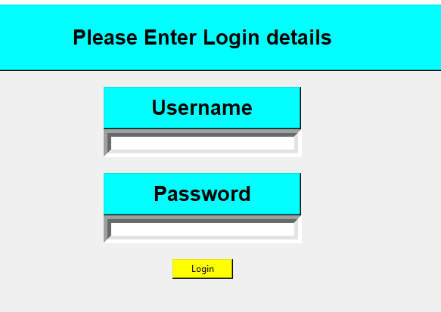

**HOME:**

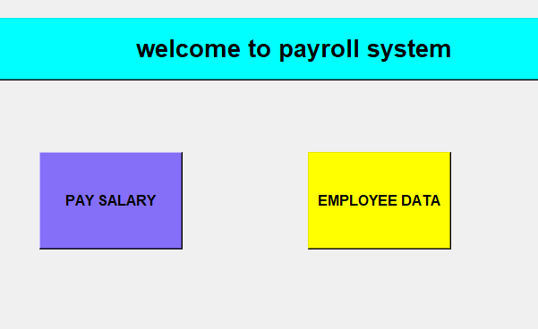

**PAYROLL :**

**1.**

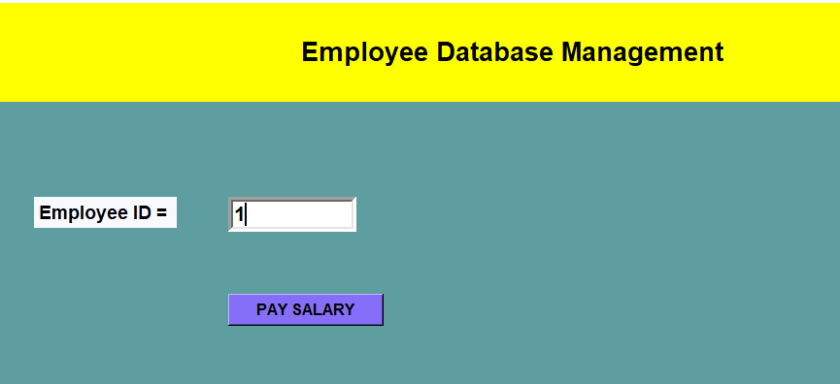

**2.**

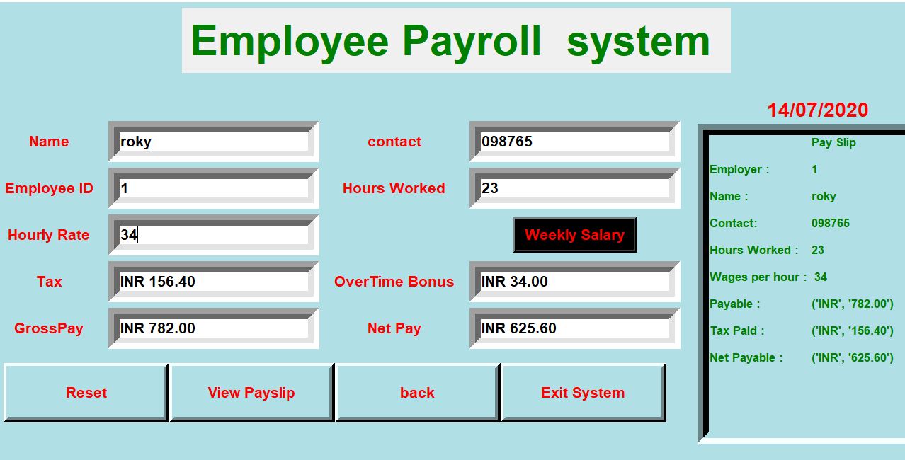

**Employee**

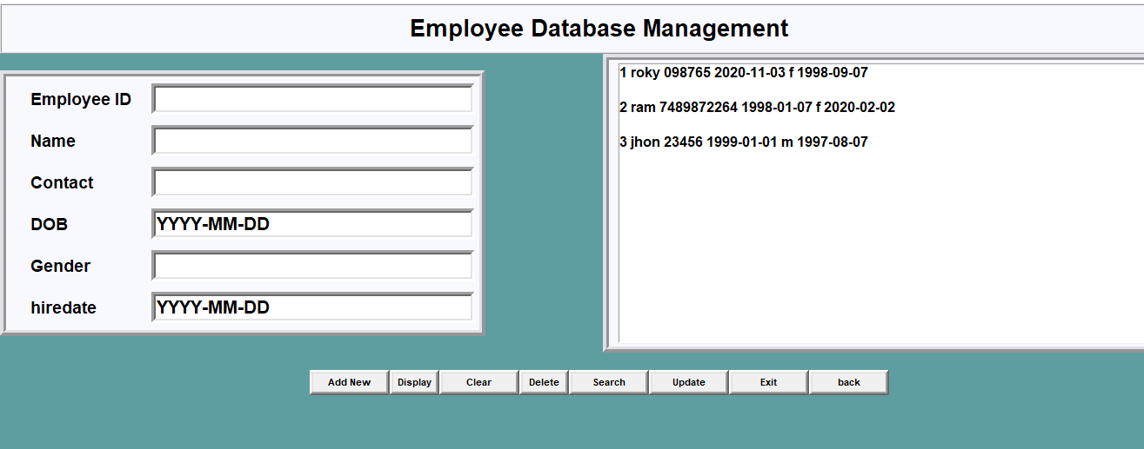

**Add new employee:**

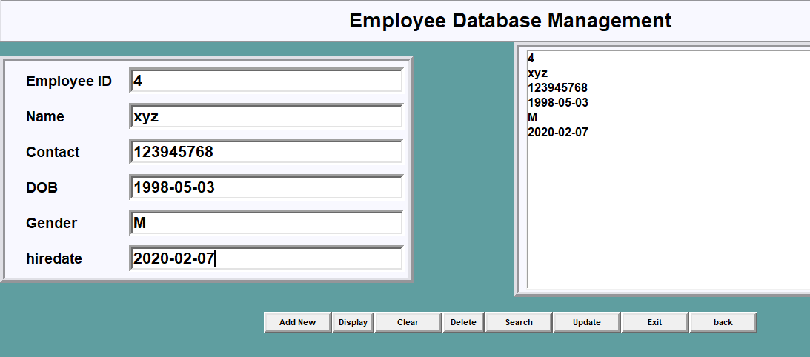

**Search by id:**

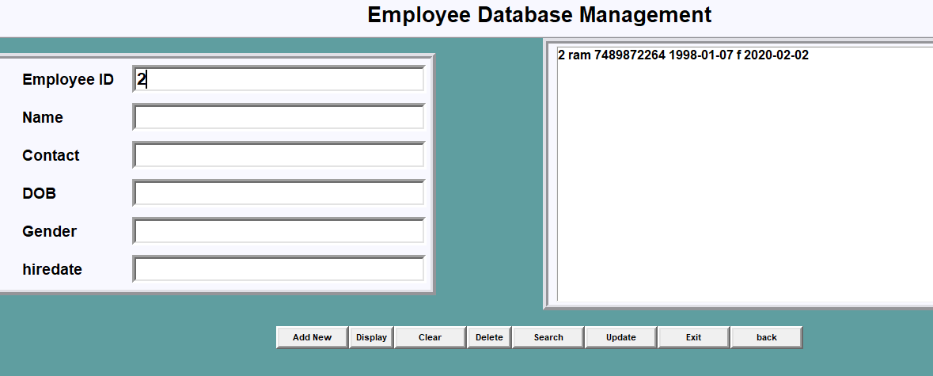

**Admin table :**

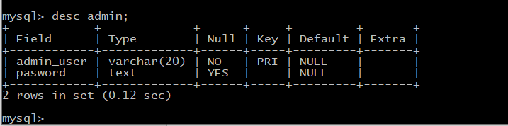

**Employee table:**

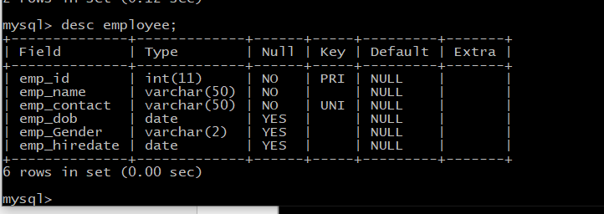

**Transaction table:**

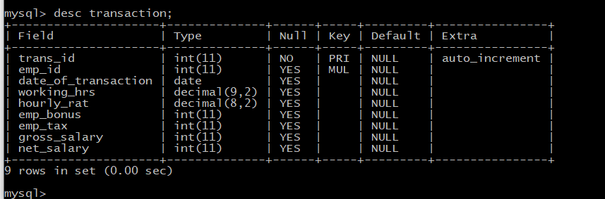

**code for admin backend:**

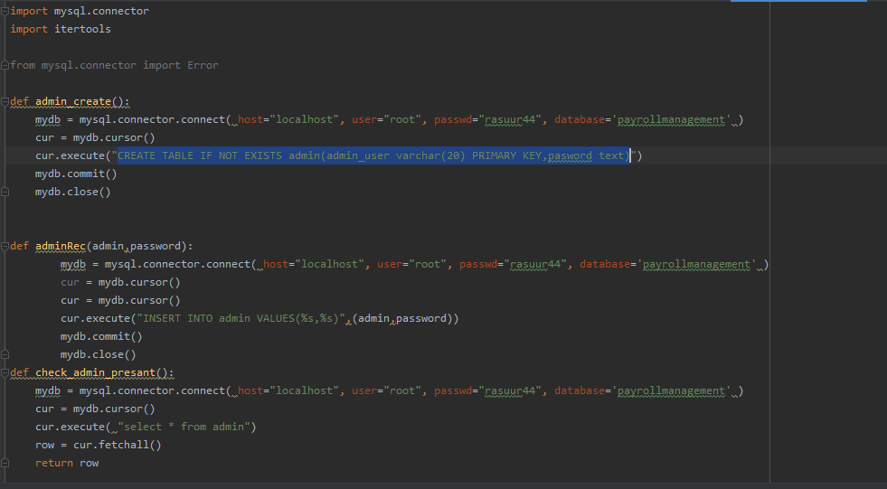

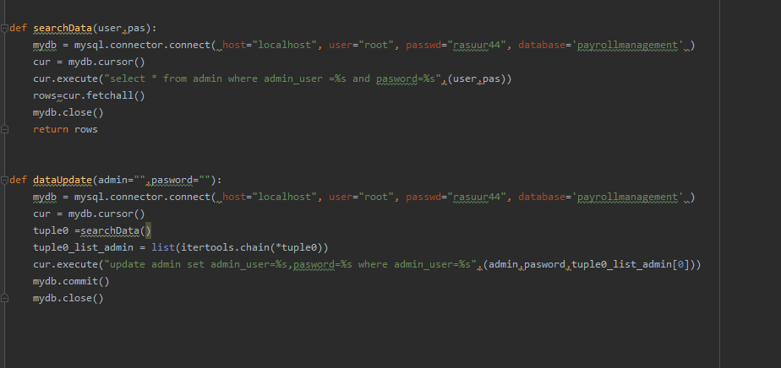

**Back end for employee:**

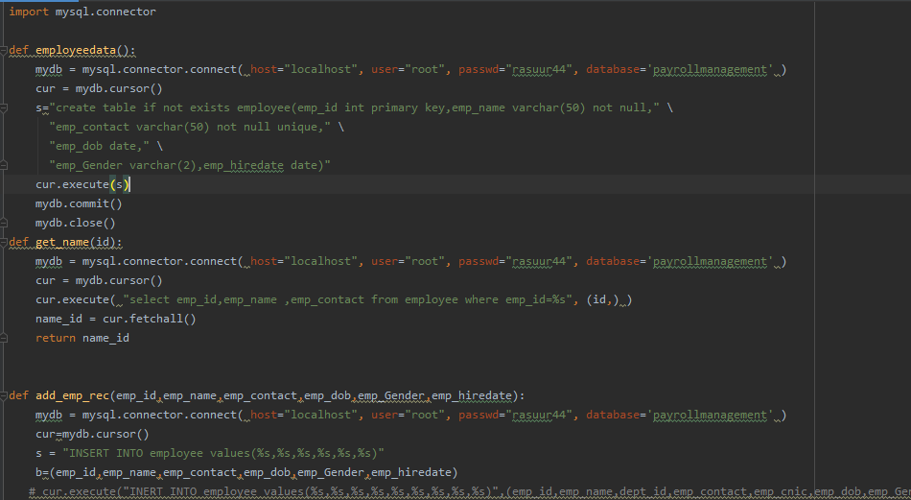

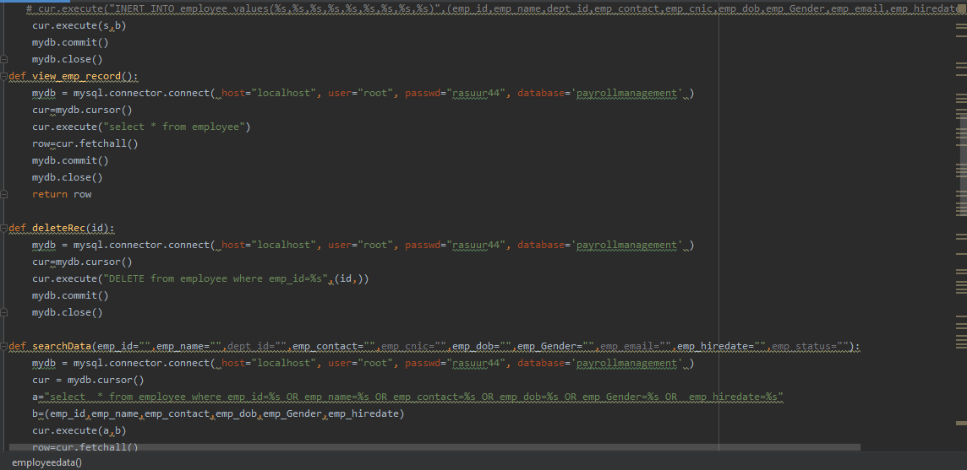

**Back end for payroll.**

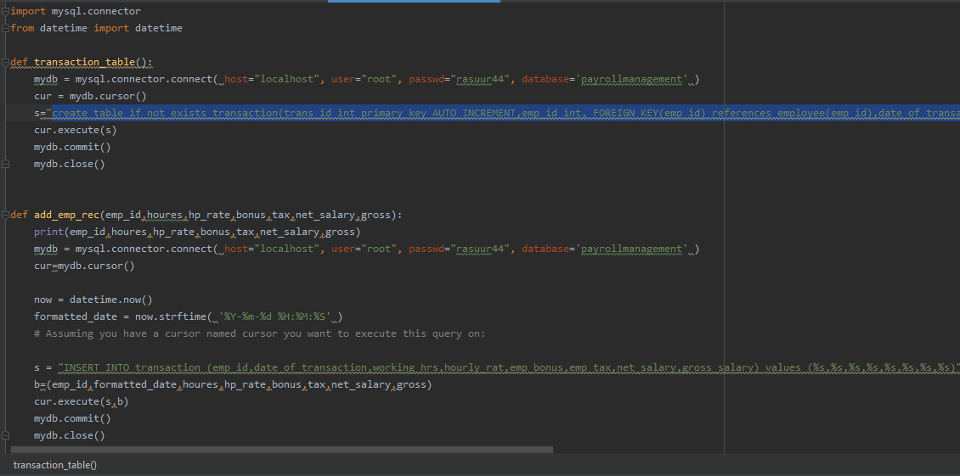

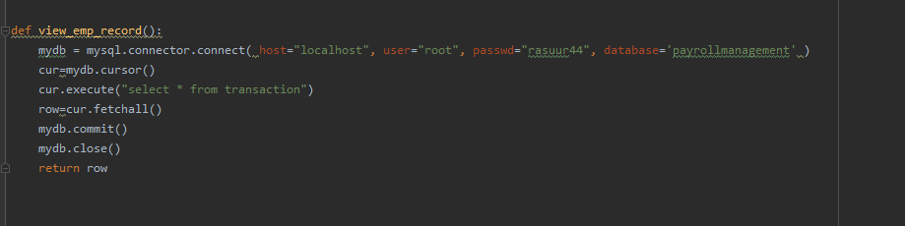

REFERENCES

* + - * https://www.w3schools.com/sql/sql_intro.asp
      * https://docs.python.org/3/library/tkinter.html
      * https://www.jetbrains.com/pycharm/
      * https://www.youtube.com
      * https://www.tutorialspoint.com/python/python_gui_programming.htm
      * https://www.tutorialspoint.com/dbms/index.html
      * https://www.javatpoint.com/dbms-tutorial
      * https://realpython.com/python-gui-tkinter/

THANK YOU