课题五 点阵式 LCD 动态显示系统设计
- 实验目的
- 了解点阵式液晶显示器的硬件接口电路、控制原理和方法
通过学习点阵式 LCD 的硬件结构和工作原理，掌握如何与该设备进行通信和控制。
理解 LCD 的初始化设置、数据传输方式以及如何通过程序控制显示内容。
- 掌握点阵英文、汉字和图形的字模提取和显示方法
学习如何提取字符、汉字和图形的点阵数据（字模），并将其正确显示在 LCD 屏幕上。
理解点阵数据的存储格式以及如何将其映射到 LCD 的显示内存中。
- 掌握点阵式 LCD 动态显示程序的设计思路和实现方法
学习如何通过程序实现动态显示效果，例如滚动显示、切换显示内容等。
掌握如何根据实际需求设计程序逻辑，例如公交车报站系统的动态显示功能。

- 课程设计内容
根据128*64点阵液晶显示控制器说明书，认真阅读和理解LCD的硬件接口电路、控制原理，并根据ASCⅡ码、汉字码以及图形的提取和显示方法，设计连接硬件线路，然后编写公交车报站监控程序，使汽车运行过程中，液晶显示屏在司机的控制下，按照行车路线用汉字动态显示下一站的站名。

- 系统功能
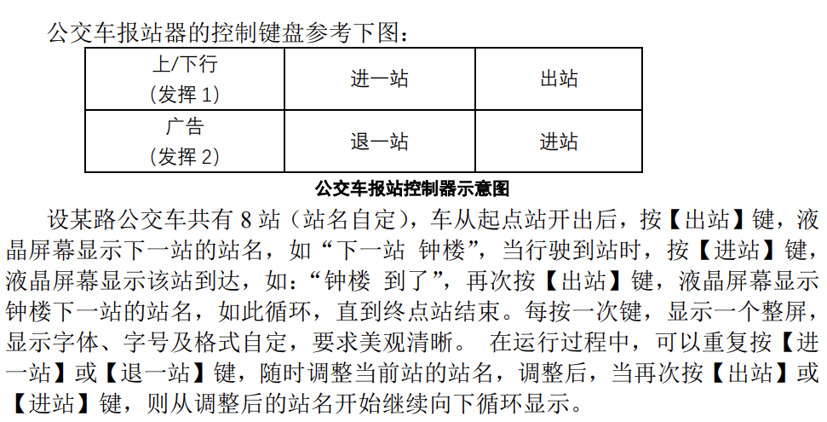
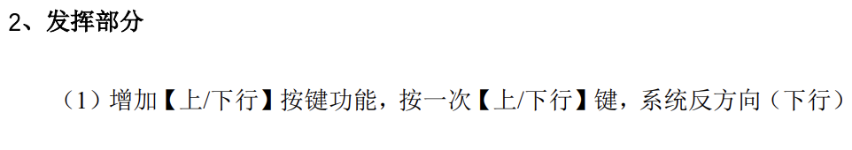
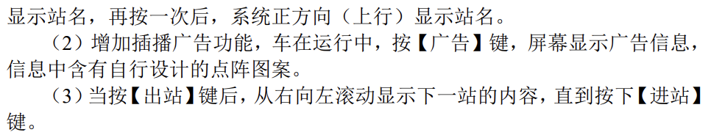

- 设计思路
- 连线
首先分别选取控制 8255、12864 的片选信号，选取 ISA 的 CS1、CS2，得到 8255、12864 的地址空间，并为其分配相应地址。
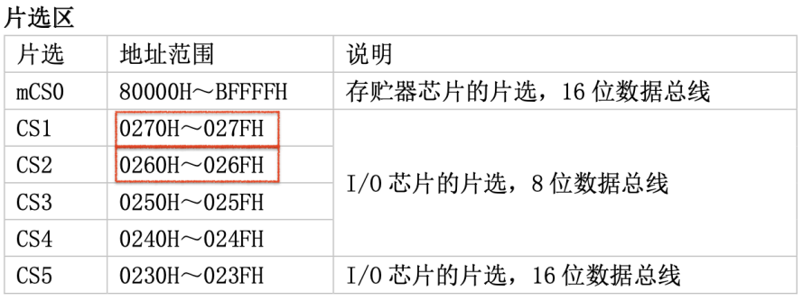
8255 连接外设（键盘），只需要设计 6 个功能，则只需要检测键盘的 1 行8 列是否按下，即接 KCL1 和 A。
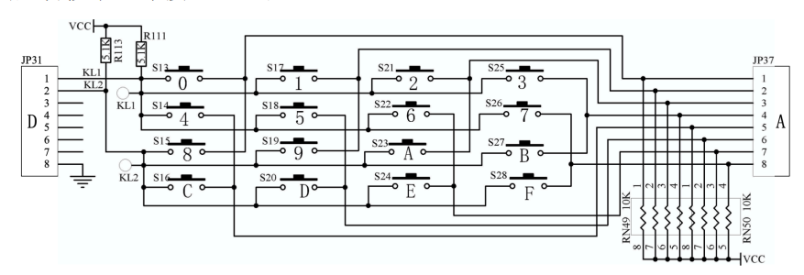
- 8255初始化
通过代码，设置8255初始化命令字 1xxx x001.

- 12864设置
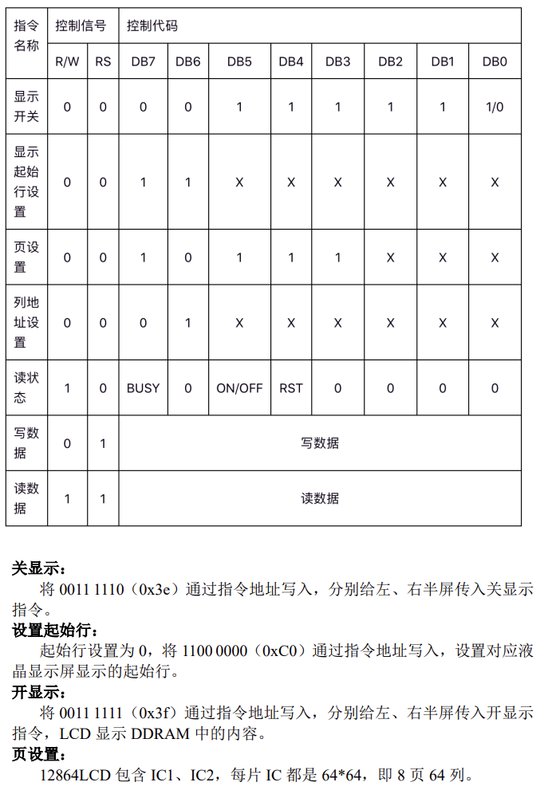
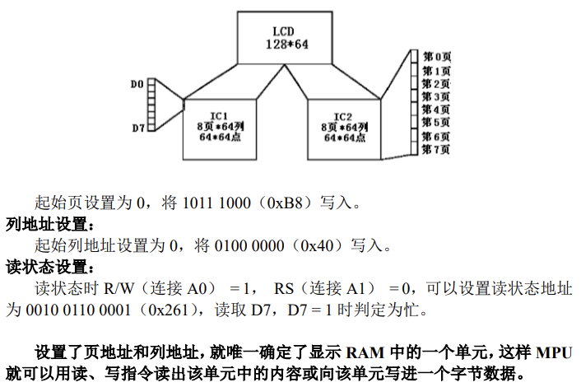

- 源代码设计
- /********************************************************
- * 12864J液晶显示器
- *12864J：1.图形点阵液晶显示器，分辨率为128X64。可显示图形
- * 和8×4个(16×16点阵)汉字。
- * 2.采用8位数据总线并行输入输出和8条控制线。
- * 3.指令简单，7种指令
- ********************************************************/
- #include <stdio.h>
- #define WR_COM_AD_L 0x264 //写左半屏指令地址
- #define WR_COM_AD_R 0x260 //写右半屏指令地址
- #define WR_DATA_AD_L 0x266 //写左半屏数据地址
- #define WR_DATA_AD_R 0x262 //写右半屏数据地址
- #define RD_BUSY_AD 0x261 //查忙地址
- #define RD_DATA_AD 0x263 //读数据地址
- #define PA_Addr 0x270
- #define PB_Addr 0x271
- #define PC_Addr 0x272
- #define CON_Addr 0x273
- #define u8 unsigned char
- #define u16 unsigned int

- #define X 0xB8 //起始显示行基址
- #define Y 0x40 //起始显示列基址
- #define FirstLine 0xC0 //起始显示行

- extern void outportb( unsigned int, char);
- extern char inportb( unsigned int );

- u8 AllKey()
- {
- u8 i;
- outportb(PB_Addr, 0x0);
- i = (~inportb(PC_Addr) & 0x1);
- return i;
- }

- int lastop = 0, lastx = 0;

- //下
- unsigned char xia[] = {
- 0x02,0x02,0x02,0x02,0x02,0x02,0xFE,0x02,0x02,0x42,0x82,0x02,0x02,0x02,0x02,0x00,
- 0x00,0x00,0x00,0x00,0x00,0x00,0xFF,0x00,0x00,0x00,0x00,0x01,0x06,0x00,0x00,0x00};
- //一
- unsigned char yi[] = {
- 0x80,0x80,0x80,0x80,0x80,0x80,0x80,0x80,0x80,0x80,0x80,0x80,0x80,0x80,0x80,0x00,
- 0x00,0x00,0x00,0x00,0x00,0x00,0x00,0x00,0x00,0x00,0x00,0x00,0x00,0x00,0x00,0x00};
- //站
- unsigned char zhan[] = {
- 0x00,0xC8,0x08,0x09,0x0E,0xE8,0x08,0x00,0x00,0x00,0xFF,0x10,0x10,0x10,0x10,0x00,
- 0x10,0x30,0x17,0x10,0x0E,0x09,0x08,0xFF,0x41,0x41,0x41,0x41,0x41,0xFF,0x00,0x00};
- //到
- unsigned char dao[] = {
- 0x42,0x62,0x52,0x4A,0xC6,0x42,0x52,0x62,0xC2,0x00,0xF8,0x00,0x00,0xFF,0x00,0x00,
- 0x40,0xC4,0x44,0x44,0x7F,0x24,0x24,0x24,0x20,0x00,0x0F,0x40,0x80,0x7F,0x00,0x00};
- //了
- unsigned char le[] = {
- 0x00,0x02,0x02,0x02,0x02,0x02,0x02,0xE2,0x22,0x12,0x0A,0x06,0x02,0x00,0x00,0x00,
- 0x00,0x00,0x00,0x00,0x00,0x40,0x80,0x7F,0x00,0x00,0x00,0x00,0x00,0x00,0x00,0x00};

- //终
- unsigned char zhong[] = {
- 0x20,0x30,0xAC,0x63,0x30,0x20,0x10,0x18,0xA7,0x44,0xA4,0x14,0x0C,0x00,0x00,0x00,
- 0x22,0x67,0x22,0x12,0x12,0x02,0x01,0x21,0x24,0x44,0x48,0x91,0x01,0x02,0x02,0x00};

- //点
- unsigned char dian[] = {
- 0x00,0x00,0xC0,0x40,0x40,0x40,0x7F,0x48,0x48,0x48,0x48,0xC8,0x08,0x08,0x00,0x00,
- 0x80,0x40,0x37,0x04,0x04,0x14,0x64,0x04,0x14,0x64,0x04,0x07,0x10,0xE0,0x00,0x00};

- //横
- unsigned char heng[] = {
- 0xC0,0xC0,0xC0,0xC0,0xC0,0xC0,0xC0,0xC0,0xC0,0xC0,0xC0,0xC0,0xC0,0xC0,0xC0,0xC0,
- 0x03,0x03,0x03,0x03,0x03,0x03,0x03,0x03,0x03,0x03,0x03,0x03,0x03,0x03,0x03,0x03};

- //竖
- unsigned char shu[] = {
- 0x00,0x00,0x00,0x00,0x00,0x00,0xFF,0xFF,0xFF,0xFF,0x00,0x00,0x00,0x00,0x00,0x00,
- 0x00,0x00,0x00,0x00,0x00,0x00,0xFF,0xFF,0xFF,0xFF,0x00,0x00,0x00,0x00,0x00,0x00};

- //L1
- unsigned char L1[] = {
- 0x00,0x00,0x00,0x00,0x00,0x00,0xC0,0xC0,0xC0,0xC0,0xC0,0xC0,0xC0,0xC0,0xC0,0xC0,
- 0x00,0x00,0x00,0x00,0x00,0x00,0xFF,0xFF,0xFF,0xFF,0x03,0x03,0x03,0x03,0x03,0x03};

- //L2
- unsigned char L2[] = {
- 0xC0,0xC0,0xC0,0xC0,0xC0,0xC0,0xC0,0xC0,0xC0,0xC0,0x00,0x00,0x00,0x00,0x00,0x00,
- 0x03,0x03,0x03,0x03,0x03,0x03,0xFF,0xFF,0xFF,0xFF,0x00,0x00,0x00,0x00,0x00,0x00};

- //L3
- unsigned char L3[] = {
- 0x00,0x00,0x00,0x00,0x00,0x00,0xFF,0xFF,0xFF,0xFF,0xC0,0xC0,0xC0,0xC0,0xC0,0xC0,
- 0x00,0x00,0x00,0x00,0x00,0x00,0x03,0x03,0x03,0x03,0x03,0x03,0x03,0x03,0x03,0x03};

- //L4
- unsigned char L4[] = {
- 0xC0,0xC0,0xC0,0xC0,0xC0,0xC0,0xFF,0xFF,0xFF,0xFF,0x00,0x00,0x00,0x00,0x00,0x00,
- 0x03,0x03,0x03,0x03,0x03,0x03,0x03,0x03,0x03,0x03,0x00,0x00,0x00,0x00,0x00,0x00};

- //欢
- unsigned char huan[] = {
- 0x04,0x24,0x44,0x84,0x64,0x9C,0x40,0x30,0x0F,0xC8,0x08,0x08,0x28,0x18,0x00,0x00,
- 0x10,0x08,0x06,0x01,0x82,0x4C,0x20,0x18,0x06,0x01,0x06,0x18,0x20,0x40,0x80,0x00};

- //迎
- unsigned char ying[] = {
- 0x40,0x40,0x42,0xCC,0x00,0x00,0xFC,0x04,0x02,0x00,0xFC,0x04,0x04,0xFC,0x00,0x00,
- 0x00,0x40,0x20,0x1F,0x20,0x40,0x4F,0x44,0x42,0x40,0x7F,0x42,0x44,0x43,0x40,0x00};

- //报
- unsigned char bao[] = {
- 0x10,0x10,0x10,0xFF,0x10,0x90,0x00,0xFE,0x82,0x82,0x82,0x92,0xA2,0x9E,0x00,0x00,
- 0x04,0x44,0x82,0x7F,0x01,0x00,0x00,0xFF,0x80,0x43,0x2C,0x10,0x2C,0x43,0x80,0x00};

- //考
- unsigned char kao[] = {
- 0x20,0x20,0x24,0x24,0x24,0x24,0xBF,0x64,0x24,0x34,0x28,0x24,0x22,0x20,0x20,0x00,
- 0x10,0x08,0x04,0x02,0x01,0x0D,0x0B,0x09,0x49,0x89,0x49,0x39,0x01,0x00,0x00,0x00};

- //西
- unsigned char xi[] = {
- 0x02,0x02,0xE2,0x22,0x22,0xFE,0x22,0x22,0x22,0xFE,0x22,0x22,0xE2,0x02,0x02,0x00,
- 0x00,0x00,0xFF,0x48,0x44,0x43,0x40,0x40,0x40,0x43,0x44,0x44,0xFF,0x00,0x00,0x00};

- //安
- unsigned char an[] = {
- 0x80,0x90,0x8C,0x84,0x84,0x84,0xF5,0x86,0x84,0x84,0x84,0x84,0x94,0x8C,0x80,0x00,
- 0x00,0x80,0x80,0x84,0x46,0x49,0x28,0x10,0x10,0x2C,0x23,0x40,0x80,0x00,0x00,0x00};

- //交
- unsigned char jiao[] = {
- 0x08,0x08,0x88,0x68,0x08,0x08,0x09,0x0E,0x08,0x08,0x88,0x28,0x48,0x88,0x08,0x00,
- 0x80,0x81,0x40,0x40,0x21,0x22,0x14,0x08,0x14,0x22,0x41,0x40,0x80,0x81,0x80,0x00};

- //通
- unsigned char tong[] = {
- 0x40,0x42,0xCC,0x00,0x00,0xE2,0x22,0x2A,0x2A,0xF2,0x2A,0x26,0x22,0xE0,0x00,0x00,
- 0x80,0x40,0x3F,0x40,0x80,0xFF,0x89,0x89,0x89,0xBF,0x89,0xA9,0xC9,0xBF,0x80,0x00};

- //大
- unsigned char da[] = {
- 0x20,0x20,0x20,0x20,0x20,0x20,0x20,0xFF,0x20,0x20,0x20,0x20,0x20,0x20,0x20,0x00,
- 0x80,0x80,0x40,0x20,0x10,0x0C,0x03,0x00,0x03,0x0C,0x10,0x20,0x40,0x80,0x80,0x00};

- //学
- unsigned char xue[] = {
- 0x40,0x30,0x11,0x96,0x90,0x90,0x91,0x96,0x90,0x90,0x98,0x14,0x13,0x50,0x30,0x00,
- 0x04,0x04,0x04,0x04,0x04,0x44,0x84,0x7E,0x06,0x05,0x04,0x04,0x04,0x04,0x04,0x00};

- //空格
- unsigned char empty[] = {
- 0x00,0x00,0x00,0x00,0x00,0x00,0x00,0x00,0x00,0x00,0x00,0x00,0x00,0x00,0x00,0x00,
- 0x00,0x00,0x00,0x00,0x00,0x00,0x00,0x00,0x00,0x00,0x00,0x00,0x00,0x00,0x00,0x00};

- unsigned char zhandian[8][3][32] = {
- {
- // 大
- {0x20,0x20,0x20,0x20,0x20,0x20,0x20,0xFF,0x20,0x20,0x20,0x20,0x20,0x20,0x20,0x00,
- 0x80,0x80,0x40,0x20,0x10,0x0C,0x03,0x00,0x03,0x0C,0x10,0x20,0x40,0x80,0x80,0x00},
- // 一
- {0x80,0x80,0x80,0x80,0x80,0x80,0x80,0x80,0x80,0x80,0x80,0x80,0x80,0x80,0x80,0x00,
- 0x00,0x00,0x00,0x00,0x00,0x00,0x00,0x00,0x00,0x00,0x00,0x00,0x00,0x00,0x00,0x00},
- // 上
- {0x00,0x00,0x00,0x00,0x00,0x00,0xFF,0x40,0x40,0x40,0x40,0x40,0x40,0x00,0x00,0x00,
- 0x40,0x40,0x40,0x40,0x40,0x40,0x7F,0x40,0x40,0x40,0x40,0x40,0x40,0x40,0x40,0x00}
- },
- {
- // 大
- {0x20,0x20,0x20,0x20,0x20,0x20,0x20,0xFF,0x20,0x20,0x20,0x20,0x20,0x20,0x20,0x00,
- 0x80,0x80,0x40,0x20,0x10,0x0C,0x03,0x00,0x03,0x0C,0x10,0x20,0x40,0x80,0x80,0x00},
- // 一
- {0x80,0x80,0x80,0x80,0x80,0x80,0x80,0x80,0x80,0x80,0x80,0x80,0x80,0x80,0x80,0x00,
- 0x00,0x00,0x00,0x00,0x00,0x00,0x00,0x00,0x00,0x00,0x00,0x00,0x00,0x00,0x00,0x00},
- // 下
- {0x02,0x02,0x02,0x02,0x02,0x02,0xFE,0x02,0x02,0x42,0x82,0x02,0x02,0x02,0x02,0x00,
- 0x00,0x00,0x00,0x00,0x00,0x00,0xFF,0x00,0x00,0x00,0x00,0x01,0x06,0x00,0x00,0x00}
- },
- {
- // 大
- {0x20,0x20,0x20,0x20,0x20,0x20,0x20,0xFF,0x20,0x20,0x20,0x20,0x20,0x20,0x20,0x00,
- 0x80,0x80,0x40,0x20,0x10,0x0C,0x03,0x00,0x03,0x0C,0x10,0x20,0x40,0x80,0x80,0x00},
- // 二
- {0x00,0x00,0x08,0x08,0x08,0x08,0x08,0x08,0x08,0x08,0x08,0x08,0x08,0x00,0x00,0x00,
- 0x10,0x10,0x10,0x10,0x10,0x10,0x10,0x10,0x10,0x10,0x10,0x10,0x10,0x10,0x10,0x00},
- // 上
- {0x00,0x00,0x00,0x00,0x00,0x00,0xFF,0x40,0x40,0x40,0x40,0x40,0x40,0x00,0x00,0x00,
- 0x40,0x40,0x40,0x40,0x40,0x40,0x7F,0x40,0x40,0x40,0x40,0x40,0x40,0x40,0x40,0x00}
- },
- {
- // 大
- {0x20,0x20,0x20,0x20,0x20,0x20,0x20,0xFF,0x20,0x20,0x20,0x20,0x20,0x20,0x20,0x00,
- 0x80,0x80,0x40,0x20,0x10,0x0C,0x03,0x00,0x03,0x0C,0x10,0x20,0x40,0x80,0x80,0x00},
- // 二
- {0x00,0x00,0x08,0x08,0x08,0x08,0x08,0x08,0x08,0x08,0x08,0x08,0x08,0x00,0x00,0x00,
- 0x10,0x10,0x10,0x10,0x10,0x10,0x10,0x10,0x10,0x10,0x10,0x10,0x10,0x10,0x10,0x00},
- // 下
- {0x02,0x02,0x02,0x02,0x02,0x02,0xFE,0x02,0x02,0x42,0x82,0x02,0x02,0x02,0x02,0x00,
- 0x00,0x00,0x00,0x00,0x00,0x00,0xFF,0x00,0x00,0x00,0x00,0x01,0x06,0x00,0x00,0x00}
- },
- {
- // 大
- {0x20,0x20,0x20,0x20,0x20,0x20,0x20,0xFF,0x20,0x20,0x20,0x20,0x20,0x20,0x20,0x00,
- 0x80,0x80,0x40,0x20,0x10,0x0C,0x03,0x00,0x03,0x0C,0x10,0x20,0x40,0x80,0x80,0x00},
- // 三
- {0x00,0x04,0x84,0x84,0x84,0x84,0x84,0x84,0x84,0x84,0x84,0x84,0x84,0x04,0x00,0x00,
- 0x20,0x20,0x20,0x20,0x20,0x20,0x20,0x20,0x20,0x20,0x20,0x20,0x20,0x20,0x20,0x00},
- // 上
- {0x00,0x00,0x00,0x00,0x00,0x00,0xFF,0x40,0x40,0x40,0x40,0x40,0x40,0x00,0x00,0x00,
- 0x40,0x40,0x40,0x40,0x40,0x40,0x7F,0x40,0x40,0x40,0x40,0x40,0x40,0x40,0x40,0x00}
- },
- {
- // 大
- {0x20,0x20,0x20,0x20,0x20,0x20,0x20,0xFF,0x20,0x20,0x20,0x20,0x20,0x20,0x20,0x00,
- 0x80,0x80,0x40,0x20,0x10,0x0C,0x03,0x00,0x03,0x0C,0x10,0x20,0x40,0x80,0x80,0x00},
- // 三
- {0x00,0x04,0x84,0x84,0x84,0x84,0x84,0x84,0x84,0x84,0x84,0x84,0x84,0x04,0x00,0x00,
- 0x20,0x20,0x20,0x20,0x20,0x20,0x20,0x20,0x20,0x20,0x20,0x20,0x20,0x20,0x20,0x00},
- // 下
- {0x02,0x02,0x02,0x02,0x02,0x02,0xFE,0x02,0x02,0x42,0x82,0x02,0x02,0x02,0x02,0x00,
- 0x00,0x00,0x00,0x00,0x00,0x00,0xFF,0x00,0x00,0x00,0x00,0x01,0x06,0x00,0x00,0x00}
- },
- {
- // 大
- {0x20,0x20,0x20,0x20,0x20,0x20,0x20,0xFF,0x20,0x20,0x20,0x20,0x20,0x20,0x20,0x00,
- 0x80,0x80,0x40,0x20,0x10,0x0C,0x03,0x00,0x03,0x0C,0x10,0x20,0x40,0x80,0x80,0x00},
- // 四
- {0x00,0xFC,0x04,0x04,0x04,0xFC,0x04,0x04,0x04,0xFC,0x04,0x04,0x04,0xFC,0x00,0x00,
- 0x00,0x7F,0x28,0x24,0x23,0x20,0x20,0x20,0x20,0x21,0x22,0x22,0x22,0x7F,0x00,0x00},
- // 上
- {0x00,0x00,0x00,0x00,0x00,0x00,0xFF,0x40,0x40,0x40,0x40,0x40,0x40,0x00,0x00,0x00,
- 0x40,0x40,0x40,0x40,0x40,0x40,0x7F,0x40,0x40,0x40,0x40,0x40,0x40,0x40,0x40,0x00}
- },
- {
- // 大
- {0x20,0x20,0x20,0x20,0x20,0x20,0x20,0xFF,0x20,0x20,0x20,0x20,0x20,0x20,0x20,0x00,
- 0x80,0x80,0x40,0x20,0x10,0x0C,0x03,0x00,0x03,0x0C,0x10,0x20,0x40,0x80,0x80,0x00},
- // 四
- {0x00,0xFC,0x04,0x04,0x04,0xFC,0x04,0x04,0x04,0xFC,0x04,0x04,0x04,0xFC,0x00,0x00,
- 0x00,0x7F,0x28,0x24,0x23,0x20,0x20,0x20,0x20,0x21,0x22,0x22,0x22,0x7F,0x00,0x00},
- // 下
- {0x02,0x02,0x02,0x02,0x02,0x02,0xFE,0x02,0x02,0x42,0x82,0x02,0x02,0x02,0x02,0x00,
- 0x00,0x00,0x00,0x00,0x00,0x00,0xFF,0x00,0x00,0x00,0x00,0x01,0x06,0x00,0x00,0x00}
- }
- };

- //***************************************
- //基本控制
- //***************************************
- //写左半屏控制指令
- void WRComL(unsigned char _data)
- {
- outportb(WR_COM_AD_L, _data);
- while (inportb(RD_BUSY_AD) & 0x80) //检查液晶显示是否处于忙状态
- {;}
- }

- //写右半屏控制指令
- void WRComR(unsigned char _data)
- {
- outportb(WR_COM_AD_R, _data);
- while (inportb(RD_BUSY_AD) & 0x80) //检查液晶显示是否处于忙状态
- {;}
- }

- //写左半屏数据
- void WRDataL(unsigned char _data)
- {
- outportb(WR_DATA_AD_L, _data);
- while (inportb(RD_BUSY_AD) & 0x80) //检查液晶显示是否处于忙状态
- {;}
- }

- //写右半屏数据
- void WRDataR(unsigned char _data)
- {
- outportb(WR_DATA_AD_R, _data);
- while (inportb(RD_BUSY_AD) & 0x80) //检查液晶显示是否处于忙状态
- {;}
- }

- //显示左半屏数据，count-显示数据个数
- void DisplayL(unsigned char *pt, char count)
- {
- while (count--)
- {
- WRDataL(*pt++); //写左半屏数据
- }
- }

- //显示右半屏数据，count-显示数据个数
- void DisplayR(unsigned char * pt, char count)
- {
- while (count--)
- {
- WRDataR(*pt++); //写右半屏数据
- }
- }

- //设置左半屏起始显示行列地址,x-X起始行序数(0-7)，y-Y起始列序数(0-63)
- void SETXYL(unsigned char x, unsigned char y)
- {
- WRComL(x+X); //行地址=行序数+行基址
- WRComL(y+Y); //列地址=列序数+列基址
- }

- //设置右半屏起始显示行列地址,x:X起始行序数(0-7)，y:Y起始列序数(0-63)
- void SETXYR(unsigned char x, unsigned char y)
- {
- WRComR(x+X); //行地址=行序数+行基址
- WRComR(y+Y); //列地址=列序数+列基址
- }

- //***************************************
- //显示图形
- //***************************************
- //显示左半屏一行图形,A-X起始行序数(0-7)，B-Y起始列地址序数(0-63)
- void LineDisL(unsigned char x, unsigned char y, unsigned char * pt)
- {
- SETXYL(x,y); //设置起始显示行列
- DisplayL(pt, 64); //显示数据
- }

- //显示右半屏一行图形,A-X起始行地址序数(0-7)，B-Y起始列地址序数(0-63)
- void LineDisR(unsigned char x, unsigned char y, unsigned char * pt)
- {
- SETXYR(x,y); //设置起始显示行列
- DisplayR(pt, 64); //显示数据
- }

- //***************************************
- //显示字体，显示一个数据要占用X行两行位置
- //***************************************
- //右半屏显示一个字节/字：x-起始显示行序数X(0-7)；y-起始显示列序数Y(0-63)；pt-显示字数据首地址
- void ByteDisR(unsigned char x, unsigned char y,unsigned char * pt)
- {
- SETXYR(x,y); //设置起始显示行列地址
- DisplayR(pt, 8); //显示上半行数据
- SETXYR(x+1,y); //设置起始显示行列地址
- DisplayR(pt+8, 8); //显示下半行数据
- }

- void WordDisR(unsigned char x, unsigned char y,unsigned char * pt)
- {
- SETXYR(x,y); //设置起始显示行列地址
- DisplayR(pt, 16); //显示上半行数据
- SETXYR(x+1,y); //设置起始显示行列地址
- DisplayR(pt+16, 16); //显示下半行数据
- }

- //左半屏显示一个字节/字：x-起始显示行序数X(0-7)；y-起始显示列序数Y(0-63)；pt-显示字数据首地址
- void ByteDisL(unsigned char x, unsigned char y,unsigned char * pt)
- {
- SETXYL(x,y); //设置起始显示行列地址
- DisplayL(pt, 8); //显示上半行数据
- SETXYL(x+1,y); //设置起始显示行列地址
- DisplayL(pt+8, 8); //显示下半行数据
- }

- void WordDisL(unsigned char x, unsigned char y,unsigned char * pt)
- {
- SETXYL(x,y); //设置起始显示行列地址
- DisplayL(pt, 16); //显示上半行数据
- SETXYL(x+1,y); //设置起始显示行列地址
- DisplayL(pt+16, 16); //显示下半行数据
- }
- //清屏
- void LCDClear()
- {
- //清左半屏
- unsigned char x,y;
- char j;
- x = 0; //起始行，第0行
- y = 0; //起始列，第0列
- for (x = 0; x < 8; x++) //共8行
- {
- SETXYL(x,y); //设置起始显示行列地址
- j = 64;
- while (j--)
- WRDataL(0);
- }
- //清右半屏
- x = 0; //起始行，第0行
- y = 0; //起始列，第0列
- for (x = 0; x < 8; x++) //共8行
- {
- SETXYR(x,y); //设置起始显示行列地址
- j = 64;
- while (j--)
- WRDataR(0);
- }
- }

- //液晶初始化
- void LCD_INIT()
- {
- WRComL(0x3e); //初始化左半屏，关显示
- WRComL(FirstLine); //设置起始显示行，第0行
- WRComR(0x3e); //初始化右半屏，关显示
- WRComR(FirstLine); //设置起始显示行，第0行
- LCDClear(); //清屏
- WRComL(0x3f); //开显示
- WRComR(0x3f); //开显示
- }

- //延时程序
- void DelayTime()
- {
- unsigned char i;
- unsigned int j;
- for (i = 0; i < 1; i++)
- {
- for (j = 0; j < 0x8fff; j++)
- {;}
- }
- }

- u8 SPDelayTime()
- {
- unsigned char i;
- unsigned int j;
- for (i = 0; i < 1; i++)
- {
- for (j = 0; j < 0x00ff; j++)
- if (AllKey()) {
- return 1;
- }
- }
- return 0;
- }

- //下一站XX
- void dis1(int x)
- {
- u8 a[8][32], b1[128], b2[128], c1[128], c2[128];
- u8 i, j, p1, p2;

- for(i = 0;i < 32; i++) {
- a[0][i] = xia[i];
- a[1][i] = yi[i];
- a[2][i] = zhan[i];
- a[3][i] = empty[i];
- a[4][i] = zhandian[x][0][i];
- a[5][i] = zhandian[x][1][i];
- a[6][i] = zhandian[x][2][i];
- a[7][i] = empty[i];
- }

- while(!AllKey()) {
- for (i = 0; i < 4; i ++)
- WordDisL(2, i * 16, a[i]);
- for (i = 0; i < 4; i ++)
- WordDisR(2, i * 16, a[i + 4]);

- p1 = p2 = 0;
- for (i = 0; i < 8; i ++)
- for (j = 0; j < 16; j ++) {
- b1[p1 ++] = a[i][j];
- b2[p2 ++] = a[i][j + 16];
- }
- for (i = 0; i < 128; i ++) {
- c1[i] = b1[(i + 1) % 128];
- c2[i] = b2[(i + 1) % 128];
- }

- p1 = p2 = 0;
- for (i = 0; i < 8; i ++)
- for (j = 0; j < 16; j ++) {
- a[i][j] = c1[p1 ++];
- a[i][j + 16] = c2[p2 ++];
- }

- if (SPDelayTime() == 1)
- break;
- }
- lastop = 0;
- lastx = x;
- }

- int flag = 0;

- //XX到了
- void dis2(int x)
- {
- WordDisL(2,16,zhandian[x][0]);
- WordDisL(2,32,zhandian[x][1]);
- WordDisL(2,48,zhandian[x][2]);

- WordDisR(2,16,dao); //第2行,第32列，左半屏，显示一个字子程序
- WordDisR(2,32,le);
- if ((flag == 0 && x == 7) || (flag == 1 && x == 0)) {
- WordDisL(4,48,zhong);
- WordDisR(4,0,dian);
- }
- lastop = 1;
- lastx = x;
- }

- void showad() {
- WordDisL(0, 0, L1);WordDisL(0, 16, heng);WordDisL(0, 32, heng);WordDisL(0, 48, heng);
- WordDisR(0, 0, heng);WordDisR(0, 16, heng);WordDisR(0, 32, heng);WordDisR(0, 48, L2);
- WordDisL(2, 0, shu);WordDisL(2, 16, empty);WordDisL(2, 32, huan);WordDisL(2, 48, ying);
- WordDisR(2, 0, bao);WordDisR(2, 16, kao);WordDisR(2, 32, empty);WordDisR(2, 48, shu);
- WordDisL(4, 0, shu);WordDisL(4, 16, xi);WordDisL(4, 32, an);WordDisL(4, 48, jiao);
- WordDisR(4, 0, tong);WordDisR(4, 16, da);WordDisR(4, 32, xue);WordDisR(4, 48, shu);
- WordDisL(6, 0, L3);WordDisL(6, 16, heng);WordDisL(6, 32, heng);WordDisL(6, 48, heng);
- WordDisR(6, 0, heng);WordDisR(6, 16, heng);WordDisR(6, 32, heng);WordDisR(6, 48, L4);
- }

- extern char inportb( unsigned int ); //读I/O
- extern void outportb( unsigned int, char);

- u8 buffer[8] = {0x10, 0x10, 0x10, 0x10, 0x10, 0x10, 0x10, 0x10}; //置显示缓冲器初值

- void delay(u16 ms)
- {
- u16 i;
- while(ms--)
- {
- i = 100;
- do
- {;}while(--i);
- }
- }

- u8 key()
- {
- u8 i, j, keyResult;
- u8 bNoKey = 1;
- while(bNoKey)
- {

- if (AllKey() == 0) //调用判有无闭合键函数
- continue;
- i = 0xfe;
- keyResult = 0;
- do
- {
- outportb(PB_Addr, i);
- j = ~inportb(PC_Addr);
- if (j & 1)
- {
- bNoKey = 0;

- }
- else //没有键按下
- {
- keyResult++; //列计数器加1
- i = ((i << 1) | 1);
- }
- }while(bNoKey && (i != 0xff));
- }
- return keyResult;
- }

- u8 lastkey = 17;

- u8 pos = 0;
- u8 now =17;
- u16 cnt;

- main()
- {
- LCD_INIT();
- outportb(CON_Addr, 0x89);
- flag = 0;
- while (1)
- {
- now = key();
- if (now == 0) {
- if(flag == 0)
- {
- flag = 1;
- if (pos == 7) pos --;
- }
- else
- {
- flag = 0;
- if (pos == 0) pos ++;
- }
- DelayTime();
- }
- if (now == 1) {
- if(flag == 0) pos++;
- else pos--;
- pos = (pos + 8) % 8;
- DelayTime();
- }
- if (now == 2) {
- LCD_INIT();
- dis1(pos);
- }
- if (now == 4) {
- LCD_INIT();
- DelayTime();
- showad();
- for (cnt = 0; cnt < 10; cnt ++) DelayTime();
- LCD_INIT();
- DelayTime();
- if (lastop == 0) dis1(lastx);
- else dis2(lastx);

- }
- if (now == 5) {
- if(flag == 0) pos--;
- else pos++;
- pos = (pos + 8) % 8;
- DelayTime();

- }
- if (now == 6) {
- LCD_INIT();
- dis2(pos);
- if(flag == 0){
- if (pos != 7)
- pos ++;
- }
- else if(pos != 0) pos --;
- DelayTime();
- }
- }
- }

