**B.1 - Report**

I had a bit of trouble setting everything up and getting started on work. The B.1 document wasn’t clear enough for me and made me feel stuck for a while. I’m not even sure how much I am supposed to write in this report. I figured from the tutorial video that I was meant to watch, that I needed to install PyCharm, though I don’t recall that program being mentioned, just IntelliJ IDEA. So, I downloaded that, as well as Anaconda. I hadn’t used Anaconda before. From the week one tutorial, it seems that other people have used it in a unit that I had not done, as my only prior AI subject was AI for Games.

I went to the environments tab in Anaconda, and created an environment called B1, and then in PyCharm, I created a new project, and specified an already existing Conda environment. The tutorials I saw online of PyCharm and creating environments demonstrated a different interface for creating a project and specifying the details for the environment, so it was a bit confusing. In the tutorial video, and in other tutorial videos, I noticed that they were all working from a folder called “venv”, which I couldn’t find. I went to settings and added python as an interpreter, and applied that, and then the folder showed up, but I switched it back to Conda since that was the interpreter that I was recommended to use. Eventually, I realised that there was an extra tab in the Conda environment, and the venv folder was there. When it came to the stock-prediction python file, I put it in the scripts folder in the venv folder and followed through the tutorial. At first, I didn’t realise that the file already included everything that NeuralNine had typed up in his video, so edited part of the file but then un-did it as it was already functional. I later added a requirements file, with the pip install packages listed, and a description of what to do in the README file, just like was done in the P1 download.

What I understood from the tutorial video I watched, was that the code of v0.1, at least, needs to be given a time frame, from which it then makes a prediction.

I included the following

Output for v0.1 below

**P1**

Test.py

This took a long time to get working, as I had a lot of errors regarding my requirements, mainly with tensorflow. At first, I had to change scilearn in the requirements file to scikit-learn, and then I had to uninstall tensorflow, and then reinstall it, while specifying a version below 2.15.0 (I chose 2.14.0). Afterwards, I had issues with every other requirement, and had to reinstall numpy first, then the others. When I finally had it all installed, I had an error regarding tensorflow flags, followed by another error. I spent some time trying to fix the flags error, but realised that it can easily be ignored by adding the following



The final error I had was with h5py. I specified the file path, but for some reason it was still searching for ‘2024-08-16_AMZN-sh-1-sc-1-sbd-0-huber_loss-adam-LSTM-seq-50-step-15-layers-2-units-256’, even though I specified 2021, like the file that was in the results folder. It’s probably not ideal, but a quick fix was just to change the name of the file (in file explorer) to the 2024 AMZN name, and then it started working.

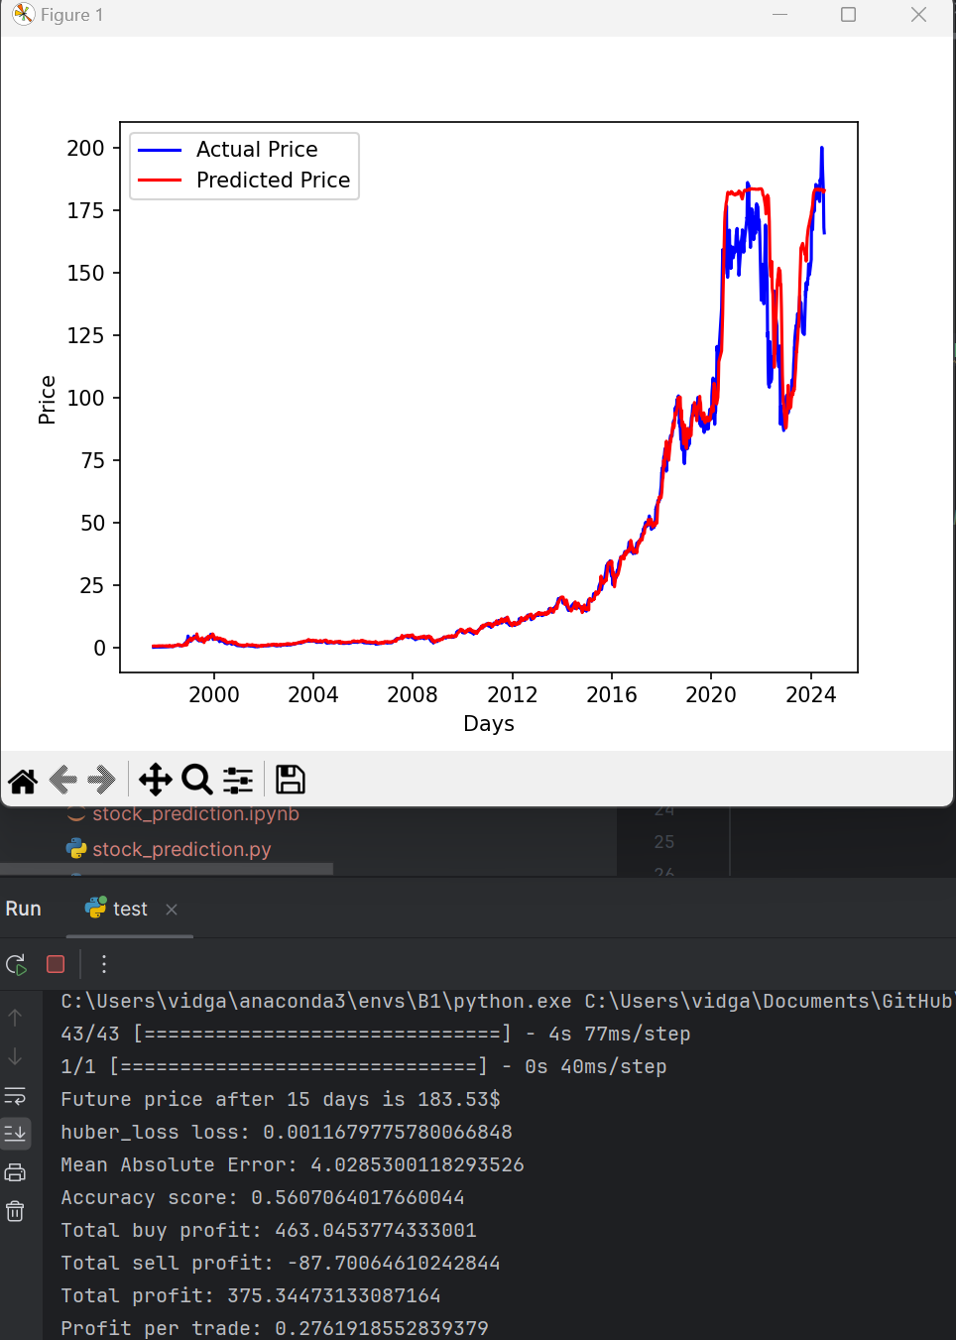

Train.py

This file when run, consisted of 500 epochs to train. Since I am new to this, I didn’t realise it would take so long. This program had been running for 1.5-2 hours, and it had only got to 200 out of 500 epochs. I tried switching the GPU mode on my computer, to see if that would speed it up, but it didn’t help. In future tasks, I’ll likely have to take this run time into consideration for how I manage my time. I couldn’t get a screenshot of the chart before the deadline, because I didn’t realise it would take so long for the program to run.

stockprediction.py and parameters.py didn’t return anything at runtime.