**• Draw use case diagram for UC-1 (Unlock) and UC-4 (RetireUser)**

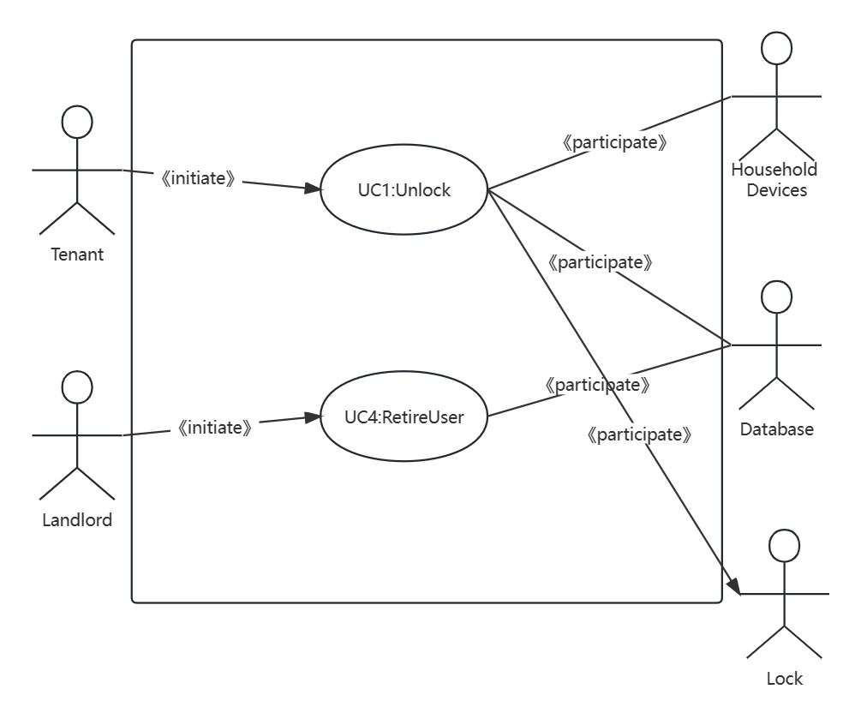

**• Write the use case schemas of UC-1 and UC-4**

Use Case Schema for UC-1 (Unlock)

Use Case UC1: Unlock

Related requirements: REQ2,REQ3 and REQ8 stated in the table of REQs

Goal: The tenant wants to unlock and enter their home.

Initiating Actor: Tenant

Participating Actors: Lock, Household Devices, Database

Precondition: The tenant is within proximity of the home.

Postcondition: The door is unlocked and the tenant is able to enter the home.

Main Flow:

i.The tenant approaches the door.

ii.The system detects the proximity of the tenant's mobile phone using the Bluetooth network.

iii.The system sends a signal to the lock to unlock the door.

iv.The lock mechanism unlocks the door.

v.The system activates the household devices based on the tenant's preferences.

Alternative Flow:

If the system fails to detect the tenant's mobile phone or the Bluetooth network is not available, the door remains locked.

Use Case Schema for UC-4 (RetireUser)

Use Case: RetireUser

Related requirements: REQ3,REQ7 and REQ8 stated in the table of REQs

Goal: The landlord wants to retire an existing user account and disable access to the home.

Initiating Actor: Landlord

Participating Actors: Database

Precondition: The landlord has the necessary authorization to retire a user account.

Postcondition: The user account is retired and access to the home is disabled for the retired user.

Main Flow:

i.The landlord accesses the system's administrative interface.

ii.The landlord selects the option to retire a user account.

iii.The system prompts the landlord to enter the details of the user account to be retired.

iv.The landlord provides the necessary information.

v.The system verifies the information and checks if the user account exists.

vi.If the user account is found, the system marks it as retired and disables access for the retired user.

vii.The system updates the database to reflect the changes.

Alternative Flow:

If the provided user account information is invalid or the user account does not exist, the system displays an error message and the retirement process is not completed.

**• Write the acceptance tests for UC-1 and UC-4**

Acceptance Tests for UC-1 (Unlock)

Test Case 1:

Description: Test successful unlocking of the door by the tenant.

Precondition: The tenant is within proximity of the home.

Steps:

i.The tenant approaches the door.

ii.The system detects the proximity of the tenant's mobile phone using the Bluetooth network.

iii.The system sends a signal to the lock to unlock the door.

Expected Result: The door unlocks and the tenant is able to enter the home.

Test Case 2:

Description: Test unlocking failure when the tenant's mobile phone is not detected.

Precondition: The tenant is not within proximity of the home.

Steps:

i.The tenant approaches the door.

ii.The system fails to detect the proximity of the tenant's mobile phone using the Bluetooth network.

Expected Result: The door remains locked and the tenant is unable to enter the home.

Acceptance Tests for UC-4 (RetireUser)

Test Case 1:

Description: Test successful retirement of an existing user account by the landlord.

Precondition: The landlord has the necessary authorization to retire a user account.

Steps:

i.The landlord accesses the system's administrative interface.

ii.The landlord selects the option to retire a user account.

iii.The landlord provides the necessary information of the user account to be retired.

iv.The system verifies the information and checks if the user account exists.

v.The user account is found and marked as retired.

Expected Result: The user account is retired and access to the home is disabled for the retired user.

Test Case 2:

Description: Test failure to retire a user account when the provided information is invalid.

Precondition: The landlord has the necessary authorization to retire a user account.

Steps:

i.The landlord accesses the system's administrative interface.

ii.The landlord selects the option to retire a user account.

iii.The landlord provides invalid information of the user account to be retired.

iv.The system verifies the information and checks if the user account exists.

Expected Result: The system displays an error message indicating that the provided information is invalid and the retirement process is not completed.