**Chapter 1**

# INTRODUCTION

Breast cancer is one of the most dangerous and prevalent cancers among women, causing the deaths of large numbers of women worldwide. Breast cancer accounts for 8.4% of diagnosed cancers and 6.6% of cancer-related deaths worldwide, according to a World Health Organization (WHO) report [1]. Breast cancer accounted for 15.9% of all reported cancers among Saudi citizens and 28.7% of all reported cancers among women of all ages, according to the Saudi Health Council [2]. Breast cancer is more common in women with dense breasts, and there is a relationship between density and age, with younger women having denser breasts than older women [3]. The American College of Radiology developed the Breast Imaging Data and Reporting System (BI-RADS). Table 1 presents the four BI-RADS assessment categories.

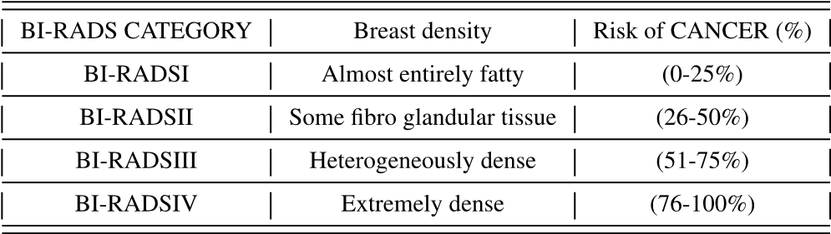

Despite recent developments in computer vision, screening mammography is still read and interpreted manually under the supervision of a radiologist. However, the enormous number of screening images is difficult for radiologists to handle accurately. Recently, medical imaging researchers have used stateof-the-art techniques to solve problems with breast cancer analysis [4]. Several research has been carried out on the automatic identification of breast cancer. According to the World Health Organization, BC is the most frequently diagnosed cancer in women, accounting for approximately one in four newly diagnosed cancer cases. According to the World Cancer Research Fund International, only 1.7 million new cases were reported in 2012 (WCRF). Despite its high incidence and even the absence of early signs [5], early identification of BC can considerably improve the chances of survival. According to the WCRF, patients identified with stage I/II BC have a five-year survival rate of 80-90 percent, while patients diagnosed with stage III/IV BC have a survival rate of only 24 percent. As a result, it is obvious that the proper classification of benign tumors is essential to encourage patients to seek appropriate therapy and obtain a better prognosis. As a result, considerable research in the diagnosis of BC focuses on accurately identifying individuals as malignant or benign. Many Machine-Learning (ML) algorithms and neural network (NN) approaches have been used in the BC Wisconsin diagnostic and prognostic dataset. For the classification challenge, researchers have presented a large number of ML techniques in previous articles. We fully describe the various classification algorithms used to classify BC in this investigation. We mainly focus on artificial neural network (ANN) methods based on deep learning (DL), as well as support vector machines (SVM) based on traditional machine learning (ML) and k-nearest neighbor (KNN) and decision tree (DT) algorithms. BC data has lots of varieties, open-source and private included. In the 1990s, a Wisconsin hospital collected three datasets, one of which was WBCD, which has strong representation and comparability due to having many algorithms applied to it. 94.36% to 99.90% is the range within which the classification accuracies of different algorithms are achieved. Developing different ML algorithms that are better improved is still needed to obtain alternative answers to complex BC data in the real world or other medical data, even though very high accuracies are achievable with a significant number of already existing algorithms. Though not the only criterion, classification accuracy is intuitive and especially important. The need for new algorithms to be developed to improve the existing techniques, considering that they still have drawbacks despite having their specific advantages. Accuracy in physicians’ decision-making is greatly aided by these algorithms once used to build healthcare systems that can provide second opinions. Open-source benchmark databases beginning with ANNs, then SVM, DTs, and k-NNs are analyzed by the ML algorithms highlighted in the coming subsections. In this paper, our main contributions are:

• We presented an ensemble of machine learning-based methods for breast cancer diagnosis and prognosis using an ensemble of machine learning classifiers.

• We presented a comprehensive comparison of the performance of various machine learning and ensemble machine learning-based classifiers.

• We evaluated different sampling methods to address the class imbalance issue in our datasets. • We demonstrated that the proposed method outperforms various state-of-the-art methods for the detection of breast cancer.

# Chapter 2

# LITERATURE SURVEY

Many automatic systems for breast cancer classification have emerged in recent years; these systems use different approaches. Breast cancer categorization is a classification problem that requires the extraction of discriminatory features and then classification. State-of-the-art strategies for breast cancer staging that have been proposed are discussed in the following paragraphs. Whitaker et al. [10] suggested a two-stage patch classification technique for mammography using two texture descriptors: ‘‘Histogram of Oriented Texture (HOT)’’ and ‘‘Pass Band Discrete Cosine Transform (PB-DCT).’’ In the first stage, mammogram patches are classified as normal or abnormal. The second stage uses a support vector machine (SVM) to classify aberrant mammographic regions as benign or malignant. Jothilakshmi and Raaza [13] developed a texture-based strategy to identify malignant and benign using multiple SVMs, with features retrieved using ‘‘grey-level co-occurrence matrices (GLCM). In [14] proposed a new approach to classify benign and malignant breast masses. The approach converts two-dimensional contours of breast masses on mammography into a one-dimensional signature. DT is a popular classification method that is easy to learn and interpret while improving human readability. On the diagnostic data set, the researchers used 10-fold cross-validation to discover the optimal combination of parameters, and this model had an accuracy of 93.62% and a specificity of 90.66% [22]. In a multidimensional feature space filled with known instances of a training dataset, nearest neighbors algorithms classify the data by discovering its nearest neighbors [23]. The better the dimension ratios for the nearest neighbors, the higher the predictive efficiency. Because the results of this algorithm depend on how the distance between the data is measured, both approaches, the Manhattan distance, and the Euclidean distance were examined this time. SVM is a supervised learning technique for classifying, predicting, and detecting outliers. They are cheap and effective, particularly in high-dimensional areas, because they only require a subset of training points on support vectors. On diagnostic data, SVM achieved 98 percent accuracy [24] and 78.35 percent accuracy using the polynomial kernel.

Since NNs are capable of capturing the relationships between attributes, it is largely used for BC detection. Liu et al. [25] presented a DT algorithm for BC detection and used an under-sampling approach to address the issue of an imbalanced training class, which improved the results. Quinlan [26] presented a better DT method for BC detection and achieved a performance accuracy of 94%. However, one classifier cannot learn all the features of the BC detection and recurrence rate [27]. Considering the drawback of a single classifier, various ensemble-based algorithms are proposed. This [28] used the hybrid method proposed by Zhang et al. [29] where the authors presented a hybrid classifier with various sets of features and used SVM for classification. The fuzzy approach for feature selection and the fuzzy nearest neighbor method for BC detection are combined into a hybrid classification system for BC detection [24]. Data can be effectively classified using classification and data mining methods.

Such methods have prevalent use in the medical field for analysis and diagnosis so decisions can be made. Classification techniques [30] such as AdaBoost, KNN, and K Tree, as well as neural networks, feature selection methods, and SVM [29], have been used in a variety of study domains. Goodman et al. [31] used three different approaches, including artificial immune recognition system (AIRS), optimized learning vector quantification (LVQ), and large LVQ, with an accuracy of 97.2%, 96.7%, and 96. 8%, respectively.

Using the SVM class possibility that is based kernel (CPBK) algorithm, Li and Liu [32] achieved a classification accuracy of 93.26%. The accuracy of an SVM-based classifier reported in [33] was 97.60%. Ensemble of classifiers is another essential method to improve the performance of a single classifier [34]. The predictions by a single classifier are combined by various techniques in the ensemble-based classifiers, which improves the overall prediction and makes more accurate predictions than a single classifier [35]. In typical settings of the ensemble-based classifiers, training data is replicated by k times and then build k classifiers by re-sampling the original data [36].

Similarly, various voting methods exist for classification. To make the qualifier run multiple times, take a training set and a qualifier and change the distribution of instances in the training set. To arrive at the final classification, the results of the constructed classifiers [37] are concatenated. The most prevalent voting approach is to combine the results of the base-level classifiers using a plurality.

However, this strategy does not use metal fetching, and all training sets and classifiers use the same voting technique [38]. The one-dimensional signature is then segmented into subsections to extract local contour features.

Finally, these features are fed to an SVM classifier. Laroussi et al. [39] Proposed two CAD systems for the classification of mammograms breast density for two and four ‘‘BI-RADS’’ layer.

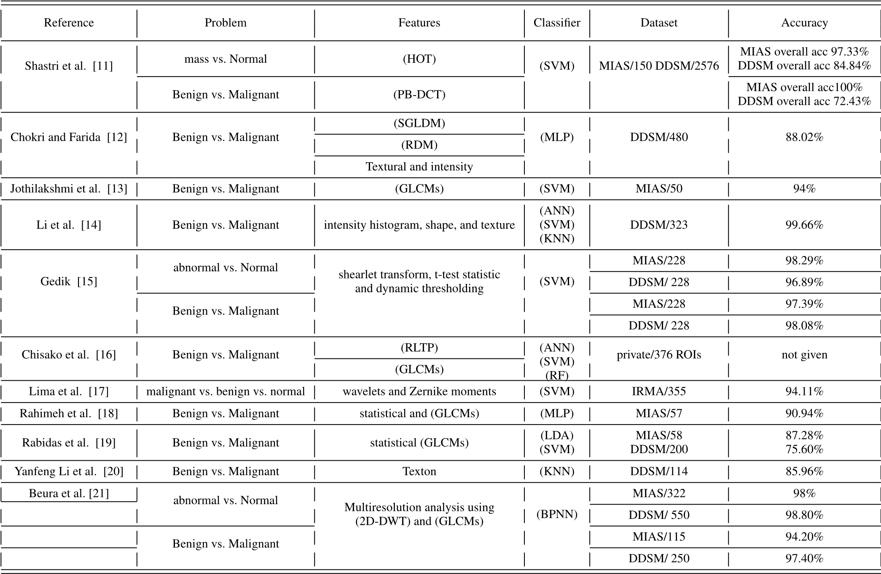 **FIGURE 1: Summary of breast cancer classification.**

This is the classes consisting of features computed using different Law filters of varying lengths. The feature vectors are then fed to classifiers ‘PNN,’ ‘NFC,’ and ‘SVM’ to classify tissue density. Previous works have shown promising results using various classifiers.

However, previous studies have demonstrated that using an ensemble of classifiers improves the results. In this work, we address this gap and present a method that uses different classifiers, i.e., an ensemble of classifiers, to improve the results of breast cancer detection. An overview of techniques is given in Figure 1 for breast cancer classification methods.

# Chapter 3

# BACKGROUND

## 3.1 BREAST CANCER

Breast cancer is a disease in which malignant (cancer) cells grow in the breast tissues. A tumor is a mass of diseased tissue. There are two types of breast tumors: non-cancerous, ‘‘benign,’’ and cancerous, or ‘‘malignant.’’ Cancer starts in the cells that are the basic building blocks in the breast or other body parts that make up tissue. Occasionally the way of cell outgrowth goes fault, and new cells form or old or damaged cells would not die as they do when the body does not need them [7]. Any new breast, lump, or breast changes should then be monitored by a health care professional experienced in the diagnosis of breast disease that is commonly a sign of breast cancer [8]. No treatment has yet been discovered for cancer tumors. However, early detection of breast cancer is crucial to minimize the number of cancer deaths and enhance patients’ quality of life. On a mass can be ‘circumscribed’, ‘Micro-lobulated’, ‘Obscured’, ‘Indistinct’, or ‘Speculated’ as shown in Figure 2. The most widespread and recognized factors increasing the risk of breast cancer are female sex, age, genetics, and having dense breasts. Breast density is a measure used to depict the extent of the distinctive tissues that form a woman’s breasts and how the breasts look on a mammogram. Breast cancer is more common in women with dense breasts, and there is a relationship between densities and women’s age, with younger women having denser breasts than older women [3]. The American College of Radiology created ‘BI-RADS,’ which stands for Breast Imaging Data and Reporting System [9]. Figure 4 illustrates the ‘BI-RADS evaluation categories. ‘BI-RADS’ advantageously encourages radiologists to consider which category is most appropriate.

**3.2 COMPUTER-AIDED DIAGNOSIS (CAD)**

A computer-aided diagnostic (CAD) system analyzes radiographic evidence to determine the likelihood that a feature represents a certain disease process.’’ (eg benign vs. malignant) [10]. CAD systems for breast cancer utilize various pattern recognition techniques. In general, there are three main modules in a CAD system: mammogram, the shape of a specific breast mass can be ‘Round,’ ‘Oval,’ ‘Lobular,’ ‘Irregular,’ or ‘architectural distortion’ as shown in Figure 2. ‘Circumscribed oval’- and ‘round-shaped’ masses strongly suggest that a lesion is benign. In contrast, masses of irregular shape usually raise suspicion of malignancy, the edges of breast detection, segmentation, and classification. Mass detection is a challenging issue but plays a significant role in the diagnosis of breast cancer.



**FIGURE 2. Shape of breast mass.**

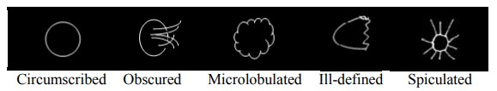

**FIGURE 3. Edges of breast mass.**

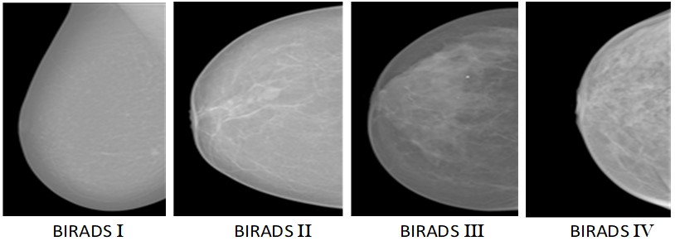

**FIGURE 4. Mammogram images example of four “BI-RADS.I”: Fatty BI-RADS1, Fibroglandular BI-RADS2, Hetrogenously BI-RADS3, Extermely BI-RADS4: Extermely dense.**

The detection task is to find the location of a lesion on a mammogram if one exists. Detection generally comprises three modules: (1) detecting suspicious regions (i.e., by density, micro-calcifications, and mass) (2) extracting features, and (3) eliminating false positive regions. Mass segmentation is the next stage, which is the process of partitioning mammogram images into regions possessing identical characteristics. Mass classification is the last stage, categorizing the input regions of interest (ROIs) as Mass or Normal, depending on abnormality. Mass lesions are then categorized as benign or malignant. Breast mass classification can be grouped for the data training stage. Breast mass detection and breast density classification would greatly help treat breast cancer. One problem with using CAD systems for mass detection is the high false-positive rate since masses and normal dense tissue is comparable on a mammogram.

**Chapter 4**

# METHODOLOGY

This section presents the method used for an ensemble of ML classifiers. This architecture is composed of four different ML models. They are stacked and then further trained as an ensemble. After training, the ANN model is used for the outcome. The illustration of our proposed DL network is shown in Figure 4. The performance is compared with the several ML classifiers individually with and without up- sampling techniques. We also compared the performance of the proposed ensemble model with other ensemble models.

hand-crafted features for breast cancer classification. Previous works have shown promising results using various classifiers. However, previous studies have demonstrated that using an ensemble of classifiers improves the results. In this work, we address this gap and present a method that uses different classifiers, i.e., an ensemble of classifiers, to improve the results of breast cancer detection. An overview of techniques is given in Figure 5 for breast cancer classification methods.

In this study, we design a classification framework by an ensemble of four ML-based classifiers named SVM, LR, NB, and DT. An ensemble model is stacked, and predictions are concatenated and then fed to the ANN model for final prediction. Each of the algorithms used in our study is also briefly explained next section. The steps of the proposed model can be summarized below:

1. We used machine learning based classifiers on a training dataset
2. In the second step, the K-fold method retrieves the most common outcome from these classifiers.
3. In third step, we concatenated results from machine learning classifiers
4. New training dataset streamlined as a result
5. In this step, we input the new dataset into the default ANN
6. Result and evaluation of outputs

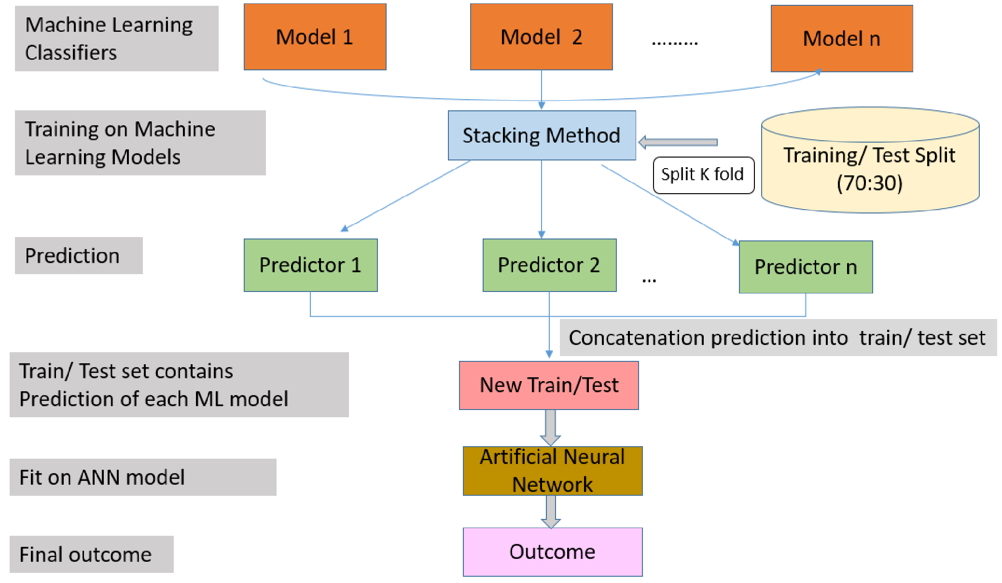

**FIGURE 5: Illustration of the proposed network architecture.**

# 4.1 SUPPORT VECTOR MACHINE (SVM)

A supervised ML-based technique, SVM selects the moderate number of samples called support vectors and builds a linear discriminant function. SVM solved the restriction of linear limits [40]. SVM can be considered a two-class data set that can be partitioned linearly to show a maximum hyperplane margin.

The new samples are linearly fit or appear linearly separable in the high-level plane following the selection of the appropriate mapping. The SVM tries to find the most advantageous hyperplane that minimizes the distance between two groups [41].

# 4.2 LOGISTIC REGRESSION (LR)

The LR method is created by replicating the posterior probability of K groups across linear roles in x while ensuring they equal one and stay within the range [0, 1]. Logit shifts K -1, or log probabilities can be used to describe LR.

Although the final group is used as the denominator in the odds ratio, the choice of the denominator is indeterminate because the counts are divided evenly. Since there is only one linear role when K = 2, the style is direct. This technique is often used in biostatic tasks where binary responses are repeated.

# 4.3 NAIVE BAYES (NB)

Bayes theorem [42] is used to suggest the NB algorithm. The NB classifier can be revised in the following ways using Bayes’ theorem and the exact procedures [43]. We conclude that there is a training set of instances *T*. There are group marks on these specimens. *C*1*,C*2 ···*Ck* are the names of the groups. Each specimen is an n-dimensional agent represented by the formula *X* = *x*1*,x*2 ···*xn*. It states that *X* has n features since it has n dimensions.

A specimen *X* is predicted to be a member of group*Ci* if the probability that group *i* depends on *X* is greater than the probability that each of the other groups depends on *X*, or formally:

*p*(*Ci*|*X*) *> P*(*Cj*|*X*) *for* 1 ≤ *j* ≥ *kj* = *i*) (1)

Using Bayes’ Theorem P (Ci |X) is calculated as follows:

*P*(*Ci*|*X*) = *P*(*X*|*Ci*)*P*(*Ci*)*/P*(*X*) (2)

# 4.4 DECISION TREE (DT)

DT that begins with huge groupings of specimens within clearly defined categories [44]. Specimens are used for patterns that allow groups to be accurately characterized by combining nominal and numerical features. These markers are then represented as models, resulting in decision frameworks or sets of if-then processes that can be used to distinguish new samples, emphasizing making designs understandable and accurate. To determine the ‘goodness’ of a test, the C4.5 calculus uses equations based on theoretical data; specifically, they choose the test that takes the most data from a collection of specimens while limiting themselves to evaluating a single characteristic.The limitation of DT is how to handle the issue of over-fitting and unknown values. C4.5 method of DT can address the issue of unknown values, especially the samples with unknown values are ignored.

# 4.5 ARTIFICIAL NEURAL NETWORK (ANN)

In the past decades, ANNs have been utilized by researchers, thus making them a relevant research area. Greatly, the network has enabled great success, especially in BC classification and early-stage prognosis [45]. ANN models usually have three layers: input, hidden, and output [31]. The layers comprise interconnected neurons with nonlinear switching activation functions to enhance nonlinear capacity. First, the input layer gets the data, then passes it to a hidden layer for analysis and returns the results to the output layer. Results shows are now displayed through the output layer. However, given the constraints, training an ANN will likely require long informal chains of computing processes.

**Chapter 5**

# EXPERIMENTAL RESULT

In this section, we present the datasets used in this study and the experimental evaluations to demonstrate the usefulness of our proposed model. In this study, following previous studies, we used accuracy to evaluate the performance. Classification results are analyzed using a 10-fold cross-validation technique.

# 5.1 DATASET DETAILS

The Breast cancer Wisconsin (Diagnosis)[1] and Breast cancer Wisconsin (Prognosis)[2] databases are used in this study.

**FIGURE 6: Dataset distribution**

Wisconsin Breast Cancer (Diagnosis) contains 569 instances and 32 attributes (an ID and a target variable). Wisconsin Breast Cancer (Prognosis) contains 198 instances and 34 attributes (containing an ID and a target variable). The forecast dataset also had four missing attribute values, which were removed; furthermore, the forecast data set is considerably skewed, with 151 non-recurring and 47 recurring outcomes.

Dataset distribution is given in Figure 6. In the BC Wisconsin Diagnostic and Prognostic data sets, two additional strategies (algorithm approach and data approach) were implemented to solve the problem of an unbalanced classification problem. To start with, we used cost-sensitive learning or a misclassification penalty as a misclassification penalty while training the model to improve performance in minority classes.

This is achieved by adding the misclassification cost to the error or using it to weight the error. Second, the dataset can be resampled, making this approach more versatile. Up-sampling and down-sampling are used to increase the number of minority classes in the resampling. Data standardization was done to ensure that the data was consistent. Each type of data had the same content and format.

# 5.2 EVALUATION METRIC

We have used accuracy as a evaluation metric is this study. All reported results are the average results. Accuracy is defined as follows:

*Accuracy=Number of correct predictions/ All the samples*

*Accuracy*:

# 5.3 EXPERIMENTAL RESULTS AND DISCUSSION

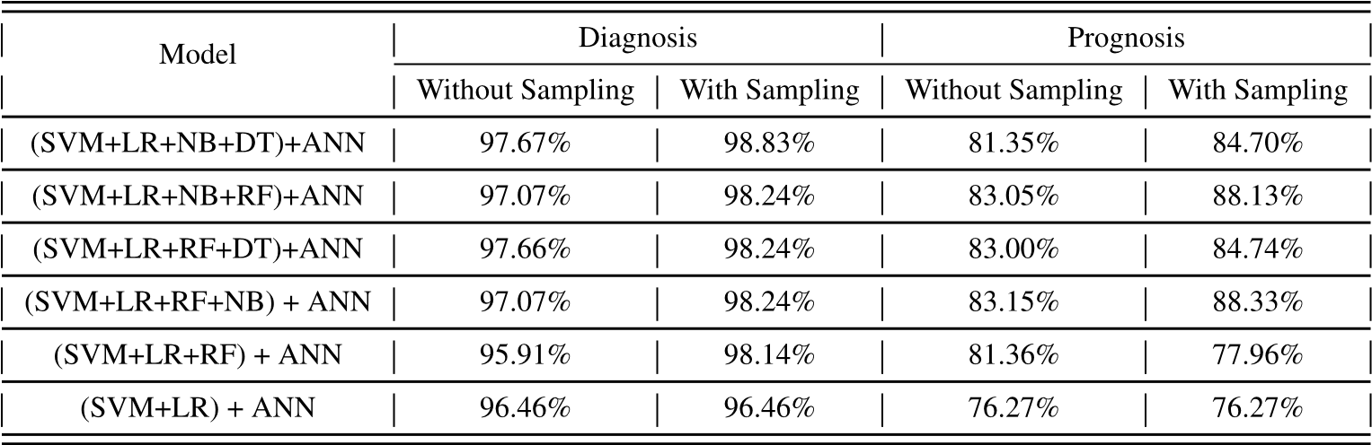This section describes the results and presents the baseline models used to compare our proposed model. To evaluate the performance of the proposed model, we compare it with various machine learning classifiers and other methods. All the algorithms were used with their default parameters in this study. Figure 7 and Figure 8 show the results of all ML classifiers and DL classifiers used in our study.

**FIGURE 7: Ensemble of ML classifiers with ANN with and without the sampling.**

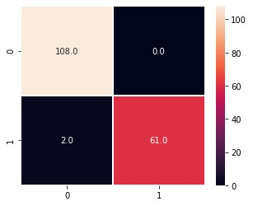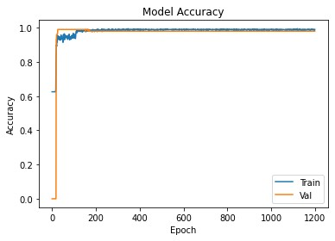

**FIGURE 8: Illustrate of confusion matrix (Diagnosis). FIGURE 9: Illustration of train/test accuracy (Diagnosis).**

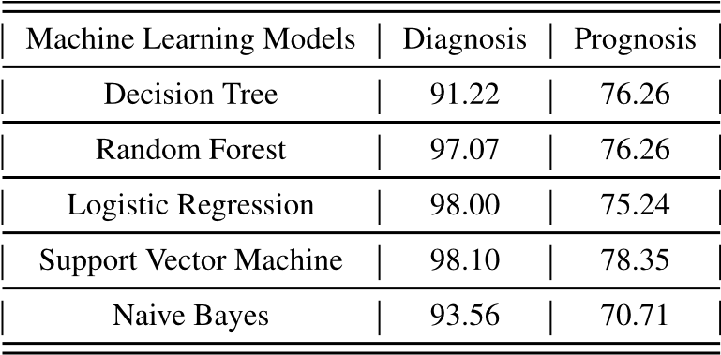

**FIGURE 10: Comparison of ML classifiers. Average accuracy (%) is reported as evaluation metric**

It can be observed from Table 4 that SVM outperforms all ML-based classifiers on both diagnosis BC with 98.10% accuracy and prognosis BC dataset with 78.35% accuracy. In contrast, the worst classifier on the diagnosis dataset is DT with 91.22% accuracy and NB on the prognosis dataset with 70.71%. For DL-based classifiers, ANN performs well on both datasets, with 98.24% accuracy on the diagnosis dataset and 90.22% accuracy on the prognosis dataset compared to Comparing all the different ensemble models in Table 6 shows which model performed best for each dataset. The best ensemble model is the ensemble of (SVM + LR + NB + DT) in both cases (without 97.67% and with upsampling 98.83%). In contrast, the worst-performing combination is (SVM+LR+RF) in both cases (95.91% for without sampling and 98.14% for upsampling) on the diagnosis dataset. For prognosis, the best ensemble model combines (SVM+LR+RF+NB) in both cases (without 83.15% and with upsampling 88.33%). In contrast, the worst-performing combination is (SVM+LR) in both cases (76.27% for without and 76.27% with up-sampling) on prognosis. The increment of 1.16% was observed on diagnosis and 5.18% on the prognosis dataset when the upsampling technique was used. The confusion matrix and train/test accuracy of best-performing ensemble classifiers.

#### 5.4 TRANSFER LEARNING

To get better machine learning results, we use transfer learning. Specifically, knowledge from one domain (source domain) is transferred to another domain (target domain). The ImageNet data set includes approximately 1.2 million images and 1000 categories, whereas the data set obtained in this study is 900 images and three disease categories. For comparison, there is insufficient corn disease data to train a deep network, so transfer learning technology is used.

Without adding data, _ne-tune the Inception V3, VGG-16, ResNet18, andVGG-19 networks:

Create and load the weight pre-trained by ImageNet, and connect a new FC layer.

# 5.5 ANALYSIS

We also analysed the effects of applying balanced class weights with sampling and measured the performance when applying different K values, as shown below in the figure.11 and the Figure 12.

We observed that performance increased substantially for all tested combinations of classifiers when compared with up-sampling on the prognosis dataset. We also note that the confusion matrices below show that when K is 5 instead of 10, the model (SVM + LR + RF + DT) trained on the forecast outperforms.

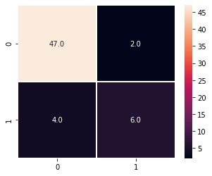

**FIGURE 11.** Illustration of confusion matrix (Prognosis) when K D 5

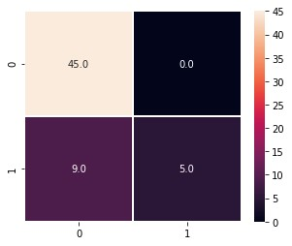

**FIGURE 12.** Illustration of confusion matrix (Prognosis) when K D 10.

# CONCLUSION

We proposed a method for breast cancer diagnosis and prognosis using machine learning techniques in this research. Benchmark datasets are used for the experiments. Classifiers based on machine learning and deep learning have shown their exceptional potential to increase classification and prediction accuracy. Several ensembles of different ML-based classifiers were also tested for the classification of Breast Cancer. We found out that SVM outperforms both datasets compared to all ML classifiers and ANN from DL classifiers when used individually. For the ensembling method, (SVM + LR + NB + DT) performs well without and with up-sampling on the diagnosis dataset, whereas (SVM+LR+RF+NB) outperforms all other combinations on the prognosis dataset when ANN is used as a final layer. We also observed an increase in performance when balanced class weights are used along with the up-sampling technique as compared to without, and the up-sampling technique is used individually. The performance was also analysed using a different number of K-fold for the best ensemble classifier. In the future, we intend to apply more advanced models for the automatic detection of Breast Cancer.

## REFERENCES

1. Cancer Burden Rise to 18.1 million New Cases and 9.6 million Cancer Deaths in 2018, International Agency for Research on Cancer, World Health Organization, Geneva, Switzerland, 2018, p. 3.
2. W. S. Alqahtani, N. A. Almufareh, D. M. Domiaty, G. Albasher,

M. A. Alduwish, H. Alkhalaf, B. Almuzzaini, S. S. Al-Marshidy, R. Alfraihi, A. M. Elasbali, and H. G. Ahmed, ‘‘Epidemiology of cancer in Saudi Arabia Thru 2010–2019: A systematic review with constrained meta-analysis,’’ AIMS Public Health, vol. 7, no. 3, p. 679, 2020.

1. J. Wei, H.-P. Chan, Y.-T. Wu, C. Zhou, M. A. Helvie, A. Tsodikov, L. M. Hadjiiski, and B. Sahiner, ‘‘Association of computerized mammographic parenchymal pattern measure with breast cancer risk: A pilot casecontrol study,’’ Radiology, vol. 260, no. 1, pp. 42–49, Jul. 2011.
2. G. Litjens, T. Kooi, B. E. Bejnordi, A. A. A. Setio, F. Ciompi, M. Ghafoorian, J. A. V. D. Laak, B. V. Ginneken, and C. I. Sánchez, ‘‘A survey on deep learning in medical image analysis,’’ Med. Image Anal., vol. 42, pp. 60–88, Dec. 2017.
3. M. Milosevic, D. Jankovic, A. Milenkovic, and D. Stojanov, ‘‘Early diagnosis and detection of breast cancer,’’ Technol. Health Care, vol. 26, no. 4, pp. 729–759, 2018.
4. B. Surendiran and A. Vadivel, ‘‘Mammogram mass classification using various geometric shape and margin features for early detection of breast cancer,’’ Int. J. Med. Eng. Informat., vol. 4, no. 1, pp. 36–54, 2012.
5. R. A. Castellino, ‘‘Computer aided detection (CAD): An overview,’’ Cancer Imag., vol. 5, no. 1, pp. 17–19, 2005.
6. E. Darcey, N. McCarthy, E. K. Moses, C. Saunders, G. Cadby, and J. Stone, ‘‘Is mammographic breast density an endophenotype for breast cancer?’’ Cancers, vol. 13, no. 15, p. 3916, Aug. 2021.
7. W. A. Berg, C. Campassi, P. Langenberg, and M. J. Sexton, ‘‘Breast imaging reporting and data system: Inter- and intraobserver variability in feature analysis and final assessment,’’ Amer. J. Roentgenol., vol. 174, no. 6, pp. 1769–1777, Jun. 2000.
8. K. Whitaker, ‘‘Earlier diagnosis: The importance of cancer symptoms,’’ Lancet Oncol., vol. 21, no. 1, pp. 6–8, Jan. 2020.
9. A. A. Shastri, D. Tamrakar, and K. Ahuja, ‘‘Density-wise two stage mammogram classification using texture exploiting descriptors,’’ Expert Syst. Appl., vol. 99, pp. 71–82, Jun. 2018.
10. F. Chokri and M. H. Farida, ‘‘Mammographic mass classification according to Bi-RADS lexicon,’’ IET Comput. Vis., vol. 11, no. 3, pp. 189–198, Apr. 2017.
11. G. R. Jothilakshmi and A. Raaza, ‘‘Effective detection of mass abnormalities and its classification using multi-SVM classifier with digital mammogram images,’’ in Proc. Int. Conf. Comput., Commun. Signal Process. (ICCCSP), Jan. 2017, pp. 1–6.
12. H. Li, X. Meng, T. Wang, Y. Tang, and Y. Yin, ‘‘Breast masses in mammography classification with local contour features,’’ Biomed. Eng. OnLine, vol. 16, no. 1, pp. 1–12, Dec. 2017.
13. N. Gedik, ‘‘A new feature extraction method based on multi-resolution representations of mammograms,’’ Appl. Soft Comput., vol. 44, pp. 128–133, Jul. 2016.
14. C. Muramatsu, T. Hara, T. Endo, and H. Fujita, ‘‘Breast mass classification on mammograms using radial local ternary patterns,’’ Comput. Biol. Med., vol. 72, pp. 43–53, May 2016.
15. S. M. L. de Lima, A. G. da Silva-Filho, and W. P. dos Santos, ‘‘Detection and classification of masses in mammographic images in a multi-kernel approach,’’ Comput. Methods Programs Biomed., vol. 134, pp. 11–29, Oct. 2016.
16. R. Rouhi and M. Jafari, ‘‘Classification of benign and malignant breast tumors based on hybrid level set segmentation,’’ Expert Syst. Appl., vol. 46, pp. 45–59, Mar. 2016.
17. R. Rabidas, J. Chakraborty, and A. Midya, ‘‘Analysis of 2D singularities for mammographic mass classification,’’ IET Comput. Vis., vol. 11, no. 1, pp. 22–32, Feb. 2017.
18. Y. Li, H. Chen, G. K. Rohde, C. Yao, and L. Cheng, ‘‘Texton analysis for mass classification in mammograms,’’ Pattern Recognit. Lett., vol. 52, pp. 87–93, Jan. 2015.
19. S. Beura, B. Majhi, and R. Dash, ‘‘Mammogram classification using two dimensional discrete wavelet transform and gray-level co-occurrence matrixfordetectionofbreastcancer,’’Neurocomputing,vol.154,pp. 1–14, Apr. 2015.
20. R. AlamKhan, N. Ahmad, and N. Minallah, ‘‘Classification and regression analysis of the prognostic breast cancer using generation optimizing algorithms,’’ Int. J. Comput. Appl., vol. 68, no. 25, pp. 42–47, Apr. 2013.
21. R. Nisbet, J. Elder, and G. D. Miner, Handbook of Statistical Analysis and Data Mining Applications. New York, NY, USA: Academic, 2009.
22. A. Onan, ‘‘A fuzzy-rough nearest neighbor classifier combined with consistency-based subset evaluation and instance selection for automated diagnosis of breast cancer,’’ Expert Syst. Appl., vol. 42, no. 20, pp. 6844–6852, 2015.
23. Y.-Q. Liu, C. Wang, and L. Zhang, ‘‘Decision tree based predictive models for breast cancer survivability on imbalanced data,’’ in Proc. 3rd Int. Conf. Bioinf. Biomed. Eng., Jun. 2009, pp. 1–4.
24. J. R. Quinlan, ‘‘Improved use of continuous attributes in C4.5,’’ J. Artif. Intell. Res., vol. 4, pp. 77–90, Mar. 1996.
25. H. Wang, B. Zheng, S. W. Yoon, and H. S. Ko, ‘‘A support vector machinebased ensemble algorithm for breast cancer diagnosis,’’ Eur. J. Oper. Res., vol. 267, no. 2, pp. 687–699, Jun. 2018.
26. M. F. Akay, ‘‘Support vector machines combined with feature selection for breast cancer diagnosis,’’ Expert Syst. Appl., vol. 36, no. 2, pp. 3240–3247, 2009.
27. B. Zheng, S. W. Yoon, and S. S. Lam, ‘‘Breast cancer diagnosis based on feature extraction using a hybrid of K-means and support vector machine algorithms,’’ Expert Syst. Appl., vol. 41, pp. 1476–1482, Mar. 2014.
28. A. G. Dunn, J. Leask, X. Zhou, K. D. Mandl, and E. Coiera, ‘‘Associations between exposure to and expression of negative opinions about human papillomavirus vaccines on social media: An observational study,’’ J. Med. Internet Res., vol. 17, no. 6, p. e144, Jun. 2015.
29. D. E. Goodman, L. Boggess, and A. Watkins, ‘‘Artificial immune system classification of multiple-class problems,’’ in Proceedings of the Artificial Neural Networks in Engineering ANNIE, vol. 2. St. Louis, MO, USA: ASME, 2002, pp. 179–183.
30. D.-C. Li and C.-W. Liu, ‘‘A class possibility on based kernel to increase classification accuracy for small data sets using support vector machines,’’ Expert Syst. Appl., vol. 37, no. 4, pp. 3104–3110, Apr. 2010.
31. H. Cevikalp, B. Triggs, H. S. Yavuz, Y. Küçük, M. Küçük, and A. Barkana, ‘‘Large margin classifiers based on affine hulls,’’ Neurocomputing, vol. 73, nos. 16–18, pp. 3160–3168, Oct. 2010.
32. L. Rokach, ‘‘Ensemble-based classifiers,’’ Artif. Intell. Rev., vol. 33, nos. 1–2, pp. 1–39, Feb. 2010.
33. T. G. Dietterich, ‘‘Machine-learning research,’’ AI Mag., vol. 18, no. 4,

p. 97, 1997.

1.
2.