REPORT – OIL PRICE COLLECTOR

Github

UNIX Script for Data Collection:
When the script is started, it will automatically check for the existence of user commands such as awk, cat and MySQL as well as the necessary files for data logging. If the commands do not exist, the script will not proceed. If the files do not exist, they are created using the echo “” > “filename.filetype” pipe.
if command -v /usr/bin/echo >&2 && command -v /usr/bin/curl >&2 && command -v /usr/bin/cat >&2 &&
command -v /usr/bin/grep >&2 && command -v /usr/bin/awk >&2 && command -v /usr/bin/mysql >&2 && ! [ -z "${MYSQLPASS}" ]; then
if ! [ -f "./cron_log.log" ]; then
/usr/bin/echo "" > "./cron_log.log"
fi
...

It will then curl the website OilPrices to the existing response.html in the current directory. To ensure the script hasn’t been blocked by the website, that the page accessed is still in in existence, and that the website isn’t down, it searches for relevant words.
echo “” > “filename.filetype” pipe.
if [[ "$result" != 0 ]] || echo "$response" | grep -q "Sorry - the page you tried to reach is no longer here." || /usr/bin/echo "$response" | grep -q "Error" || echo "$response" | grep -q "404"; then
...
else
/usr/bin/echo "<ERROR: Scraper Blocked / Website Down> <getPriceData> <71>" >> ./cron_log.log

It then proceeds to extract the price data from the relevant elements on the website and input this data into the database. The script verifies that the structure of the page has not changed by verifying if the values returned are valid and are not empty strings.
prices_str=($(/usr/bin/grep -m 5 'class="value"' 'response.html' | /usr/bin/awk -F '<[^>]*>' '{print $2}'))
numcheck='^[0-9]+([.][0-9]{2})?$'
if [[ ${prices_str[0]} =~ $numcheck]]; then

for price in "${prices_str[@]}"; do
price1=$(/usr/bin/echo "$price" | /usr/bin/awk '{print $1+0.0}')
prices+=($price1)
done
/usr/bin/mysql -u "moiz" -p"${MYSQLPASS}" "CW_1314" <<EOF
SELECT * FROM CW_1314.OILPRICES;
EOF

sqlexists=$?

if [[ $sqlexists != 0 ]]; then
sudo /usr/bin/echo "ERROR: MySQL is Not Functioning Correctly" >> /tmp/cron_log.txt
…….
The script then proceeds to insert details such as date and time as well as corresponding fuel prices to the database.

UNIX Script for Graph Plotting:

When the script is started, it also will automatically check for the existence of user commands such as awk, cat and MySQL as well as the necessary files for data logging. If the commands do not exist, the script will not proceed.
if command -v /usr/bin/echo >/dev/null >&2 && command -v /usr/bin/curl >/dev/null >&2 && command -v /usr/bin/cat >/dev/null >&2 &&
…….
if ! [ -f "./data_BRENT.dat" ]; then
/usr/bin/echo "" > "./data_BRENT.dat"
fi
…….
#test to check if user's mysql is working correctly
/usr/bin/mysql -u"moiz" -p"${MYSQLPASS}" "CW_1314" <<EOF
SELECT * FROM CW_1314.OILPRICES;
EOF
# handles sql errors and logs them
sqlexists=$?

if [[ $sqlexists == 0 ]]; then

The script will then extract the necessary data and format it in order to produce a suitable graph (using awk).
data=$(/usr/bin/mysql -u "moiz" -p"${MYSQLPASS}" "CW_1314" <<EOFMYSQL
SELECT OilID, MAX(Price), MIN(Price), MAX(RecordID)
FROM CW_1314.OILPRICES
WHERE DatapointID IN (SELECT READING.DatapointID FROM READING WHERE MarketDate='${date}')
GROUP BY OilID;
EOFMYSQL
)

#parses the required data from the SQL query results
date=$(/usr/bin/date +"%Y-%m-%d")
……. [DATA EXTRACTION INTO BRENTdata, WTIdata, MURBANdata
WTIdata=($(/usr/bin/echo "$data" | /usr/bin/awk 'NR==2 {print $2}') $(/usr/bin/echo "$data" | /usr/bin/awk 'NR==2 {print $3}') $(/usr/bin/echo "$data" | /usr/bin/awk 'NR==2 {print $4}'))
……...

#parses the required data from the SQL query results
BRENTHighest="${BRENTdata[0]}"
….
BRENTLatest=$(/usr/bin/mysql -u "moiz" -p"${MYSQLPASS}" "CW_1314" <<EOFMYSQL
SELECT Price
FROM CW_1314.OILPRICES
WHERE RecordID = ${BRENTLatestID}
AND OilID=2;
EOFMYSQL
)

The script then gets the necessary data to plot the average chart from the database and parses it into the required format.
WTIAvg=$(/usr/bin/mysql -u "moiz" -p"${MYSQLPASS}" "CW_1314" <<EOFMYSQL
SELECT MarketDate, ROUND(avg(OILPRICES.Price), 2) AS "DAILY AVERAGE"
FROM OILPRICES
JOIN READING ON OILPRICES.DatapointID = READING.DatapointID
WHERE OilID=1
GROUP BY READING.MarketDate;
EOFMYSQL
)
WTIAvg=$(/usr/bin/echo "$WTIAvg" | /usr/bin/grep -v "MarketDate")
/usr/bin/echo "$WTIAvg" | /usr/bin/awk '{ printf "%s %s\n", $1, $2 }' > "data_WTI_weekly.dat"

The script will then extract the necessary data and format it in order to produce a suitable graph (using awk). A graph is then plotted of time against oil prices for each of Murban, Brent and WTI. If the time is beyond 22:30, labels will be added to reflect the closure of different stock markets at times throughout the day. If no data points are collected for that day, there will be a message reflecting this.

/usr/bin/gnuplot<< EOF
set terminal png size 1000,600
set output './database/image_${date}.png'
set label "TODAY \$USD" at graph 1.0225,0.66 textcolor rgbcolor "#0c0d0d" font ",18"
set label "Murban Latest: \$${MURBANLatest}" at graph 1.0275,0.6 textcolor rgbcolor "#1c1c1c" font ",11”
…….
set xlabel "Time" font ",15"

Example Graph:
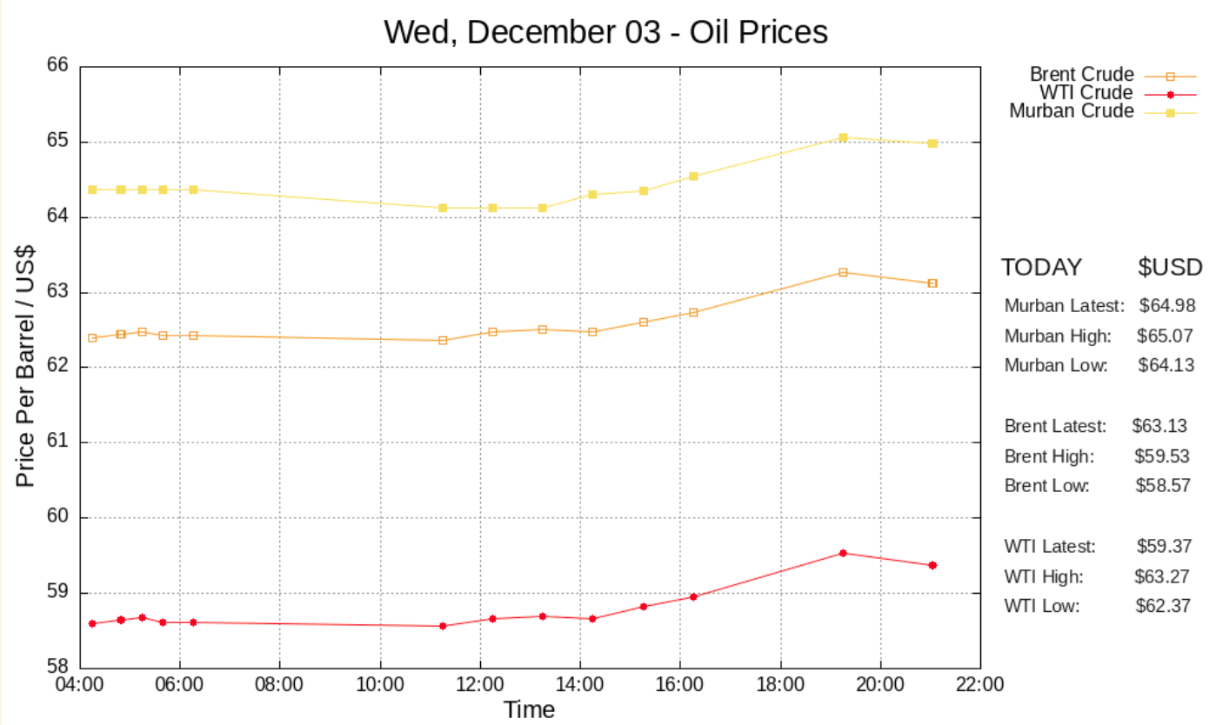

Sets the date corresponding to today and configures axes
set timefmt "%H:%M:%S"
set title "$datedisplay - Oil Prices" offset 10,0.0 font ",20"
…….
set key outside
"data_WTI.dat" using 1:2 title "WTI Crude" with linespoints linetype 7 linewidth 1.5 pointsize 0.9, \
…….
EOF

The script will then extract necessary data from the database in order to plot a graph reflecting the variation in oil prices across the past week.
date_curr_display=$(/usr/bin/date +"%b %d")
...
/usr/bin/gnuplot <<EOF
set terminal png size 1000,600
set output './database/week/image_week_${date}.png'
set ylabel "Price Per Barrel / US$" font ",15" offset 1
...
set title "Oil Prices: ${date_min_display} → ${date_curr_display} " offset 7,-0.7 font ",20"
...
set xrange ['${date_min}':'${date}']
EOF

It will then plot a weekly graph of Murban, WTI and Brent crude oil prices.

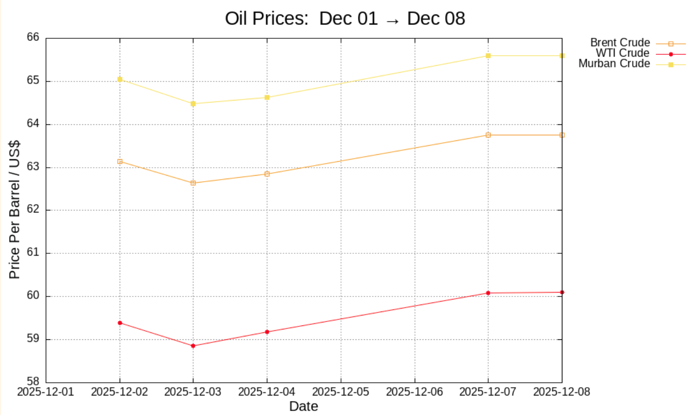

The script will end by extracting time, price and OilType values from the database into .dat files so that they can be read when the next set of graphs is plotted.

Use of MySQL for data storage:

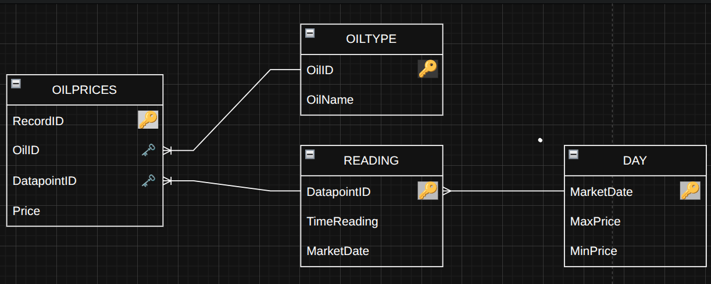
MySQL is used to oil prices - the OILTYPE table is used to store the different varieties of oil, with an ID for each type along with its’ name. The OILPRICES table is used to store individual readings, with each individual reading having its own ID, Price, OilID and DatapointID. The READING table identifies each unique reading with its own DatapointID, along with the Time and Date being stored.

Crontab for Script execution
The crontab is configured so the script will execute every 15 minutes and update the database. Due to the volatile nature of crude oil prices, the 15 minute interval is necessary.

