SOFTBANK, INC.

BANKING SYSTEM - USER GUIDE

Prepared By: Moiz Sajjad
Thank you for choosing SoftBank. We hope that you will enjoy using our product as much as we enjoyed making it.
This document contains the user manual for the banking system. It contains lengthy instructions for every feature on our state-of-the art banking system, to ensure you have a seamless experience.

1: On Startup:
When the program is first started, it will attempt to create necessary files needed for the system to run effectively. This takes around 10 seconds, and ‘Please wait….’ should be output.

2: Main Menu:
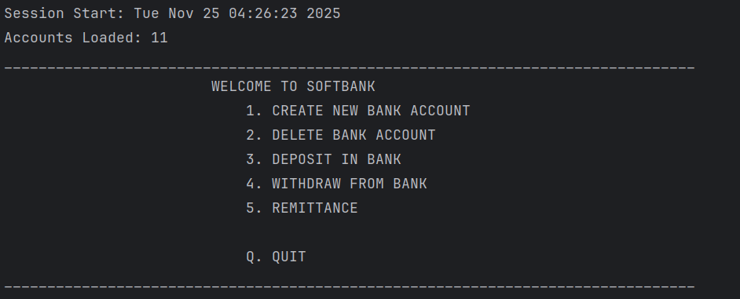
Once you reach the main menu, the session information is displayed at the top of the output. Simply
press the number corresponding to your desired action, followed by the ENTER key in order to proceed with your choice.

3: Create Account:
Press 1, followed by enter, to create an account. Follow the on-screen directions to make an account. The name must be a valid string, and the ID Number must be a valid 8-digit integer, while the pin must be a valid, 4-digit integer. Please copy your Account Number and remember your PIN as well as the last four digits of your ID Number
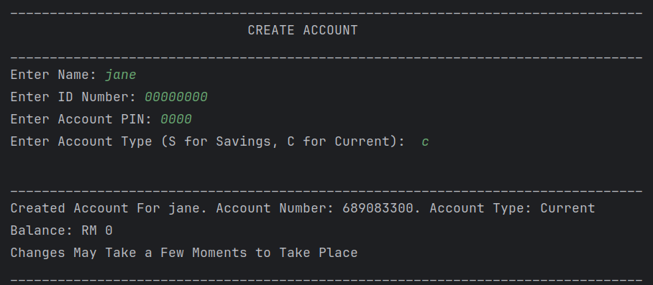

4: Delete Account:
Press 2, followed by enter, to delete an account. A list of all currently-available accounts will be produced and output by the program. Please type in the desired account number, followed by enter. Follow the on-screen instructions to delete an account.
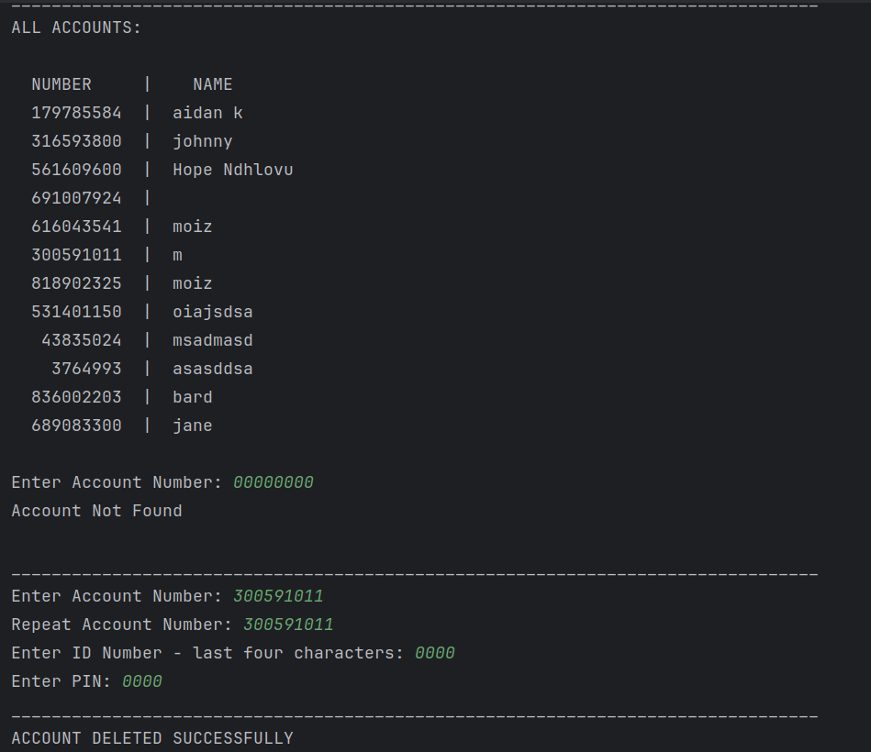
5: Deposit In Account:
Press 4, followed by enter, to enter the deposit function. Follow the on-screen instructions to deposit an amount between RM0 and RM50000 into an account.

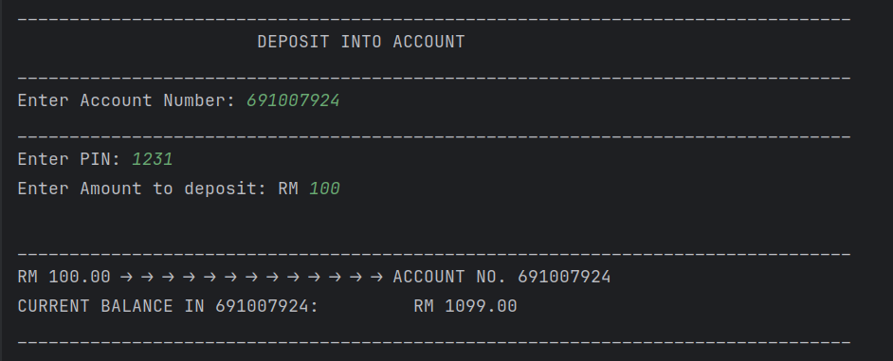

6: Withdraw From Account:
Press 5, followed by enter, to enter the withdraw function. Follow the on-screen instructions to withdraw an amount between RM0 and the account balance from an account.
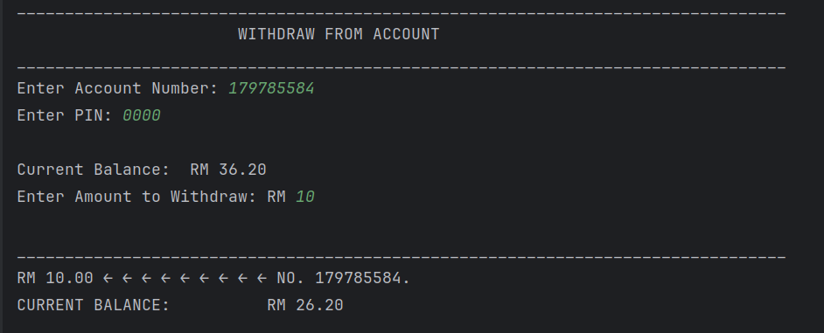

7: Remittance:
Press 5, followed by enter, to enter the remittance function. Follow the on-screen instructions to transfer an amount from one bank account to another. Please bear in mind that transfers between types of accounts (Savings and Current) will incur the following charges:
1- Savings → Current: 2%
2- Current → Savings: 3%
