Final Project Report

Part A: Data Construction and Parameter-Setting:

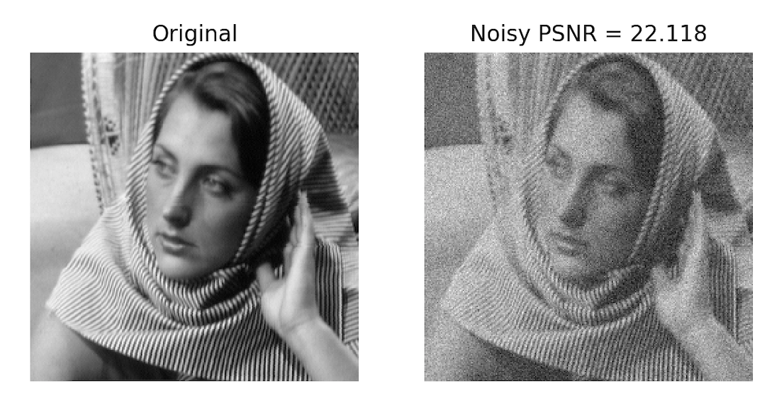

Insert PSNR value of noisy image: 22.118

Part B: DCT Dictionary

How is the error constraint satisfied for each patch in batch mode?

Since we don’t have the ground truth, we can try to nullify as many as possible entries with small absolute values in the sparse domain. So by accumulating square of small entries and comparing the sum to epsilon, we can find the cardinality of the signal in the sparse domain.

Insert average MSE of the reconstruction: 415.83

Insert average number of non-zeros of the reconstruction: 6.07

Discuss the obtained values below:

We obtained a reconstructed image with PSNR = 30.161 which signifies that even with a fixed dictionary we can achieve a substantial improvement of PSNR. Also the solution is highly sparse in local regions, which also means success.

DCT reconstructed image:

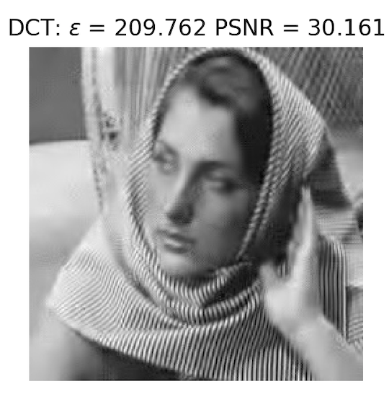

Enter epsilon value: 209.762

Enter PSNR of reconstruction: 30.161

Discuss the obtained results below:

PSNR obtained is much higher than the corrupted image, which means success of the algorithm and also a promising success of an iterative algorithm.

Part C: Procrustes Dictionary Learning

The obtained learned dictionary: Discuss the obtained dictionary:

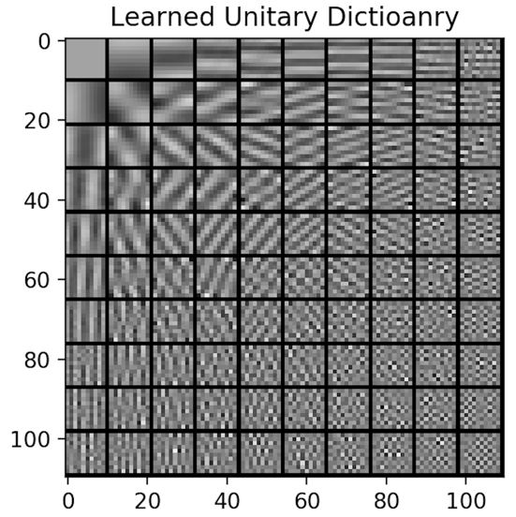The learned dictionary can adapt to Barbara.png: specifically, horizontal and vertical “stripes” of the DCT dictionary now become diagonal stripes which is a rich feature of Barbara.png.

Average MSE and number of nonzeros as a function of the iteration:

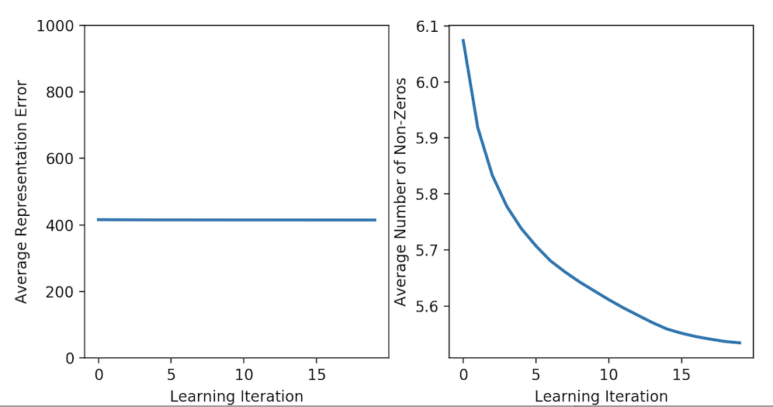

Discuss the obtained curves:

Average representation error goes down but slowly, and also average number of non-zeros goes down.

Procrustes reconstructed image:

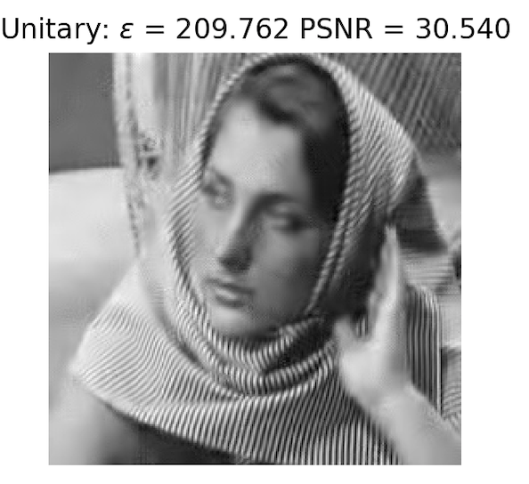

Enter epsilon value: 209.762

Enter PSNR of reconstruction: 30.540

Discuss the obtained results below:

By making the dictionary learnable, the algorithm can further improve the reconstructed image.

Compare the results of the DCT dictionary and the learned dictionary:

Learned dictionary can further improve the PSNR, but the improvement is slightly better.

Part D: SOS boosting

SOS-boosted reconstructed image:

Enter epsilon value: 230.738

Enter rho value: 1.00

Enter PSNR of reconstruction: 30.677

Discuss the obtained result and compare to DCT and learned dictionary:

SOS boosting can further improve the result of learned dictionary. By combining the discussion above, we can observe that making the dictionary adaptive and improving PSNR by SOS boosting can both improve the quality of the reconstructed image.