128-7.5025 122-9.735 102-12.1575 本-7.9875

128-6.1878 122-7.1568 102-10.3358 本-6.0423

Contiki p6 my-6.92--5.177

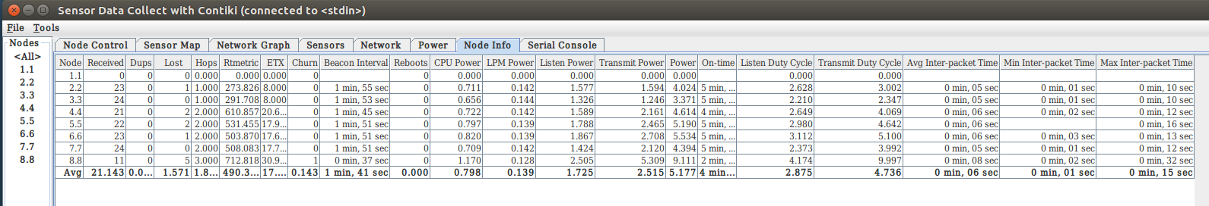

Contiki p5 my--9.28--5.153

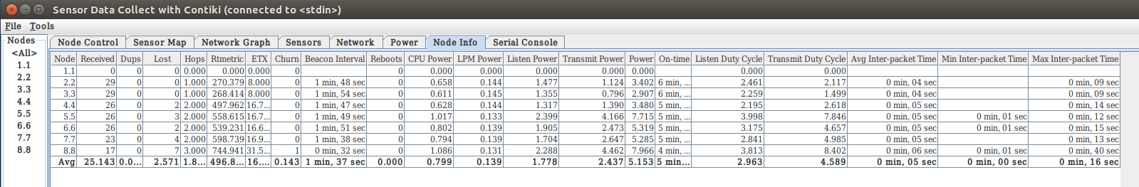

Contiki p4 my--6.83--5.339

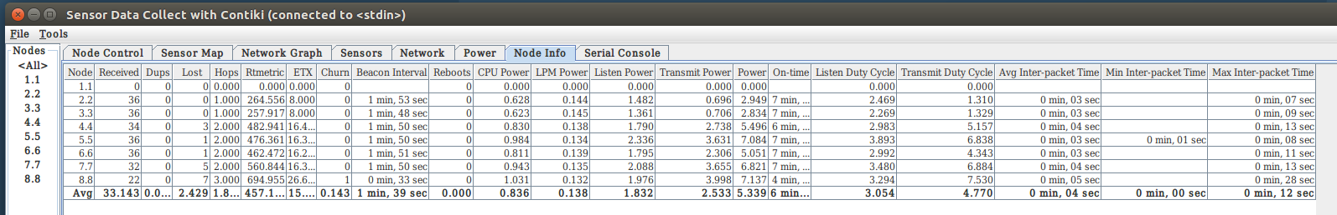

Contiki p3 my--8.92--8.5

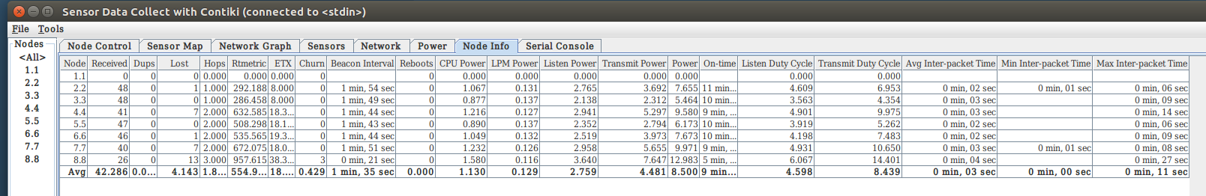

Contiki p3 128--6.82

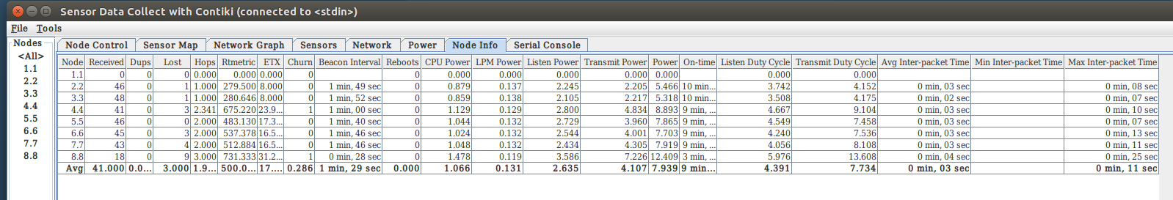

Contiki p4 128--8.82

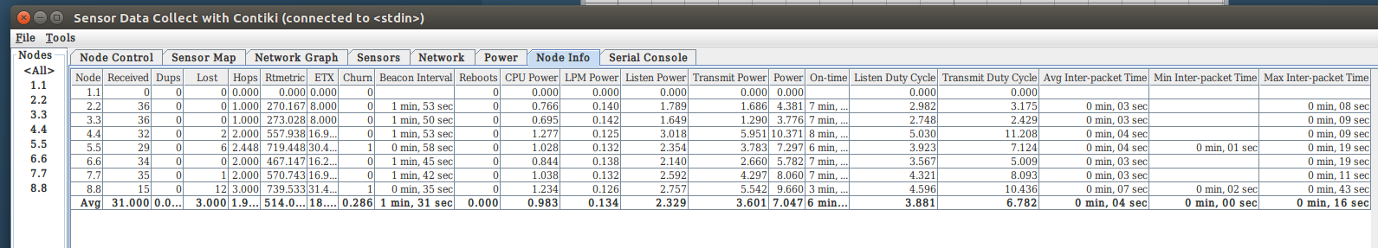

Contiki p5 128--5.73

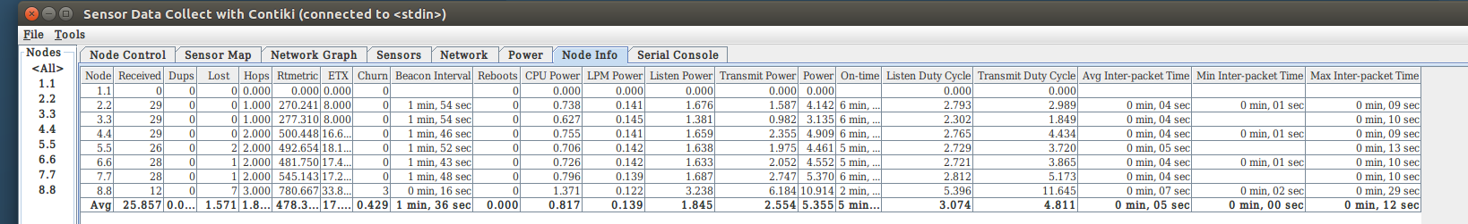

Contiki p6 128--8.64

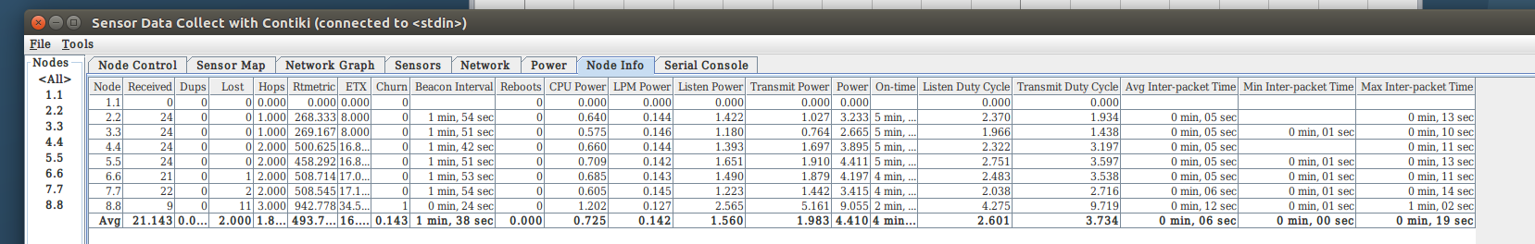

Contiki p6 122--8.70

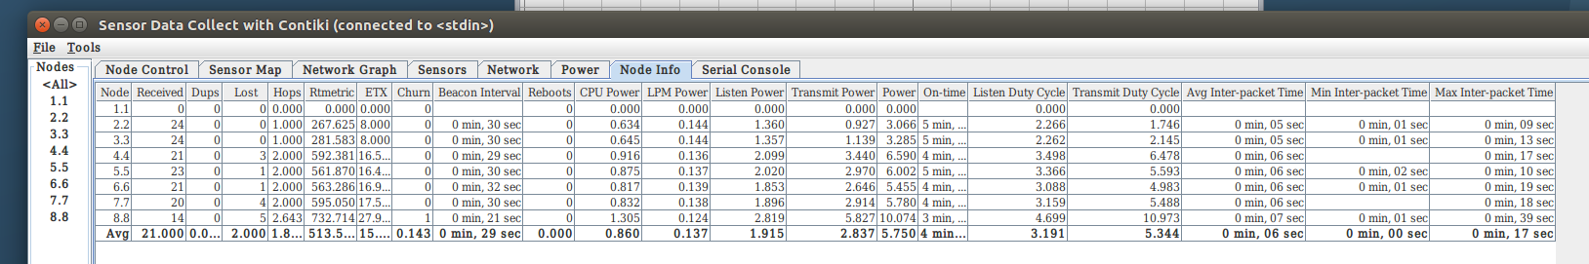

Contiki p5 122--7.78

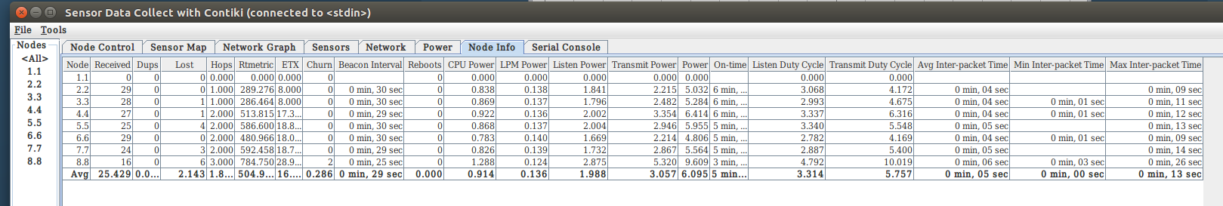

Contiki p4 122--10.00

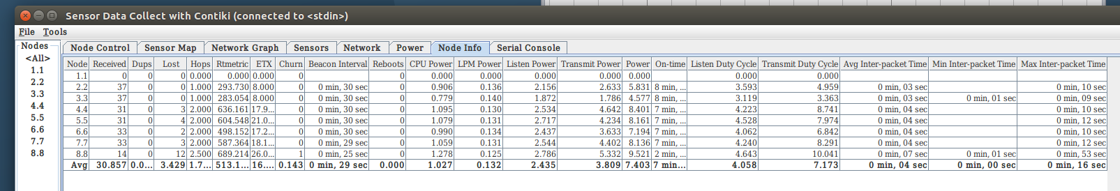

Contiki p3 122--12.46

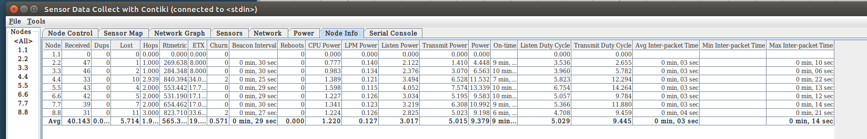

Contiki p6 102--11.51

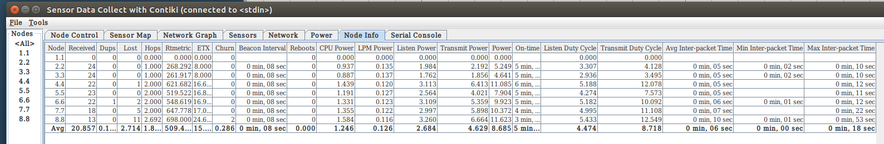

Contiki p5 102--6.12

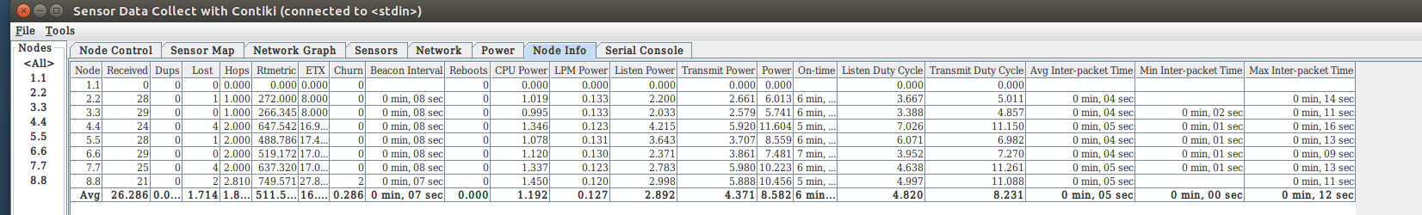

Contiki p4 102--10.37

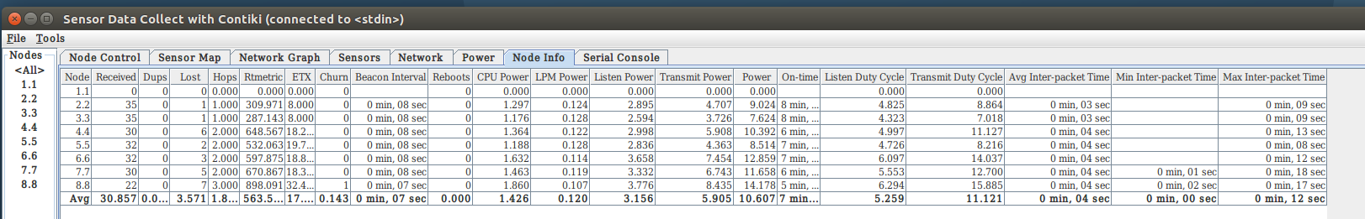

Contiki p3 102--20.63

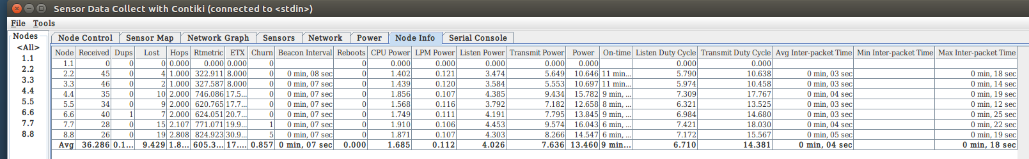

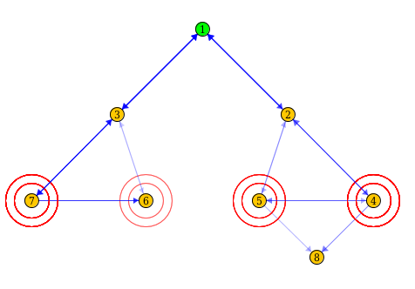

|  |
| --- |
| **Algorithm :** Mobility Detection |
| **Input:** All nodes from neighbor.  **Output:** The returned mobility flag. |
| 1. **begin** 2. **if***（node exists in neighbor list）***then** 3. *Node compute**AvgRSSI;* 4. **if***（abs(RSSI-AvgRSSI)<10）***then** 5. **return** *mobility is false；* 6. **else** 7. **return** *mobility is true;* 8. **else** 9. add node to neighbor list; 10. **end** |

|  |
| --- |
| **Algorithm 2:** Dynamic Trickle Timer |
| **Input:** Imin，Imax，state，k |
| 1. **function** *INITIALIZATION ( )* 2. *I=Imin;* 3. **function** *INTERVALBEGINS ( )* 4. *t=random(I/2,I);* 5. *c=0;* 6. **function** CONSISTENTTRANSMISSIONRECEIVED ( ) 7. c = c+1; 8. **function** TIMEREXPIRES ( ) 9. **if** (k>=c) **then** 10. Transmit DIO message; 11. **else** 12. transmission is suppressed; 13. **endif** 14. **function** INTERVALENDS ( ) 15. c = 0; 16. **if** InconsistentTransmissionReceived **then** 17. I = Imin; 18. **else** 19. I = I∗2; 20. **if** (I >= Imax) **then** 21. I = Imax; 22. **endif** |

|  |
| --- |
| **Algorithm 1:** Best Parent Selection Function |
| **Input:** All parents in candidate parent list.  **Output:** The returned preferred parent. |
| 1. **if***（higher RSSI than threshold&& mobility is false）***then** 2. **return** *parent_with_max_AvgRSSI;* 3. **Break** 4. **else if***（higher RSSI than threshold&& mobility is true）***then** 5. **return** *parent_with_max_AvgRSSI;* 6. **Break** 7. **else if***（lower RSSI than threshold）***then** 8. **return** *parent_with_max_AvgRSSI;* 9. **endfor** |