UNIVERSITI MALAYSIA SARAWAK
Faculty of Computer Science and Information Technology
TMA3084 Software Engineering Laboratory | Semester 1, 2026/2027
PROJECT PROPOSAL
(Product Requirements Document)
FCSIT HubSpace
Group Number / Name | Group 18 – Techna
Lab Group / Demonstrator | Group 2 – Raynold Kabai
Client / Organisation | Nurul Hasanah Binti Julkipli , Exco Student Hub , PERTEKMA
Lecturer | Mdm. Nurfauza Jali
GitHub Repository | https://github.com/102647/FCSIT-HubSpace
Version / Date | v1.0 (original) - 17/10/2026

Team Members
No. | Name | Matric No. | TSPi Role | Signature
1 | Daniella Calleigh Thet Anak Catherine | 102506 | Team Leader | 
2 | Dhika Danisha Anak Tonis | 103868 | Support Manager | 
3 | Cahill Sakai Anthony | 102482 | Development Manager | 
4 | Khanishya Dyana Binti Mohamad Maurice | 102647 | Planning Manager | 
5 | Nasha Dharmara Binti Abdullah | 105335 | Quality/Process Manager | 

Declaration
By signing above, we certify that this proposal is our own work, that all external sources, libraries, APIs and AI-assisted content are acknowledged, and that we have not engaged in plagiarism or unauthorised collusion (Peraturan Akademik UNIMAS, Etika Akademik). AI tool usage is recorded in LOGAI.

Table of Contents
Abstract 2
1. Introduction 3
1.1 Client Background 3
1.2 Team Background 4
2. Problem Statement 4
3. Project Objectives & Success Metrics 5
4. Project Perspective 5
4.1 Target Users 5
4.2 System Context and Architecture 6
5. Project Scope 6
5.1 In Scope / Out of Scope 7
5.2 Features and User Stories 7
5.3 AI Feature 8
5.4 Non-Functional Requirements and Constraints 8
5.5 System Environment 9
6. Task Allocation & Team Contribution 9
7. Team Goals 10
8. Expected Results 11
8.1 Working System 11
8.2 Documentation and Artefacts 11
9. Project Planning 12
9.1 Methodology 12
9.2 Submission Schedule 12
9.3 Development Milestones (GitHub) 12
9.4 Risks and Assumptions 13
10. References 14
Appendix A: Client Meeting Evidence 15
Appendix B: Revision History 16

Abstract
FCSIT HubSpace is a proposed Flutter mobile application developed by Techna, a team of five third-year Software Engineering students, for Nur Deanne Afiffy Binti Mohd Rusle, secretary of PERTEKMA at the Faculty of Computer Science and Information Technology (FCSIT), Universiti Malaysia Sarawak (UNIMAS). The Student Hub serves as a shared space for students to study, conduct group discussions, attend consultations, and work on projects. However, its current manual management process creates difficulties in checking room and table availability, increases the risk of overlapping bookings, and causes information loss during secretariat shift handovers. Additionally, manual student ID verification and rigid booking durations limit convenience and efficient space utilization. To address these issues, FCSIT HubSpace will provide a centralized platform where students and lecturers can view real-time availability, make flexible bookings, check in upon arrival, and access announcements, while the PERTEKMA secretariat manages reservations and verifies student access. The application will be developed using Flutter to support both Android and iOS devices. Its AI-powered assistant, integrated with the Google Gemini API, will understand natural-language queries about space availability and recommend suitable rooms or tables based on group size, purpose, and preferred time. Ultimately, FCSIT HubSpace aims to improve booking efficiency, reduce administrative workload, prevent scheduling conflicts, and provide a more convenient, accessible, and organized Student Hub experience for the FCSIT community.

1. Introduction
The Faculty of Computer Science and Information Technology (FCSIT) Student Hub is a shared space where students gather for group meetings, revision sessions and wait for their next class, and where lecturers hold consultations and small group sessions. The hub is managed by PERTEKMA (Persatuan Teknologi Maklumat), the official student representative body of FCSIT. PERTEKMA appoints a secretariat who takes care of the hub in shifts, managing its rooms and tables, and keeping the space organized. Availability is currently handled manually, so students and lecturers often cannot tell whether a room or table is free until they arrive. Because the hub is run in shifts, information about bookings and room status can also be lost when one secretariat member hands over to the next. This leads to wasted time, overlapping bookings, reserved spaces that go unused and repetitive work for the secretariat.
This project proposes the FCSIT HubSpace, a Flutter mobile application that gives students, lecturers and the secretariat one shared place to view live availability, make bookings and manage the space. A mobile app is the right fit because the need arises on the move. Students decide where to go between classes, while walking across campus or just before a meeting, and nearly all of them carry a smartphone. It offers instant access, push notifications for reminders and released slots, and quick check-in, which suit short, time-sensitive decisions better than a desktop website. It also gives each secretariat shift the same up-to-date record, so nothing is lost at handover. Flutter lets one codebase serve both Android and iOS users, which lowers development effort and keeps the experience consistent. An AI assistant answers availability questions in plain language and recommends suitable spaces, helping users find the right place quickly and reducing the secretariat’s workload.

1.1 Client Background
We first interviewed the secretary of PERTEKMA on 14 October 2026 to understand how the Student Hub is currently managed. She advised us to refer to Nurul Hasanah Binti Julkipli, the Exco of the Student Hub, for further information.Our client is Nurul Hasanah Binti Julkipli, Exco Student Hub, Persatuan Teknologi Maklumat (PERTEKMA) of Faculty of Computer Science and Information Technology. The intended users are all FCSIT students, covering every programme and year of study and FCSIT staffs.

1.2 Team Background
Techna is a team of five third-year Software Engineering students. Guided by our motto, “Innovating the Digital Future,” we aim to develop innovative digital solutions that keep pace with global technological progress and support Malaysia’s ambition to become a competitive, technology-driven nation. With a focus on the education system, we aim to simplify everyday processes within educational institutions by developing practical and user-friendly solutions, such as an easy-to-use booking system for reserving facilities and spaces on campus. Through technology, we hope to improve convenience, efficiency, and accessibility for students and staff while contributing to a smarter and more connected educational environment.
Logo and motto:


Team’s relevant skills:
Our developer team brings web development, database design, AI integration and UI/UX design skills, backed by first-hand experience as FCSIT students who use the hub, to build FCSIT SpaceHub.

2. Problem Statement
A Flutter mobile application, FCSIT HubSpace, that digitizes Student Hub management by providing real-time study space availability, secure student ID verification, and flexible booking features aligned with faculty rules.

ID | Current process / problem | Impact on client | Evidence (source)
P1 | No centralized system to check availability of study spaces in the Student Hub | Students face uncertainty and inefficiency when trying to use the hub | Meeting Minutes, Agenda Item #1
P2 | Manual enforcement of Student Hub rules (ID verification, restricted access, food policy) | Time-consuming, prone to oversight, inconsistent enforcement | Meeting Minutes, Agenda Item #2
P3 | Booking duration limits not aligned with student needs (especially off-campus students) | Students may be unable to use spaces flexibly between classes | Meeting Minutes, Client Feedback #2
Table 1: Summary of client problems

3. Project Objectives & Success Metrics
No. | Objective | Solves | Success metric (how we measure) | Priority
O1 | To study and analyse the current Student Hub processes and rules | P1, P2 | Requirements documented and validated with PERTEKMA stakeholders | High
O2 | To design and develop the FCSIT HubSpace application with booking features | P1, P3 | All Must-have FRs pass acceptance tests | High
O3 | To implement secure student ID verification for access control | P2 | >=95% successful ID validation during testing | High
O4 | To test and evaluate the system with the client | All | >=50 test cases executed, >=70% coverage, UAT sign-off | Medium
Table 2: Project objectives and success metrics

4. Project Perspective

4.1 Target Users
The system serves three primary user groups interacting with the FCSIT Student Hub, summarized in Table 3 below:
User type | Description | Main needs / goals | Device / tech level
Students (FCSIT) | Undergraduate and postgraduate students of the Faculty Computer Science and Information Technology use the hub for group discussions, revision, or waiting between classes. | • View live availability of rooms/tables  • Make flexible bookings without strict time limits  • Quick check-in and AI-assisted space recommendations | Android/iOS smartphone, everyday digital literacy.
Faculty Staff | Faculty staff members holding student consultations or small group discussions in the hub. | • Secure reliable room bookings ahead of time  • Avoid schedule overlaps with student events | Smartphone or tablet, comfortable with mobile apps.
Secretariat (PERTEKMA Admin) | Student representatives appointed by PERTEKMA managing the hub physical space on shifts. | • Manage room status and shift handovers  • Verify student IDs for FCSIT-only access  • Approve/reject bookings and post announcements | Smartphone or administrative dashboard interface, high familiarity.
Table 3: Target users

4.2 System Context and Architecture
The FCSIT HubSpace mobile application introduces a digital, centralized ecosystem that replaces the manual, paper-based, and shift-handover tracking previously used by PERTEKMA.
- System Architecture: The client-side application is built using Flutter (Dart 3) to support both Android and iOS platforms from a single codebase. The mobile frontend communicates securely with a cloud backend (Firebase Auth & Cloud Firestore) responsible for user authentication, student verification checks, real-time database synchronization, and push notifications. An external AI API (Google Gemini) is integrated via secure cloud functions to process natural language availability queries and provide smart space recommendations
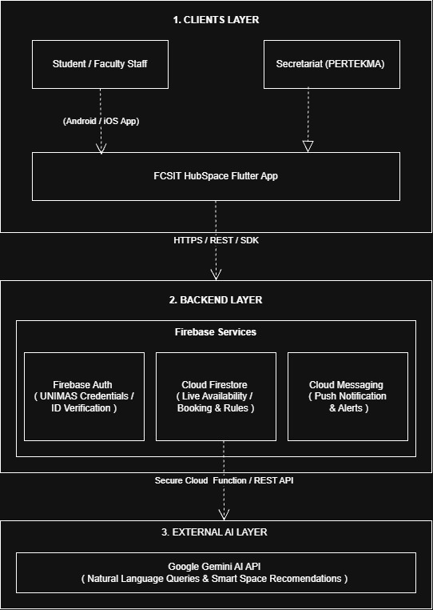
Figure 1 : High-level system architecture

5. Project Scope

5.1 In Scope / Out of Scope
Establishing clear project boundaries ensures focused development and prevents scope creep, aligned with stakeholder rules:
In scope (will deliver this semester) | Out of scope (will not deliver)
Cross-platform Flutter mobile app (Android & iOS) | Integration with university-wide central timetabling systems beyond FCSIT Student Hub scope.
User registration, authentication, and role-based access control (Student, Lecturer, Secretariat). | Camera- or sensor-based crowd counting to detect real occupancy.
Student ID verification and FCSIT-only access enforcement. | Occupancy prediction and usage analytics reports.
Real-time live status tracking for Student Hub rooms and tables | Personal timetable upload and class-gap suggestions
Flexible booking system with unconstrained duration limits to accommodate gaps between classes. | Booking of facilities outside the Student Hub (lecture halls, labs, other faculty spaces)
Secretariat dashboard for approvals, rule guidelines (e.g., food/beverage policies), and announcements. | Online payment or booking fees
AI natural-language assistant and smart space recommender. | Web or desktop version of the app
Table 4: Scope boundary

5.2 Features and User Stories
Features are grouped into functional modules and prioritized using the MoSCoW method, carrying forward FR-IDs into the SRS and GitHub issue tracking:
FR-ID | Module | User story (As a … I want … so that …) | Priority
FR-01 | User Management | As a student or lecturer, I want to log in using my UNIMAS credentials so that my identity is verified and my records are saved. | Must
FR-02 | Access Control & Verification | As a secretariat member, I want the system to verify student IDs so that access to the Student Hub is strictly restricted to FCSIT students | Must
FR-03 | Space Availability | As a student, I want to view the real-time availability status of rooms and tables so that I can see what spaces are free instantly | Must
FR-04 | Booking Management | As a student or lecturer, I want to book a room or table with flexible usage periods and no rigid duration limits so that I can accommodate my schedule between classes. | Must
FR-05 | Check-in and Check-out System | As a student, I want to check in upon arrival so that unused reservations are automatically released. | Should
FR-06 | Secretariat Dashboard | As a secretariat member, I want to manage room statuses, approve bookings, display hub rules (such as prohibition of food and drinks except mineral water) and post announcements so that order is maintained. | Must
FR-AI-01 | AI Feature | As a student or lecturer, I want to ask natural language questions about availability and get smart recommendations so that I can find the best space quickly. | Must
Table 5: Features and user stories
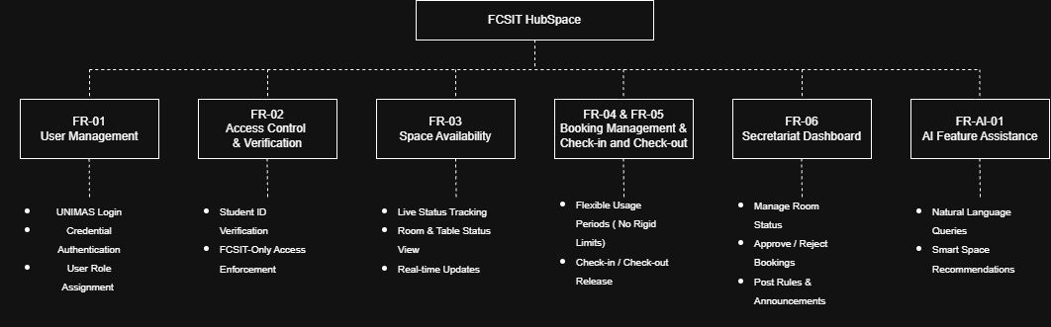
Figure 2: System modules diagram

5.3 AI Feature
The AI assistant provides core functional value by removing search friction and interpreting complex user queries in plain language:
Item | Description
AI capability | Natural-language conversational assistant and smart space recommender.
User value | Solves uncertainty and inefficiency in finding spaces (P1) by allowing users to query availability in plain language and receive optimal room suggestions based on group size and purpose.
Input → Output | User text prompts (e.g., "Is there a room for 6 people at 2 PM tomorrow?") paired with live database availability JSON data.  → Natural language conversational response and recommendation cards detailing the best matching room/table.
AI service / API | Google Gemini API / Cloud ML integration.
Constraints | API key protection (stored securely on backend/cloud), rate-limiting, low latency (< 3s response), offline fallback message if the API fails, and data privacy compliance.
Table 6: AI feature summary

5.4 Non-Functional Requirements and Constraints
NFR-ID | Category | Requirement / constraint | Target
NFR-01 | Performance | Main app screens and live availability updates load quickly. | < 2 seconds on mid-range smartphones.
NFR-02 | Security | API keys and sensitive credentials must never be stored in source code or public repositories. | 0 hardcoded secrets in the Git repository .
NFR-03 | Availability | The mobile app backend and database remain accessible for live status updates during hub operational hours. | $≥$ 99% uptime during operating hours.
NFR-04 | Usability | User interface is intuitive, adhering to Material 3 design guidelines with accessible layout structures. | $≥$ 80% positive feedback during UAT.
NFR-05 | Compatibility | The mobile app supports mainstream mobile operating systems. | Android 8.0+ and iOS 12+.
Table 7: Non-functional requirements and constraints

5.5 System Environment
Layer | Technology / tool | Justification
Mobile app | Flutter (Dart 3), Material 3 | Course requirement; enables a single cross-platform codebase for Android and iOS.
State management | Provider / Riverpod | Efficient reactive state management for real-time UI synchronization.
Backend / database | Firebase Auth,Cloud Firestore,Cloud Messaging | Real-time NoSQL database synchronization ideal for live room/table status tracking and ID verification handling.
AI service | Google Gemini API | Reliable cloud LLM API for natural language understanding and recommendations.
Version control & CI | GitHub, GitHub Actions | Course requirement; supports collaborative spec-first Git Flow and automated testing.
Target devices | Android 8.0+ & iOS devices | Standard student smartphone baseline at UNIMAS.
Table 8: System environment

6. Task Allocation & Team Contribution
Techna consists of five members, each given a specific role within the Team Software Process introduction (TSPi) to maintain clear responsibilities and foster effective collaboration during the development of FCSIT HubSpace. Tasks are distributed according to each member’s role and specific functional requirements. All members will participate in development, testing, documentation, and project management tasks to support the successful completion of the project. Feature ownership will be managed through GitHub Issues and pull requests, while task progress will be monitored using Trello and TSPi planning records.

Member | TSPi role | Owned features (FR-IDs) | Other responsibilities / contribution
Daniella Calleigh Thet Anak Catherine | Team Leader | FR-01 | Team meetings, client communication, WEEK reports, progress monitoring
Cahill Sakai Anthony | Development Manager | FR-04, FR-AI-01 | Flutter architecture, backend/AI integration, code reviews
Khanishya Dyana Binti Mohamad Maurice | Planning Manager | FR-03 | Requirements, TASK/SCHEDULE, milestones, repository setup, GitHub Projects
Nasha Dharmara Binti Abdullah | Quality/Process Manager | FR-05 | Test Planning, LOGTEST, LOGD, CI and coverage, UAT
Dhika Danisha Anak Tonis | Support Manager | FR-02, FR-06 | CI/CD, LOGAI, API security, release documentation

Table 9: Task allocation and contribution

7. Team Goals
Techna has set four quantifiable team objectives to promote effective teamwork, timely project delivery, and the successful creation of FCSIT HubSpace. These objectives will direct the team’s performance during the project and will be evaluated in weekly progress meetings.

No. | Team goal | Measure
G1 | Develop a functional and reliable FCSIT HubSpace application. | All mandatory requirements pass acceptance testing, with at least 50 automated tests and 60% code coverage by Milestone 3, aiming for 70% coverage and UAT sign-off by final evaluation.
G2 | Ensure effective project planning and timely completion. | Complete all four project milestones by the deadlines.
G3 | Encourage fair task distribution and active participation. | Each member is responsible for at least one functional requirement (FR-ID) and submits at least one reviewed and merged pull request per development sprint.
G4 | Maintain effective communication with the client. | Conduct client consultations or validation sessions, document feedback in meeting minutes, and incorporate agreed changes into the requirements.
Table 10: Team goals

8. Expected Results

8.1 Working System
By the end of the project, FCSIT students will be able to log in to the Student Hub Flutter mobile app (Android/iOS) with their UNIMAS credentials, see the live status of every room and table (available, occupied, reserved or maintenance), book a slot, and check in when they arrive. Lecturers can book rooms for consultations or group sessions. The secretariat manages the Hub from a simple dashboard where she updates availability, approves or rejects bookings, manages who may access the app, and posts announcements. The AI feature is a natural-language assistant that reads the live availability data through a secure API setup and answers questions such as "Is there a free room for 6 people at 2 PM tomorrow?", recommends the most suitable room based on group size, purpose and time, and answers common questions about opening hours and rules.
The system is ready for release when all Must-have functional requirements pass acceptance testing, at least 50 test cases (unit, widget and integration) are written with at least 60% coverage, the GitHub Actions CI pipeline passes, the cloud AI feature works against live data, and AI usage is recorded in LOGAI. The final package is an installable APK/IPA that matches the tagged v1.0.0 release on the main branch, together with the final report, user manual, a 5–10 minute demo video and a signed client acceptance form obtained after UAT. No secrets or API keys are stored in the repository.

8.2 Documentation and Artefacts
Deliverable | Submitted with
Project Proposal (original) | Proposal Submission (Week 4)
Revised Proposal and Software Requirements Specification (SRS) | Initial Report (Week 9)
Runnable prototype (4–5 screens), tagged release | Demo 1 (Week 9)
Software Design Specification (SDS), test plan and results (LOGTEST), user manual, maintenance plan, client acceptance form | Final Report (Week 13)
Release APK, demo video (5–10 min), presentation slides | Final Demo 2 (Week 14)
GitHub repository and complete project file | e-Archive (Week 15)
TSPi forms (LOGT, LOGD, LOGAI, SCHEDULE, SUMP, SUMQ, SUMS, SUMTASK, WEEK, PEER) and meeting minutes | Ongoing; compiled in Final Report
Table 11: Deliverables

9. Project Planning

9.1 Methodology
The team will follow Agile Scrum with 2-week sprints (Schwaber & Sutherland, 2020). This suits the client because the client has limited free time and her requirements, such as how strictly to verify FCSIT students, may become clearer as she sees working screens. Each sprint ends with a short review with the client, so feedback arrives early and changes are cheap. Work follows the TSPi roles in Section 6 ( Humphrey,2000): the Team Leader runs weekly meetings, client communication and WEEK reports; the Planning Manager owns the requirements, schedule and GitHub Projects board; the Development Manager owns the Flutter architecture, backend and AI integration; the Quality/Process Manager owns test planning, LOGTEST, LOGD and UAT; and the Support Manager owns CI/CD, LOGAI and release documentation. Every task follows a spec-first Git Flow workflow on GitHub (Driessen, 2010): issue → feature branch → pull request with at least one peer approval → GitHub Actions CI checks → merge to develop, with main kept for tagged releases. Any AI-assisted work is recorded in LOGAI and linked to its pull request.

9.2 Submission Schedule
Phase | Deliverable | Week | Due
Phase 1: Planning & Development | Proposal Submission | 4 | 9 Oct 2026
 | Proposal Presentation | 5 | 19 – 23 Oct 2026
 | Initial Report | 9 | 16 Nov 2026
 | Demo 1 | 9 | 16 – 20 Nov 2026
Phase 2: Finalisation & Closure | Final Report | 13 | 24 Dec 2026
 | Final Demo 2 | 14 | 28 – 31 Dec 2026
 | e-Archive | 15 | Before 10 Jan 2027
Table 12: Submission schedule

9.3 Development Milestones (GitHub)
Table 13 lists the four development milestones with their weights and key outputs. The work is planned in six sprints: Sprint 0 (Weeks 3–5, 5–25 Oct), then Sprint 1 (26 Oct – 8 Nov), Sprint 2 (16–29 Nov), Sprint 3 (30 Nov – 13 Dec), Sprint 4 (14–27 Dec) and Sprint 5 (28 Dec – 3 Jan), with light work only during the mid-term break (9–15 Nov). Figure 3 shows these sprints with the milestones and submission dates on a Week 3 to Week 16 timeline.
Milestone | Week | Key output | Status
M1 – Scope & Requirements | 4 – 5 | GitHub repo, issue board, CI file; proposal and initial SRS in /docs | In progress
M2 – Design & Prototype | 9 | SDS draft, 4–5 screen prototype, green CI, v0.2.0 tag | Not started
M3 – Product & Verification | 13 | ≥50 tests, ≥60% coverage, AI feature working | Not started
M4 – Final Release & Acceptance | 15 | Release APK v1.0.0, client sign-off, e-Archive | Not started
Table 13: Development milestones
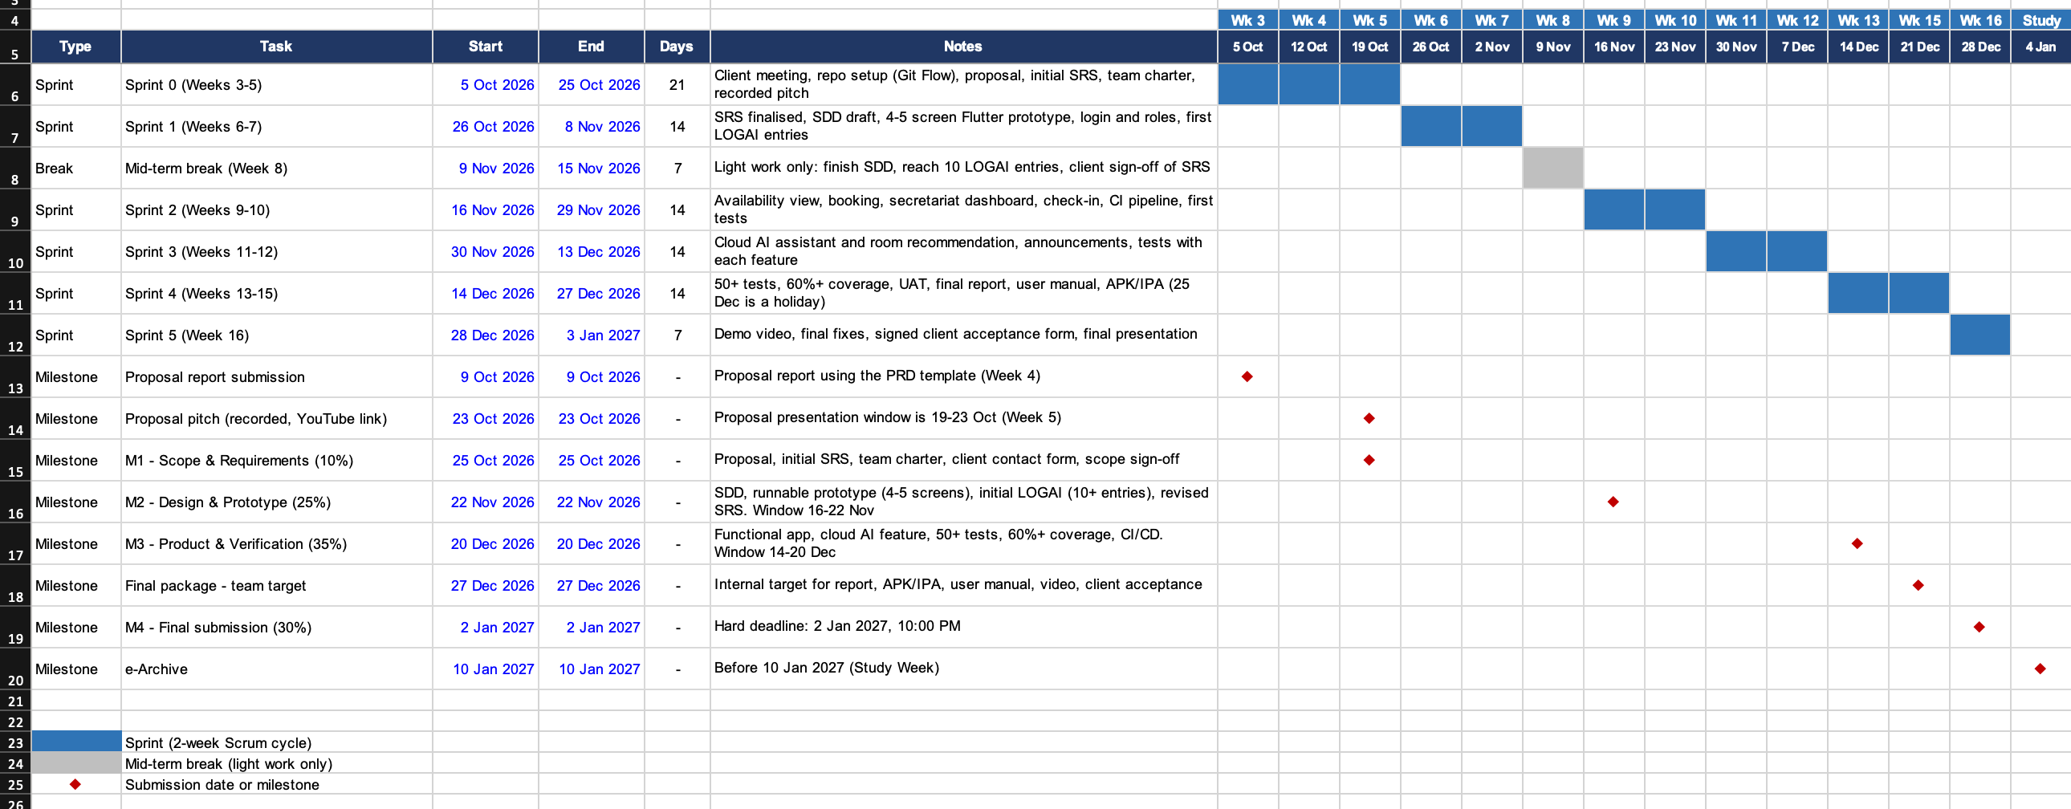Figure 3: Gantt chart

9.4 Risks and Assumptions
ID | Risk / assumption | Likelihood | Impact | Mitigation
R1 | Client is unavailable for meetings or slow to reply | Medium | High | Agree a fixed fortnightly slot; online meeting or WhatsApp fallback; record decisions in minutes
R2 | AI API free tier limits exceeded or service is slow | Medium | Medium | Cache common answers, rate-limit requests, keep keys on the server only, and let the app work without AI if the API fails
R3 | Faculty student list is not available for FCSIT-only access | Medium | Medium | Fall back to UNIMAS email login with secretariat approval of each sign-up
R4 | Skill gaps in the team (Flutter, AI integration, authentication) | Medium | Medium | Assign an owner per area, hold short knowledge-sharing sessions, start AI work early
R5 | Team availability drops during exam period and year-end holidays | High | Medium | Finish core features before Sprint 4; set tasks in advance for the holiday period
A1 | Assumption: the client can give room and table details and Hub rules early | Medium | High | Confirm in Sprint 1; use sample data if delayed
A2 | Assumption: requirements, such as flexible booking periods and student id verification ,may change after the consultation with PERTEKMA Exco Student Hub and Madam Rozita. | Medium | High | Hold the final SRS sign-off after the consultation; keep booking rules easy to change
Table 14: Risks and assumptions

10. References
Driessen, V. (2010, January 5). A successful Git branching model.
-https://nvie.com/posts/a-successful-git-branching-model/
FlutterFire. (n.d.). FlutterFire documentation. https://firebase.flutter.dev
GitHub. (n.d.). GitHub Actions documentation. https://docs.github.com/en/actions
Google. (n.d.-a). Firebase documentation. https://firebase.google.com/docs
Google. (n.d.-b). Gemini API documentation. https://ai.google.dev/gemini-api/docs
Humphrey, W. S. (2000). Introduction to the Team Software Process.
Rousset, R. (n.d.). provider [Computer software]. pub.dev.https://pub.dev/packages/provider
Schwaber, K., & Sutherland, J. (2020). The Scrum guide.
-https://scrumguides.org/scrum-guide.html
The Flutter Authors. (n.d.). Flutter documentation. https://docs.flutter.dev/

Appendix A: Client Meeting Evidence
Meeting Details: 14/10/2026, 7:30 pm – 8:00 pm, Google Meet
Attendees:
- All 5 members
- Client: Nur Deanne Afiffy Binti Mohd Rusle (105576), PERTEKMA Secretary
Key Decisions:
- The team will consider the existing Student Hub regulations in the proposed FCSIT HubSpace system, including FCSIT-only access, student ID verification, and food and drink restrictions.
- The team will review the booking functionality to accommodate students who need flexible usage periods without fixed booking duration limits.
- Further consultation with PERTEKMA Exco Student Hub and Madam Rozita will be pursued before finalizing the project’s requirements and scope.
Evidence:
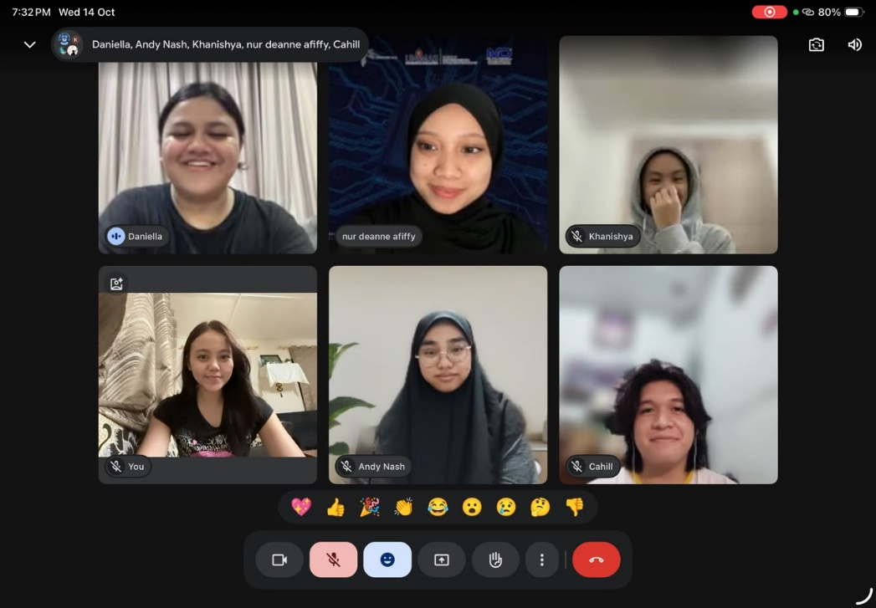

Appendix B: Revision History
Version | Date | Changes (e.g. after proposal presentation feedback) | By
1.0 | 17th October 2026 | Original Submission | Daniella Calleigh Thet Anak Catherine

Appendix C : Pitching Video

https://youtu.be/cTHAo-K1zWM?feature=shared


