**The Relationship Between Changes in Waterfowl Numbers and Water Quality at Toronto Beaches**

**Yuanting Han**

**26 September 2024**

This paper analyzes the relationship between waterfowl and water environment in Toronto beach and their spatial distribution. The study found that the number of waterfowl was positively correlated with water quality and temperature. The increase in the number of waterfowl will affect the turbidity of the water, and the number of waterfowl is highest at 15-20℃. From the spatial distribution of waterfowl numbers, Ward Island beach has the highest density of waterfowl numbers. The article also recommends long-term monitoring of waterfowl populations to assess environmental conditions in real time.

**Table of contents**

**1 Introduction**1

**2 Data**2

2.1 Data resource2

2.2 Relationship Between Waterfowl Numbers and Turbidity 3

2.3 Impact of Spatial Factors on Waterfowl Numbers4

2.4 Impact of Water Temperature on Waterfowl Numbers4

**3 Discussion**5

3.1 Relationship Between Environmental Variables and Waterfowl5

3.2 The spatial structure of waterfowl populations6

**4 Suggestion and expectation**6

**1 Introduction**

Water quality plays a vital role in the surrounding ecological environment, and also affects human survival. As an important part of aquatic ecosystem, waterfowl abundance and distribution often become one of the monitoring conditions for water quality indicators (Saini et al., 2017; Zhang et al., 2017). Water clarity and turbidity are also important indicators for evaluating water quality, which not only determine the living conditions of aquatic organisms, but also directly affect the feeding and nesting behaviors of waterfowl (Thapa & Saund, 2012).

This study focused on different beaches in Toronto to explore the relationship between waterfowl numbers, water quality, and temperature, as well as the spatial distribution of waterfowl numbers. As the capital of Canada, Toronto has a high degree of urbanization and human activity, both of which have a significant impact on water quality.

The purpose of this study is to explore the potential relationship between water quality and waterfowl by processing the collected data, and to provide a scientific basis for waterfowl conservation and raising public awareness of water quality issues. Through this study, we hope to raise public awareness of water quality and ecological protection and promote effective management of the aquatic environment.

**2. Data**

**2.1 Data resource**

The dataset "Toronto Beaches Observations" was downloaded from Open Data Toronto. It contains 18,000 rows and 13 variables. We cleaned the data by removing unnecessary variables and rows where waterfowl numbers or turbidity were marked as NA. This left us with 3,260 rows and 7 variables. The data is current as of September 13, 2024.

All data were analyzed using R (R Core Team, 2024). Data processing was carried out using the tidyverse (Wickham et al., 2019), ggplot2 (H. Wickham, 2016), and opendatatoronto (Gelfand, 2022) packages. For this analysis, we retained only the following variables: dataCollectionDate, beachName, windSpeed, windDirection, waterFowl, waterClarity, and turbidity. The cleaned dataset is presented in Table 1.

Table 1 Beach Waterfowl Records

|  |  |  |  |  |  |  |
| --- | --- | --- | --- | --- | --- | --- |
| dataCollectionDate | beachName | windSpeed | windDirection | waterFowl | waterClarity | turbidity |
| 2010-08-03 | Marie Curtis Park East Beach | 5 | SW | 12 | Clear | 0.9 |
| 2010-08-03 | Sunnyside Beach | 5 | SW | 30 | Clear | 0.6 |
| 2010-08-03 | Hanlan's Point Beach | 5 | SW | 20 | Clear | 0.1 |
| 2010-08-03 | Centre Island Beach | 5 | SW | 30 | Clear | 0.1 |

First, descriptive statistics were performed on the cleaned data, calculating the mean, median, maximum, and minimum values for waterfowl numbers and turbidity across different beaches (Table 2). From the table, it can be observed that the highest number of waterfowl was recorded at Ward's Island Beach, with a count of 1,000. The area with the highest average waterfowl count was Centre Island Beach, with a mean of 85, which also had the highest median. The maximum turbidity was recorded at Kew Balmy Beach, with a value of 228. The highest average turbidity was found at Bluffer's Beach Park, with a value of 14.57. In contrast, at Ward's Island Beach, the maximum number of waterfowl was significantly higher than other areas, while the average turbidity was only 2.21. This suggests a potential relationship between turbidity and waterfowl numbers.

Table 2 Overview of Waterfowl and Turbidity Across Different Beaches

|  |  |  |  |  |  |  |  |  |
| --- | --- | --- | --- | --- | --- | --- | --- | --- |
| beachName | waterFowl | | | | turbidity | | | |
| Mean | Median | Max | Min | Mean | Median | Max | Min |
| Bluffer's Beach Park | 49.8 | 45 | 200 | 2 | 14.57 | 2.40 | 214.6 | 0.10 |
| Centre Island Beach | 85.0 | 60 | 300 | 3 | 2.29 | 1.35 | 13.0 | 0.10 |
| Cherry Beach | 23.9 | 20 | 68 | 1 | 3.27 | 1.70 | 12.0 | 0.30 |
| Gibraltar Point Beach | 13.3 | 10 | 75 | 2 | 1.50 | 1.10 | 5.6 | 0.10 |
| Hanlan's Point Beach | 34.6 | 24 | 200 | 2 | 1.43 | 1.00 | 7.0 | 0.10 |
| Kew Balmy Beach | 27.5 | 35 | 200 | 5 | 13.29 | 2.45 | 228.0 | 0.50 |
| Marie Curtis Park East | 23.2 | 12 | 300 | 1 | 3.65 | 1.47 | 230. | 0.10 |
| Sunnyside Beach | 38.6 | 24 | 503 | 1 | 2.04 | 1.22 | 47.0 | 0.01 |
| Ward's Island Beach | 54.8 | 25 | 1000 | 1 | 2.21 | 1.70 | 14.5 | 0.30 |
| Woodbine Beaches | 53.8 | 35 | 315 | 1 | 5.85 | 1.80 | 203.0 | 0.10 |

A scatter plot was created to analyze waterfowl numbers across different beaches over the sampling dates (Figure 1). It was found that from 2012 to 2024, Sunnyside Beach consistently had a higher number of waterfowl compared to other areas, with no particular area dominating before 2012. At Ward's Island Beach, the highest number of recorded waterfowl was during 2010-2011, which also marked the peak period for overall waterfowl counts. The graph indicates a general trend of increasing waterfowl numbers followed by a decline, with an overall decrease observed after 2011. The counts in 2015, 2016, and 2023 were particularly low.

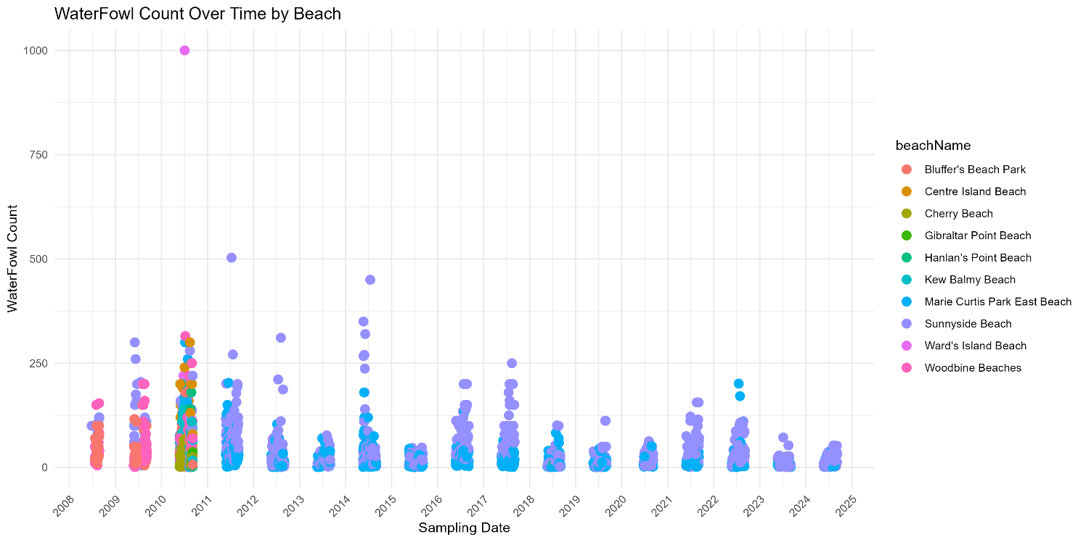

Figure 1 Scatter Plot of Waterfowl Numbers Distribution by Sampling Dates

**2.2** **Relationship Between Waterfowl Numbers and Turbidity**

A linear fit was performed on waterfowl numbers and turbidity, revealing a significant positive correlation between the two. As turbidity increases, the number of waterfowl gradually rises. Most waterfowl counts are concentrated within the turbidity range of 0-50 (Figure 2).

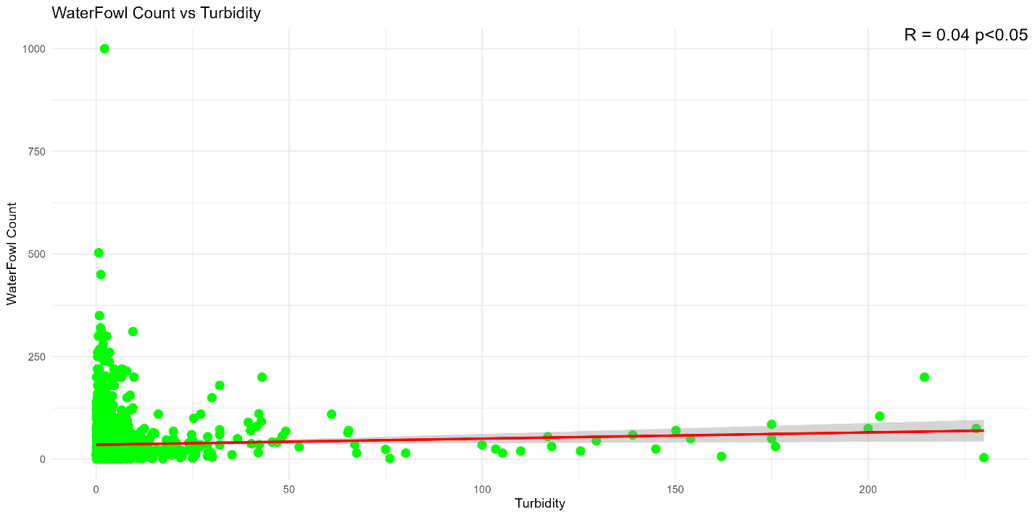

Figure 2 Relationship Between Turbidity and Waterfowl Numbers

**2.3** **Impact of Spatial Factors on Waterfowl Numbers**

Statistics on the average number of waterfowl across different beaches reveal that Centre Island Beach has the highest average count, while Gibraltar Point Beach has the lowest. There are significant differences in waterfowl numbers among the various beaches, indicating clear spatial variability (Figure 3).

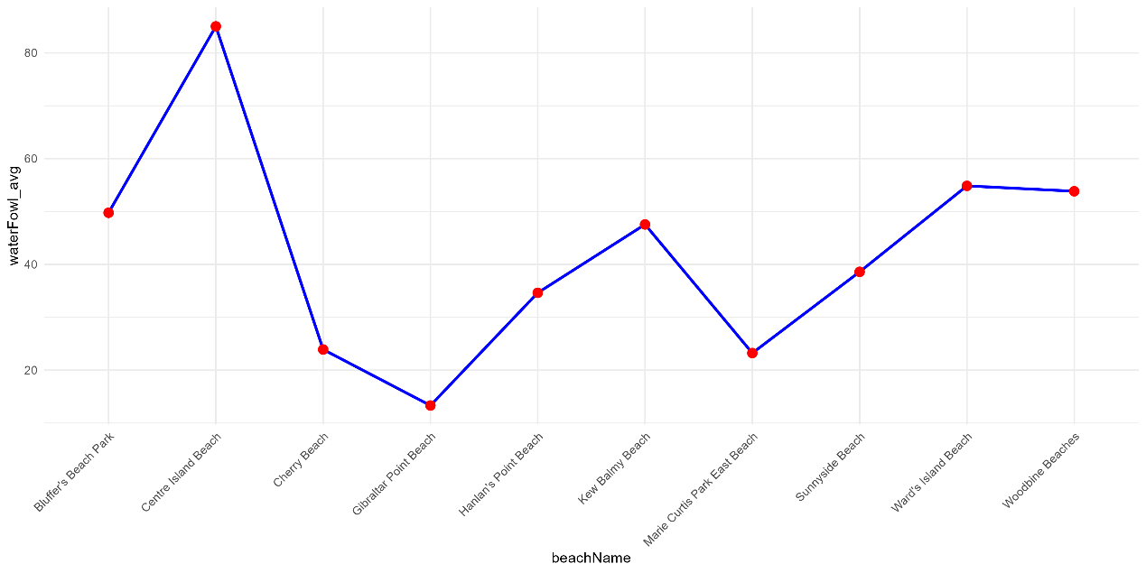

Figure 3 Average Waterfowl Numbers Across Different Beaches

**2.4 Impact of Water Temperature on Waterfowl Numbers**

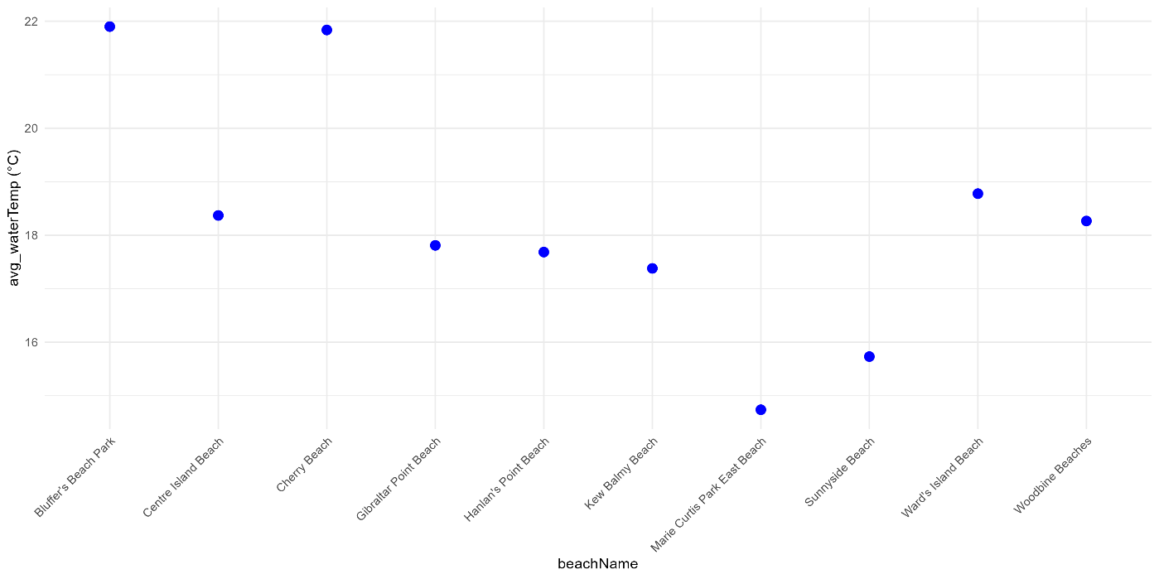

Figure 4 Average Water Temperature Across Different Beaches

The average water temperature at Bluffer's Beach Park is the highest, reaching 22°C. In contrast, Marie Curtis Park East has the lowest average water temperature, while the remaining beaches have average temperatures around 18°C (Figure 4).

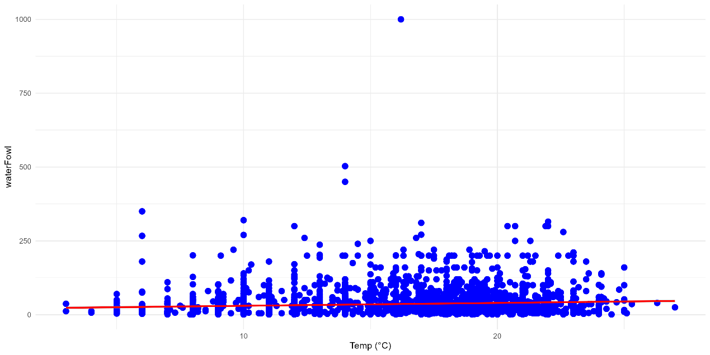

Figure 5 Relationship Between Water Temperature and Waterfowl Numbers

There is a positive correlation between water temperature and waterfowl numbers, with the number of waterfowl showing a trend of increasing and then decreasing as water temperature rises, primarily concentrated at temperatures between 15-20°C.

**3 Discussion**

**3.1 Relationship Between Environmental Variables and Waterfowl**

In this study, the analysis of the relationship between water turbidity, temperature, and waterfowl species numbers reveals a positive correlation between water turbidity, temperature, and the number of migratory birds. This phenomenon may be directly related to the activity patterns of waterfowl. When foraging or resting in the water, waterfowl stir up sediments by swimming or diving, increasing suspended particles and thereby reducing water clarity. The biological activities of waterfowl in the water will increase the organic carbon content in the water, and the increase of organic matter in the water will promote the algal outbreak and trigger algal bloom. In areas with high density of waterfowl, the disturbance of waterfowl activity will make the sediment suspended and increase the turbidity of the water.

Waterfowl also have an impact on water quality, but this varies from region to region. The area with the highest average turbidity is Bluff Beach Park, while Ward Island Beach has a relatively low turbidity despite having the highest number of waterfowl. This shows that in addition to waterfowl activities, water quality is still affected by other factors, such as human activities, other fish, crabs and other biological activities, as well as physical factors, such as water flow speed, sediment suspension, etc., also have a significant impact on turbidity.

In addition, water temperature is another important factor affecting waterfowl numbers and behavior. Studies have shown that waterfowl prefer to live in water temperatures between 15-20°C, when waterfowl populations peak. The number of waterfowl also decreased with the change of temperature. This may be because waterfowl prefer to move around and forage in this temperature range, and extreme temperature changes can affect their survival and the availability of food sources. Moreover, excessively high water temperatures may exacerbate problems related to water eutrophication, further deteriorating water quality and indirectly affecting waterfowl numbers. According to Recep Yetis (2021), water temperature is an important environmental variable explaining the species richness of waterbirds.

In summary, the activities of waterfowl significantly impact water quality, particularly water clarity and turbidity, especially in areas with high waterfowl density where disturbances to the water body are more evident. Changes in water temperature also significantly influence the distribution of waterfowl; suitable temperature ranges promote their breeding and foraging, while excessively high temperatures may stress the aquatic environment and habitats of waterfowl. AP Mishra (2023) suggested that water quality might impact the breeding and migration of waterbirds.

**3.2 The spatial structure of waterfowl populations**

In this study, there are significant differences in waterfowl populations across different beaches. For example, Centre Island Beach has the highest average waterfowl count, highlighting its status as an important habitat for waterfowl. In contrast, the Cape Gibraltar beach has the lowest number of waterfowl. These differences may be due to environmental differences in different Spaces, such as less food at the beach or more human activity.

In addition, the highest number of waterfowl was seen at Ward Island Beach, with up to 1,000 birds in a single observation. This suggests that the area is more suitable for waterfowl. Sunny Beach also showed relatively high numbers of waterfowl at multiple sampling sites, especially after 2012, suggesting that the area could be used as a waterfowl habitat.

**4 Suggestion and expectation**

The waterfowl population should be continuously monitored in the future. This enables real-time assessment of waterfowl population changes and monitoring of environmental conditions. In areas where there are a large number of waterfowl living, more protection areas should be set up to reduce the impact of human activities and be more conducive to the survival and reproduction of waterfowl.

At the same time, it is necessary to further study the environmental factors affecting waterfowl, from the habitat environment structure and food sources, to explore the impact of both on waterfowl.

**Appendix**

加上上传github的网址

**Reference**

Gelfand S (2022). opendatatoronto: Access the City of Toronto Open Data Portal R package version 0.1.5, <https://CRAN.R-project.org/package=opendatatoronto>.

H. Wickham. ggplot2: Elegant Graphics for Data Analysis. Springer-Verlag New York, 2016.

Mishra, A.P.; Kumar, S.; Patra, R.; Kumar, A.; Sahu, H.; Chandra, N.; Pande, C.B.; Alshehri, F. Physicochemical Parameters of Water and Its Implications on Avifauna and Habitat Quality. *Sustainability* 2023, *15*, 9494. https://doi.org/10.3390/su15129494

R Core Team (2024). R: A Language and Environment for Statistical Computing R Foundation for Statistical Computing, Vienna, Austria. <https://www.R-project.org/>

Wickham, Hadley, Mara Averick, Jennifer Bryan, Winston Chang, Lucy D’Agostino McGowan, Romain François, Garrett Grolemund, et al. 2019. “Welcome to the tidyverse.” Journal of Open Source Software 4 (43): 1686. <https://doi.org/10.21105/joss.01686>.

Sahana M, Saini M, Areendran G, et al. Assessing Wetland ecosystem health in Sundarban Biosphere Reserve using pressure-state-response model and geospatial techniques[J]. Remote Sensing Applications: Society and Environment, 2022, 26: 100754. <https://doi.org/10.1016/j.rsase.2022.100754>

Yetis, R., Nergiz, H. & Yetis, A.D. Effects of water quality on the species richness and population distribution of waterbirds in Ahlat marshes, Turkey. *Biologia* 76, 3299–3309 (2021). https://doi.org/10.1007/s11756-021-00810-0

Zhang Y, Jeppesen E, Liu X, et al. Global loss of aquatic vegetation in lakes[J]. Earth-Science Reviews, 2017, 173: 259-265. <https://doi.org/10.1016/j.earscirev.2017.08.013>