1.Player Settings

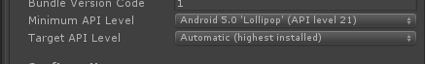

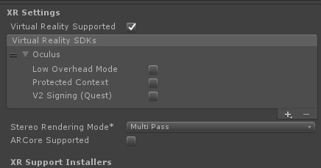

1. 移动身体碰到碰撞体会显示真实世界
2. LeftHandAnchor和RightHandAnchor要有OVRGrabber脚本可以抓取带有OVRGrabbable脚本的物体

参考资料

<https://blog.csdn.net/weixin_42066580/article/details/95620971>

<https://blog.csdn.net/weixin_38239050/article/details/101672951>

<https://blog.csdn.net/weixin_38239050/article/details/101692916>

## Touch Input Mapping

The following diagrams illustrate common input mappings for Oculus Touch controllers. For more information on additional mappings that are available, refer to ****OVRInput**** in the [Unity Scripting Reference](https://developer.oculus.com/documentation/quest/latest/concepts/unity-reference-scripting/) guide.

### **Virtual Mapping (Accessed as a Combined Controller)**

When accessing the Oculus Touch controllers as a combined pair with OVRInput.Controller.Touch, the virtual mapping closely matches the layout of a typical gamepad split across the left and right hands.

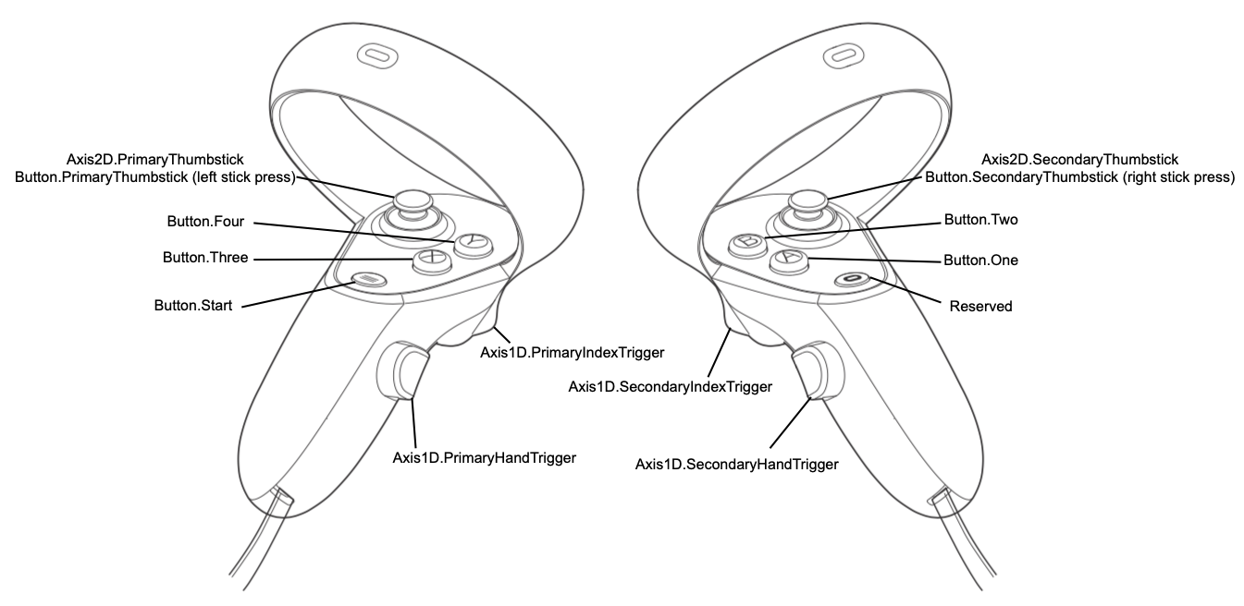

### **Virtual Mapping (Accessed as Individual Controllers)**

When accessing the left or right controller individually with OVRInput.Controller.LTouch or OVRInput.Controller.RTouch, the virtual mapping changes to allow for hand-agnostic input bindings. For example, the same script can dynamically query the left or right controller depending on which hand it is attached to, and Button.One is mapped appropriately to either the A or X button.

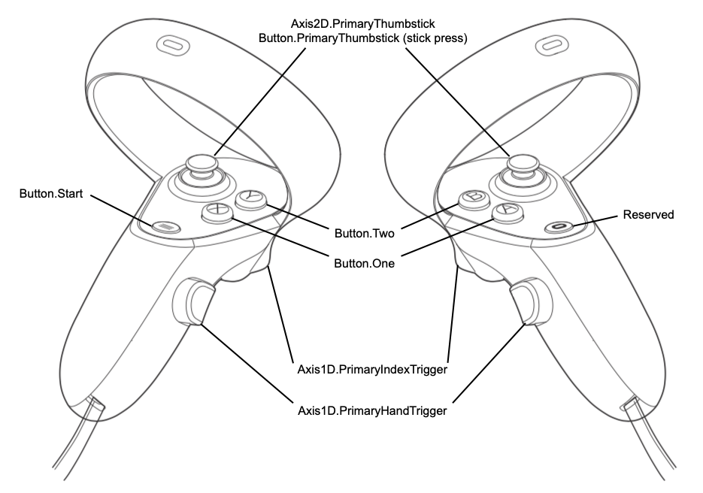

### **Raw Mapping**

The raw mapping directly exposes the controllers. The layout of the controllers closely matches the layout of a typical gamepad split across the left and right hands.

