实验课程名称：__人工智能_
实验项目名称 | A*算法搜索 |  |  | 实验成绩
实 验 者 | 林文敏 | 专业班级 | 计算机科学与技术5班 | 学 号 | 3216004669
实验日期 | 2018.9.20

一、实验内容
熟悉和掌握 A* 算法实现迷宫寻路功能

二、实验设计（原理分析及流程）
原理分析：A*（A-Star)算法是一种静态路网中求解最短路最有效的方法。公式表示为：f(n)=g(n)+h(n)，其中f(n)是节点n从初始点到目标点的估价函数，g(n)是在状态空间中从初始节点到n节点的实际代价，h(n)是从n到目标节点最佳路径的估计代价。保证找到最短路径（最优解的）条件，关键在于估价函数h(n)的选取：估价值h(n)小于等于n到目标节点的距离实际值，这种情况下，搜索的点数多，搜索范围大，效率低，但能得到最优解。如果估价值大于实际值，搜索的点数少，搜索范围小，效率高，但不能保证得到最优解。
流程：
1，从起点A开始, 把它作为待处理的方格存入一个”开启列表”, 开启列表就是一个等待检查方格的列表.
2，寻找起点A周围可以到达的方格, 将它们放入”开启列表”, 并设置它们的”父方格”为A.
3，从”开启列表”中删除起点 A, 并将起点 A 加入”关闭列表”, “关闭列表”中存放的都是不需要再次检查的方格.
4， 从 “开启列表” 中选择 F 值最低的方格C.
5，把它从 “开启列表” 中删除, 并放到 “关闭列表” 中.
6，检查它所有相邻并且可以到达 (障碍物和 “关闭列表” 的方格都不考虑) 的方格. 如果这些方格还不在 “开启列表” 里的话, 将它们加入 “开启列表”, 计算这些方格的 G, H 和 F 值各是多少, 并设置它们的 “父方格”为C .
7， 如果某个相邻方格 D 已经在 “开启列表” 里了, 检查如果用新的路径 (就是经过C 的路径) 到达它的话, G值是否会更低一些, 如果新的G值更低, 那就把它的 “父方格” 改为目前选中的方格 C, 然后重新计算它的 F 值和 G 值 (H 值不需要重新计算, 因为对于每个方块, H 值是不变的). 如果新的 G 值比较高, 就说明经过 C 再到达 D 不是一个明智的选择, 因为它需要更远的路, 这时我们什么也不做.
8，然后继续找F值最小的，如此循环下去…
把起始格添加到 "开启列表"

三、实验代码及数据记录
1.代码
A*算法寻找路径主要算法
class Astar {
constructor(row = 20, col = 20) {
this.myMap = [];
this.row = row;
this.col = col;
this.startPoint = this.endPoint = {x: 0, y: 0};
this.openList = [];
this.closeList = [];
this.UNIT = 30;
this.CELL = 32;

// up, right, down, left
this.offset = [{ x: -1, y: 0 }, { x: 0, y: 1 }, { x: 1, y: 0 }, { x: 0, y: -1 }];
this.isOver = this.isSetStart = this.isSetEnd = false;
this.isDrawStart = this.isDrawEnd = false;
this.status = '';
this.msg = '';
this.setupMap();
this.drawMap();
}

setupMap() {
// generate map
for (let i = 0; i < this.row; i++) {
this.myMap[i] = [];
for (let j = 0; j < this.col; j++) {
this.myMap[i][j] = '0';
}
}
// set walls
let tmpRow, tmpCol;
for (let i = 59; i >= 0; i--) {
this.setWalls();
}

// set up canvas
const canvas = document.getElementById('canvas');
canvas.width = this.col * this.CELL + this.CELL - this.UNIT;
canvas.height = this.row * this.CELL + this.CELL - this.UNIT;
this.ctx = canvas.getContext('2d');
this.ctx.fillRect(0, 0, canvas.width, canvas.height);

canvas.addEventListener('click', event => {
if (!this.isSetStart && !this.isSetEnd) {
return;
}

if (this.isDrawStart ) {
alert('只能设置一个起点！');
return;
}

if (this.isDrawEnd ) {
alert('只能设置一个终点！');
return;
}

let tempX = Math.floor((event.clientX - canvas.offsetLeft) / this.CELL);
let tempY = Math.floor((event.clientY - canvas.offsetTop) / this.CELL);

let type = '0';
if (this.isSetStart) {
type = '2';
this.isDrawStart = true;
this.startPoint = {x: tempY, y: tempX};
}

if (this.isSetEnd) {
type = '3';
this.isDrawEnd = true;
this.endPoint = {x: tempY, y: tempX};
}

if (this.myMap[tempY][tempX] !== '0') {
alert('当前位置无效，请重新设置！');
this.isDrawStart = false;
this.isDrawEnd = false;
return;
}
this.clearPoint(type);
this.myMap[tempY][tempX] = type;
this.drawMap();
});
}

drawMap() {
this.myMap.map((str, i) => {
str.forEach((fill, j) => {
switch (fill) {
case '0':
this.ctx.fillStyle = '#f3f3f3';
break;
case '1':
// wall
this.ctx.fillStyle = '#000000';
break;
case '2':
// start point
this.ctx.fillStyle = '#ff0000';
break;
case '3':
// end point
this.ctx.fillStyle = '#0000ff';
break;
default:
break;
}
this.ctx.fillRect(
j * this.CELL + (this.CELL - this.UNIT),
i * this.CELL + (this.CELL - this.UNIT),
this.UNIT,
this.UNIT
);
});
});
}
navigate() {
if (this.getF(this.startPoint) === 1) {
this.msg = '无需寻路！';
return;
}
this.currentPoint = this.startPoint;
do {
this.closeList.push(this.currentPoint);
this.checkAround(this.currentPoint);
if (this.openList.length === 0) {
this.isOver = true;
this.status = 'fail';
this.msg = '无路可走！'
}
if (this.isOver) {
console.log(`navigate ${this.status}!`);
break;
}
let FList = [];
this.openList.map((item, i) => {
// find the floor F value
FList[i] = this.getF(item);
});
let index = this.getMinIndex(FList);
let minList = [];
let i = 0,
currentIndex;
if (index.length > 1) {
index.map((item, i) => {
minList[i] = this.distance(this.openList[item]);
});
const tmp = this.getMinIndex(minList);
i = tmp[0];
}
currentIndex = index[i];
this.currentPoint = this.openList[currentIndex];
this.openList.splice(currentIndex, 1);
} while (this.openList)
}
checkAround(point) {
for (let i = 0; i < 4; i++) {
const tmp = this.calc(point, i);
// the checked point beyond boundary || attach wall || already in open/close List
if (!this.myMap[tmp.x] || !this.myMap[tmp.x][tmp.y] || this.myMap[tmp.x][tmp.y] === '1' || this.isInList(tmp, this.closeList) || this.isInList(tmp, this.openList)) {
continue;
}
// find the endpoint
if (tmp.x === this.endPoint.x && tmp.y === this.endPoint.y) {
this.isOver = true;
this.status = 'success';
this.msg = '寻路成功！';
const pathArr = [];
let tmp = this.closeList[this.closeList.length - 1];
while (tmp.parent) {
pathArr.push(tmp);
tmp = tmp.parent;
}
pathArr.reverse();
pathArr.map((item, i) => {
let timer = null;
timer = setTimeout(() => {
this.drawPath(item);
clearTimeout(timer);
}, i * 100);
});
break;
}
tmp.parent = point;
this.openList.push(tmp);
}
}
getF(point) {
const G = Math.abs(this.startPoint.x - point.x) + Math.abs(this.startPoint.y - point.y);
const H = Math.abs(this.endPoint.x - point.x) + Math.abs(this.endPoint.y - point.y);
return G + H;
}
// get the distance of current point and checked point
distance(point) {
return Math.abs(this.currentPoint.x - point.x) + Math.abs(this.currentPoint.y - point.y);
}
// return index array or an index
getMinIndex(arr) {
let valueList = [];
const min = Math.min(...arr);
arr.map((item, i) => {
if (item === min) {
valueList.push(i);
}
});
return valueList;
}
// add the offset value for current point
calc(point, i) {
if (this.offset[i]) {
return {
x: point.x + this.offset[i].x,
y: point.y + this.offset[i].y,
}
}
}
drawPath(point) {
this.ctx.fillStyle = '#00ff00';
this.ctx.fillRect(
point.y * this.CELL + (this.CELL - this.UNIT),
point.x * this.CELL + (this.CELL - this.UNIT),
this.UNIT,
this.UNIT);
}
isInList(point, list) {
let tmp;
list.map((item) => {
if (item.x === point.x && item.y === point.y) {
tmp = true;
}
});
return tmp;
}

clearPoint(type) {
for (let i = this.row - 1 ; i >= 0; i--) {
for (let j = this.col - 1; j >= 0; j--) {
if (this.myMap[i][j] === type) {
this.myMap[i][j] = '0';
}
}
}
}
setStart() {
this.isSetStart = true;
this.isDrawStart = this.isDrawEnd = this.isSetEnd = false;
}

setEnd() {
this.isSetEnd = true;
this.isDrawEnd = this.isDrawStart = this.isSetStart = false;
}

setWalls() {
const row = Math.floor(Math.random() * this.row);
const col = Math.floor(Math.random() * this.col);

if (this.myMap[row][col] === '1') {
this.setWalls();
} else {
this.myMap[row][col] = '1';
}
}
}

var app = new Astar();
// event handle
document.getElementById('setStart').onclick = () => {
app.setStart();
}

document.getElementById('setEnd').onclick = () => {
app.setEnd();
}

document.getElementById('navigate').onclick = () => {
if (app.startPoint.x === app.endPoint.x && app.startPoint.y === app.endPoint.y) {
alert('请先设置起始点！');
return;
}
app.navigate();
document.getElementById('msg').innerText = app.msg;
}

页面算法
<!DOCTYPE html>
<html lang="en">
<head>
<meta charset="UTF-8">
<meta name="viewport" content="width=device-width, initial-scale=1.0, minimum-scale=1.0, maximum-scale=1.0, user-scalable=no">
<title>Astar</title>
<style>
canvas {
margin-top: 10px;
}
#msg {
margin-left: 10px;
}
</style>
</head>
<body>
<div>
<button id="setStart">设置起点</button>
<button id="setEnd">设置终点</button>
<button id="navigate">寻找路径</button>
<span id='msg'></span>
</div>
<canvas id="canvas"></canvas>
<script src="Astar.js"></script>
</body>
</html>

2. 结果截图
起始页面
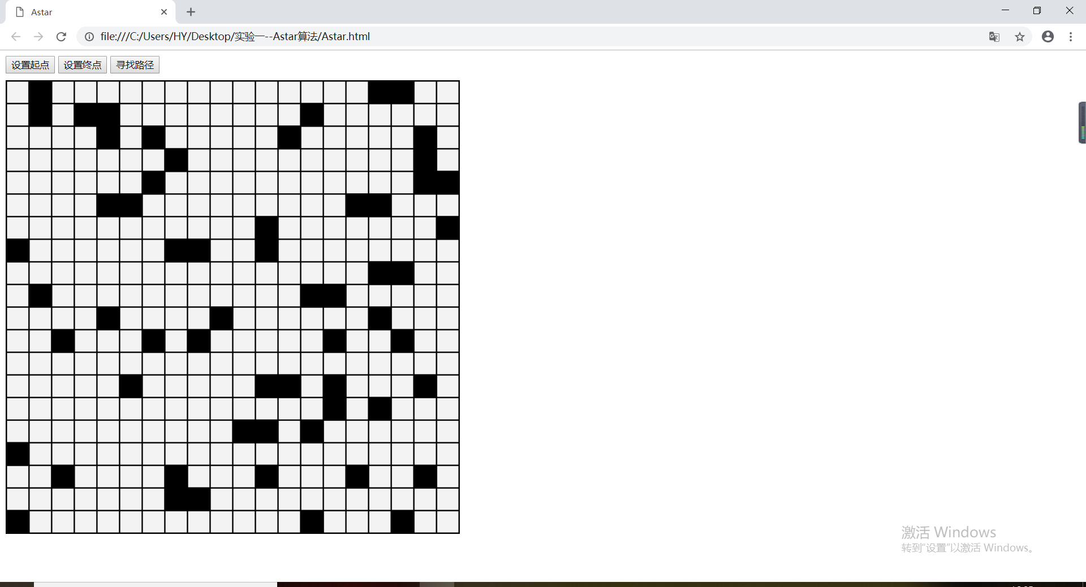
设置起点
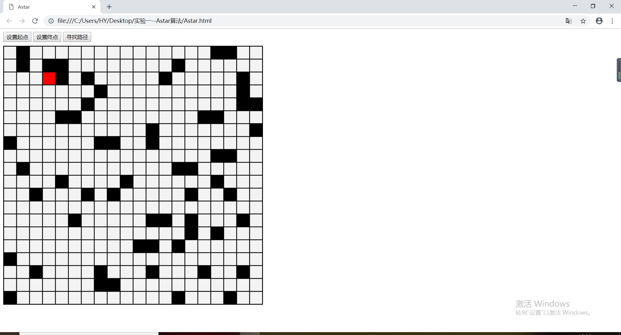
设置终点
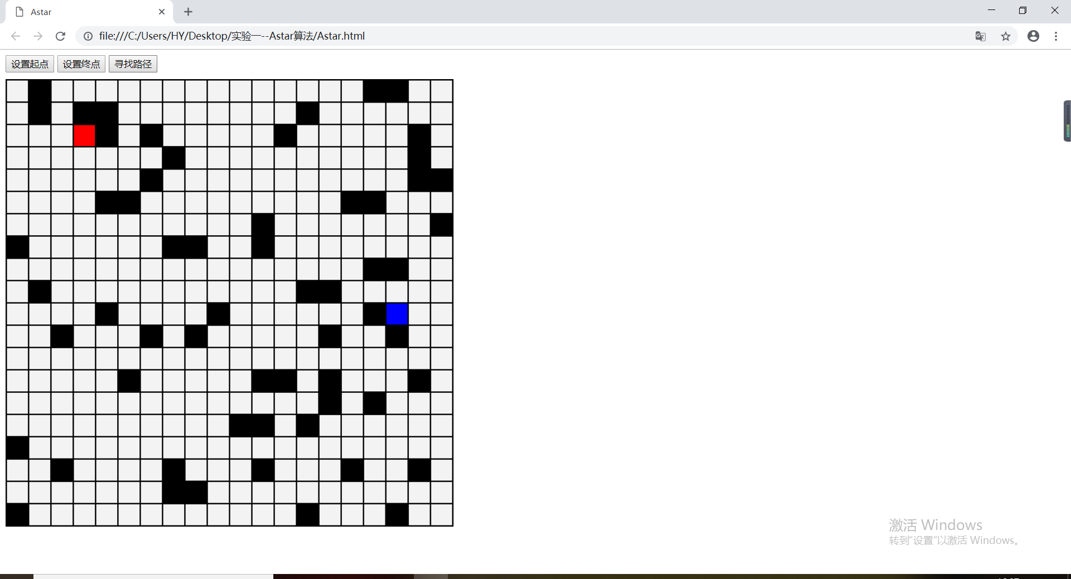
查找路径
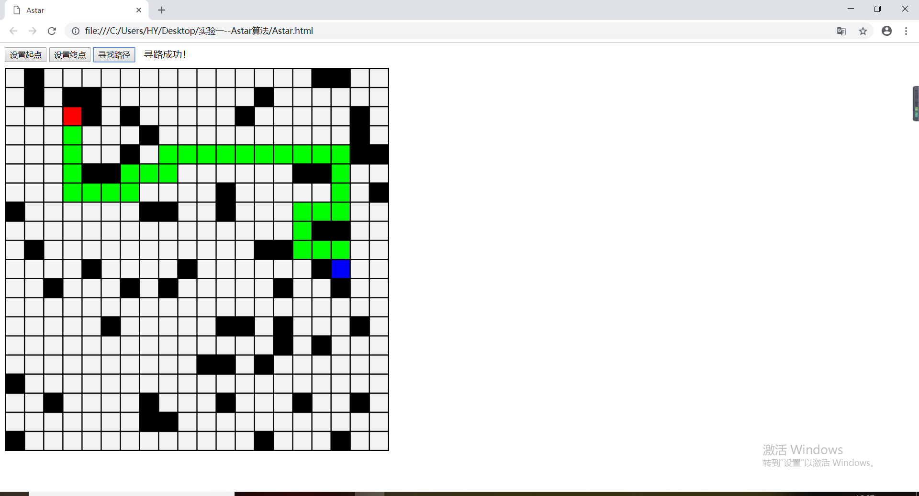
无路可走情况
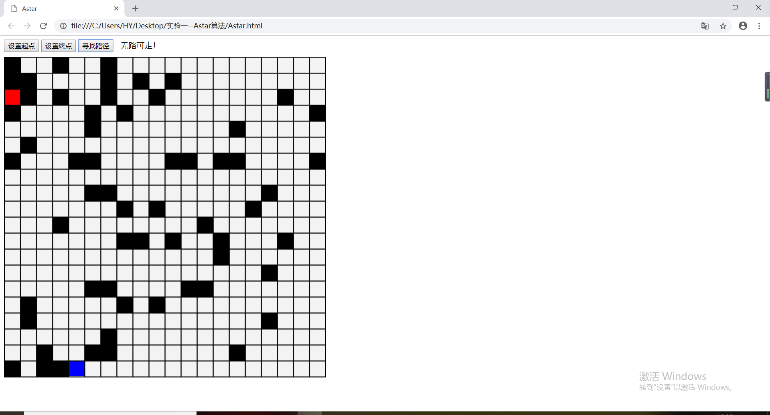
无需寻路情况
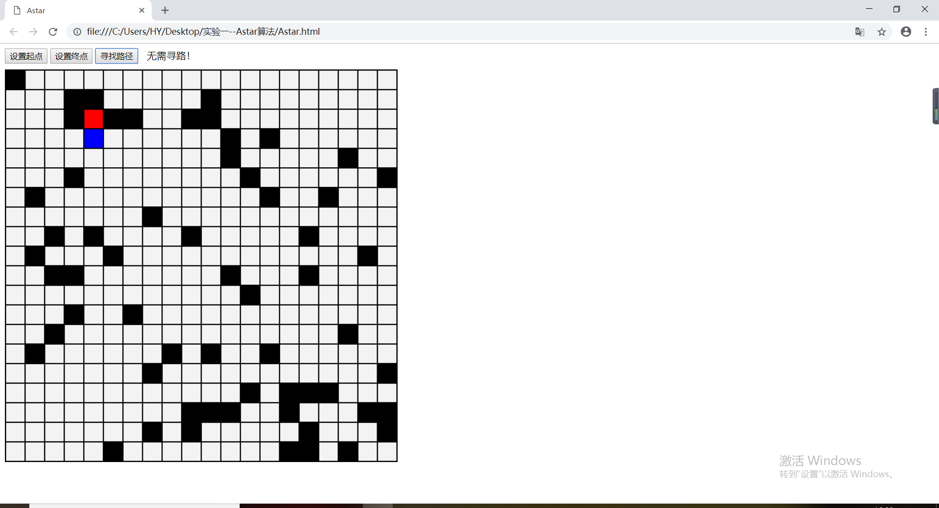
只能设置一个起点终点报错情况
