太阳、月亮、季节与潮汐

【操作步骤】

1. 配置太阳、月亮、季节
2. 太阳的信息解读
3. 月亮与季节的信息解读
4. 配置潮汐

【参考】

* 配置

sun:

sensor:

- platform: moon

- platform: season

- platform: worldtidesinfo

api_key: 7da8ea6b-a34a-4da6-a84b-f894d756dbe3

* worldtides网站

<https://www.worldtides.info>

* 太阳信息示意图

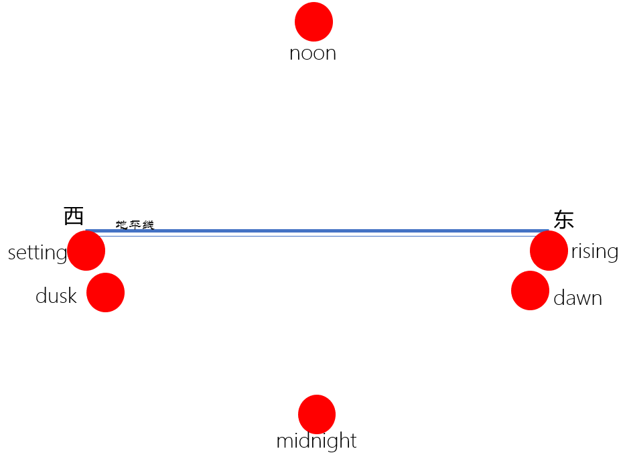 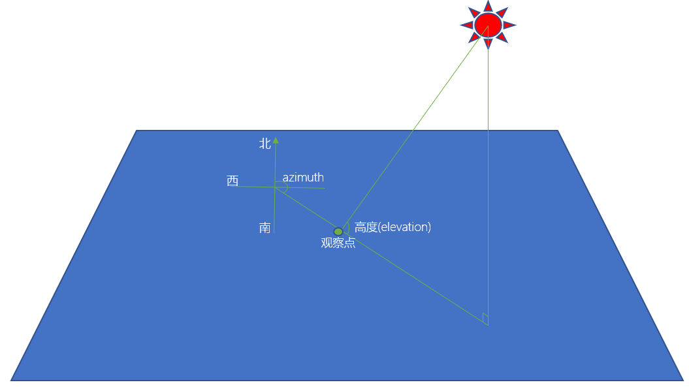

* 月亮状态

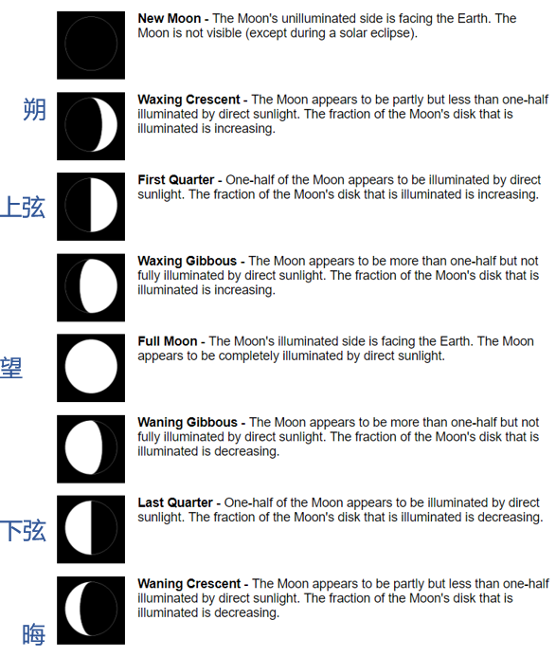

天气与预报——yr、DarkSky、……

【操作步骤】

1. 配置yr
2. 获得DarkSky的API Key
3. 解读DarkSky配置
4. 使用packages配置DarkSky
5. 其它天气组件

【参考】

* yr天气的配置介绍

<https://www.home-assistant.io/components/sensor.yr/>

* DarkSky天气域配置介绍

<https://www.home-assistant.io/components/weather.darksky/>

* DarkSky传感器域配置介绍

<https://www.home-assistant.io/components/sensor.darksky/>

* DarkSky网站

<https://darksky.net/>

* DarkSky的配置example_7_2_1.yaml

# example_7_2_1.yaml

sensor:

- platform: darksky

api_key: d9f896cba3d240816d83bd1dbcb388a0

forecast: 1

language: zh

monitored_conditions:

- summary

- temperature

- humidity

- precip_probability

weather:

- platform: darksky

api_key: d9f896cba3d240816d83bd1dbcb388a0

mode: hourly

group:

weather_sensor_darksky:

name: DarkSky天气传感器

entities: sensor.dark_sky_summary, sensor.dark_sky_temperature, sensor.dark_sky_humidity, sensor.dark_sky_precip_probability

darksky:

name: DarkSky

entities: group.weather_sensor_darksky, weather.dark_sky

view: yes

* HomeAssistant中天气相关组件介绍

<https://www.home-assistant.io/components/#weather>

红外遥控——博联RM系列产品

【硬件准备】

* 博联RM系列产品（任选一）  
  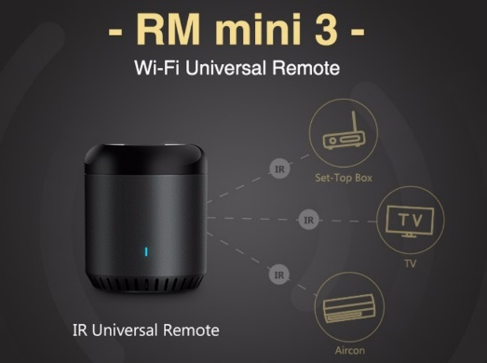 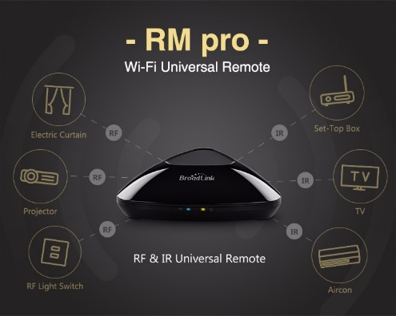

【操作步骤】

1. 接入博联RM红外转发设备
2. 学习红外码
3. 配置红外码开关设备
4. 脚本调用红外发送服务

【参考】

* 博联官网

<http://www.broadlink.com.cn/>

* 博联RM Switch组件

<https://www.home-assistant.io/components/switch.broadlink/>

* 视频中演示的配置样例

switch:

- platform: broadlink

host: 192.168.31.177

mac: '34:EA:34:40:79:3A'

switches:

tv_power:

friendly_name: "电视开关"

command_on: 'xxxxxxxxxxxxxxxx'

command_off: 'xxxxxxxxxxxxxxxx'

* 视频中演示的脚本样例

tv_input_select:

alias: 切换电视输入源

sequence:

- service: switch.broadlink_send_packet_192_168_31_177

data:

packet:

- "xxxxxxxxxxxxxxxxxxx"

红外遥控——小米万能遥控器

【硬件准备】

* 小米万能遥控器  
  

【操作步骤】

1. 安装miio，获得小米万能遥控器的token
2. 接入小米万能遥控器设备
3. 学习红外码
4. 配置对应命令与脚本

【参考】

* 小米万能遥控器组件

<https://www.home-assistant.io/components/remote.xiaomi_miio/>

* 视频中演示的配置样例

# example_7_4_1.yaml

remote:

- platform: xiaomi_miio

name: xiaomi_rm

host: x.x.x.x

token: xxxxxxxxxxxxxxxxxx

commands:

tv_power:

command:

- raw:xxxxxxxxxxxxxxxxxxxxxxxx

tv_input:

command: raw:xxxxxxxxxxxxxxxxxx

script:

tv_power:

alias: 电视开关

sequence:

- service: remote.send_command

entity_id: 'remote.xiaomi_rm'

data:

command: 'tv_power'

tv_input:

alias: 输入源切换

sequence:

- service: remote.send_command

entity_id: 'remote.xiaomi_rm'

data:

command:

- 'tv_input'

入侵检测——FolderWatcher

【操作步骤】

1. folder_watcher与对应自动化配置解释
2. 上传packages配置文件，重启homeassistant
3. 增加whitelist_external_dirs配置
4. 实验配置效果

【参考】

* folder_watcher组件

<https://www.home-assistant.io/components/folder_watcher/>

* 配置样例example_7_5_1.yaml

# example_7_5_1.yaml

folder_watcher:

- folder: /home/pi

patterns:

- '*.yaml'

- '*.txt'

automation:

alias: Files WatchDog

trigger:

platform: event

event_type: folder_watcher

action:

service: notify.zhujisheng_gmail

data_template:

title: 文件系统被修改！

message: "{{trigger.event.data.file}} in {{trigger.event.data.folder}} has been {{ trigger.event.data.event_type }}"