使用TensorFlow进行物体识别

【操作步骤】

1. 使用pip安装TensorFlow
2. 下载TensorFlow/Models项目之物体识别data/protos/utils三目录
3. 安装protoc，编译protos目录内容
4. 下载TensorFlow/Models项目之物体识别训练好的模型文件
5. 配置TensorFlow图像处理，识别汽车

【参考】

* TensorFlow网站

<https://www.tensorflow.org/?hl=zh-cn>

* HA中TensorFlow图像处理配置说明

<https://www.home-assistant.io/components/image_processing.tensorflow/>

* TensorFlow/Models项目之物体识别

<https://github.com/tensorflow/models/tree/master/research/object_detection>

* + 我们需要其中data/protos/utils三目录内容
  + 下载github项目子目录的工具页面<https://minhaskamal.github.io/DownGit/#/home>
* protobuf项目

<https://github.com/protocolbuffers/protobuf/>

* Windows下运行命令

for /f %G in ('dir /b object_detection\protos\*.proto') do bin\protoc object_detection\protos\%G --python_out=.

* TensorFlow/Models项目之物体识别已训练好的模型

<https://github.com/tensorflow/models/blob/master/research/object_detection/g3doc/detection_model_zoo.md>

选择其中[faster_rcnn_inception_v2_coco](http://download.tensorflow.org/models/object_detection/faster_rcnn_inception_v2_coco_2018_01_28.tar.gz)模型

* HA配置目录下，tensorflow相关文件结构

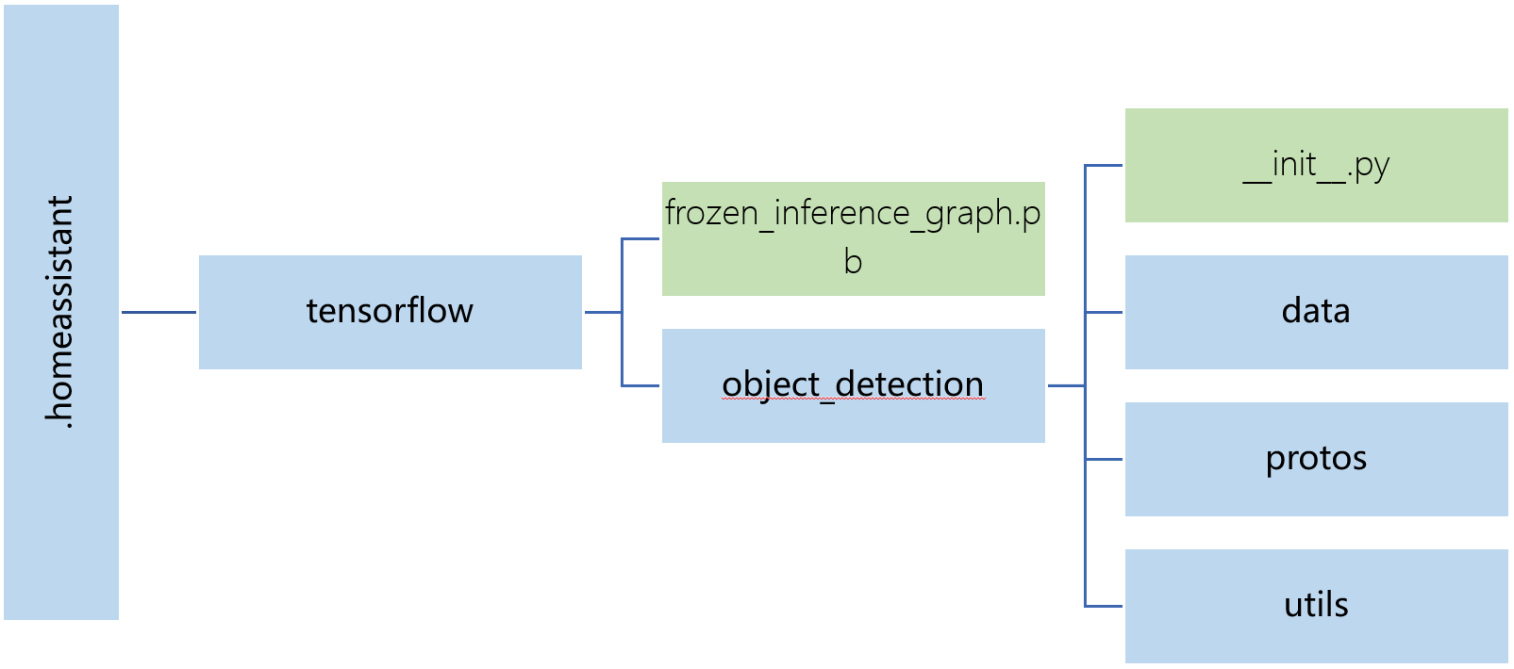

* 相关配置样例

# example

camera:

- platform: rpi_camera

name: road

- platform: local_file

name: cars_on_road

file_path: /home/pi/Pictures/cars_on_road.jpg

image_processing:

- platform: tensorflow

scan_interval: 1000000

confidence: 30

source:

- entity_id: camera.road

name: car_detect

file_out:

- "/home/pi/Pictures/cars_on_road.jpg"

model:

graph: /home/pi/.homeassistant/tensorflow/frozen_inference_graph.pb

categories:

- person

- car

- trunk

script:

car_detection:

alias: tensorflow识别汽车

sequence:

- service: image_processing.scan

data:

entity_id: image_processing.car_detect