Student ID: 103219618

Name: Syed Asim Razvi

# Setup Screenshot

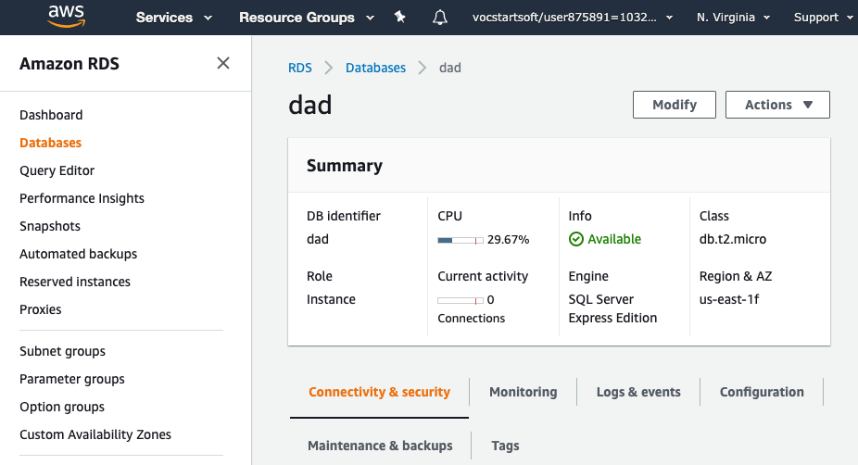

# Task 2 Screenshot

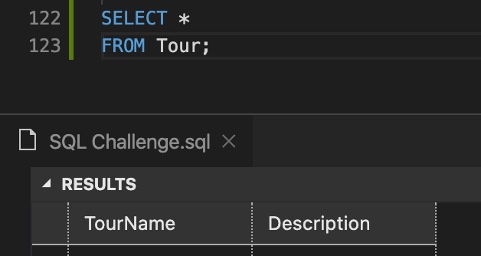

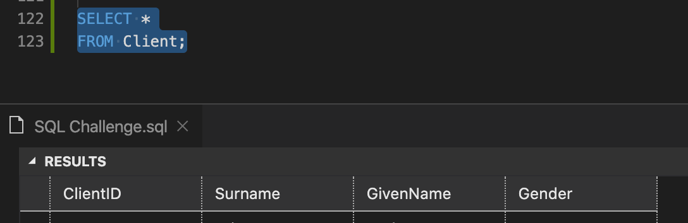

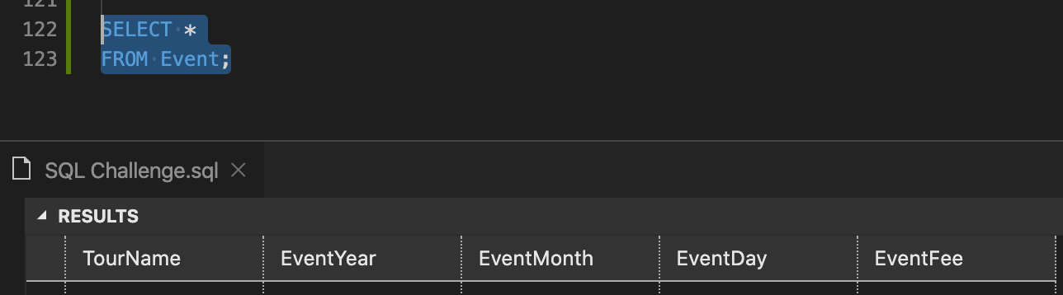

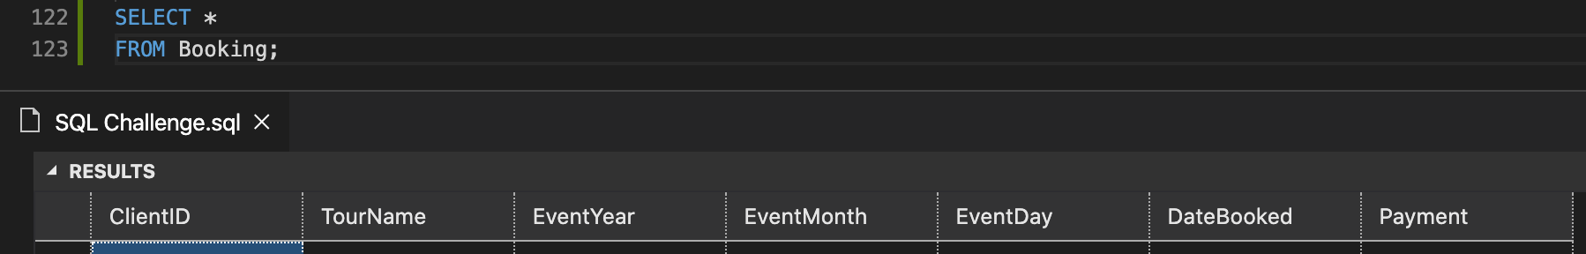

# Task 3 Screenshot

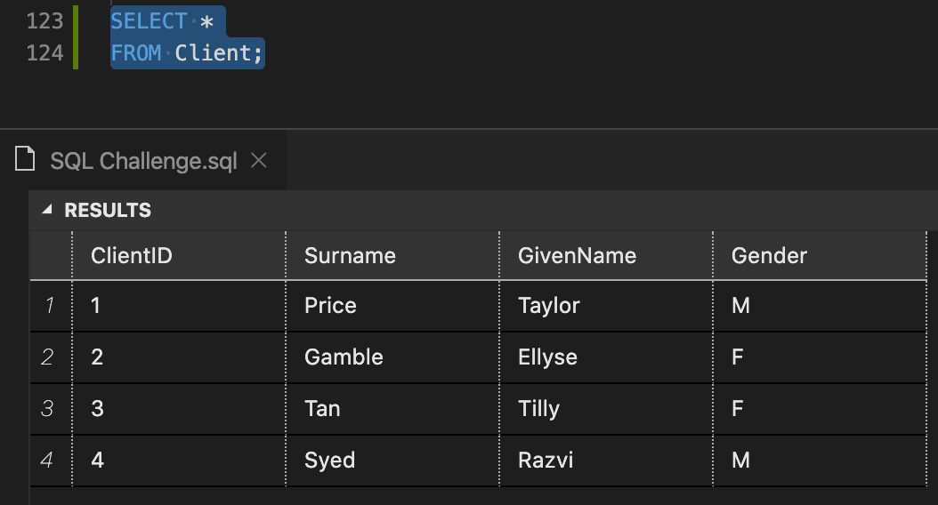

# Task 4

QUERY 1

SELECT C.Surname, C.GivenName, T.TourName, T.Description, E.EventYear, E.EventMonth, E.EventDay, E.EventFee, B.DateBooked, B.Payment

FROM Client C

INNER JOIN Booking B

ON C.ClientID = B.ClientID

INNER JOIN Event E

ON E.EventYear = B.EventYear AND E.EventMonth = B.EventMonth AND E.EventDay = B.EventDay

INNER JOIN Tour T

ON E.TourName = T.TourName;

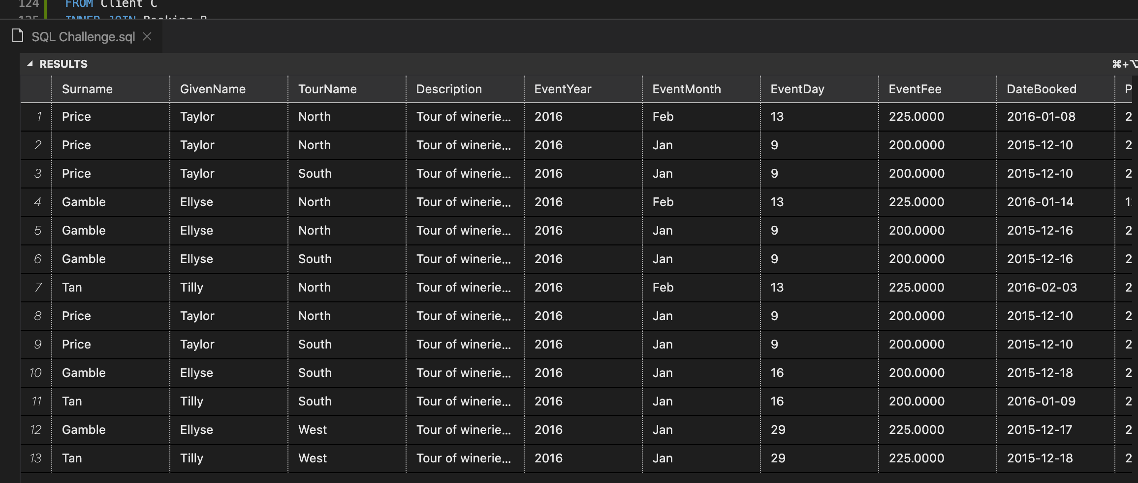

QUERY 2

SELECT EventMonth, TourName, Count(*) AS 'Num Bookings'

FROM Booking

GROUP BY EventMonth, TourName;

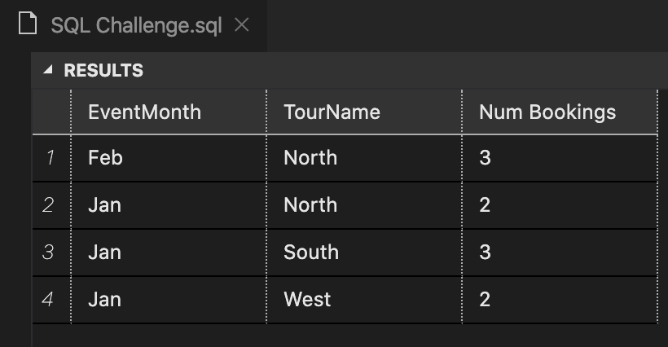

QUERY 3

SELECT *

FROM Booking

WHERE Payment > (SELECT AVG(Payment) FROM Booking);

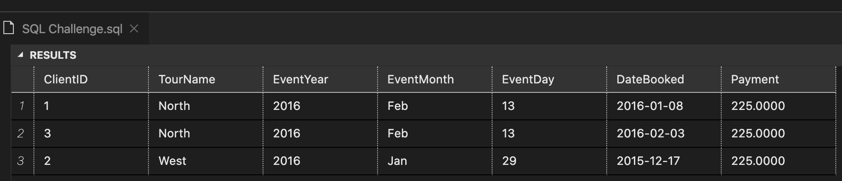

# Task 5

CREATE VIEW [Task 5] AS

SELECT C.Surname AS 'Client Last Name', C.GivenName AS 'Client First Name', T.TourName, T.Description, E.EventYear, E.EventMonth, E.EventDay, E.EventFee, B.DateBooked, B.Payment

FROM Client C

INNER JOIN Booking B

ON C.ClientID = B.ClientID

INNER JOIN Event E

ON E.EventYear = B.EventYear AND E.EventMonth = B.EventMonth AND E.EventDay = B.EventDay

INNER JOIN Tour T

ON E.TourName = T.TourName;

SELECT * FROM [TASK 5];

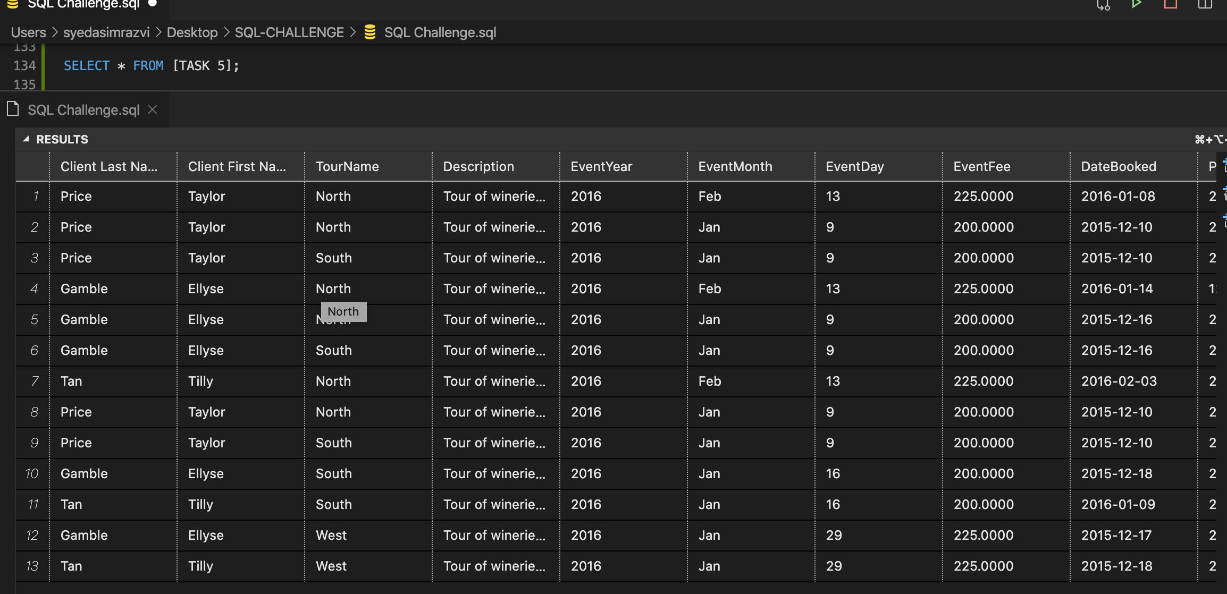

# Task 6

In SQL FILE