Experiment 1: Introduction to AI DevOps Tools: Git, Docker, Kubernetes, Prometheus

Learning Objective: Students should gain foundational knowledge of popular DevOps tools used in AI development workflows, including Git, Docker, Kubernetes, and Prometheus, and understand their individual roles in modern software development and deployment pipelines.

Tools: Git, Docker, Kubernetes, Prometheus

Theory:
AI DevOps Tools help connect AI development with software operations. They make sure AI models are built, tested, deployed, and monitored smoothly. These tools reduce manual work, save time, and improve reliability.
Using DevOps tools in AI projects helps teams update models faster, fix issues quickly, and keep applications running without interruption. They also help maintain quality and performance as AI systems grow.
- Git helps keep a history of code changes, so mistakes can be fixed easily and progress is not lost.
- Docker helps developers run AI applications on any system without errors caused by environment differences.
- Kubernetes makes sure AI applications stay available even when traffic increases or servers fail.
- Prometheus helps teams understand how well the AI system is performing and warns them when problems occur.
Overall, AI DevOps tools make AI applications more stable, scalable, and easier to manage.
Steps:

- Setup Git for Version Control:
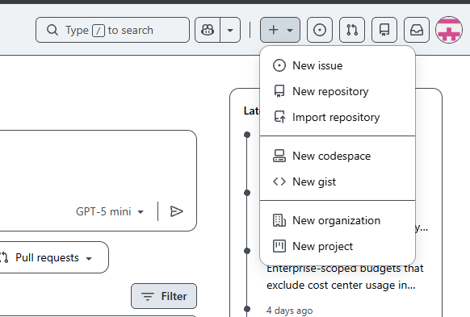
- Install Git
Download and install Git from the official website for your operating system.
- Configure Git
Set your name and email to identify your commits.
- Create or Clone a Repository
Start a new project or copy an existing one from a remote repository.
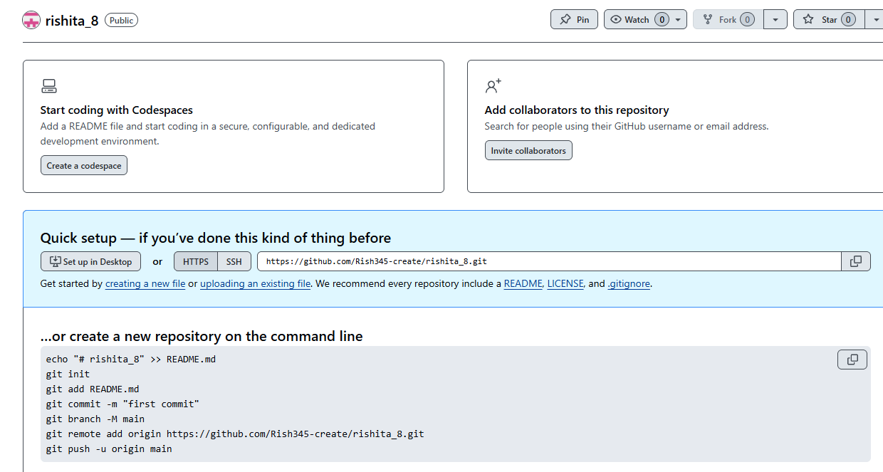
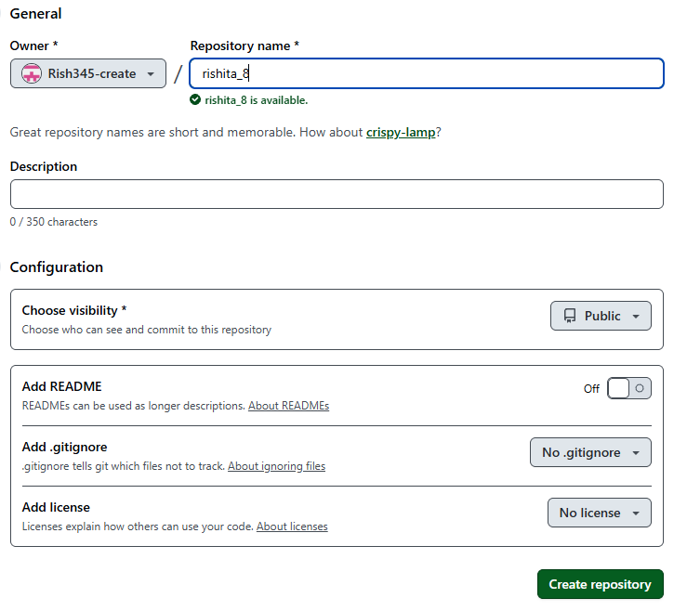
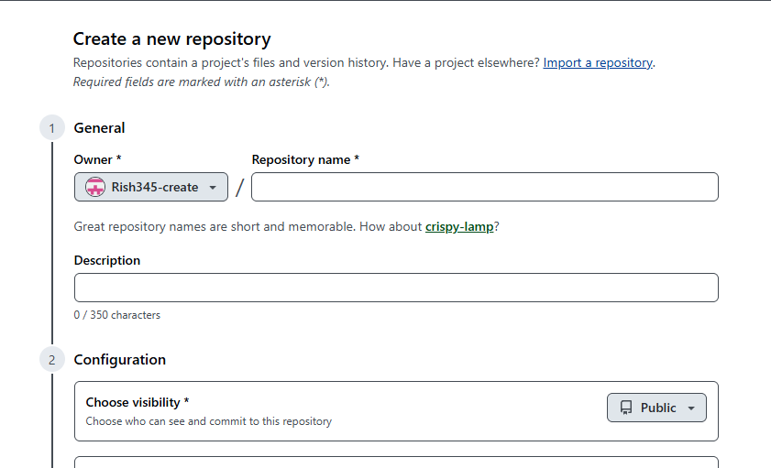
.

Dockerizing a Simple Application:
- Install Docker
Download and install Docker on your system.
- Create a Dockerfile
Write a Dockerfile to define how the application should be built and run.
- Build the Docker Image
Use Docker commands to create an image from the Dockerfile.
- Run the Container
Start the application inside a Docker container
Deploy Containers using Kubernetes:
  - Set Up Kubernetes
Install and start a Kubernetes cluster (like Minikube or Kind).
  - Create Deployment File
Write a YAML file to define how the container should run.
  - Deploy the Application
Use Kubernetes commands to deploy the container to the cluster.
  - Access and Manage the App
Expose the app and monitor its status using Kubernetes tools.
Monitor the Application using Prometheus:
- Install Prometheus
Set up Prometheus on your system or Kubernetes cluster.
- Configure Targets
Tell Prometheus which application or services to monitor.
- Collect Metrics
Prometheus automatically gathers performance data from the application.
- View Alerts and Data
Check metrics on the dashboard and receive alerts when issues occur.

- Sample Dockerfile:

# Use an official Java runtime as the base image
FROM openjdk:11-jdk-slim

# Copy the application JAR file
COPY target/sample-app.jar /app/sample-app.jar

# Run the application
CMD ["java", "-jar", "/app/sample-app.jar"]

- Sample Kubernetes Deployment:

apiVersion: apps/v1
kind: Deployment
metadata:
name: sample-app
spec:
replicas: 3
selector:
matchLabels:
app: sample-app
template:
metadata:
labels:
app: sample-app
spec:
containers:
- name: sample-app
image: sample-app:latest
ports:
- containerPort: 8080

- Prometheus Configuration Snippet:

scrape_configs:
- job_name: 'kubernetes'
static_configs:
- targets: ['localhost:9090']
Conclusion:

Viva Questions:
- What is the role of Git in DevOps?
- How does Docker ensure consistent environments?
- What are the advantages of using Kubernetes in container orchestration?
- Explain how Prometheus collects and displays metrics.
- Why are DevOps tools essential in AI development?

For Faculty Use:
Correction Parameters | Formative Assessment  [40%] | Timely completion of Practical  [ 40%] | Attendance/ Learning  Attitude [20%]
Marks
Obtained

